DSWD DROMIC Report #1 on the Fire Incident
in Brgy. 23, Bacolod City, Negros Occidental
as of 30 April 2021, 6PM

SUMMARY

On 27 April 2021, a fire incident occurred in Brgy. 23 in Bacolod City, Negros Occidental.

Source: DSWD-FO VI

- Status of Affected Families / Persons
A total of 13 families or 26 persons were affected by the fire incident in Brgy. 23, Bacolod City, Negros Occidental (see Table 1).

Table 1. Number of Affected Families / Persons
REGION / PROVINCE / MUNICIPALITY |  | NUMBER OF AFFECTED
 |  | Barangays | Families | Persons
GRAND TOTAL |  | 1 | 13 | 26
REGION VI |  | 1 | 13 | 26
Negros Occidental |  | 1 | 13 | 26
 | Bacolod City (capital) | 1 | 13 | 26
Note: Ongoing assessment and validation being conducted.
Source: DSWD-FO VI

- Status of Displaced Families Outside Evacuation Center
There are 13 families or 26 persons temporarily staying with their relatives and/or friends (see Table 2).

Table 2. Number of Displaced Families / Persons Outside Evacuation Center
REGION / PROVINCE / MUNICIPALITY |  | NUMBER OF DISPLACED
 |  | OUTSIDE ECs
 |  | Families |  | Persons
 |  | CUM | NOW | CUM | NOW
GRAND TOTAL |  | 13 | 13 | 26 | 26
REGION VI |  | 13 | 13 | 26 | 26
Negros Occidental |  | 13 | 13 | 26 | 26
 | Bacolod City (capital) | 13 | 13 | 26 | 26
Note: Ongoing assessment and validation being conducted.
Source: DSWD-FO VI

- Damaged Houses
A total of four (4) houses were damaged; of which three (3) were totally damaged and one (1) was partially damaged (see Table 3).

Table 3. Number of Damaged Houses
REGION / PROVINCE / MUNICIPALITY |  | NO. OF DAMAGED HOUSES
 |  | Total | Totally | Partially
GRAND TOTAL |  | 4 | 3 | 1
REGION VI |  | 4 | 3 | 1
Negros Occidental |  | 4 | 3 | 1
 | Bacolod City (capital) | 4 | 3 | 1
Note: Ongoing assessment and validation being conducted.
Source: DSWD-FO VI

- Assistance Provided
A total of ₱80,287.74 worth of assistance was provided to the affected families; of which, ₱75,737.74 from DSWD and ₱4,550.00 from LGU (see Table 4).

Table 4. Cost of Assistance Provided to the Affected Families / Persons
REGION / PROVINCE / MUNICIPALITY |  | COST OF ASSISTANCE
 |  | DSWD | LGU | NGOs | OTHERS | GRAND TOTAL
GRAND TOTAL |  | 75,737.74 | 4,550.00 | - | - | 80,287.74
REGION VI |  | 75,737.74 | 4,550.00 | - | - | 80,287.74
Negros Occidental |  | 75,737.74 | 4,550.00 | - | - | 80,287.74
 | Bacolod City (capital) | 75,737.74 | 4,550.00 | - | - | 80,287.74
Source: DSWD-FO VI

SITUATIONAL REPORT
DSWD-DRMB
DATE | SITUATIONS / ACTIONS UNDERTAKEN
30 April 2021 | - The Disaster Response Operations Monitoring and Information Center (DROMIC) of the DSWD-DRMB is closely coordinating with DSWD-FO VI for significant reports on the status of affected families, assistance, and relief efforts.

DSWD-FO VI
DATE | SITUATIONS / ACTIONS UNDERTAKEN
30 April 2021 | - DSWD-FO VI provided a total of ₱75,737.74 worth of relief assistance which consists of 26 family food packs, 13 hygiene kits, 13 sleeping kits and 13 family kits to the affected families.  - DSWD-FO VI provided Technical Assistance to DROMIC Focal of Bacolod City LGU on DROMIC Report Writing.

*****
The Disaster Response Operations Monitoring and Information Center (DROMIC) of the DSWD-DRMB is closely coordinating with DSWD-FO VI for any significant disaster response updates.

Prepared by:

MARIE JOYCE G. RAFANAN

LESLIE R. JAWILI
Releasing Officer

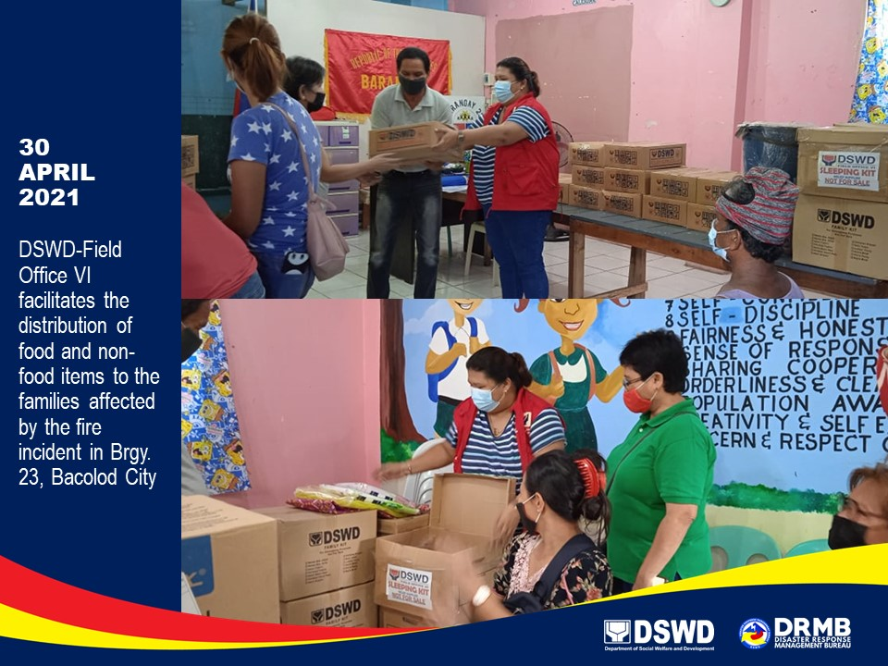
PHOTO DOCUMENTATION

