DSWD DROMIC Report #10 on Typhoon “Bising”
as of 23 April 2021, 6PM

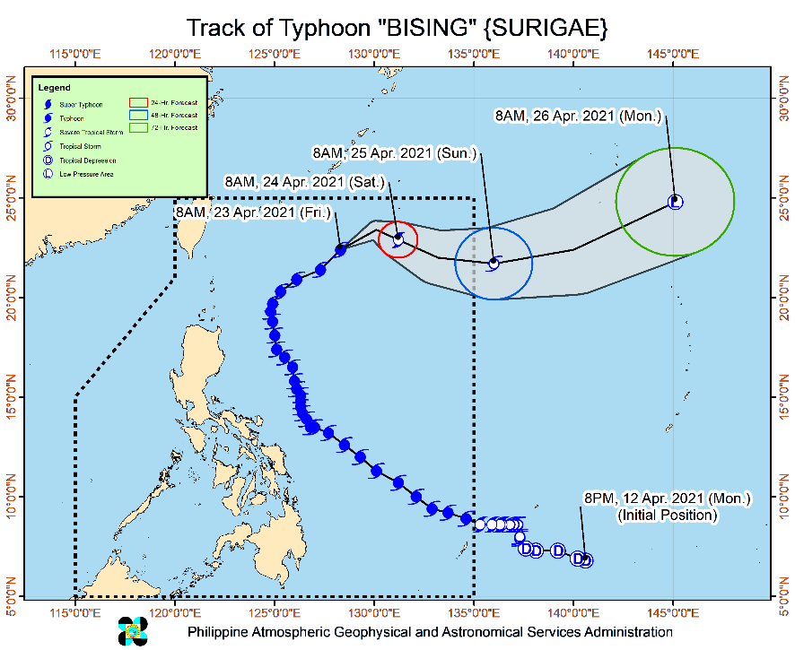
Situation Overview

Issued at 11:00 AM, 23 April 2021, TYPHOON "BISING" SLIGHTLY WEAKENS AND ACCELERATES WHILE MOVING NORTHEASTWARD AWAY FROM THE LANDMASS OF LUZON.

- Tropical cyclone winds of at least strong breeze to near gale in strength extend outward up to 320 km from the center of the typhoon. Destructive typhoon-force winds extend outward up to 50 km from the center of the typhoon.
- Hazards affecting coastal waters
- In the next 24 hours, under the influence of Typhoon “BISING”, the following sea conditions will be experienced over the coastal waters of the country:
- Rough to very rough will be experienced over the northern seaboard of Northern Luzon (2.5 to 4.5 m). Sea travel is risky for small seacrafts over these waters. Mariners without the proper experience should immediately seek safe harbor.
- Moderate to rough seas over the eastern seaboards of Luzon (1.5 to 3.0 m). Mariners of small seacrafts are advised not to venture out over these waters. Inexperienced mariners of these vessels should avoid navigating in these conditions.
- Track and Intensity Outlook:
- On the forecast track, Typhoon “BISING” will move generally northeastward until tonight before turning east southeastward to eastward on Saturday (24 April) and eastward to east northeastward on Sunday (25 April) morning. The typhoon is forecast to exit the Philippine Area of Responsibility on Saturday late evening or Sunday early morning.
- “BISING” will continue to weaken throughout the remainder of the forecast period. It is forecast to be downgraded to severe tropical storm category this afternoon or tonight and tropical storm category tomorrow before transitioning into an extratropical cyclone outside the PAR on Monday (26 April).

At 10:00 AM today, the center of the eye of Typhoon "BISING" was located based on all available data at 715 km East Northeast of Basco, Batanes or 715 km East Northeast of Itbayat, Batanes (22.6 °N, 128.5 °E )
Source: DOST-PAGASA Severe Weather Bulletin

- Status of Affected Families / Persons
A total of 85,570 families or 344,958 persons were affected in 1,099 barangays in Regions II, V, VIII and Caraga (see Table 1).

Table 1. Number of Affected Families / Persons
REGION / PROVINCE / MUNICIPALITY |  | NUMBER OF AFFECTED
 |  | Barangays | Families | Persons
GRAND TOTAL |  | 1,099 | 85,570 | 344,958
REGION II |  | 9 | 112 | 303
Isabela |  | 9 | 112 | 303
 | Divilacan | 2 | 18 | 65
 | Maconacon | 7 | 94 | 238
REGION V |  | 636 | 35,575 | 136,837
Albay |  | 206 | 15,668 | 57,541
 | Bacacay | 16 | 868 | 3,233
 | Camalig | 10 | 2,567 | 9,314
 | Daraga (Locsin) | 7 | 148 | 562
 | Guinobatan | 21 | 2,170 | 7,628
 | Jovellar | 2 | 2 | 8
 | Legazpi City (capital) | 19 | 987 | 4,220
 | Libon | 17 | 417 | 1,996
 | City of Ligao | 13 | 218 | 770
 | Malilipot | 12 | 1,009 | 3,475
 | Malinao | 19 | 1,264 | 4,561
 | Manito | 6 | 828 | 2,619
 | Oas | 7 | 59 | 230
 | Pio Duran | 4 | 437 | 1,730
 | Polangui | 13 | 152 | 527
 | Rapu-Rapu | 8 | 690 | 2,698
 | Santo Domingo (Libog) | 15 | 1,093 | 3,463
 | Tiwi | 17 | 2,759 | 10,507
Camarines Norte |  | 14 | 106 | 450
 | Basud | 1 | 16 | 69
 | Jose Panganiban | 2 | 32 | 121
 | Labo | 3 | 17 | 57
 | Talisay | 8 | 41 | 203
Camarines Sur |  | 148 | 4,431 | 17,997
 | Baao | 5 | 89 | 353
 | Bato | 7 | 149 | 648
 | Bombon | 2 | 14 | 48
 | Buhi | 3 | 120 | 483
 | Bula | 4 | 95 | 473
 | Calabanga | 4 | 169 | 797
 | Caramoan | 27 | 866 | 3,290
 | Garchitorena | 4 | 104 | 507
 | Goa | 13 | 183 | 668
 | Iriga City | 11 | 428 | 1,822
 | Lagonoy | 6 | 57 | 209
 | Magarao | 1 | 6 | 28
 | Minalabac | 1 | 16 | 77
 | Nabua | 7 | 34 | 149
 | Naga City | 1 | 66 | 185
 | Ocampo | 4 | 31 | 147
 | Pasacao | 1 | 68 | 269
 | Pili (capital) | 1 | 5 | 24
 | Presentacion (Parubcan) | 14 | 854 | 3,416
 | Ragay | 7 | 87 | 299
 | Sagñay | 3 | 231 | 967
 | San fernando | 1 | 3 | 6
 | San Jose | 8 | 52 | 220
 | Sipocot | 1 | 19 | 49
 | Siruma | 2 | 14 | 64
 | Tinambac | 10 | 671 | 2,799
Catanduanes |  | 211 | 14,652 | 58,170
 | Province | 1 | 18 | 78
 | Bagamanoc | 11 | 339 | 1,082
 | Baras | 25 | 1,252 | 4,628
 | Bato | 17 | 2,031 | 8,164
 | Caramoran | 21 | 724 | 2,760
 | Gigmoto | 9 | 437 | 1,944
 | Pandan | 20 | 528 | 2,344
 | Panganiban (Payo) | 12 | 392 | 1,502
 | San Andres (Calolbon) | 14 | 662 | 2,554
 | San Miguel | 20 | 2,020 | 9,251
 | Viga | 4 | 57 | 237
 | Virac (capital) | 57 | 6,192 | 23,626
Masbate |  | 7 | 73 | 287
 | Mobo | 1 | 8 | 34
 | Pio V. Corpuz (Limbuhan) | 5 | 59 | 224
 | San Pascual | 1 | 6 | 29
Sorsogon |  | 50 | 645 | 2,392
 | Bulan | 5 | 185 | 534
 | Bulusan | 8 | 64 | 230
 | Castilla | 2 | 19 | 62
 | Gubat | 2 | 6 | 26
 | Irosin | 4 | 24 | 117
 | Juban | 4 | 46 | 194
 | Prieto Diaz | 10 | 87 | 314
 | Santa Magdalena | 3 | 13 | 58
 | City of Sorsogon (capital) | 12 | 201 | 857
REGION VIII |  | 446 | 49,831 | 207,561
Biliran |  | 4 | 51 | 255
 | Cabucgayan | 1 | 3 | 15
 | Culaba | 2 | 2 | 10
 | Maripipi | 1 | 46 | 230
Eastern Samar |  | 152 | 30,098 | 122,668
 | Arteche | 20 | 4,551 | 16,890
 | Can-Avid | 1 | 5,774 | 28,870
 | Dolores | 1 | 1,627 | 6,504
 | Jipapad | 13 | 2,510 | 10,040
 | Maslog | 1 | 76 | 380
 | Oras | 23 | 3,906 | 15,786
 | San Julian | 5 | 92 | 315
 | San Policarpo | 17 | 4,520 | 17,769
 | Sulat | 11 | 162 | 664
 | Taft | 2 | 11 | 43
 | Balangiga | 1 | 45 | 133
 | General MacArthur | 2 | 231 | 869
 | Guiuan | 23 | 1,404 | 4,230
 | Hernani | 9 | 2,454 | 9,727
 | Lawaan | 1 | 2,454 | 9,727
 | Llorente | 2 | 46 | 164
 | Mercedes | 14 | 197 | 405
 | Salcedo | 6 | 38 | 152
Leyte |  | 4 | 1,204 | 6,020
 | San Miguel | 3 | 1,188 | 5,940
 | MacArthur | 1 | 16 | 80
Northern Samar |  | 175 | 14,144 | 59,996
 | Allen | 1 | 7 | 29
 | Biri | 1 | 26 | 113
 | Bobon | 5 | 177 | 931
 | Catarman (capital) | 15 | 1,013 | 4,731
 | Lavezares | 5 | 120 | 528
 | Mondragon | 4 | 91 | 407
 | San Antonio | 5 | 53 | 168
 | San Jose | 4 | 37 | 96
 | Victoria | 6 | 27 | 119
 | Catubig | 13 | 350 | 1,484
 | Gamay | 4 | 408 | 1,484
 | Laoang | 17 | 1,056 | 4,711
 | Lapinig | 3 | 820 | 4,214
 | Las Navas | 23 | 5,856 | 23,783
 | Mapanas | 7 | 507 | 2,245
 | Palapag | 32 | 1,860 | 7,457
 | Pambujan | 15 | 664 | 2,756
 | San Roque | 14 | 1,070 | 4,731
 | Silvino Lobos | 1 | 2 | 9
Western Samar |  | 110 | 4,333 | 18,617
 | Almagro | 1 | 3 | 12
 | Gandara | 8 | 83 | 319
 | Matuguinao | 1 | 2 | 3
 | Pagsanghan | 2 | 12 | 37
 | San Jorge | 7 | 27 | 119
 | Santa Margarita | 2 | 70 | 350
 | Tarangnan | 2 | 24 | 108
 | Basey | 5 | 264 | 1,312
 | Calbiga | 1 | 1 | 5
 | City of Catbalogan (capital) | 20 | 691 | 3,314
 | Daram | 12 | 164 | 896
 | Jiabong | 1 | 69 | 197
 | Paranas (Wright) | 1 | 7 | 23
 | Pinabacdao | 11 | 189 | 905
 | San Sebastian | 14 | 2,263 | 9,130
 | Santa Rita | 5 | 91 | 415
 | Talalora | 2 | 7 | 22
 | Villareal | 1 | 75 | 244
 | Zumarraga | 14 | 291 | 1,206
Southern Leyte |  | 1 | 1 | 5
 | Saint Bernard | 1 | 1 | 5
CARAGA |  | 8 | 52 | 257
Agusan del Norte |  | 3 | 39 | 199
 | City of Cabadbaran | 3 | 39 | 199
Surigao del Norte |  | 5 | 13 | 58
 | Bacuag | 1 | 1 | 4
 | Malimono | 1 | 7 | 32
 | San Benito | 1 | 2 | 9
 | Sison | 2 | 3 | 13
Note: Ongoing assessment and validation being conducted.
Source: DSWD-FOs II, V, VIII and Caraga

- Status of Displaced Families / Persons
- Inside Evacuation Centers
There are 779 families or 3,262 persons currently taking temporary shelter in 24 evacuation centers in Region V (see Table 2).

Table 2. Number of Displaced Families / Persons Inside Evacuation Centers
REGION / PROVINCE / MUNICIPALITY |  | NUMBER OF EVACUATION CENTERS (ECs) |  | NUMBER OF DISPLACED
 |  |  |  | INSIDE ECs
 |  |  |  | Families |  | Persons
 |  | CUM | NOW | CUM | NOW | CUM | NOW
GRAND TOTAL |  | 731 | 24 | 14,791 | 779 | 57,749 | 3,262
REGION II |  | 6 | - | 112 | - | 303 | -
Isabela |  | 6 | - | 112 | - | 303 | -
 | Divilacan | 2 | - | 18 | - | 65 | -
 | Maconacon | 4 | - | 94 | - | 238 | -
REGION V |  | 670 | 24 | 13,372 | 779 | 52,586 | 3,262
Albay |  | 214 | - | 5,652 | - | 20,497 | -
 | Bacacay | 12 | - | 342 | - | 1,403 | -
 | Camalig | 9 | - | 314 | - | 838 | -
 | Daraga (Locsin) | 7 | - | 148 | - | 562 | -
 | Guinobatan | 29 | - | 1,574 | - | 5,652 | -
 | Jovellar | 1 | - | 1 | - | 3 | -
 | Legazpi City (capital) | 13 | - | 177 | - | 630 | -
 | Libon | 8 | - | 76 | - | 450 | -
 | City of Ligao | 14 | - | 218 | - | 770 | -
 | Malilipot | 7 | - | 137 | - | 526 | -
 | Malinao | 27 | - | 1,264 | - | 4,561 | -
 | Manito | 2 | - | 69 | - | 255 | -
 | Oas | 7 | - | 59 | - | 230 | -
 | Pio Duran | 8 | - | 260 | - | 1,074 | -
 | Polangui | 22 | - | 152 | - | 527 | -
 | Rapu-Rapu | 2 | - | 105 | - | 456 | -
 | Santo Domingo (Libog) | 23 | - | 213 | - | 660 | -
 | Tiwi | 23 | - | 543 | - | 1,900 | -
Camarines Norte |  | 12 | - | 81 | - | 370 | -
 | Basud | 2 | - | 7 | - | 37 | -
 | Jose Panganiban | 2 | - | 32 | - | 121 | -
 | Labo | 3 | - | 10 | - | 35 | -
 | Talisay | 5 | - | 32 | - | 177 | -
Camarines Sur |  | 160 | 24 | 2,815 | 779 | 11,634 | 3,262
 | Baao | 3 | - | 14 | - | 42 | -
 | Bato | 9 | - | 149 | - | 648 | -
 | Bombon | 4 | - | 14 | - | 48 | -
 | Buhi | 3 | - | 110 | - | 443 | -
 | Bula | 7 | - | 42 | - | 222 | -
 | Calabanga | 5 | - | 169 | - | 797 | -
 | Caramoan | 27 | - | 234 | - | 930 | -
 | Garchitorena | 4 | 4 | 104 | 104 | 507 | 507
 | Goa | 8 | - | 82 | - | 322 | -
 | Iriga City | 5 | - | 22 | - | 88 | -
 | Lagonoy | 6 | - | 57 | - | 209 | -
 | Magarao | 1 | - | 6 | - | 28 | -
 | Nabua | 7 | - | 34 | - | 149 | -
 | Naga City | 3 | 3 | 66 | 66 | 185 | 185
 | Ocampo | 4 | - | 21 | - | 90 | -
 | Pasacao | 6 | - | 68 | - | 269 | -
 | Pili (capital) | 1 | - | 5 | - | 24 | -
 | Presentacion (Parubcan) | 17 | 17 | 609 | 609 | 2,570 | 2,570
 | Ragay | 8 | - | 87 | - | 299 | -
 | Sagñay | 4 | - | 231 | - | 967 | -
 | San fernando | 1 | - | 3 | - | 6 | -
 | San Jose | 8 | - | 49 | - | 209 | -
 | Sipocot | 1 | - | 19 | - | 49 | -
 | Siruma | 2 | - | 6 | - | 34 | -
 | Tinambac | 16 | - | 614 | - | 2,499 | -
Catanduanes |  | 242 | - | 4,393 | - | 18,533 | -
 | Province | 1 | - | 5 | - | 19 | -
 | Bagamanoc | 15 | - | 199 | - | 627 | -
 | Baras | 31 | - | 366 | - | 1,274 | -
 | Bato | 38 | - | 229 | - | 926 | -
 | Caramoran | 13 | - | 246 | - | 956 | -
 | Gigmoto | 6 | - | 82 | - | 368 | -
 | Pandan | 9 | - | 173 | - | 814 | -
 | Panganiban (Payo) | 3 | - | 15 | - | 84 | -
 | San Andres (Calolbon) | 25 | - | 436 | - | 1,611 | -
 | San Miguel | 36 | - | 1,005 | - | 4,908 | -
 | Viga | 3 | - | 31 | - | 122 | -
 | Virac (capital) | 62 | - | 1,606 | - | 6,824 | -
Masbate |  | 7 | - | 71 | - | 283 | -
 | Mobo | 1 | - | 8 | - | 34 | -
 | Pio V. Corpuz (Limbuhan) | 5 | - | 57 | - | 220 | -
 | San Pascual | 1 | - | 6 | - | 29 | -
Sorsogon |  | 35 | - | 360 | - | 1,269 | -
 | Bulan | 4 | - | 108 | - | 218 | -
 | Bulusan | 6 | - | 44 | - | 147 | -
 | Castilla | 1 | - | 1 | - | 5 | -
 | Gubat | 2 | - | 6 | - | 26 | -
 | Irosin | 4 | - | 24 | - | 117 | -
 | Juban | 6 | - | 46 | - | 194 | -
 | Prieto Diaz | 3 | - | 44 | - | 160 | -
 | Santa Magdalena | 3 | - | 13 | - | 58 | -
 | City of Sorsogon (capital) | 6 | - | 74 | - | 344 | -
REGION VIII |  | 53 | - | 1,268 | - | 4,664 | -
Eastern Samar |  | 5 | - | 59 | - | 120 | -
 | Can-Avid | 4 | - | 48 | - | 77 | -
 | Taft | 1 | - | 11 | - | 43 | -
Leyte |  | 1 | - | 6 | - | 34 | -
 | MacArthur | 1 | - | 6 | - | 34 | -
Northern Samar |  | 34 | - | 879 | - | 3,417 | -
 | Bobon | 1 | - | 22 | - | 96 | -
 | Catarman (capital) | 3 | - | 161 | - | 268 | -
 | Laoang | 11 | - | 282 | - | 1,399 | -
 | Las Navas | 1 | - | 29 | - | 107 | -
 | Mapanas | 3 | - | 35 | - | 156 | -
 | San Roque | 15 | - | 350 | - | 1,391 | -
Western Samar |  | 13 | - | 324 | - | 1,093 | -
 | San Sebastian | 13 | - | 324 | - | 1,093 | -
CARAGA |  | 2 | - | 39 | - | 196 | -
Agusan del Norte |  | 1 | - | 32 | - | 164 | -
 | City of Cabadbaran | 1 | - | 32 | - | 164 | -
Surigao del Norte |  | 1 | - | 7 | - | 32 | -
 | Malimono | 1 | - | 7 | - | 32 | -
Note: Ongoing assessment and validation being conducted.
Source: DSWD-FOs II, V, VIII and Caraga

- Outside Evacuation Centers
There are 245 families or 846 persons temporarily staying with their relatives and/or friends in Region V (see Table 3).

Table 3. Number of Displaced Families / Persons Outside Evacuation Centers
REGION / PROVINCE / MUNICIPALITY |  | NUMBER OF DISPLACED
 |  | OUTSIDE ECs
 |  | Families |  | Persons
 |  | CUM | NOW | CUM | NOW
GRAND TOTAL |  | 24,244 | 245 | 92,800 | 846
REGION V |  | 22,318 | 245 | 84,606 | 846
Albay |  | 10,016 | - | 37,044 | -
 | Bacacay | 526 | - | 1,830 | -
 | Camalig | 2,253 | - | 8,476 | -
 | Guinobatan | 596 | - | 1,976 | -
 | Jovellar | 1 | - | 5 | -
 | Legazpi City (capital) | 810 | - | 3,590 | -
 | Libon | 341 | - | 1,546 | -
 | Malilipot | 872 | - | 2,949 | -
 | Manito | 759 | - | 2,364 | -
 | Pio Duran | 177 | - | 656 | -
 | Rapu-Rapu | 585 | - | 2,242 | -
 | Santo Domingo (Libog) | 880 | - | 2,803 | -
 | Tiwi | 2,216 | - | 8,607 | -
Camarines Norte |  | 25 | - | 80 | -
 | Basud | 9 | - | 32 | -
 | Labo | 7 | - | 22 | -
 | Talisay | 9 | - | 26 | -
Camarines Sur |  | 1,616 | 245 | 6,363 | 846
 | Baao | 75 | - | 311 | -
 | Buhi | 10 | - | 40 | -
 | Bula | 53 | - | 251 | -
 | Caramoan | 632 | - | 2,360 | -
 | Goa | 101 | - | 346 | -
 | Iriga City | 406 | - | 1,734 | -
 | Minalabac | 16 | - | 77 | -
 | Ocampo | 10 | - | 57 | -
 | Presentacion (Parubcan) | 245 | 245 | 846 | 846
 | San Jose | 3 | - | 11 | -
 | Siruma | 8 | - | 30 | -
 | Tinambac | 57 | - | 300 | -
Catanduanes |  | 10,386 | - | 40,033 | -
 | Province | 140 | - | 455 | -
 | Bagamanoc | 140 | - | 455 | -
 | Baras | 886 | - | 3,354 | -
 | Bato | 1,802 | - | 7,238 | -
 | Caramoran | 478 | - | 1,804 | -
 | Gigmoto | 355 | - | 1,576 | -
 | Pandan | 355 | - | 1,530 | -
 | Panganiban (Payo) | 377 | - | 1,418 | -
 | San Andres (Calolbon) | 226 | - | 943 | -
 | San Miguel | 1,015 | - | 4,343 | -
 | Viga | 26 | - | 115 | -
 | Virac (capital) | 4,586 | - | 16,802 | -
Masbate |  | 2 | - | 4 | -
 | Pio V. Corpuz (Limbuhan) | 2 | - | 4 | -
Sorsogon |  | 273 | - | 1,082 | -
 | Bulan | 77 | - | 316 | -
 | Bulusan | 8 | - | 42 | -
 | Castilla | 18 | - | 57 | -
 | Prieto Diaz | 43 | - | 154 | -
 | City of Sorsogon (capital) | 127 | - | 513 | -
REGION VIII |  | 1,926 | - | 8,194 | -
Western Samar |  | 1,926 | - | 8,194 | -
 | San Sebastian | 1,926 | - | 8,194 | -
Note: Ongoing assessment and validation being conducted.
Source: DSWD-FOs V and VIII

- Damaged Houses
There are 1,730 damaged houses; of which, 137 are totally damaged and 1,593 are partially damaged (see Table 4).

Table 4. Number of Damaged Houses
REGION / PROVINCE / MUNICIPALITY |  | NO. OF DAMAGED HOUSES
 |  | Total | Totally | Partially
GRAND TOTAL |  | 1,730 | 137 | 1,593
REGION VIII |  | 1,724 | 136 | 1,588
Biliran |  | 52 | 2 | 50
 | Cabucgayan | 3 | - | 3
 | Culaba | 2 | 1 | 1
 | Maripipi | 47 | 1 | 46
Eastern Samar |  | 20 | - | 20
 | Arteche | 1 | - | 1
 | Can-Avid | 3 | - | 3
 | General MacArthur | 16 | - | 16
Leyte |  | 16 | - | 16
 | MacArthur | 16 | - | 16
Northern Samar |  | 403 | 71 | 332
 | Victoria | 2 | - | 2
 | Laoang | 8 | - | 8
 | Mapanas | 36 | 20 | 16
 | Pambujan | 213 | 37 | 176
 | San Roque | 144 | 14 | 130
Western Samar |  | 1,232 | 63 | 1,169
 | Basey | 10 | - | 10
 | Calbiga | 1 | - | 1
 | City of Catbalogan (capital) | 628 | 14 | 614
 | Daram | 88 | 47 | 41
 | Jiabong | 1 | - | 1
 | Pinabacdao | 162 | 1 | 161
 | San Sebastian | 321 | 1 | 320
 | Santa Rita | 21 | - | 21
Southern Leyte |  | 1 | - | 1
 | Saint Bernard | 1 | - | 1
CARAGA |  | 6 | 1 | 5
Surigao del Norte |  | 6 | 1 | 5
 | Bacuag | 1 | - | 1
 | San Benito | 2 | 1 | 1
 | Sison | 3 | - | 3
. Source: DSWD-FOs VIII and Caraga

- Assistance Provided
A total of ₱1,723,751.20 worth of assistance was provided to the affected families; of which, ₱169,476.20 was provided by DSWD and by ₱1,554,275.00 from LGUs (see Table 5).

Table 5. Cost of Assistance Provided to Affected Families / Persons
REGION / PROVINCE / MUNICIPALITY |  | COST OF ASSISTANCE
 |  | DSWD | LGUs | NGOs | OTHERS | GRAND TOTAL
GRAND TOTAL |  | 169,476.20 | 1,554,275.00 | - | - | 1,723,751.20
REGION II |  | - | 94,050.00 | - | - | 94,050.00
Isabela |  | - | 94,050.00 | - | - | 94,050.00
 | Divilacan | - | 94,050.00 | - | - | 94,050.00
REGION V |  | 169,476.20 | 1,460,225.00 | - | - | 1,629,701.20
Albay |  | 169,476.20 | - | - | - | 169,476.20
 | Libon | 169,476.20 | - | - | - | 169,476.20
Camarines Sur |  | - | 1,458,545.00 | - | - | 1,458,545.00
 | Bombon | - | 512,640.00 | - | - | 512,640.00
 | Siruma | - | 445,905.00 | - | - | 445,905.00
 | Tinambac | - | 500,000.00 | - | - | 500,000.00
Sorsogon |  | - | 1,680.00 | - | - | 1,680.00
 | Pilar | - | 1,680.00 | - | - | 1,680.00
Source: DSWD-FOs II and V

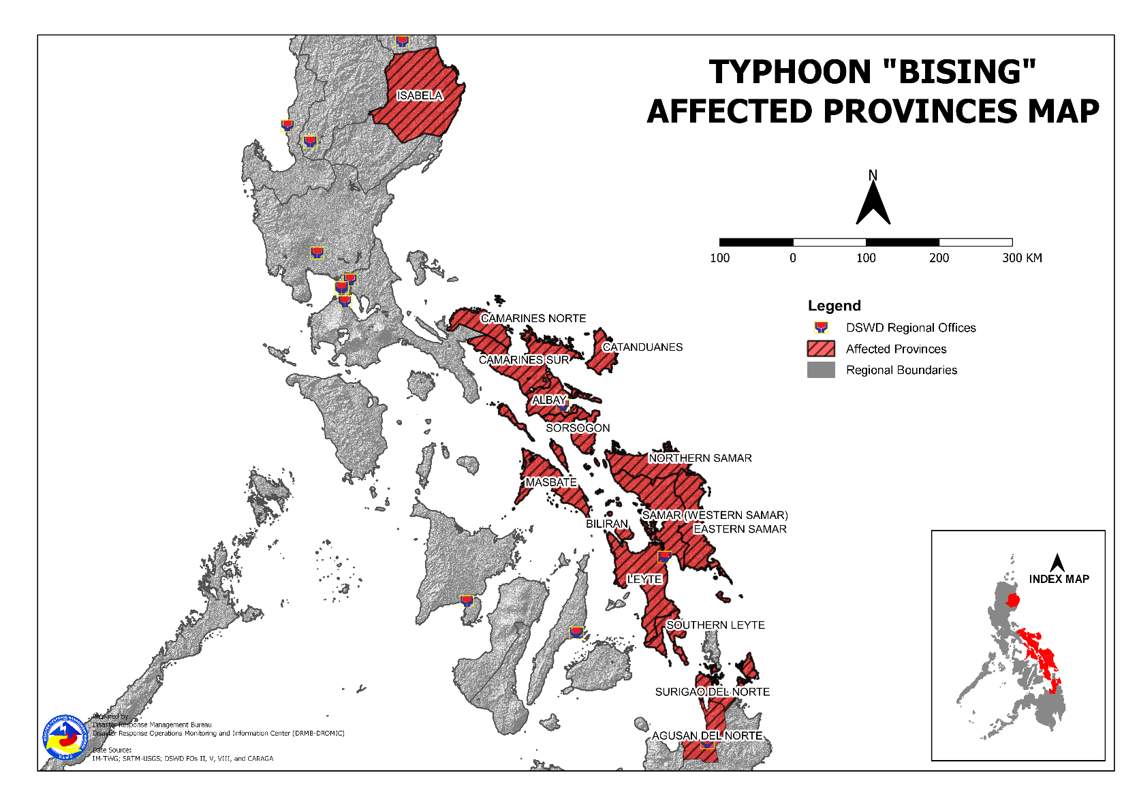
DSWD DISASTER RESPONSE INFORMATION

Situational Reports

DSWD-DRMB
DATE | SITUATIONS / ACTIONS UNDERTAKEN
23 April 2021 | - The Disaster Response Management Bureau is on RED Alert Status and is closely coordinating with the concerned field offices for significant disaster response updates.  - All QRT members and emergency equipment are on standby and ready for deployment.

DSWD-FO CAR
DATE | SITUATIONS / ACTIONS UNDERTAKEN
22 April 2021 | - Replenishment of 2,002 FFPs and 400 hygiene kits to Kalinga and 2,002 FFPs and 500 hygiene kits to Ifugao.  - DSWD-FO CAR ensures compliance to the CCCM and IDP Protection Guidelines and COVID19 Protocols.  - DSWD-FO CAR ensures availability of evacuation centers to accommodate displaced families and individuals.  - DSWD-FO CAR is closely monitoring weather updates and information.  - DSWD-FO CAR ensures availability of food and non-food items for resource augmentation as the need arises.  - DSWD-FO CAR DRR Focal persons is in close coordination with the LDRRMOs and MSWDOs for weather reports and updates.

DSWD-FO I
DATE | SITUATIONS / ACTIONS UNDERTAKEN
17 April 2021 | - DSWD-FO I is closely monitoring the movement of Typhoon” BISING” through the DOST – PAGASA and in close coordination with the Regional Disaster Risk Reduction and Management Council 1 (RDRRMC1). Likewise, Provincial Operations Offices (POOs) are in close coordination with the different Provincial/City/Municipal Disaster Risk Reduction and Management Councils (P/C/MDRRMCs) and Provincial/City/ Municipality Social Welfare and Development Offices (P/C/MSWDOs) to monitor the adverse effects that might be brought by the weather disturbance.  - DSWD-FO I Incident Management Team (IMT) is still activated and on duty while other DSWD staff are on standby for possible augmentation. Likewise, the Field Office ensures availability and readiness of resources.

DSWD-FO II
DATE | SITUATIONS / ACTIONS UNDERTAKEN
22 April 2021 | - The 24-hour duty of DRMD Regional Disaster Management Response Team is already deactivated.  - Continuous monitoring by the SWADTs and P/C/MATS of DSW-FO II with regard to the present weather condition of every municipality in the five (5) provinces of Region 2.  - DSWD-FO II Disaster Response Management Division through the Disaster Response Information and Management Section continuously monitor the weather advisory.  - DSWD-FO II ensures availability of Food and Non-Food Items (FNIs) at any given time.  - SWADTs/Provincial Operations Offices (POOs)/C/MATs closely coordinating with their respective Provincial/City/Municipal Disaster Risk Reduction and Management Councils (P/C/MDRRMCs) that are monitoring the effects brought by this weather disturbance.

DSWD-FO III
DATE | SITUATIONS / ACTIONS UNDERTAKEN
17 April 2021 | - Activated the Rapid Development Team (RDT) of DRMD that will render skeletal duties during onset of disaster to continuously monitor weather disturbance and coordinates with the Provincial Extension Offices for the situation of their respective LGUs.  - The 15 QRTs are ready for deployment upon the activation of the Blue and Red alert status of the RDRRMC 3.  - The Regional Warehouse and Fort Magsaysay Hub has ongoing repacking of FFPs.

DSWD-FO MIMAROPA
DATE | SITUATIONS / ACTIONS UNDERTAKEN
15 April 2021 | - SWADT Offices are alerted to monitor daily local weather condition and related eventualities, and ensure provision of information to all concerned offices, divisions, sections, and units.  - On-call status of the expanded R/P/C/M QRTs together with special projects staff on a 24/7 basis for possible activation of Operation Center to respond in case any untoward incident and eventualities are reported.  - DSWD-FO MIMAROPA is in close coordination with the Office of Civil Defense (OCD) and RDRRMC MIMAROPA for any updates for monitoring purposes and response mechanism for areas that will be affected.  - Standby logistical equipment and workforce thru coordination with SWADT Offices and concerned LGUs on the management of stranded passengers, in ports and terminals.  - Information and Communication Technology Management Unit (ICTMU) is on standby status to ensure robust communication system.

DSWD-FO V
DATE | SITUATIONS / ACTIONS UNDERTAKEN
23 April 2021 | - DSWD-FO V DRMD team are activated and on-duty at DSWD-FO V Operations Center.  - DSWD-FO V is continuously monitoring weather updates and information.  - The Resource Operation Section ensures the availability of family food packs and non-food items as need arises.  - DSWD FO-V QTRs are alerted.  - PAT and MAT members in the six (6) provinces are activated and instructed to coordinate with the P/MDRRMOs, C/MSWDOs for weather reports and updates.

DSWD-FO VI
DATE | SITUATIONS / ACTIONS UNDERTAKEN
14 April 2021 | - All QRT members are on stand by and ready for augmentation if needed.  - RDANA team is composed of 40 trained QRTs and is ready to be deployed if needed. 30 QRT members in-charge for reports also undergone training on DROMIC Protocols last September 17-19 and 24-26, 2020.  - DSWD-FO VI continuously conducts TA provision to LGUs and SWAD Offices on DROMIC Reporting.  - DSWD-FO VI issued a total of 150 vests, 50 GO bags, 50 survival bags, and 50 sleeping kits to QRT members in the region and field staff.

DSWD-FO VII
DATE | SITUATIONS / ACTIONS UNDERTAKEN
19 April 2021 | - DSWD-FO VII shared its preparedness measures including its Food and Non-Food Relief Stockpile Status during the PDRA Meeting for Typhoon Bising on 17 April 2021.  - Regional/Provincial/City/Municipal Quick Response Team remains on standby alert and ready for mobilization.  - City and Municipal Action Team and SWAD Offices is coordinating with their local counterparts and their respective LDRRMCs for any weather related incidents, impacts/effects.  - Continuous monitoring by the DSWD Regional DROMIC Focal for the latest weather updates from PAGASA and cascading the same for widest dissemination to Provincial /City/Municipal Action Teams.  - Regional Disaster Division is in close coordination with OCD-7 and other RDRRMC members for response mobilization activities. Regional QRT members on standby alert.  - Warehouses in the three island provinces remain on standby alert for any response activities. Repacking of relief goods is continuously being conducted.

DSWD-FO VIII
DATE | SITUATIONS / ACTIONS UNDERTAKEN
23 April 2021 | - A total of 2,095 families or 8,078 persons have pre-emptively evacuated in 112 evacuation centers in Region VIII. All of these families have returned home.  - DSWD-FO VIII delivered additional 66 FFPs to Hernani, Eastern Samar today. Another 1,700 FFPs were delivered to Arteche, 2,000 FFPs to Jipapad, and 923 FFPs to Can-avid, Eastern Samar.  - Prepositioned Family Food Packs (FFPs) in Samar Island, Biliran and Southern Leyte which can be distributed immediately by the P/C/MATs to Local Government Units that need augmentation support.

DSWD-FO CARAGA
DATE | SITUATIONS / ACTIONS UNDERTAKEN
21 April 2021 | - DSWD-FO CARAGA is continuously coordinating with the LGUs for the possible augmentation assistance to the affected families.
*****
The Disaster Response Operations Monitoring and Information Center (DROMIC) of the DSWD-DRMB is closely monitoring the effects of Typhoon “Bising” and is coordinating with the concerned DSWD Field Offices for any significant updates.

Prepared by:
DIANE C. PELEGRINO
JEM ERIC F. FAMORCAN
MARIE JOYCE G. RAFANAN
JAN ERWIN ANDREW I. ONTANILLAS

RODEL V. CABADDU
Releasing Officer

PHOTO DOCUMENTATION
