DSWD DROMIC Report #11 on Typhoon “Bising”
as of 24 April 2021, 6PM

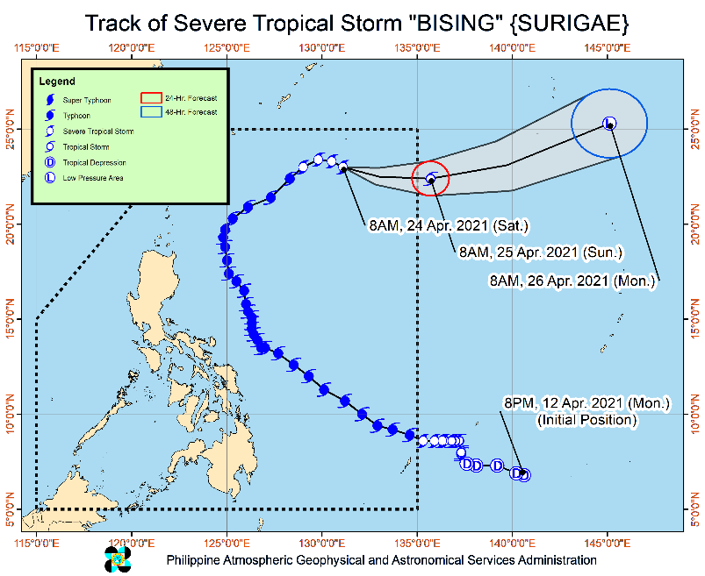
Situation Overview

Issued at 11:00 AM, 24 April 2021, "BISING" CONTINUES TO WEAKEN WHILE MOVING EAST-SOUTHEASTWARD OVER THE PHILIPPINE SEA.

- Tropical cyclone winds of at least strong breeze to near gale in strength extend outward up to 500 km from the center of the severe tropical storm.
- Hazards affecting coastal waters
- In the next 24 hours, under the influence of Severe Tropical Storm BISING”, moderate to rough seas will be experienced over the northern and eastern seaboards of Northern Luzon (1.5 to 3.5 m). Mariners of small seacrafts are advised not to venture out over these waters. Inexperienced mariners of these vessels should avoid navigating in these conditions.
- Track and Intensity Outlook:
- “BISING” is forecast to exit the Philippine Area of Responsibility tomorrow (25 April) morning. Further weakening is expected throughout the forecast period due to unfavorable atmospheric and oceanic conditions.

At 10:00 AM today, the center of Severe Tropical Storm "BISING" was estimated based on all available data at 1,005 km East Northeast of Extreme Northern Luzon (22.9 °N, 131.3 °E )
Source: DOST-PAGASA Severe Weather Bulletin

- Status of Affected Families / Persons
A total of 98,546 families or 401,867 persons were affected in 1,134 barangays in Regions II, V, VIII and Caraga (see Table 1).

Table 1. Number of Affected Families / Persons
REGION / PROVINCE / MUNICIPALITY |  | NUMBER OF AFFECTED
 |  | Barangays | Families | Persons
GRAND TOTAL |  | 1,134 | 98,546 | 401,867
REGION II |  | 9 | 112 | 303
Isabela |  | 9 | 112 | 303
 | Divilacan | 2 | 18 | 65
 | Maconacon | 7 | 94 | 238
REGION V |  | 645 | 36,010 | 138,546
Albay |  | 206 | 15,668 | 57,541
 | Bacacay | 16 | 868 | 3,233
 | Camalig | 10 | 2,567 | 9,314
 | Daraga (Locsin) | 7 | 148 | 562
 | Guinobatan | 21 | 2,170 | 7,628
 | Jovellar | 2 | 2 | 8
 | Legazpi City (capital) | 19 | 987 | 4,220
 | Libon | 17 | 417 | 1,996
 | City of Ligao | 13 | 218 | 770
 | Malilipot | 12 | 1,009 | 3,475
 | Malinao | 19 | 1,264 | 4,561
 | Manito | 6 | 828 | 2,619
 | Oas | 7 | 59 | 230
 | Pio Duran | 4 | 437 | 1,730
 | Polangui | 13 | 152 | 527
 | Rapu-Rapu | 8 | 690 | 2,698
 | Santo Domingo (Libog) | 15 | 1,093 | 3,463
 | Tiwi | 17 | 2,759 | 10,507
Camarines Norte |  | 14 | 106 | 450
 | Basud | 1 | 16 | 69
 | Jose Panganiban | 2 | 32 | 121
 | Labo | 3 | 17 | 57
 | Talisay | 8 | 41 | 203
Camarines Sur |  | 157 | 4,866 | 19,706
 | Baao | 5 | 89 | 353
 | Bato | 7 | 149 | 648
 | Bombon | 2 | 14 | 48
 | Buhi | 3 | 120 | 483
 | Bula | 4 | 95 | 473
 | Calabanga | 4 | 169 | 797
 | Caramoan | 34 | 1,149 | 4,335
 | Garchitorena | 4 | 104 | 507
 | Goa | 15 | 299 | 1,184
 | Iriga City | 11 | 428 | 1,822
 | Lagonoy | 6 | 57 | 209
 | Magarao | 1 | 6 | 28
 | Minalabac | 1 | 16 | 77
 | Nabua | 7 | 34 | 149
 | Naga City | 1 | 66 | 185
 | Ocampo | 4 | 31 | 147
 | Pasacao | 1 | 68 | 269
 | Pili (capital) | 1 | 5 | 24
 | Presentacion (Parubcan) | 14 | 890 | 3,564
 | Ragay | 7 | 87 | 299
 | Sagñay | 3 | 231 | 967
 | San fernando | 1 | 3 | 6
 | San Jose | 8 | 52 | 220
 | Sipocot | 1 | 19 | 49
 | Siruma | 2 | 14 | 64
 | Tinambac | 10 | 671 | 2,799
Catanduanes |  | 211 | 14,652 | 58,170
 | Province | 1 | 18 | 78
 | Bagamanoc | 11 | 339 | 1,082
 | Baras | 25 | 1,252 | 4,628
 | Bato | 17 | 2,031 | 8,164
 | Caramoran | 21 | 724 | 2,760
 | Gigmoto | 9 | 437 | 1,944
 | Pandan | 20 | 528 | 2,344
 | Panganiban (Payo) | 12 | 392 | 1,502
 | San Andres (Calolbon) | 14 | 662 | 2,554
 | San Miguel | 20 | 2,020 | 9,251
 | Viga | 4 | 57 | 237
 | Virac (capital) | 57 | 6,192 | 23,626
Masbate |  | 7 | 73 | 287
 | Mobo | 1 | 8 | 34
 | Pio V. Corpuz (Limbuhan) | 5 | 59 | 224
 | San Pascual | 1 | 6 | 29
Sorsogon |  | 50 | 645 | 2,392
 | Bulan | 5 | 185 | 534
 | Bulusan | 8 | 64 | 230
 | Castilla | 2 | 19 | 62
 | Gubat | 2 | 6 | 26
 | Irosin | 4 | 24 | 117
 | Juban | 4 | 46 | 194
 | Prieto Diaz | 10 | 87 | 314
 | Santa Magdalena | 3 | 13 | 58
 | City of Sorsogon (capital) | 12 | 201 | 857
REGION VIII |  | 472 | 62,372 | 262,761
Biliran |  | 4 | 51 | 255
 | Cabucgayan | 1 | 3 | 15
 | Culaba | 2 | 2 | 10
 | Maripipi | 1 | 46 | 230
Eastern Samar |  | 152 | 30,098 | 122,668
 | Arteche | 20 | 4,551 | 16,890
 | Can-Avid | 1 | 5,774 | 28,870
 | Dolores | 1 | 1,627 | 6,504
 | Jipapad | 13 | 2,510 | 10,040
 | Maslog | 1 | 76 | 380
 | Oras | 23 | 3,906 | 15,786
 | San Julian | 5 | 92 | 315
 | San Policarpo | 17 | 4,520 | 17,769
 | Sulat | 11 | 162 | 664
 | Taft | 2 | 11 | 43
 | Balangiga | 1 | 45 | 133
 | General MacArthur | 2 | 231 | 869
 | Guiuan | 23 | 1,404 | 4,230
 | Hernani | 9 | 2,454 | 9,727
 | Lawaan | 1 | 2,454 | 9,727
 | Llorente | 2 | 46 | 164
 | Mercedes | 14 | 197 | 405
 | Salcedo | 6 | 38 | 152
Leyte |  | 4 | 1,204 | 6,020
 | San Miguel | 3 | 1,188 | 5,940
 | MacArthur | 1 | 16 | 80
Northern Samar |  | 201 | 26,685 | 115,196
 | Allen | 1 | 7 | 29
 | Biri | 1 | 26 | 113
 | Bobon | 5 | 177 | 931
 | Catarman (capital) | 15 | 1,013 | 4,731
 | Lavezares | 5 | 120 | 528
 | Mondragon | 4 | 91 | 407
 | San Antonio | 5 | 53 | 168
 | San Jose | 4 | 37 | 96
 | Victoria | 6 | 27 | 119
 | Catubig | 13 | 350 | 1,484
 | Gamay | 4 | 408 | 1,484
 | Laoang | 43 | 13,597 | 59,911
 | Lapinig | 3 | 820 | 4,214
 | Las Navas | 23 | 5,856 | 23,783
 | Mapanas | 7 | 507 | 2,245
 | Palapag | 32 | 1,860 | 7,457
 | Pambujan | 15 | 664 | 2,756
 | San Roque | 14 | 1,070 | 4,731
 | Silvino Lobos | 1 | 2 | 9
Western Samar |  | 110 | 4,333 | 18,617
 | Almagro | 1 | 3 | 12
 | Gandara | 8 | 83 | 319
 | Matuguinao | 1 | 2 | 3
 | Pagsanghan | 2 | 12 | 37
 | San Jorge | 7 | 27 | 119
 | Santa Margarita | 2 | 70 | 350
 | Tarangnan | 2 | 24 | 108
 | Basey | 5 | 264 | 1,312
 | Calbiga | 1 | 1 | 5
 | City of Catbalogan (capital) | 20 | 691 | 3,314
 | Daram | 12 | 164 | 896
 | Jiabong | 1 | 69 | 197
 | Paranas (Wright) | 1 | 7 | 23
 | Pinabacdao | 11 | 189 | 905
 | San Sebastian | 14 | 2,263 | 9,130
 | Santa Rita | 5 | 91 | 415
 | Talalora | 2 | 7 | 22
 | Villareal | 1 | 75 | 244
 | Zumarraga | 14 | 291 | 1,206
Southern Leyte |  | 1 | 1 | 5
 | Saint Bernard | 1 | 1 | 5
CARAGA |  | 8 | 52 | 257
Agusan del Norte |  | 3 | 39 | 199
 | City of Cabadbaran | 3 | 39 | 199
Surigao del Norte |  | 5 | 13 | 58
 | Bacuag | 1 | 1 | 4
 | Malimono | 1 | 7 | 32
 | San Benito | 1 | 2 | 9
 | Sison | 2 | 3 | 13
Note: Ongoing assessment and validation being conducted.
Source: DSWD-FOs II, V, VIII and Caraga

- Status of Displaced Families / Persons
- Inside Evacuation Centers
A total of 14,951 families or 58,431 persons took temporary shelter in 737 evacuation centers in Regions II, V, VII and CARAGA (see Table 2).

Table 2. Number of Displaced Families / Persons Inside Evacuation Centers
REGION / PROVINCE / MUNICIPALITY |  | NUMBER OF EVACUATION CENTERS (ECs) |  | NUMBER OF DISPLACED
 |  |  |  | INSIDE ECs
 |  |  |  | Families |  | Persons
 |  | CUM | NOW | CUM | NOW | CUM | NOW
GRAND TOTAL |  | 737 | - | 14,951 | - | 58,431 | -
REGION II |  | 6 | - | 112 | - | 303 | -
Isabela |  | 6 | - | 112 | - | 303 | -
 | Divilacan | 2 | - | 18 | - | 65 | -
 | Maconacon | 4 | - | 94 | - | 238 | -
REGION V |  | 676 | - | 13,532 | - | 53,268 | -
Albay |  | 214 | - | 5,652 | - | 20,497 | -
 | Bacacay | 12 | - | 342 | - | 1,403 | -
 | Camalig | 9 | - | 314 | - | 838 | -
 | Daraga (Locsin) | 7 | - | 148 | - | 562 | -
 | Guinobatan | 29 | - | 1,574 | - | 5,652 | -
 | Jovellar | 1 | - | 1 | - | 3 | -
 | Legazpi City (capital) | 13 | - | 177 | - | 630 | -
 | Libon | 8 | - | 76 | - | 450 | -
 | City of Ligao | 14 | - | 218 | - | 770 | -
 | Malilipot | 7 | - | 137 | - | 526 | -
 | Malinao | 27 | - | 1,264 | - | 4,561 | -
 | Manito | 2 | - | 69 | - | 255 | -
 | Oas | 7 | - | 59 | - | 230 | -
 | Pio Duran | 8 | - | 260 | - | 1,074 | -
 | Polangui | 22 | - | 152 | - | 527 | -
 | Rapu-Rapu | 2 | - | 105 | - | 456 | -
 | Santo Domingo (Libog) | 23 | - | 213 | - | 660 | -
 | Tiwi | 23 | - | 543 | - | 1,900 | -
Camarines Norte |  | 12 | - | 81 | - | 370 | -
 | Basud | 2 | - | 7 | - | 37 | -
 | Jose Panganiban | 2 | - | 32 | - | 121 | -
 | Labo | 3 | - | 10 | - | 35 | -
 | Talisay | 5 | - | 32 | - | 177 | -
Camarines Sur |  | 166 | - | 2,975 | - | 12,316 | -
 | Baao | 3 | - | 14 | - | 42 | -
 | Bato | 9 | - | 149 | - | 648 | -
 | Bombon | 4 | - | 14 | - | 48 | -
 | Buhi | 3 | - | 110 | - | 443 | -
 | Bula | 7 | - | 42 | - | 222 | -
 | Calabanga | 5 | - | 169 | - | 797 | -
 | Caramoan | 30 | - | 249 | - | 981 | -
 | Garchitorena | 4 | - | 104 | - | 507 | -
 | Goa | 10 | - | 198 | - | 838 | -
 | Iriga City | 5 | - | 22 | - | 88 | -
 | Lagonoy | 6 | - | 57 | - | 209 | -
 | Magarao | 1 | - | 6 | - | 28 | -
 | Nabua | 7 | - | 34 | - | 149 | -
 | Naga City | 3 | - | 66 | - | 185 | -
 | Ocampo | 4 | - | 21 | - | 90 | -
 | Pasacao | 6 | - | 68 | - | 269 | -
 | Pili (capital) | 1 | - | 5 | - | 24 | -
 | Presentacion (Parubcan) | 18 | - | 638 | - | 2,685 | -
 | Ragay | 8 | - | 87 | - | 299 | -
 | Sagñay | 4 | - | 231 | - | 967 | -
 | San fernando | 1 | - | 3 | - | 6 | -
 | San Jose | 8 | - | 49 | - | 209 | -
 | Sipocot | 1 | - | 19 | - | 49 | -
 | Siruma | 2 | - | 6 | - | 34 | -
 | Tinambac | 16 | - | 614 | - | 2,499 | -
Catanduanes |  | 242 | - | 4,393 | - | 18,533 | -
 | Province | 1 | - | 5 | - | 19 | -
 | Bagamanoc | 15 | - | 199 | - | 627 | -
 | Baras | 31 | - | 366 | - | 1,274 | -
 | Bato | 38 | - | 229 | - | 926 | -
 | Caramoran | 13 | - | 246 | - | 956 | -
 | Gigmoto | 6 | - | 82 | - | 368 | -
 | Pandan | 9 | - | 173 | - | 814 | -
 | Panganiban (Payo) | 3 | - | 15 | - | 84 | -
 | San Andres (Calolbon) | 25 | - | 436 | - | 1,611 | -
 | San Miguel | 36 | - | 1,005 | - | 4,908 | -
 | Viga | 3 | - | 31 | - | 122 | -
 | Virac (capital) | 62 | - | 1,606 | - | 6,824 | -
Masbate |  | 7 | - | 71 | - | 283 | -
 | Mobo | 1 | - | 8 | - | 34 | -
 | Pio V. Corpuz (Limbuhan) | 5 | - | 57 | - | 220 | -
 | San Pascual | 1 | - | 6 | - | 29 | -
Sorsogon |  | 35 | - | 360 | - | 1,269 | -
 | Bulan | 4 | - | 108 | - | 218 | -
 | Bulusan | 6 | - | 44 | - | 147 | -
 | Castilla | 1 | - | 1 | - | 5 | -
 | Gubat | 2 | - | 6 | - | 26 | -
 | Irosin | 4 | - | 24 | - | 117 | -
 | Juban | 6 | - | 46 | - | 194 | -
 | Prieto Diaz | 3 | - | 44 | - | 160 | -
 | Santa Magdalena | 3 | - | 13 | - | 58 | -
 | City of Sorsogon (capital) | 6 | - | 74 | - | 344 | -
REGION VIII |  | 53 | - | 1,268 | - | 4,664 | -
Eastern Samar |  | 5 | - | 59 | - | 120 | -
 | Can-Avid | 4 | - | 48 | - | 77 | -
 | Taft | 1 | - | 11 | - | 43 | -
Leyte |  | 1 | - | 6 | - | 34 | -
 | MacArthur | 1 | - | 6 | - | 34 | -
Northern Samar |  | 34 | - | 879 | - | 3,417 | -
 | Bobon | 1 | - | 22 | - | 96 | -
 | Catarman (capital) | 3 | - | 161 | - | 268 | -
 | Laoang | 11 | - | 282 | - | 1,399 | -
 | Las Navas | 1 | - | 29 | - | 107 | -
 | Mapanas | 3 | - | 35 | - | 156 | -
 | San Roque | 15 | - | 350 | - | 1,391 | -
Western Samar |  | 13 | - | 324 | - | 1,093 | -
 | San Sebastian | 13 | - | 324 | - | 1,093 | -
CARAGA |  | 2 | - | 39 | - | 196 | -
Agusan del Norte |  | 1 | - | 32 | - | 164 | -
 | City of Cabadbaran | 1 | - | 32 | - | 164 | -
Surigao del Norte |  | 1 | - | 7 | - | 32 | -
 | Malimono | 1 | - | 7 | - | 32 | -
Note: Ongoing assessment and validation being conducted.
Source: DSWD-FOs II, V, VIII and Caraga

- Outside Evacuation Centers
A total of 24,519 families or 93,827 persons temporarily staying with their relatives and/or friends in Regions V and VIII (see Table 3).

Table 3. Number of Displaced Families / Persons Outside Evacuation Centers
REGION / PROVINCE / MUNICIPALITY |  | NUMBER OF DISPLACED
 |  | OUTSIDE ECs
 |  | Families |  | Persons
 |  | CUM | NOW | CUM | NOW
GRAND TOTAL |  | 24,519 | - | 93,827 | -
REGION V |  | 22,593 | - | 85,633 | -
Albay |  | 10,016 | - | 37,044 | -
 | Bacacay | 526 | - | 1,830 | -
 | Camalig | 2,253 | - | 8,476 | -
 | Guinobatan | 596 | - | 1,976 | -
 | Jovellar | 1 | - | 5 | -
 | Legazpi City (capital) | 810 | - | 3,590 | -
 | Libon | 341 | - | 1,546 | -
 | Malilipot | 872 | - | 2,949 | -
 | Manito | 759 | - | 2,364 | -
 | Pio Duran | 177 | - | 656 | -
 | Rapu-Rapu | 585 | - | 2,242 | -
 | Santo Domingo (Libog) | 880 | - | 2,803 | -
 | Tiwi | 2,216 | - | 8,607 | -
Camarines Norte |  | 25 | - | 80 | -
 | Basud | 9 | - | 32 | -
 | Labo | 7 | - | 22 | -
 | Talisay | 9 | - | 26 | -
Camarines Sur |  | 1,891 | - | 7,390 | -
 | Baao | 75 | - | 311 | -
 | Buhi | 10 | - | 40 | -
 | Bula | 53 | - | 251 | -
 | Caramoan | 900 | - | 3,354 | -
 | Goa | 101 | - | 346 | -
 | Iriga City | 406 | - | 1,734 | -
 | Minalabac | 16 | - | 77 | -
 | Ocampo | 10 | - | 57 | -
 | Presentacion (Parubcan) | 252 | - | 879 | -
 | San Jose | 3 | - | 11 | -
 | Siruma | 8 | - | 30 | -
 | Tinambac | 57 | - | 300 | -
Catanduanes |  | 10,386 | - | 40,033 | -
 | Province | 140 | - | 455 | -
 | Bagamanoc | 140 | - | 455 | -
 | Baras | 886 | - | 3,354 | -
 | Bato | 1,802 | - | 7,238 | -
 | Caramoran | 478 | - | 1,804 | -
 | Gigmoto | 355 | - | 1,576 | -
 | Pandan | 355 | - | 1,530 | -
 | Panganiban (Payo) | 377 | - | 1,418 | -
 | San Andres (Calolbon) | 226 | - | 943 | -
 | San Miguel | 1,015 | - | 4,343 | -
 | Viga | 26 | - | 115 | -
 | Virac (capital) | 4,586 | - | 16,802 | -
Masbate |  | 2 | - | 4 | -
 | Pio V. Corpuz (Limbuhan) | 2 | - | 4 | -
Sorsogon |  | 273 | - | 1,082 | -
 | Bulan | 77 | - | 316 | -
 | Bulusan | 8 | - | 42 | -
 | Castilla | 18 | - | 57 | -
 | Prieto Diaz | 43 | - | 154 | -
 | City of Sorsogon (capital) | 127 | - | 513 | -
REGION VIII |  | 1,926 | - | 8,194 | -
Western Samar |  | 1,926 | - | 8,194 | -
 | San Sebastian | 1,926 | - | 8,194 | -
Note: Ongoing assessment and validation being conducted.
Source: DSWD-FOs V and VIII

- Damaged Houses
There are 1,793 damaged houses; of which, 138 are totally damaged and 1,655 are partially damaged (see Table 4).

Table 4. Number of Damaged Houses
REGION / PROVINCE / MUNICIPALITY |  | NO. OF DAMAGED HOUSES
 |  | Total | Totally | Partially
GRAND TOTAL |  | 1,793 | 138 | 1,655
REGION VIII |  | 1,787 | 137 | 1,650
Biliran |  | 52 | 2 | 50
 | Cabucgayan | 3 | - | 3
 | Culaba | 2 | 1 | 1
 | Maripipi | 47 | 1 | 46
Eastern Samar |  | 20 | - | 20
 | Arteche | 1 | - | 1
 | Can-Avid | 3 | - | 3
 | General MacArthur | 16 | - | 16
Leyte |  | 16 | - | 16
 | MacArthur | 16 | - | 16
Northern Samar |  | 466 | 72 | 394
 | Victoria | 2 | - | 2
 | Laoang | 71 | 1 | 70
 | Mapanas | 36 | 20 | 16
 | Pambujan | 213 | 37 | 176
 | San Roque | 144 | 14 | 130
Western Samar |  | 1,232 | 63 | 1,169
 | Basey | 10 | - | 10
 | Calbiga | 1 | - | 1
 | City of Catbalogan (capital) | 628 | 14 | 614
 | Daram | 88 | 47 | 41
 | Jiabong | 1 | - | 1
 | Pinabacdao | 162 | 1 | 161
 | San Sebastian | 321 | 1 | 320
 | Santa Rita | 21 | - | 21
Southern Leyte |  | 1 | - | 1
 | Saint Bernard | 1 | - | 1
CARAGA |  | 6 | 1 | 5
Surigao del Norte |  | 6 | 1 | 5
 | Bacuag | 1 | - | 1
 | San Benito | 2 | 1 | 1
 | Sison | 3 | - | 3
. Source: DSWD-FOs VIII and Caraga

- Assistance Provided
A total of ₱3,328,748.29 worth of assistance was provided to the affected families; of which, ₱2,733,018.29 was provided by DSWD and by ₱595,730.00 from LGUs (see Table 5).

Table 5. Cost of Assistance Provided to Affected Families / Persons
REGION / PROVINCE / MUNICIPALITY |  | COST OF ASSISTANCE
 |  | DSWD | LGU | NGOs | OTHERS | GRAND TOTAL
GRAND TOTAL |  | 2,733,018.29 | 595,730.00 | - | - | 3,328,748.29
REGION II |  | - | 94,050.00 | - | - | 94,050.00
Isabela |  | - | 94,050.00 | - | - | 94,050.00
 | Divilacan | - | 94,050.00 | - | - | 94,050.00
REGION V |  | 169,476.20 | 501,680.00 | - | - | 671,156.20
Albay |  | 169,476.20 | - | - | - | 169,476.20
 | Libon | 169,476.20 | - | - | - | 169,476.20
Camarines Sur |  | - | 500,000.00 | - | - | 500,000.00
 | Tinambac | - | 500,000.00 | - | - | 500,000.00
Sorsogon |  | - | 1,680.00 | - | - | 1,680.00
 | Pilar | - | 1,680.00 | - | - | 1,680.00
REGION VIII |  | 2,563,542.09 | - | - | - | 2,563,542.09
Eastern Samar |  | 2,218,146.54 | - | - | - | 2,218,146.54
 | Arteche | 924,681.00 | - | - | - | 924,681.00
 | Can-Avid | 227,362.74 | - | - | - | 227,362.74
 | Jipapad | 1,066,102.80 | - | - | - | 1,066,102.80
Northern Samar |  | 345,395.55 | - | - | - | 345,395.55
 | Catarman (capital) | 345,395.55 | - | - | - | 345,395.55
Note: The decrease in the number of costs of assistance provided by the LGU is based on the final report submitted by the DSWD-FO V
Source: DSWD-FOs II and V

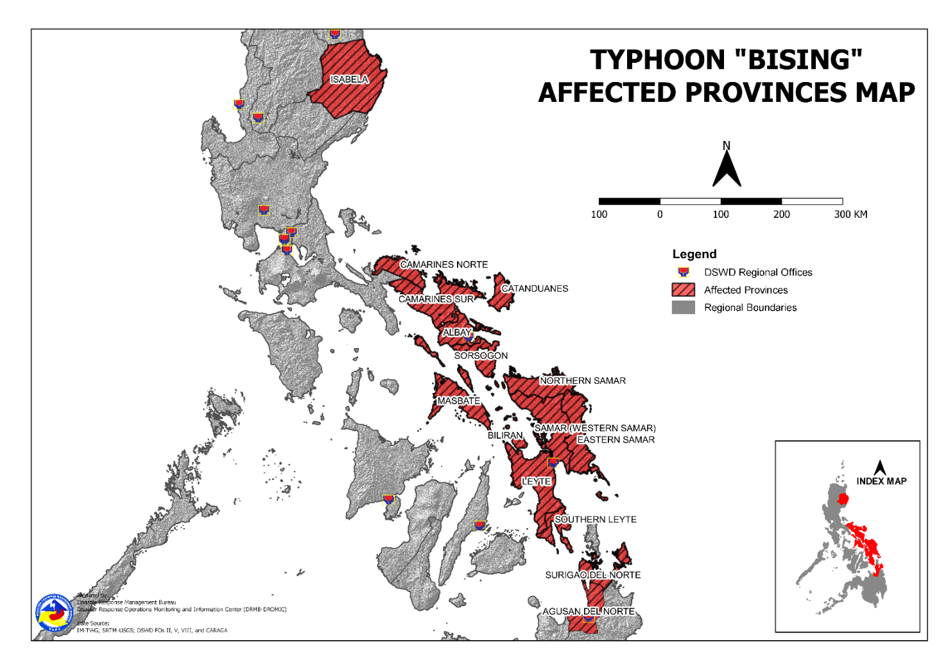
DSWD DISASTER RESPONSE INFORMATION

Situational Reports

DSWD-DRMB
DATE | SITUATIONS / ACTIONS UNDERTAKEN
24 April 2021 | - The Disaster Response Management Bureau is on RED Alert Status and is closely coordinating with the concerned field offices for significant disaster response updates.  - All QRT members and emergency equipment are on standby and ready for deployment.

DSWD-FO CAR
DATE | SITUATIONS / ACTIONS UNDERTAKEN
22 April 2021 | - Replenishment of 2,002 FFPs and 400 hygiene kits to Kalinga and 2,002 FFPs and 500 hygiene kits to Ifugao.  - DSWD-FO CAR ensures compliance to the CCCM and IDP Protection Guidelines and COVID19 Protocols.  - DSWD-FO CAR ensures availability of evacuation centers to accommodate displaced families and individuals.  - DSWD-FO CAR is closely monitoring weather updates and information.  - DSWD-FO CAR ensures availability of food and non-food items for resource augmentation as the need arises.  - DSWD-FO CAR DRR Focal persons is in close coordination with the LDRRMOs and MSWDOs for weather reports and updates.

DSWD-FO I
DATE | SITUATIONS / ACTIONS UNDERTAKEN
17 April 2021 | - DSWD-FO I is closely monitoring the movement of Typhoon” BISING” through the DOST – PAGASA and in close coordination with the Regional Disaster Risk Reduction and Management Council 1 (RDRRMC1). Likewise, Provincial Operations Offices (POOs) are in close coordination with the different Provincial/City/Municipal Disaster Risk Reduction and Management Councils (P/C/MDRRMCs) and Provincial/City/ Municipality Social Welfare and Development Offices (P/C/MSWDOs) to monitor the adverse effects that might be brought by the weather disturbance.  - DSWD-FO I Incident Management Team (IMT) is still activated and on duty while other DSWD staff are on standby for possible augmentation. Likewise, the Field Office ensures availability and readiness of resources.

DSWD-FO II
DATE | SITUATIONS / ACTIONS UNDERTAKEN
23 April 2021 | - DSWD-FO II submitted their terminal report.

DSWD-FO III
DATE | SITUATIONS / ACTIONS UNDERTAKEN
17 April 2021 | - Activated the Rapid Development Team (RDT) of DRMD that will render skeletal duties during onset of disaster to continuously monitor weather disturbance and coordinates with the Provincial Extension Offices for the situation of their respective LGUs.  - The 15 QRTs are ready for deployment upon the activation of the Blue and Red alert status of the RDRRMC 3.  - The Regional Warehouse and Fort Magsaysay Hub has ongoing repacking of FFPs.

DSWD-FO MIMAROPA
DATE | SITUATIONS / ACTIONS UNDERTAKEN
15 April 2021 | - SWADT Offices are alerted to monitor daily local weather condition and related eventualities, and ensure provision of information to all concerned offices, divisions, sections, and units.  - On-call status of the expanded R/P/C/M QRTs together with special projects staff on a 24/7 basis for possible activation of Operation Center to respond in case any untoward incident and eventualities are reported.  - DSWD-FO MIMAROPA is in close coordination with the Office of Civil Defense (OCD) and RDRRMC MIMAROPA for any updates for monitoring purposes and response mechanism for areas that will be affected.  - Standby logistical equipment and workforce thru coordination with SWADT Offices and concerned LGUs on the management of stranded passengers, in ports and terminals.  - Information and Communication Technology Management Unit (ICTMU) is on standby status to ensure robust communication system.

DSWD-FO V
DATE | SITUATIONS / ACTIONS UNDERTAKEN
23 April 2021 | - DSWD-FO V submitted their terminal report.

DSWD-FO VI
DATE | SITUATIONS / ACTIONS UNDERTAKEN
14 April 2021 | - All QRT members are on stand by and ready for augmentation if needed.  - RDANA team is composed of 40 trained QRTs and is ready to be deployed if needed. 30 QRT members in-charge for reports also undergone training on DROMIC Protocols last September 17-19 and 24-26, 2020.  - DSWD-FO VI continuously conducts TA provision to LGUs and SWAD Offices on DROMIC Reporting.  - DSWD-FO VI issued a total of 150 vests, 50 GO bags, 50 survival bags, and 50 sleeping kits to QRT members in the region and field staff.

DSWD-FO VII
DATE | SITUATIONS / ACTIONS UNDERTAKEN
23 April 2021 | - DSWD-FO VII submitted their terminal report.

DSWD-FO VIII
DATE | SITUATIONS / ACTIONS UNDERTAKEN
23 April 2021 | - A total of 4,894 families or 20,335 persons have pre-emptively evacuated in 192 evacuation centers in Region VIII. All of these families have returned home.  - DSWD-FO VIII delivered additional 800 FFPs to Arteche and 500 FFPs to Oras, Eastern Samar  - Prepositioned Family Food Packs (FFPs) in Samar Island, Biliran and Southern Leyte which can be distributed immediately by the P/C/MATs to Local Government Units that need augmentation support.

DSWD-FO CARAGA
DATE | SITUATIONS / ACTIONS UNDERTAKEN
21 April 2021 | - DSWD-FO CARAGA is continuously coordinating with the LGUs for the possible augmentation assistance to the affected families.
*****
The Disaster Response Operations Monitoring and Information Center (DROMIC) of the DSWD-DRMB is closely monitoring the effects of Typhoon “Bising” and is coordinating with the concerned DSWD Field Offices for any significant updates.

Prepared by:
MARIEL B. FERRARIZ
MARIE JOYCE G. RAFANAN

LESLIE R. JAWILI
Releasing Officer

PHOTO DOCUMENTATION
