DSWD DROMIC Report #2 on the Fire Incident
in Brgy. Cupang, Muntinlupa City
as of 30 April 2021, 6PM

SUMMARY

On 27 April 2021 at 11:30 PM, a fire incident occurred in Purok 2, Aquino Compound, Brgy. Cupang, Muntinlupa City. The cause of fire is still under investigation.
Source: DSWD-FO NCR

- Status of Affected Families / Persons
A total of 350 families or 1,400 persons were affected by the fire incident in Brgy. Cupang, Muntinlupa City (see Table 1).

Table 1. Number of Affected Families / Persons
REGION / PROVINCE / MUNICIPALITY | NUMBER OF AFFECTED
 | Barangays | Families | Persons
GRAND TOTAL | 1 | 350 | 1,400
NCR | 1 | 350 | 1,400
Metro Manila | 1 | 350 | 1,400
Muntinlupa City | 1 | 350 | 1400
Note: The decrease in the number of affected families and persons is due to the ongoing assessment and validation being conducted.
Source: DSWD-FO NCR

- Status of Displaced Families Inside Evacuation Center
There are 350 families or 1,400 persons currently taking temporary shelter at the Cupang Mullet Covered Court (see Table 2).

Table 2. Number of Displaced Families / Persons Inside Evacuation Center
REGION / PROVINCE / MUNICIPALITY | NUMBER OF EVACUATION CENTERS (ECs) |  | NUMBER OF DISPLACED
 |  |  | INSIDE ECs
 |  |  | Families |  | Persons
 | CUM | NOW | CUM | NOW | CUM | NOW
GRAND TOTAL | 1 | 1 | 350 | 350 | 1,400 | 1,400
NCR | 1 | 1 | 350 | 350 | 1,400 | 1,400
Metro Manila | 1 | 1 | 350 | 350 | 1,400 | 1,400
Muntinlupa City | 1 | 1 | 350 | 350 | 1400 | 1400
Note: The decrease in the number of displaced families and persons staying inside EC is due to the ongoing assessment and validation being conducted.
Source: DSWD-FO NCR

- Damaged Houses
A total of 133 houses were totally damaged by the fire (see Table 3).

Table 3. Number of Damaged Houses
REGION / PROVINCE / MUNICIPALITY | NO. OF DAMAGED HOUSES
 | Total | Totally | Partially
GRAND TOTAL | 133 | 133 | -
NCR | 133 | 133 | -
Metro Manila | 133 | 133 | -
Muntinlupa City | 133 | 133 | -
Note: Ongoing assessment and validation being conducted.
Source: DSWD-FO NCR

- Assistance Provided
A total of ₱805,000.00 worth of assistance was provided by DSWD to the affected families (see Table 4).

Table 4. Cost of Assistance Provided to the Affected Families / Persons
REGION / PROVINCE / MUNICIPALITY | COST OF ASSISTANCE
 | DSWD | LGU | NGOs | OTHERS | GRAND TOTAL
GRAND TOTAL | 805,000.00 | - | - | - | 805,000.00
NCR | 805,000.00 | - | - | - | 805,000.00
Metro Manila | 805,000.00 | - | - | - | 805,000.00
Muntinlupa City | 805,000.00 | - | - | - | 805,000.00
Source: DSWD-FO NCR

SITUATIONAL REPORT
DSWD-DRMB
DATE | SITUATIONS / ACTIONS UNDERTAKEN
30 April 2021 | - The Disaster Response Operations Monitoring and Information Center (DROMIC) of the DSWD-DRMB is closely coordinating with DSWD-FO NCR for significant reports on the status of affected families, assistance, and relief efforts.

DSWD-FO NCR
DATE | SITUATIONS / ACTIONS UNDERTAKEN
30 April 2021 | - DSWD-FO NCR provided 350 family kits amounting to ₱805,000.00 to the affected families.

*****
The Disaster Response Operations Monitoring and Information Center (DROMIC) of the DSWD-DRMB is closely coordinating with DSWD-FO NCR for any significant disaster response updates.

Prepared by:

MARIE JOYCE G. RAFANAN

LESLIE R. JAWILI
Releasing Officer

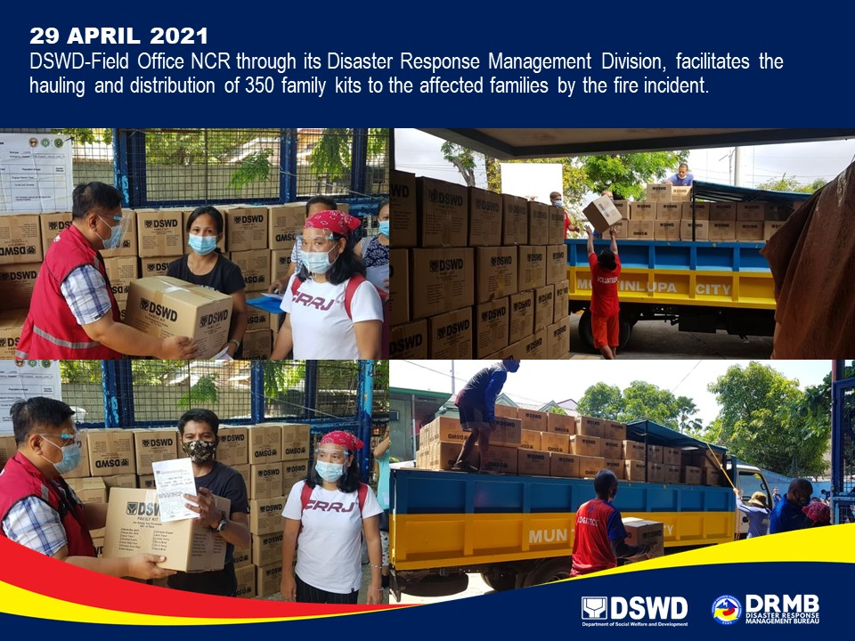
PHOTO DOCUMENTATION

