DSWD DROMIC Report #6 on Typhoon “Bising”
as of 20 April 2021, 6PM

Situation Overview
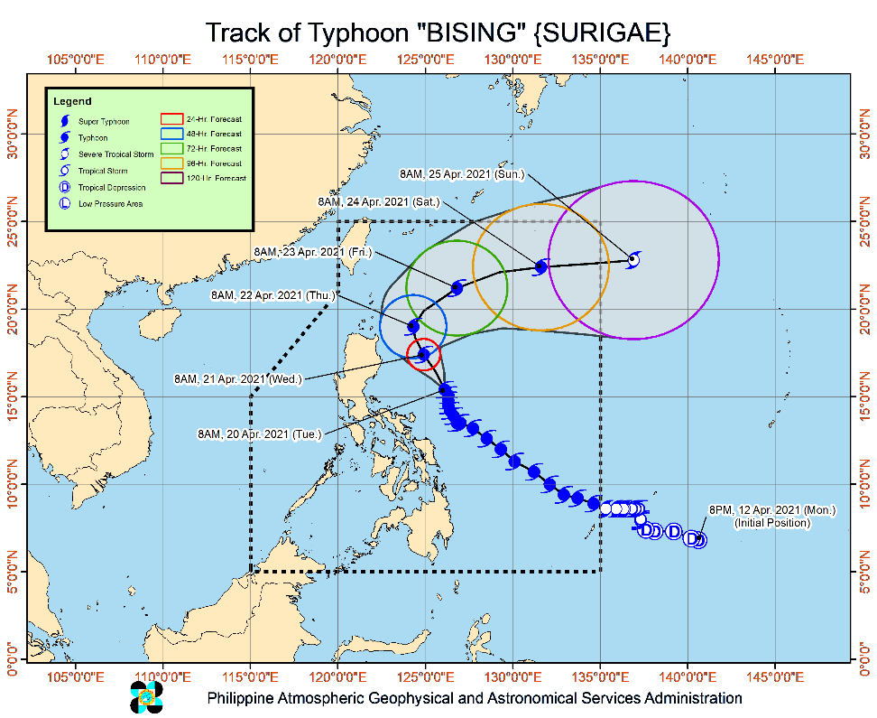
Issued at 5:00 PM, 20 April 2021, TYPHOON "BISING" CONTINUES TO MAINTAIN ITS STRENGTH AS IT MOVES SLOWLY NORTH-NORTHWESTWARD EAST OF AURORA.

- Hazards affecting land areas
- Heavy Rainfall:
  - Today (20 April), moderate to heavy rains will be experienced over Catanduanes. Light to moderate at times heavy rains over the eastern portion of Quezon, Camarines Provinces, Sorsogon, Albay, and Northern Samar.
  - Under these conditions and considering the antecedent rainfall over the aforementioned areas, flooding (including flashfloods) and rain-induced landslides are highly likely to occur especially in areas identified in hazard maps as highly or very highly susceptible to these hazards.
- PAGASA Regional Services Divisions may issue local thunderstorm/rainfall advisories and heavy rainfall warnings while the Hydrometeorology Division and River Basin Flood Forecasting and Warning Centers may issue General Flood Advisories and Basin Flood Bulletins as appropriate.
- Severe Winds:
  - PAGASA Regional Services Divisions may issue local thunderstorm/rainfall advisories and heavy rainfall warnings while the Hydrometeorology Division and River Basin Flood Forecasting and Warning Centers may issue General Flood Advisories and Basin Flood Bulletins as appropriate.
- PAGASA Regional Services Divisions may issue local thunderstorm/rainfall advisories and heavy rainfall warnings while the Hydrometeorology Division and River Basin Flood Forecasting and Warning Centers may issue General Flood Advisories and Basin Flood Bulletins as appropriate.
- Hazards affecting coastal waters
- In the next 24 hours, under the influence of Typhoon “BISING” and an enhanced northeasterly wind flow, the following sea conditions will be experienced over the coastal waters of the country:
- Very rough to high seas over the northern and eastern seaboards of Luzon (4.5 to 10.0 m), and rough to high seas over the northern and eastern seaboards of Eastern Visayas (3.0 to 7.0 m) Sea travel is risky for all types of seacrafts over these waters.
- Very rough to high seas over the northern and eastern seaboards of Luzon (4.5 to 10.0 m), and rough to high seas over the northern and eastern seaboards of Eastern Visayas (3.0 to 7.0 m) Sea travel is risky for all types of seacrafts over these waters.
- Very rough to high seas over the northern and eastern seaboards of Luzon (4.5 to 10.0 m), and rough to high seas over the northern and eastern seaboards of Eastern Visayas (3.0 to 7.0 m) Sea travel is risky for all types of seacrafts over these waters.
- Track and Intensity Outlook:
- On the forecast track, Typhoon “BISING” will move generally northward or north northwestward until tomorrow evening (21 April) or Thursday (22 April) early morning. Afterwards, the typhoon will move northeastward away from the landmass of Luzon throughout Thursday and east northeastward on Friday (23 April) and Saturday (24 April). The typhoon is projected to exit the Philippine Area of Responsibility on Sunday (25 April).
- “BISING” is forecast to gradually weaken throughout the forecast period and may be downgraded to severe tropical storm by Saturday evening or Sunday early morning.
At 4:00 PM today, the center of the eye of Typhoon "BISING" was located based on all available data at 475 km East of Baler, Aurora (16.0 °N, 126.0 °E )
Source: DOST-PAGASA Severe Weather Bulletin

- Status of Affected Families / Persons
A total of 42,102 families or 163,665 persons were affected in 782 barangays in Regions V and VIII (see Table 1).

Table 1. Number of Affected Families / Persons
REGION / PROVINCE / MUNICIPALITY |  | NUMBER OF AFFECTED
 |  | Barangays | Families | Persons
GRAND TOTAL |  | 782 | 42,102 | 163,665
REGION V |  | 534 | 28,785 | 110,833
Albay |  | 206 | 15,668 | 57,541
 | Bacacay | 16 | 868 | 3,233
 | Camalig | 10 | 2,567 | 9,314
 | Daraga (Locsin) | 7 | 148 | 562
 | Guinobatan | 21 | 2,170 | 7,628
 | Jovellar | 2 | 2 | 8
 | Legazpi City (capital) | 19 | 987 | 4,220
 | Libon | 17 | 417 | 1,996
 | City of Ligao | 13 | 218 | 770
 | Malilipot | 12 | 1,009 | 3,475
 | Malinao | 19 | 1,264 | 4,561
 | Manito | 6 | 828 | 2,619
 | Oas | 7 | 59 | 230
 | Pio Duran | 4 | 437 | 1,730
 | Polangui | 13 | 152 | 527
 | Rapu-Rapu | 8 | 690 | 2,698
 | Santo Domingo (Libog) | 15 | 1,093 | 3,463
 | Tiwi | 17 | 2,759 | 10,507
Camarines Norte |  | 2 | 19 | 107
 | Basud | 1 | 16 | 69
 | Talisay | 1 | 3 | 38
Camarines Sur |  | 111 | 3,149 | 12,863
 | Baao | 2 | 25 | 109
 | Bato | 2 | 119 | 502
 | Bombon | 2 | 14 | 48
 | Buhi | 3 | 120 | 483
 | Bula | 4 | 95 | 473
 | Calabanga | 3 | 161 | 767
 | Caramoan | 27 | 865 | 3,287
 | Garchitorena | 4 | 104 | 507
 | Goa | 13 | 115 | 436
 | Lagonoy | 6 | 57 | 209
 | Magarao | 1 | 6 | 28
 | Minalabac | 1 | 16 | 77
 | Nabua | 5 | 16 | 59
 | Naga City | 1 | 66 | 185
 | Ocampo | 3 | 21 | 90
 | Pasacao | 1 | 68 | 269
 | Pili (capital) | 1 | 5 | 24
 | Presentacion (Parubcan) | 6 | 325 | 1,361
 | Ragay | 1 | 6 | 24
 | Sagñay | 3 | 231 | 967
 | San fernando | 1 | 3 | 6
 | San Jose | 8 | 52 | 220
 | Sipocot | 1 | 19 | 49
 | Siruma | 2 | 14 | 64
 | Tinambac | 10 | 626 | 2,619
Catanduanes |  | 166 | 9,459 | 38,325
 | Province | 1 | 18 | 76
 | Bagamanoc | 6 | 147 | 643
 | Baras | 25 | 1,252 | 4,628
 | Bato | 16 | 1,899 | 7,463
 | Caramoran | 21 | 682 | 2,596
 | Gigmoto | 9 | 437 | 1,944
 | Pandan | 20 | 518 | 2,294
 | Panganiban (Payo) | 12 | 392 | 1,502
 | San Andres (Calolbon) | 10 | 464 | 1,828
 | San Miguel | 16 | 1,230 | 5,947
 | Viga | 4 | 57 | 237
 | Virac (capital) | 26 | 2,363 | 9,167
Masbate |  | 6 | 67 | 258
 | Mobo | 1 | 8 | 34
 | Pio V. Corpuz (Limbuhan) | 5 | 59 | 224
Sorsogon |  | 43 | 423 | 1,739
 | Bulusan | 8 | 33 | 137
 | Castilla | 2 | 19 | 62
 | Irosin | 4 | 24 | 117
 | Juban | 4 | 46 | 194
 | Prieto Diaz | 10 | 87 | 314
 | Santa Magdalena | 3 | 13 | 58
 | City of Sorsogon (capital) | 12 | 201 | 857
REGION VIII |  | 248 | 13,317 | 52,832
Biliran |  | 1 | 1 | 5
 | Culaba | 1 | 1 | 5
Eastern Samar |  | 81 | 8,339 | 30,825
 | Arteche | 23 | 4,551 | 16,890
 | Jipapad | 13 | 2,459 | 8,595
 | Maslog | 1 | 76 | 380
 | San Julian | 5 | 92 | 315
 | San Policarpo | 1 | 123 | 537
 | Sulat | 1 | 37 | 114
 | Taft | 1 | 12 | 47
 | General MacArthur | 2 | 42 | 138
 | Guiuan | 23 | 835 | 3,340
 | Hernani | 1 | 2 | 8
 | Lawaan | 1 | 18 | 75
 | Llorente | 2 | 46 | 164
 | Mercedes | 1 | 8 | 70
 | Salcedo | 6 | 38 | 152
Northern Samar |  | 93 | 3,410 | 14,828
 | Allen | 1 | 7 | 29
 | Biri | 1 | 26 | 113
 | Bobon | 4 | 140 | 649
 | Catarman (capital) | 8 | 324 | 924
 | Lavezares | 1 | 15 | 75
 | Mondragon | 4 | 91 | 407
 | San Antonio | 3 | 23 | 85
 | San Jose | 4 | 37 | 96
 | Victoria | 6 | 27 | 119
 | Catubig | 13 | 350 | 1,484
 | Laoang | 15 | 502 | 2,278
 | Lapinig | 3 | 820 | 4,214
 | Las Navas | 1 | 29 | 107
 | Mapanas | 6 | 155 | 626
 | Palapag | 5 | 289 | 978
 | Pambujan | 6 | 67 | 493
 | San Roque | 11 | 506 | 2,142
 | Silvino Lobos | 1 | 2 | 9
Western Samar |  | 72 | 1,566 | 7,169
 | Almagro | 1 | 3 | 12
 | Gandara | 8 | 83 | 319
 | Matuguinao | 1 | 2 | 3
 | Pagsanghan | 2 | 12 | 37
 | San Jorge | 7 | 27 | 119
 | Santa Margarita | 2 | 70 | 350
 | Tarangnan | 2 | 24 | 108
 | Basey | 5 | 264 | 1,312
 | City of Catbalogan (capital) | 16 | 504 | 2,509
 | Daram | 12 | 164 | 896
 | Jiabong | 1 | 69 | 197
 | Pinabacdao | 1 | 35 | 175
 | San Sebastian | 2 | 57 | 76
 | Zumarraga | 12 | 252 | 1,056
Southern Leyte |  | 1 | 1 | 5
 | Saint Bernard | 1 | 1 | 5
Note: Ongoing assessment and validation being conducted.
Source: DSWD-FOs V and VIII

- Status of Displaced Families / Persons
- Inside Evacuation Centers
There are 5,645 families or 23,941 persons currently taking temporary shelter in 359 evacuation centers in Regions V and VIII (see Table 2).

Table 2. Number of Displaced Families / Persons Inside Evacuation Centers
REGION / PROVINCE / MUNICIPALITY |  | NUMBER OF EVACUATION CENTERS (ECs) |  | NUMBER OF DISPLACED
 |  |  |  | INSIDE ECs
 |  |  |  | Families |  | Persons
 |  | CUM | NOW | CUM | NOW | CUM | NOW
GRAND TOTAL |  | 588 | 359 | 11,735 | 5,645 | 46,090 | 23,941
REGION V |  | 554 | 359 | 10,856 | 5,645 | 42,673 | 23,941
Albay |  | 215 | 39 | 5,652 | 598 | 20,497 | 2,395
 | Bacacay | 12 | 1 | 342 | 7 | 1,403 | 35
 | Camalig | 9 | - | 314 | - | 838 | -
 | Daraga (Locsin) | 7 | 7 | 148 | 148 | 562 | 562
 | Guinobatan | 29 | - | 1,574 | - | 5,652 | -
 | Jovellar | 1 | - | 1 | - | 3 | -
 | Legazpi City (capital) | 13 | - | 177 | - | 630 | -
 | Libon | 8 | 8 | 76 | 76 | 450 | 450
 | City of Ligao | 14 | 14 | 218 | 218 | 770 | 770
 | Malilipot | 7 | 5 | 137 | 112 | 526 | 431
 | Malinao | 27 | - | 1,264 | - | 4,561 | -
 | Manito | 2 | - | 69 | - | 255 | -
 | Oas | 7 | 4 | 59 | 37 | 230 | 147
 | Pio Duran | 8 | - | 260 | - | 1,074 | -
 | Polangui | 22 | - | 152 | - | 527 | -
 | Rapu-Rapu | 2 | - | 105 | - | 456 | -
 | Santo Domingo (Libog) | 24 | - | 213 | - | 660 | -
 | Tiwi | 23 | - | 543 | - | 1,900 | -
Camarines Norte |  | 3 | 3 | 10 | 10 | 75 | 75
 | Basud | 2 | 2 | 7 | 7 | 37 | 37
 | Talisay | 1 | 1 | 3 | 3 | 38 | 38
Camarines Sur |  | 124 | 119 | 2,195 | 2,172 | 9,121 | 9,027
 | Baao | 1 | 1 | 7 | 7 | 26 | 26
 | Bato | 2 | 2 | 119 | 119 | 502 | 502
 | Bombon | 4 | 4 | 14 | 14 | 48 | 48
 | Buhi | 1 | 1 | 32 | 32 | 118 | 118
 | Bula | 7 | 5 | 42 | 33 | 222 | 186
 | Calabanga | 4 | 4 | 161 | 161 | 767 | 767
 | Caramoan | 27 | 27 | 234 | 234 | 930 | 930
 | Garchitorena | 4 | 4 | 104 | 104 | 507 | 507
 | Goa | 8 | 8 | 80 | 80 | 312 | 312
 | Lagonoy | 6 | 6 | 57 | 57 | 209 | 209
 | Magarao | 1 | - | 6 | - | 28 | -
 | Nabua | 5 | 5 | 16 | 16 | 59 | 59
 | Naga City | 3 | 3 | 66 | 66 | 185 | 185
 | Ocampo | 4 | 4 | 21 | 21 | 90 | 90
 | Pasacao | 6 | 6 | 68 | 68 | 269 | 269
 | Pili (capital) | 1 | - | 5 | - | 24 | -
 | Presentacion (Parubcan) | 8 | 8 | 246 | 246 | 1,068 | 1,068
 | Ragay | 1 | 1 | 6 | 6 | 24 | 24
 | Sagñay | 4 | 4 | 231 | 231 | 967 | 967
 | San fernando | 1 | - | 3 | - | 6 | -
 | San Jose | 8 | 8 | 49 | 49 | 209 | 209
 | Sipocot | 1 | 1 | 19 | 19 | 49 | 49
 | Siruma | 2 | 2 | 6 | 6 | 34 | 34
 | Tinambac | 15 | 15 | 603 | 603 | 2,468 | 2,468
Catanduanes |  | 179 | 179 | 2,737 | 2,737 | 11,854 | 11,854
 | Province | 1 | 1 | 18 | 18 | 76 | 76
 | Bagamanoc | 6 | 6 | 141 | 141 | 625 | 625
 | Baras | 31 | 31 | 366 | 366 | 1,274 | 1,274
 | Bato | 36 | 36 | 214 | 214 | 866 | 866
 | Caramoran | 13 | 13 | 246 | 246 | 956 | 956
 | Gigmoto | 6 | 6 | 82 | 82 | 368 | 368
 | Pandan | 9 | 9 | 173 | 173 | 814 | 814
 | Panganiban (Payo) | 3 | 3 | 15 | 15 | 84 | 84
 | San Andres (Calolbon) | 17 | 17 | 265 | 265 | 1,012 | 1,012
 | San Miguel | 30 | 30 | 730 | 730 | 3,660 | 3,660
 | Viga | 2 | 2 | 31 | 31 | 122 | 122
 | Virac (capital) | 25 | 25 | 456 | 456 | 1,997 | 1,997
Masbate |  | 6 | - | 65 | - | 254 | -
 | Mobo | 1 | - | 8 | - | 34 | -
 | Pio V. Corpuz (Limbuhan) | 5 | - | 57 | - | 220 | -
Sorsogon |  | 27 | 19 | 197 | 128 | 872 | 590
 | Bulusan | 5 | 5 | 13 | 13 | 54 | 54
 | Castilla | 1 | - | 1 | - | 5 | -
 | Irosin | 4 | - | 24 | - | 117 | -
 | Juban | 6 | 6 | 46 | 46 | 194 | 194
 | Prieto Diaz | 3 | - | 44 | - | 160 | -
 | Santa Magdalena | 3 | 3 | 13 | 13 | 58 | 58
 | City of Sorsogon (capital) | 5 | 5 | 56 | 56 | 284 | 284
REGION VIII |  | 34 | - | 879 | - | 3,417 | -
Northern Samar |  | 34 | - | 879 | - | 3,417 | -
 | Bobon | 1 | - | 22 | - | 96 | -
 | Catarman (capital) | 3 | - | 161 | - | 268 | -
 | Laoang | 11 | - | 282 | - | 1,399 | -
 | Las Navas | 1 | - | 29 | - | 107 | -
 | Mapanas | 3 | - | 35 | - | 156 | -
 | San Roque | 15 | - | 350 | - | 1,391 | -
Note: Ongoing assessment and validation being conducted.
Source: DSWD-FOs V and VIII

- Outside Evacuation Centers
There are 8,804 families or 34,237 persons temporarily staying with their relatives and/or friends in Region V (see Table 3).

Table 3. Number of Displaced Families / Persons Outside Evacuation Centers
REGION / PROVINCE / MUNICIPALITY |  | NUMBER OF DISPLACED
 |  | OUTSIDE ECs
 |  | Families |  | Persons
 |  | CUM | NOW | CUM | NOW
GRAND TOTAL |  | 17,528 | 8,804 | 66,948 | 34,237
REGION V |  | 17,528 | 8,804 | 66,948 | 34,237
Albay |  | 9,716 | 1,129 | 36,237 | 4,209
 | Bacacay | 526 | - | 1,830 | -
 | Camalig | 2,253 | - | 8,476 | -
 | Guinobatan | 296 | - | 1,169 | -
 | Jovellar | 1 | - | 5 | -
 | Legazpi City (capital) | 810 | - | 3,590 | -
 | Libon | 341 | 341 | 1,546 | 1,546
 | Malilipot | 872 | 788 | 2,949 | 2,663
 | Manito | 759 | - | 2,364 | -
 | Pio Duran | 177 | - | 656 | -
 | Rapu-Rapu | 585 | - | 2,242 | -
 | Santo Domingo (Libog) | 880 | - | 2,803 | -
 | Tiwi | 2,216 | - | 8,607 | -
Camarines Norte |  | 9 | 9 | 32 | 32
 | Basud | 9 | 9 | 32 | 32
Camarines Sur |  | 876 | 811 | 3,417 | 2,994
 | Baao | 18 | 18 | 83 | 83
 | Buhi | 10 | 10 | 40 | 40
 | Bula | 53 | - | 251 | -
 | Caramoan | 631 | 631 | 2,357 | 2,237
 | Goa | 35 | 35 | 124 | 124
 | Minalabac | 16 | 4 | 77 | 25
 | Presentacion (Parubcan) | 79 | 79 | 293 | 293
 | San Jose | 3 | 3 | 11 | 11
 | Siruma | 8 | 8 | 30 | 30
 | Tinambac | 23 | 23 | 151 | 151
Catanduanes |  | 6,728 | 6,728 | 26,489 | 26,489
 | Province | 6 | 6 | 18 | 18
 | Bagamanoc | 6 | 6 | 18 | 18
 | Baras | 886 | 886 | 3,354 | 3,354
 | Bato | 1,685 | 1,685 | 6,597 | 6,597
 | Caramoran | 436 | 436 | 1,640 | 1,640
 | Gigmoto | 355 | 355 | 1,576 | 1,576
 | Pandan | 345 | 345 | 1,480 | 1,480
 | Panganiban (Payo) | 377 | 377 | 1,418 | 1,418
 | San Andres (Calolbon) | 199 | 199 | 816 | 816
 | San Miguel | 500 | 500 | 2,287 | 2,287
 | Viga | 26 | 26 | 115 | 115
 | Virac (capital) | 1,907 | 1,907 | 7,170 | 7,170
Masbate |  | 2 | - | 4 | -
 | Pio V. Corpuz (Limbuhan) | 2 | - | 4 | -
Sorsogon |  | 197 | 127 | 769 | 513
 | Bulusan | 9 | - | 45 | -
 | Castilla | 18 | - | 57 | -
 | Prieto Diaz | 43 | - | 154 | -
 | City of Sorsogon (capital) | 127 | 127 | 513 | 513
N ote: Ongoing assessment and validation being conducted.
Source: DSWD-FOs V and VIII

- Damaged Houses
There are 520 damaged houses; of which, 52 are totally damaged and 468 are partially damaged (see Table 4).

Table 4. Number of Damaged Houses
REGION / PROVINCE / MUNICIPALITY |  | NO. OF DAMAGED HOUSES
 |  | Total | Totally | Partially
GRAND TOTAL |  | 520 | 52 | 468
REGION VIII |  | 520 | 52 | 468
Biliran |  | 1 | 1 | -
 | Culaba | 1 | 1 | -
Western Samar |  | 519 | 51 | 468
 | City of Catbalogan (capital) | 437 | 10 | 427
 | Daram | 82 | 41 | 41
. Source: DSWD-FO VIII

- Assistance Provided
A total of ₱171,156.20 worth of assistance was provided to the affected families; of which, ₱169,476.20 was provided by DSWD and by ₱1,680.00 from LGUs (see Table 5).

Table 5. Cost of Assistance Provided to Affected Families / Persons
REGION / PROVINCE / MUNICIPALITY |  | COST OF ASSISTANCE
 |  | DSWD | LGU | NGOs | OTHERS | GRAND TOTAL
GRAND TOTAL |  | 169,476.20 | 1,680.00 | - | - | 171,156.20
REGION V |  | 169,476.20 | 1,680.00 | - | - | 171,156.20
Albay |  | 169,476.20 | - | - | - | 169,476.20
 | Libon | 169,476.20 | - | - | - | 169,476.20
Sorsogon |  | - | 1,680.00 | - | - | 1,680.00
 | Pilar | - | 1,680.00 | - | - | 1,680.00
Source: DSWD-FO V

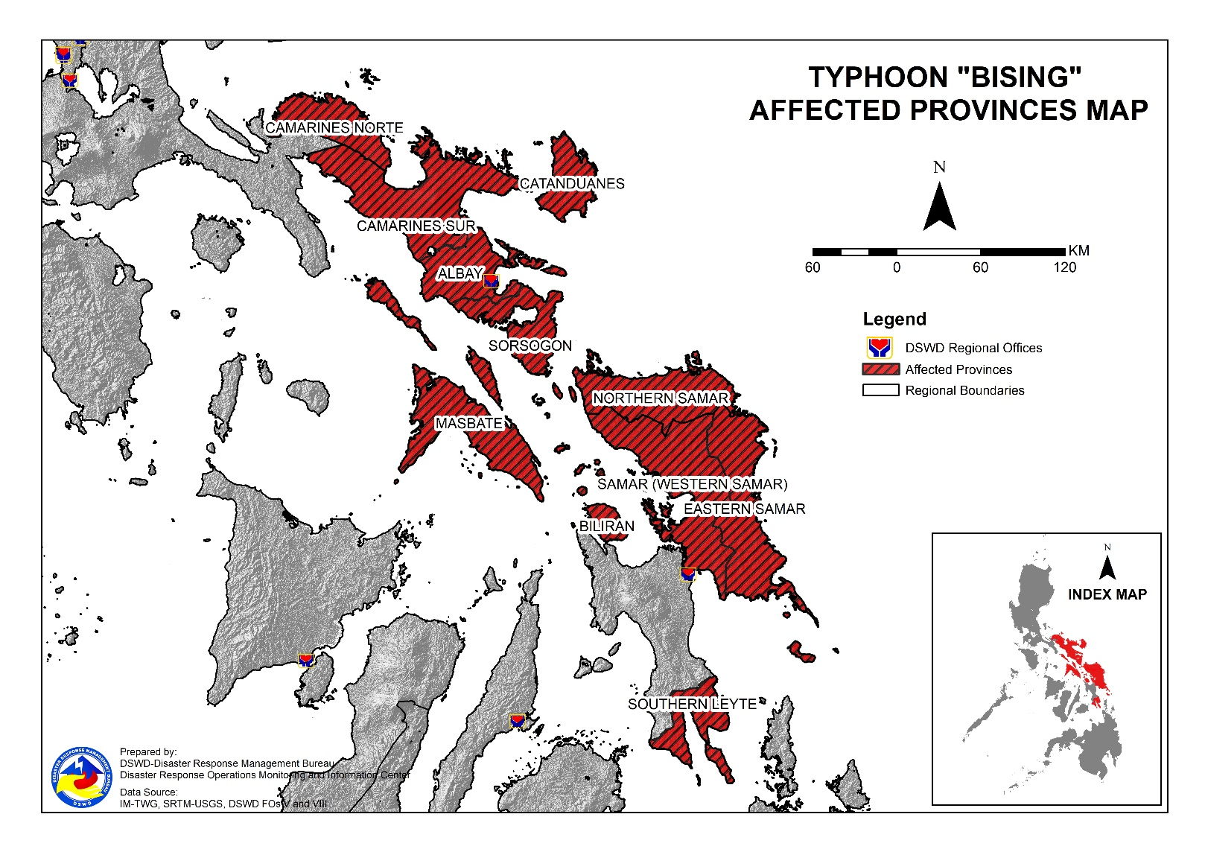
DSWD DISASTER RESPONSE INFORMATION

Status of Prepositioned Resources: Stockpile and Standby Funds
The DSWD Central Office (CO), Field Offices (FOs), and National Resource Operations Center (NROC) have stockpiles and standby funds amounting to ₱1,597,198,383.81 with breakdown as follows (see Table 2):

- Standby Funds
A total of ₱556,438,277.65 standby funds in the CO and FOs. Of the said amount, ₱517,992,176.43 is the available Quick Response Fund (QRF) in the CO.

- Stockpiles
A total of 371,523 family food packs (FFPs) amounting to ₱188,658,003.77, other food items amounting to ₱326,990,842.23 and non-food items (FNIs) amounting to ₱525,111,260.16 are available.

Table 2. Available Stockpiles and Standby Funds
REGIONAL / FIELD OFFICE | STANDBY FUNDS | FAMILY FOOD PACKS |  | OTHER FOOD ITEMS | NON-FOOD RELIEF ITEMS | TOTAL STANDBY FUNDS & STOCKPILE
 |  | QUANTITY | TOTAL COST | TOTAL COST | TOTAL COST
TOTAL | 556,438,277.65 | 371,523 | 188,658,003.77 | 326,990,842.23 | 525,111,260.16 | 1,597,198,383.81
Central Office | 517,992,176.43 | - | - | - | - | 517,992,176.43
NRLMB - NROC | - | 94,877 | 51,810,351.08 | 173,605,128.56 | 282,001,225.25 | 507,416,704.89
NRLMB - VDRC | - | 39,547 | 17,612,415.00 | 30,338,894.34 | 5,077,232.50 | 53,028,541.84
I | 1,497,055.20 | 25,973 | 13,246,230.00 | 4,968,071.94 | 27,588,610.33 | 47,299,967.47
II | 97,869.36 | 16,551 | 7,744,774.00 | 3,189,537.93 | 14,601,214.84 | 25,633,396.13
III | 3,000,908.30 | 9,639 | 4,370,660.85 | 1,458,080.00 | 13,650.00 | 8,843,299.15
CALABARZON | 3,000,000.00 | 4,778 | 2,241,852.00 | 7,243,016.20 | 8,893,219.27 | 21,378,087.47
MIMAROPA | 2,471,062.78 | 31,024 | 19,665,046.03 | 1,307,574.00 | 8,690,041.75 | 32,133,724.56
V | - | 25,904 | 10,459,199.23 | 6,046,052.60 | 15,975,310.90 | 32,480,562.73
VI | 3,000,006.07 | 21,694 | 9,099,930.09 | 27,057,440.60 | 16,163,617.28 | 55,320,994.04
VII | 2,983,087.16 | 16,273 | 7,168,275.00 | 12,723,569.32 | 7,496,480.98 | 30,371,412.46
VIII | 2,215,796.00 | 14,994 | 8,155,686.42 | 6,208,683.36 | 27,982,465.45 | 44,562,631.23
IX | 3,920,000.00 | 16,272 | 8,892,485.28 | 8,873,791.28 | 12,557,978.69 | 34,244,255.25
X | 4,116,679.92 | 16,969 | 9,435,909.68 | 12,778,169.96 | 28,765,533.66 | 55,096,293.22
XI | - | 3,096 | 1,410,537.60 | 9,398,425.00 | 13,655,695.30 | 24,464,657.90
XII | 2,748,513.85 | 3,859 | 2,122,450.00 | 6,067,654.21 | 17,967,738.53 | 28,906,356.59
CARAGA | 3,451,832.02 | 5,584 | 2,373,626.90 | 2,510,228.22 | 17,610,878.42 | 25,946,565.56
NCR | 2,931,000.00 | 1,259 | 571,145.35 | 6,881,986.45 | 3,661,874.28 | 14,046,006.08
CAR | 3,012,290.56 | 23,230 | 12,277,429.26 | 6,334,538.26 | 16,408,492.73 | 38,032,750.81
Note: The Inventory Summary is as of 20 April 2021, 4PM.
Source: DRMB and NRLMB

Situational Reports

DSWD-DRMB
DATE | SITUATIONS / ACTIONS UNDERTAKEN
20 April 2021 | - The Disaster Response Management Bureau (DRMB) is on RED Alert Status and is closely coordinating with the concerned field offices for significant disaster response updates.  - All QRT members and emergency equipment are on standby and ready for deployment.

DSWD-FO CAR
DATE | SITUATIONS / ACTIONS UNDERTAKEN
19 April 2021 | - DSWD-FO CAR participated in the Pre-Disaster Risk Assessment (PDRA) with the Cordillera RDRRMC.  - DSWD-FO CAR is closely monitoring weather updates and information.  - DSWD-FO CAR ensures availability of food and non-food items for resource augmentation as the need arises.  - DSWD-FO CAR DRR Focal persons is in close coordination with the LDRRMOs and MSWDOs for weather reports and updates.

DSWD-FO I
DATE | SITUATIONS / ACTIONS UNDERTAKEN
17 April 2021 | - DSWD-FO I is closely monitoring the movement of Typhoon ”BISING” through the DOST – PAGASA and in close coordination with the Regional Disaster Risk Reduction and Management Council 1 (RDRRMC1). Likewise, Provincial Operations Offices (POOs) are in close coordination with the different Provincial/City/Municipal Disaster Risk Reduction and Management Councils (P/C/MDRRMCs) and Provincial/City/ Municipality Social Welfare and Development Offices (P/C/MSWDOs) to monitor the adverse effects that might be brought by the weather disturbance.  - DSWD-FO I Incident Management Team (IMT) is still activated and on duty while other DSWD staff are on standby for possible augmentation. Likewise, the Field Office ensures availability and readiness of resources.

DSWD-FO II
DATE | SITUATIONS / ACTIONS UNDERTAKEN
20 April 2021 | - Continuous monitoring by the SWADTs and P/C/MATS of DSW-FO II with regard to the present weather condition of every municipality in the five (5) provinces of Region 2.  - DSWD-FO II Disaster Response Management Division (DRMD) through the Disaster Response Information and Management Section (DRIMS) continuously monitor the weather advisory.  - DSWD-FO II ensures availability of Food and Non-Food Items (FNIs) at any given time.  - SWADTs/Provincial Operations Offices (POOs)/C/MATs closely coordinating with their respective Provincial/City/Municipal Disaster Risk Reduction and Management Councils (P/C/MDRRMCs) that are currently monitoring the adverse effects brought by this weather disturbance.

DSWD-FO III
DATE | SITUATIONS / ACTIONS UNDERTAKEN
17 April 2021 | - Activated the Rapid Development Team (RDT) of DRMD that will render skeletal duties during onset of disaster to continuously monitor weather disturbance and coordinates with the Provincial Extension Offices for the situation of their respective LGUs.  - The 15 QRTs are ready for deployment upon the activation of the Blue and Red alert status of the RDRRMC 3.  - The Regional Warehouse and Fort Magsaysay Hub has ongoing repacking of Family Food Packs.

DSWD-FO MIMAROPA
DATE | SITUATIONS / ACTIONS UNDERTAKEN
15 April 2021 | - SWADT Offices are alerted to monitor daily local weather condition and related eventualities, and ensure provision of information to all concerned offices, divisions, sections, and units.  - On-call status of the expanded R/P/C/M QRTs together with special projects staff on a 24/7 basis for possible activation of Operation Center to respond in case any untoward incident and eventualities are reported.  - DSWD-FO MIMAROPA is in close coordination with the Office of Civil Defense (OCD) and RDRRMC MIMAROPA for any updates for monitoring purposes and response mechanism for areas that will be affected.  - Standby logistical equipment and workforce through coordination with SWADT Offices and concerned LGUs on the management of stranded passengers, if any, in ports and terminals.  - Information and Communication Technology Management Unit (ICTMU) is on standby status to ensure robust communication system.

DSWD-FO V
DATE | SITUATIONS / ACTIONS UNDERTAKEN
20 April 2021 | - DSWD-FO V DRMD team are activated and on-duty at DSWD-FO V Operations Center.  - DSWD-FO V is continuously monitoring weather updates and information.  - The Resource Operation Section ensures the availability of family food packs and non-food items as need arises.  - DSWD FO-V QTRs are alerted.  - PAT and MAT members in the six (6) provinces are activated and instructed to coordinate with the P/MDRRMOs, C/MSWDOs for weather reports and updates.

DSWD-FO VI
DATE | SITUATIONS / ACTIONS UNDERTAKEN
14 April 2021 | - All QRT members are on stand by and ready for augmentation if needed, following the new normal protocols of the agency.  - RDANA team is composed of 40 trained QRTs and is ready to be deployed if needed. 30 QRT members in-charge for reports also undergone training on DROMIC Protocols last September 17-19 and 24-26, 2020.  - DSWD-FO VI continuously conducts TA provision to LGUs and SWAD Offices on DROMIC Reporting.  - DSWD-FO VI issued a total of 150 vests, 50 GO bags, 50 survival bags, and 50 sleeping kits to QRT members in the region and field staff.

DSWD-FO VII
DATE | SITUATIONS / ACTIONS UNDERTAKEN
19 April 2021 | - DSWD-FO VII shared its preparedness measures including its Food and Non-Food Relief Stockpile Status during the PDRA Meeting for Typhoon Bising on 17 April 2021.  - Regional/Provincial/City/Municipal Quick Response Team remains on standby alert and ready for mobilization.  - City and Municipal Action Team and SWAD Offices is coordinating with their local counterparts and their respective LDRRMCs for any weather related incidents, impacts/effects.  - Continuous monitoring by the DSWD Regional DROMIC Focal for the latest weather updates from PAGASA and cascading the same for widest dissemination to Provincial /City/Municipal Action Teams.  - Regional Disaster Division is in closed coordination with OCD-7 and other members of the RDRRMC for any response mobilization activities/strategies. Regional QRT members on standby alert.  - Warehouses in the three island provinces remain on standby alert for any response activities. Repacking of relief goods is continuously being conducted.

DSWD-FO VIII
DATE | SITUATIONS / ACTIONS UNDERTAKEN
19 April 2021 | - A total of 3,164 families or 13,511 persons have pre-emptively evacuated in 110 evacuation centers in Region VIII.  - DSWD-FO VIII delivered 700 FFPs for prepositioning at the ESSU Campus in Can-avid, Eastern Samar last April 15, 2021. Another 700 FFPs were also delivered for prepositioning at the Eastern Samar States University (ESSU) Main Campus in Borongan City, Eastern Samar on April 16, 2021.  - DSWD-FO VIII alerted SWAD Teams and City/Municipal Actions Teams on the weather disturbance, particularly those in Northern Samar and Eastern Samar.  - DSWD-FO VIII assigned staff to render duty at the FO VIII Operations Center over the weekend, including on-call duty officers who can be made to report when the situation requires.  - DSWD-FO VIII prepositioned Family Food Packs (FFPs) in Samar Island, Biliran and Southern Leyte which can be distributed immediately by the P/C/MATs to Local Government Units that need augmentation support.  - DSWD-FO VIII alerted QRT members of the DSWD particularly SWADT leaders in Northern Samar and Eastern Samar.  - Continued activation of Provincial, Municipal, and Barangay Emergency Operations Center with 24/7 ERTs on standby.

DSWD-FO CARAGA
DATE | SITUATIONS / ACTIONS UNDERTAKEN
17 April 2021 | - DSWD-FO CARAGA is continuously monitoring the weather updates.  - DSWD-FO CARAGA QRTs are on standby for possible deployment.  - DSWD-FO CARAGA is continuously coordinating with SWADTLs and LSWDOs to monitor the situation in their respective area do responsibility.

*****
The Disaster Response Operations Monitoring and Information Center (DROMIC) of the DSWD-DRMB is closely monitoring the effects of Typhoon “Bising” and is coordinating with the concerned DSWD Field Offices for any significant updates.

Prepared by:

DIANE C. PELEGRINO
MARIEL B. FERRARIZ

RODEL V. CABADDU
Releasing Officer

PHOTO DOCUMENTATION
