DSWD DROMIC Report #9 on Typhoon “Bising”
as of 22 April 2021, 6PM

Situation Overview
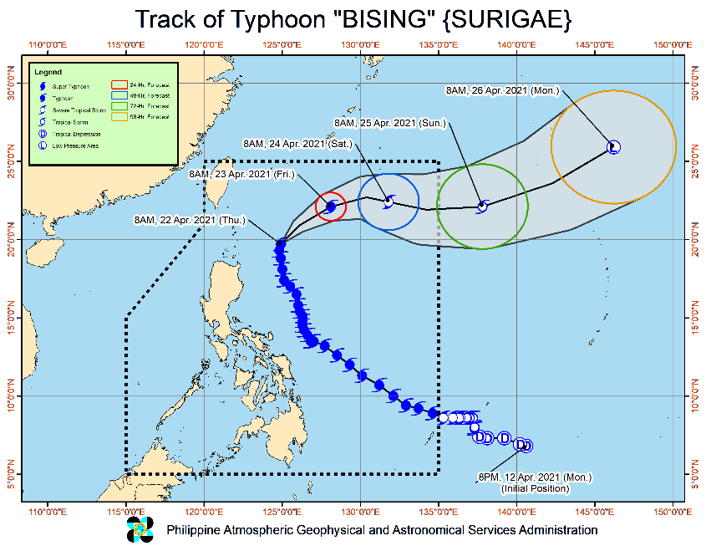

Issued at 5:00 PM, 22 April 2021, TYPHOON "BISING" ACCELERATES AND CONTINUES TO MAINTAIN ITS STRENGTH AS IT MOVES NORTH-NORTHEASTWARD AWAY FROM THE LANDMASS.

- Hazards affecting land areas
- Severe Winds:
  - Tropical cyclone winds of at least strong breeze to near gale in strength extend outward up to 370 km from the center of the typhoon. Destructive typhoon-force winds extend outward up to 90 km from the center of the typhoon.
- In the next 24 hours, the northeasterly wind flow enhanced by the typhoon will also bring strong breeze to near gale conditions with higher gusts over the coastal and mountainous areas of Ilocos Region, Apayao, Abra, and the western portion of Cagayan (i.e., those not under Tropical Cyclone Wind Signal #1).
- Hazards affecting coastal waters
- In the next 24 hours, under the influence of Typhoon “BISING” and an enhanced northeasterly wind flow, the following sea conditions will be experienced over the coastal waters of the country
- Rough to very rough seas over the western seaboards of Northern Luzon (2.8 to 4.5 m) and the northern and eastern seaboards of Northern Samar (2.5 to 4.5 m). Sea travel is risky for small seacrafts over these waters. Mariners without the proper experience should immediately seek safe harbor.
- Moderate to rough seas over the eastern seaboard of Bicol Region, northern and eastern seaboard of Northern Samar and the western seaboard of Northern and Central Luzon (1.5 to 3.0 m). Mariners of small seacrafts are advised not to venture out over these waters. Inexperienced mariners of these vessels should avoid navigating in these conditions.
- Track and Intensity Outlook:
- On the forecast track, Typhoon “BISING” will move generally northward or north northeastward today away from the landmass of Luzon before turning east northeastward tomorrow (23 April) and eastward on Saturday (24 April). The typhoon is forecast to exit the Philippine Area of Responsibility on Saturday evening or Sunday (25 April) early morning.
- “BISING” will gradually weaken throughout the remainder of the forecast period. It is forecast to be downgraded to severe tropical storm category by tomorrow and tropical storm category by Saturday before transitioning into an extratropical cyclone outside the PAR on Monday (26 April).
At 4:00 PM today, the center of the eye of Typhoon "BISING" was located based on all available data at 390 km East of Basco, Batanes (20.5 °N, 125.7 °E )
Source: DOST-PAGASA Severe Weather Bulletin

- Status of Affected Families / Persons
A total of 75,448 families or 302,564 persons were affected in 1,030 barangays in Regions II, V, VIII and Caraga (see Table 1).

Table 1. Number of Affected Families / Persons
REGION / PROVINCE / MUNICIPALITY |  | NUMBER OF AFFECTED
 |  | Barangays | Families | Persons
GRAND TOTAL |  | 1,030 | 75,448 | 302,564
REGION II |  | 9 | 112 | 303
Isabela |  | 9 | 112 | 303
 | Divilacan | 2 | 18 | 65
 | Maconacon | 7 | 94 | 238
REGION V |  | 636 | 35,507 | 136,605
Albay |  | 206 | 15,668 | 57,541
 | Bacacay | 16 | 868 | 3,233
 | Camalig | 10 | 2,567 | 9,314
 | Daraga (Locsin) | 7 | 148 | 562
 | Guinobatan | 21 | 2,170 | 7,628
 | Jovellar | 2 | 2 | 8
 | Legazpi City (capital) | 19 | 987 | 4,220
 | Libon | 17 | 417 | 1,996
 | City of Ligao | 13 | 218 | 770
 | Malilipot | 12 | 1,009 | 3,475
 | Malinao | 19 | 1,264 | 4,561
 | Manito | 6 | 828 | 2,619
 | Oas | 7 | 59 | 230
 | Pio Duran | 4 | 437 | 1,730
 | Polangui | 13 | 152 | 527
 | Rapu-Rapu | 8 | 690 | 2,698
 | Santo Domingo (Libog) | 15 | 1,093 | 3,463
 | Tiwi | 17 | 2,759 | 10,507
Camarines Norte |  | 14 | 106 | 450
 | Basud | 1 | 16 | 69
 | Jose Panganiban | 2 | 32 | 121
 | Labo | 3 | 17 | 57
 | Talisay | 8 | 41 | 203
Camarines Sur |  | 148 | 4,363 | 17,765
 | Baao | 5 | 89 | 353
 | Bato | 7 | 149 | 648
 | Bombon | 2 | 14 | 48
 | Buhi | 3 | 120 | 483
 | Bula | 4 | 95 | 473
 | Calabanga | 4 | 169 | 797
 | Caramoan | 27 | 866 | 3,290
 | Garchitorena | 4 | 104 | 507
 | Goa | 13 | 115 | 436
 | Iriga City | 11 | 428 | 1,822
 | Lagonoy | 6 | 57 | 209
 | Magarao | 1 | 6 | 28
 | Minalabac | 1 | 16 | 77
 | Nabua | 7 | 34 | 149
 | Naga City | 1 | 66 | 185
 | Ocampo | 4 | 31 | 147
 | Pasacao | 1 | 68 | 269
 | Pili (capital) | 1 | 5 | 24
 | Presentacion (Parubcan) | 14 | 854 | 3,416
 | Ragay | 7 | 87 | 299
 | Sagñay | 3 | 231 | 967
 | San fernando | 1 | 3 | 6
 | San Jose | 8 | 52 | 220
 | Sipocot | 1 | 19 | 49
 | Siruma | 2 | 14 | 64
 | Tinambac | 10 | 671 | 2,799
Catanduanes |  | 211 | 14,652 | 58,170
 | Province | 1 | 18 | 78
 | Bagamanoc | 11 | 339 | 1,082
 | Baras | 25 | 1,252 | 4,628
 | Bato | 17 | 2,031 | 8,164
 | Caramoran | 21 | 724 | 2,760
 | Gigmoto | 9 | 437 | 1,944
 | Pandan | 20 | 528 | 2,344
 | Panganiban (Payo) | 12 | 392 | 1,502
 | San Andres (Calolbon) | 14 | 662 | 2,554
 | San Miguel | 20 | 2,020 | 9,251
 | Viga | 4 | 57 | 237
 | Virac (capital) | 57 | 6,192 | 23,626
Masbate |  | 7 | 73 | 287
 | Mobo | 1 | 8 | 34
 | Pio V. Corpuz (Limbuhan) | 5 | 59 | 224
 | San Pascual | 1 | 6 | 29
Sorsogon |  | 50 | 645 | 2,392
 | Bulan | 5 | 185 | 534
 | Bulusan | 8 | 64 | 230
 | Castilla | 2 | 19 | 62
 | Gubat | 2 | 6 | 26
 | Irosin | 4 | 24 | 117
 | Juban | 4 | 46 | 194
 | Prieto Diaz | 10 | 87 | 314
 | Santa Magdalena | 3 | 13 | 58
 | City of Sorsogon (capital) | 12 | 201 | 857
REGION VIII |  | 377 | 39,777 | 165,399
Biliran |  | 4 | 24 | 120
 | Cabucgayan | 1 | 3 | 15
 | Culaba | 2 | 2 | 10
 | Maripipi | 1 | 19 | 95
Eastern Samar |  | 152 | 30,098 | 122,668
 | Arteche | 20 | 4,551 | 16,890
 | Can-Avid | 1 | 5,774 | 28,870
 | Dolores | 1 | 1,627 | 6,504
 | Jipapad | 13 | 2,510 | 10,040
 | Maslog | 1 | 76 | 380
 | Oras | 23 | 3,906 | 15,786
 | San Julian | 5 | 92 | 315
 | San Policarpo | 17 | 4,520 | 17,769
 | Sulat | 11 | 162 | 664
 | Taft | 2 | 11 | 43
 | Balangiga | 1 | 45 | 133
 | General MacArthur | 2 | 231 | 869
 | Guiuan | 23 | 1,404 | 4,230
 | Hernani | 9 | 2,454 | 9,727
 | Lawaan | 1 | 2,454 | 9,727
 | Llorente | 2 | 46 | 164
 | Mercedes | 14 | 197 | 405
 | Salcedo | 6 | 38 | 152
Leyte |  | 4 | 1,204 | 6,020
 | San Miguel | 3 | 1,188 | 5,940
 | MacArthur | 1 | 16 | 80
Northern Samar |  | 106 | 4,117 | 17,969
 | Allen | 1 | 7 | 29
 | Biri | 1 | 26 | 113
 | Bobon | 5 | 177 | 931
 | Catarman (capital) | 9 | 475 | 1,679
 | Lavezares | 5 | 120 | 528
 | Mondragon | 4 | 91 | 407
 | San Antonio | 3 | 23 | 85
 | San Jose | 4 | 37 | 96
 | Victoria | 6 | 27 | 119
 | Catubig | 13 | 350 | 1,484
 | Laoang | 15 | 502 | 2,278
 | Lapinig | 3 | 820 | 4,214
 | Las Navas | 1 | 29 | 107
 | Mapanas | 6 | 155 | 626
 | Palapag | 5 | 289 | 978
 | Pambujan | 11 | 203 | 1,029
 | San Roque | 13 | 784 | 3,257
 | Silvino Lobos | 1 | 2 | 9
Western Samar |  | 110 | 4,333 | 18,617
 | Almagro | 1 | 3 | 12
 | Gandara | 8 | 83 | 319
 | Matuguinao | 1 | 2 | 3
 | Pagsanghan | 2 | 12 | 37
 | San Jorge | 7 | 27 | 119
 | Santa Margarita | 2 | 70 | 350
 | Tarangnan | 2 | 24 | 108
 | Basey | 5 | 264 | 1,312
 | Calbiga | 1 | 1 | 5
 | City of Catbalogan (capital) | 20 | 691 | 3,314
 | Daram | 12 | 164 | 896
 | Jiabong | 1 | 69 | 197
 | Paranas (Wright) | 1 | 7 | 23
 | Pinabacdao | 11 | 189 | 905
 | San Sebastian | 14 | 2,263 | 9,130
 | Santa Rita | 5 | 91 | 415
 | Talalora | 2 | 7 | 22
 | Villareal | 1 | 75 | 244
 | Zumarraga | 14 | 291 | 1,206
Southern Leyte |  | 1 | 1 | 5
 | Saint Bernard | 1 | 1 | 5
CARAGA |  | 8 | 52 | 257
Agusan del Norte |  | 3 | 39 | 199
 | City of Cabadbaran | 3 | 39 | 199
Surigao del Norte |  | 5 | 13 | 58
 | Bacuag | 1 | 1 | 4
 | Malimono | 1 | 7 | 32
 | San Benito | 1 | 2 | 9
 | Sison | 2 | 3 | 13
Note: Ongoing assessment and validation being conducted.
Source: DSWD-FOs V, VIII and Caraga
- Status of Displaced Families / Persons
- Inside Evacuation Centers
There are 2,870 families or 12,228 persons currently taking temporary shelter in 170 evacuation centers in Regions II, V and VIII (see Table 2).

Table 2. Number of Displaced Families / Persons Inside Evacuation Centers
REGION / PROVINCE / MUNICIPALITY |  | NUMBER OF EVACUATION CENTERS (ECs) |  | NUMBER OF DISPLACED
 |  |  |  | INSIDE ECs
 |  |  |  | Families |  | Persons
 |  | CUM | NOW | CUM | NOW | CUM | NOW
GRAND TOTAL |  | 731 | 170 | 14,789 | 2,870 | 57,739 | 12,228
REGION II |  | 6 | 1 | 112 | 5 | 303 | 15
Isabela |  | 6 | 1 | 112 | 5 | 303 | 15
 | Divilacan | 2 | 1 | 18 | 5 | 65 | 15
 | Maconacon | 4 | - | 94 | - | 238 | -
REGION V |  | 670 | 169 | 13,370 | 2,865 | 52,576 | 12,213
Albay |  | 214 | - | 5,652 | - | 20,497 | -
 | Bacacay | 12 | - | 342 | - | 1,403 | -
 | Camalig | 9 | - | 314 | - | 838 | -
 | Daraga (Locsin) | 7 | - | 148 | - | 562 | -
 | Guinobatan | 29 | - | 1,574 | - | 5,652 | -
 | Jovellar | 1 | - | 1 | - | 3 | -
 | Legazpi City (capital) | 13 | - | 177 | - | 630 | -
 | Libon | 8 | - | 76 | - | 450 | -
 | City of Ligao | 14 | - | 218 | - | 770 | -
 | Malilipot | 7 | - | 137 | - | 526 | -
 | Malinao | 27 | - | 1,264 | - | 4,561 | -
 | Manito | 2 | - | 69 | - | 255 | -
 | Oas | 7 | - | 59 | - | 230 | -
 | Pio Duran | 8 | - | 260 | - | 1,074 | -
 | Polangui | 22 | - | 152 | - | 527 | -
 | Rapu-Rapu | 2 | - | 105 | - | 456 | -
 | Santo Domingo (Libog) | 23 | - | 213 | - | 660 | -
 | Tiwi | 23 | - | 543 | - | 1,900 | -
Camarines Norte |  | 12 | - | 81 | - | 370 | -
 | Basud | 2 | - | 7 | - | 37 | -
 | Jose Panganiban | 2 | - | 32 | - | 121 | -
 | Labo | 3 | - | 10 | - | 35 | -
 | Talisay | 5 | - | 32 | - | 177 | -
Camarines Sur |  | 160 | 52 | 2,813 | 1,021 | 11,624 | 4,164
 | Baao | 3 | - | 14 | - | 42 | -
 | Bato | 9 | - | 149 | - | 648 | -
 | Bombon | 4 | 4 | 14 | 14 | 48 | 48
 | Buhi | 3 | - | 110 | - | 443 | -
 | Bula | 7 | - | 42 | - | 222 | -
 | Calabanga | 5 | - | 169 | - | 797 | -
 | Caramoan | 27 | - | 234 | - | 930 | -
 | Garchitorena | 4 | 4 | 104 | 104 | 507 | 507
 | Goa | 8 | 8 | 80 | 80 | 312 | 312
 | Iriga City | 5 | - | 22 | - | 88 | -
 | Lagonoy | 6 | - | 57 | - | 209 | -
 | Magarao | 1 | - | 6 | - | 28 | -
 | Nabua | 7 | 3 | 34 | 3 | 149 | 3
 | Naga City | 3 | 3 | 66 | 66 | 185 | 185
 | Ocampo | 4 | - | 21 | - | 90 | -
 | Pasacao | 6 | 6 | 68 | 68 | 269 | 269
 | Pili (capital) | 1 | - | 5 | - | 24 | -
 | Presentacion (Parubcan) | 17 | 17 | 609 | 609 | 2,570 | 2,570
 | Ragay | 8 | 5 | 87 | 71 | 299 | 236
 | Sagñay | 4 | - | 231 | - | 967 | -
 | San fernando | 1 | - | 3 | - | 6 | -
 | San Jose | 8 | - | 49 | - | 209 | -
 | Sipocot | 1 | - | 19 | - | 49 | -
 | Siruma | 2 | 2 | 6 | 6 | 34 | 34
 | Tinambac | 16 | - | 614 | - | 2,499 | -
Catanduanes |  | 242 | 117 | 4,393 | 1,844 | 18,533 | 8,049
 | Province | 1 | - | 5 | - | 19 | -
 | Bagamanoc | 15 | - | 199 | - | 627 | -
 | Baras | 31 | 31 | 366 | 366 | 1,274 | 1,274
 | Bato | 38 | 38 | 229 | 229 | 926 | 926
 | Caramoran | 13 | 12 | 246 | 244 | 956 | 941
 | Gigmoto | 6 | - | 82 | - | 368 | -
 | Pandan | 9 | - | 173 | - | 814 | -
 | Panganiban (Payo) | 3 | - | 15 | - | 84 | -
 | San Andres (Calolbon) | 25 | - | 436 | - | 1,611 | -
 | San Miguel | 36 | 36 | 1,005 | 1,005 | 4,908 | 4,908
 | Viga | 3 | - | 31 | - | 122 | -
 | Virac (capital) | 62 | - | 1,606 | - | 6,824 | -
Masbate |  | 7 | - | 71 | - | 283 | -
 | Mobo | 1 | - | 8 | - | 34 | -
 | Pio V. Corpuz (Limbuhan) | 5 | - | 57 | - | 220 | -
 | San Pascual | 1 | - | 6 | - | 29 | -
Sorsogon |  | 35 | - | 360 | - | 1,269 | -
 | Bulan | 4 | - | 108 | - | 218 | -
 | Bulusan | 6 | - | 44 | - | 147 | -
 | Castilla | 1 | - | 1 | - | 5 | -
 | Gubat | 2 | - | 6 | - | 26 | -
 | Irosin | 4 | - | 24 | - | 117 | -
 | Juban | 6 | - | 46 | - | 194 | -
 | Prieto Diaz | 3 | - | 44 | - | 160 | -
 | Santa Magdalena | 3 | - | 13 | - | 58 | -
 | City of Sorsogon (capital) | 6 | - | 74 | - | 344 | -
REGION VIII |  | 53 | - | 1,268 | - | 4,664 | -
Eastern Samar |  | 5 | - | 59 | - | 120 | -
 | Can-Avid | 4 | - | 48 | - | 77 | -
 | Taft | 1 | - | 11 | - | 43 | -
Leyte |  | 1 | - | 6 | - | 34 | -
 | MacArthur | 1 | - | 6 | - | 34 | -
Northern Samar |  | 34 | - | 879 | - | 3,417 | -
 | Bobon | 1 | - | 22 | - | 96 | -
 | Catarman (capital) | 3 | - | 161 | - | 268 | -
 | Laoang | 11 | - | 282 | - | 1,399 | -
 | Las Navas | 1 | - | 29 | - | 107 | -
 | Mapanas | 3 | - | 35 | - | 156 | -
 | San Roque | 15 | - | 350 | - | 1,391 | -
Western Samar |  | 13 | - | 324 | - | 1,093 | -
 | San Sebastian | 13 | - | 324 | - | 1,093 | -
CARAGA |  | 2 | - | 39 | - | 196 | -
Agusan del Norte |  | 1 | - | 32 | - | 164 | -
 | City of Cabadbaran | 1 | - | 32 | - | 164 | -
Surigao del Norte |  | 1 | - | 7 | - | 32 | -
 | Malimono | 1 | - | 7 | - | 32 | -
Note: Ongoing assessment and validation being conducted.
Source: DSWD-FOs V, VIII and Caraga

- Outside Evacuation Centers
There are 4,479 families or 17,779 persons temporarily staying with their relatives and/or friends in Region V (see Table 3).

Table 3. Number of Displaced Families / Persons Outside Evacuation Centers
REGION / PROVINCE / MUNICIPALITY |  | NUMBER OF DISPLACED
 |  | OUTSIDE ECs
 |  | Families |  | Persons
 |  | CUM | NOW | CUM | NOW
GRAND TOTAL |  | 24,178 | 4,479 | 92,578 | 17,779
REGION V |  | 22,252 | 4,479 | 84,384 | 17,779
Albay |  | 10,016 | - | 37,044 | -
 | Bacacay | 526 | - | 1,830 | -
 | Camalig | 2,253 | - | 8,476 | -
 | Guinobatan | 596 | - | 1,976 | -
 | Jovellar | 1 | - | 5 | -
 | Legazpi City (capital) | 810 | - | 3,590 | -
 | Libon | 341 | - | 1,546 | -
 | Malilipot | 872 | - | 2,949 | -
 | Manito | 759 | - | 2,364 | -
 | Pio Duran | 177 | - | 656 | -
 | Rapu-Rapu | 585 | - | 2,242 | -
 | Santo Domingo (Libog) | 880 | - | 2,803 | -
 | Tiwi | 2,216 | - | 8,607 | -
Camarines Norte |  | 25 | - | 80 | -
 | Basud | 9 | - | 32 | -
 | Labo | 7 | - | 22 | -
 | Talisay | 9 | - | 26 | -
Camarines Sur |  | 1,550 | 298 | 6,141 | 1,040
 | Baao | 75 | - | 311 | -
 | Buhi | 10 | 10 | 40 | 40
 | Bula | 53 | - | 251 | -
 | Caramoan | 632 | - | 2,360 | -
 | Goa | 35 | 35 | 124 | 124
 | Iriga City | 406 | - | 1,734 | -
 | Minalabac | 16 | - | 77 | -
 | Ocampo | 10 | - | 57 | -
 | Presentacion (Parubcan) | 245 | 245 | 846 | 846
 | San Jose | 3 | - | 11 | -
 | Siruma | 8 | 8 | 30 | 30
 | Tinambac | 57 | - | 300 | -
Catanduanes |  | 10,386 | 4,181 | 40,033 | 16,739
 | Province | 140 | - | 455 | -
 | Bagamanoc | 140 | - | 455 | -
 | Baras | 886 | 886 | 3,354 | 3,354
 | Bato | 1,802 | 1,802 | 7,238 | 7,238
 | Caramoran | 478 | 478 | 1,804 | 1,804
 | Gigmoto | 355 | - | 1,576 | -
 | Pandan | 355 | - | 1,530 | -
 | Panganiban (Payo) | 377 | - | 1,418 | -
 | San Andres (Calolbon) | 226 | - | 943 | -
 | San Miguel | 1,015 | 1,015 | 4,343 | 4,343
 | Viga | 26 | - | 115 | -
 | Virac (capital) | 4,586 | - | 16,802 | -
Masbate |  | 2 | - | 4 | -
 | Pio V. Corpuz (Limbuhan) | 2 | - | 4 | -
Sorsogon |  | 273 | - | 1,082 | -
 | Bulan | 77 | - | 316 | -
 | Bulusan | 8 | - | 42 | -
 | Castilla | 18 | - | 57 | -
 | Prieto Diaz | 43 | - | 154 | -
 | City of Sorsogon (capital) | 127 | - | 513 | -
REGION VIII |  | 1,926 | - | 8,194 | -
Western Samar |  | 1,926 | - | 8,194 | -
 | San Sebastian | 1,926 | - | 8,194 | -
Note: Ongoing assessment and validation being conducted.
Source: DSWD-FOs V and VIII

- Damaged Houses
There are 1,448 damaged houses; of which, 84 are totally damaged and 1,364 are partially damaged (see Table 4).

Table 4. Number of Damaged Houses
REGION / PROVINCE / MUNICIPALITY |  | NO. OF DAMAGED HOUSES
 |  | Total | Totally | Partially
GRAND TOTAL |  | 1,448 | 84 | 1,364
REGION VIII |  | 1,442 | 83 | 1,359
Biliran |  | 24 | 2 | 22
 | Cabucgayan | 3 | - | 3
 | Culaba | 2 | 1 | 1
 | Maripipi | 19 | 1 | 18
Eastern Samar |  | 20 | - | 20
 | Arteche | 1 | - | 1
 | Can-Avid | 3 | - | 3
 | General MacArthur | 16 | - | 16
Leyte |  | 16 | - | 16
 | MacArthur | 16 | - | 16
Northern Samar |  | 150 | 18 | 132
 | Pambujan | 150 | 18 | 132
Western Samar |  | 1,232 | 63 | 1,169
 | Basey | 10 | - | 10
 | Calbiga | 1 | - | 1
 | City of Catbalogan (capital) | 628 | 14 | 614
 | Daram | 88 | 47 | 41
 | Jiabong | 1 | - | 1
 | Pinabacdao | 162 | 1 | 161
 | San Sebastian | 321 | 1 | 320
 | Santa Rita | 21 | - | 21
CARAGA |  | 6 | 1 | 5
Surigao del Norte |  | 6 | 1 | 5
 | Bacuag | 1 | - | 1
 | San Benito | 2 | 1 | 1
 | Sison | 3 | - | 3
. Source: DSWD-FOs VIII and Caraga

- Assistance Provided
A total of ₱171,156.20 worth of assistance was provided to the affected families; of which, ₱169,476.20 was provided by DSWD and by ₱1,680.00 from LGUs (see Table 5).

Table 5. Cost of Assistance Provided to Affected Families / Persons
REGION / PROVINCE / MUNICIPALITY |  | COST OF ASSISTANCE
 |  | DSWD | LGU | NGOs | OTHERS | GRAND TOTAL
GRAND TOTAL |  | 169,476.20 | 1,680.00 | - | - | 171,156.20
REGION V |  | 169,476.20 | 1,680.00 | - | - | 171,156.20
Albay |  | 169,476.20 | - | - | - | 169,476.20
 | Libon | 169,476.20 | - | - | - | 169,476.20
Sorsogon |  | - | 1,680.00 | - | - | 1,680.00
 | Pilar | - | 1,680.00 | - | - | 1,680.00
Source: DSWD-FO V

DSWD DISASTER RESPONSE INFORMATION
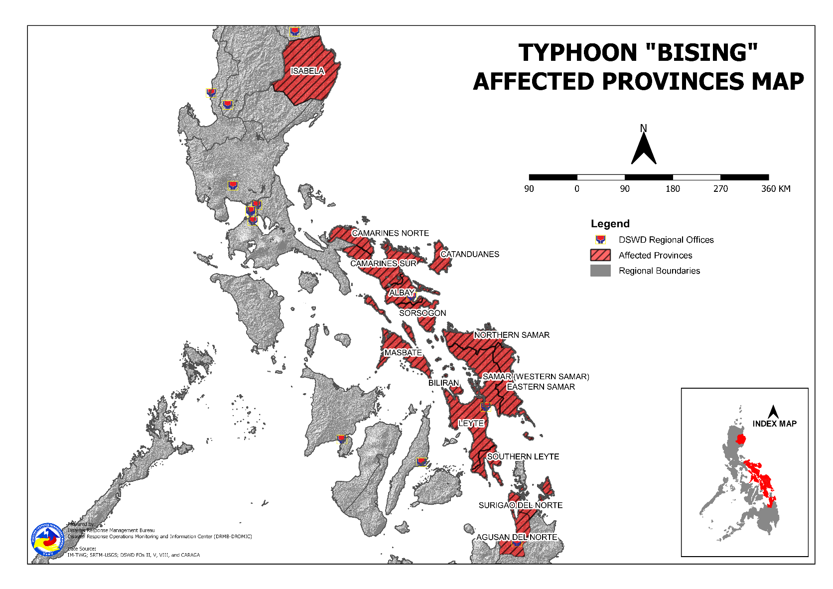

Status of Prepositioned Resources: Stockpile and Standby Funds
The DSWD Central Office (CO), Field Offices (FOs), and National Resource Operations Center (NROC) have stockpiles and standby funds amounting to ₱1,580,997,721.46 with breakdown as follows (see Table 2):

- Standby Funds
A total of ₱562,341,277.65 standby funds in the CO and FOs. Of the said amount, ₱517,992,176.43 is the available Quick Response Fund (QRF) in the CO.

- Stockpiles
A total of 361,410 family food packs (FFPs) amounting to ₱183,778,076.48, other food items amounting to ₱306,654,326.50 and non-food items (FNIs) amounting to ₱528,224,040.83 are available.

Table 2. Available Stockpiles and Standby Funds
REGIONAL / FIELD OFFICE | STANDBY FUNDS | FAMILY FOOD PACKS |  | OTHER FOOD ITEMS | NON-FOOD RELIEF ITEMS | TOTAL STANDBY FUNDS & STOCKPILE
 |  | QUANTITY | TOTAL COST | TOTAL COST | TOTAL COST
TOTAL | 562,341,277.65 | 361,410 | 183,778,076.48 | 306,654,326.50 | 528,224,040.83 | 1,580,997,721.46
Central Office | 517,992,176.43 | - | - | - | - | 517,992,176.43
NRLMB - NROC | - | 84,007 | 45,328,839.00 | 165,131,236.63 | 281,982,975.25 | 492,443,050.88
NRLMB - VDRC | - | 39,547 | 17,612,415.00 | 30,338,894.34 | 5,077,232.50 | 53,028,541.84
I | 1,497,055.20 | 27,347 | 13,946,970.00 | 4,095,469.34 | 27,588,610.33 | 47,128,104.87
II | 3,000,869.36 | 17,215 | 9,272,639.00 | 4,429,420.13 | 14,601,214.84 | 31,304,143.33
III | 3,000,908.30 | 9,642 | 4,374,670.65 | 1,458,080.00 | 13,650.00 | 8,847,308.95
CALABARZON | 3,000,000.00 | 6,238 | 2,925,132.00 | 8,898,432.20 | 9,828,294.27 | 24,651,858.47
MIMAROPA | 2,471,062.78 | 30,824 | 19,517,294.03 | 1,307,574.00 | 8,690,041.75 | 31,985,972.56
V | 3,000,000.00 | 29,359 | 11,810,817.88 | 6,407,588.30 | 15,875,389.15 | 37,093,795.33
VI | 3,000,006.07 | 18,319 | 7,830,922.09 | 15,901,319.80 | 16,163,617.28 | 42,895,865.24
VII | 2,983,087.16 | 17,713 | 7,870,575.00 | 11,881,482.22 | 7,496,480.98 | 30,231,625.36
VIII | 2,215,796.00 | 8,457 | 4,600,016.01 | 6,208,683.36 | 27,964,560.95 | 40,989,056.32
IX | 3,920,000.00 | 19,420 | 10,612,835.80 | 8,873,791.28 | 12,557,978.69 | 35,964,605.77
X | 4,116,679.92 | 17,144 | 9,756,525.48 | 11,709,275.06 | 29,322,940.66 | 54,905,421.12
XI | - | 3,796 | 1,729,457.60 | 8,888,625.00 | 14,675,465.80 | 25,293,548.40
XII | 2,748,513.85 | 3,859 | 2,122,450.00 | 6,067,654.21 | 19,117,738.53 | 30,056,356.59
CARAGA | 3,451,832.02 | 5,142 | 2,245,341.02 | 2,510,228.22 | 17,283,933.34 | 25,491,334.60
NCR | 2,931,000.00 | 1,259 | 571,145.35 | 6,881,986.45 | 3,661,874.28 | 14,046,006.08
CAR | 3,012,290.56 | 22,122 | 11,650,030.57 | 5,664,585.96 | 16,322,042.23 | 36,648,949.32
Note: The Inventory Summary is as of 22 April 2021, 4PM.
Source: DRMB and NRLMB

Situational Reports

DSWD-DRMB
DATE | SITUATIONS / ACTIONS UNDERTAKEN
22 April 2021 | - The Disaster Response Management Bureau (DRMB) is on RED Alert Status and is closely coordinating with the concerned field offices for significant disaster response updates.  - All QRT members and emergency equipment are on standby and ready for deployment.

DSWD-FO CAR
DATE | SITUATIONS / ACTIONS UNDERTAKEN
21 April 2021 | - Replenishment of 2,002 FFPs and 400 HK to Kalinga and 2,002 FFPs and 500HK to Ifugao.  - DSWD-FO CAR ensures compliance to the CCCM and IDP Protection Guidelines and COVID19 Protocols.  - DSWD-FO CAR ensures availability of evacuation centers to accommodate displaced families and individuals.  - DSWD-FO CAR is closely monitoring weather updates and information.  - DSWD-FO CAR ensures availability of food and non-food items for resource augmentation as the need arises.  - DSWD-FO CAR DRR Focal persons is in close coordination with the LDRRMOs and MSWDOs for weather reports and updates.

DSWD-FO I
DATE | SITUATIONS / ACTIONS UNDERTAKEN
17 April 2021 | - DSWD-FO I is closely monitoring the movement of Typhoon ”BISING” through the DOST – PAGASA and in close coordination with the Regional Disaster Risk Reduction and Management Council 1 (RDRRMC1). Likewise, Provincial Operations Offices (POOs) are in close coordination with the different Provincial/City/Municipal Disaster Risk Reduction and Management Councils (P/C/MDRRMCs) and Provincial/City/ Municipality Social Welfare and Development Offices (P/C/MSWDOs) to monitor the adverse effects that might be brought by the weather disturbance.  - DSWD-FO I Incident Management Team (IMT) is still activated and on duty while other DSWD staff are on standby for possible augmentation. Likewise, the Field Office ensures availability and readiness of resources.

DSWD-FO II
DATE | SITUATIONS / ACTIONS UNDERTAKEN
21 April 2021 | - The Regional Disaster Management Response Team is already activated on a 24-hour duty.  - Continuous monitoring by the SWADTs and P/C/MATS of DSW-FO II with regard to the present weather condition of every municipality in the five (5) provinces of Region 2.  - DSWD-FO II Disaster Response Management Division (DRMD) through the Disaster Response Information and Management Section (DRIMS) continuously monitor the weather advisory.  - DSWD-FO II ensures availability of Food and Non-Food Items (FNIs) at any given time.  - SWADTs/Provincial Operations Offices (POOs)/C/MATs closely coordinating with their respective Provincial/City/Municipal Disaster Risk Reduction and Management Councils (P/C/MDRRMCs) that are currently monitoring the adverse effects brought by this weather disturbance.

DSWD-FO III
DATE | SITUATIONS / ACTIONS UNDERTAKEN
17 April 2021 | - Activated the Rapid Development Team (RDT) of DRMD that will render skeletal duties during onset of disaster to continuously monitor weather disturbance and coordinates with the Provincial Extension Offices for the situation of their respective LGUs.  - The 15 QRTs are ready for deployment upon the activation of the Blue and Red alert status of the RDRRMC 3.  - The Regional Warehouse and Fort Magsaysay Hub has ongoing repacking of Family Food Packs.

DSWD-FO MIMAROPA
DATE | SITUATIONS / ACTIONS UNDERTAKEN
15 April 2021 | - SWADT Offices are alerted to monitor daily local weather condition and related eventualities, and ensure provision of information to all concerned offices, divisions, sections, and units.  - On-call status of the expanded R/P/C/M QRTs together with special projects staff on a 24/7 basis for possible activation of Operation Center to respond in case any untoward incident and eventualities are reported.  - DSWD-FO MIMAROPA is in close coordination with the Office of Civil Defense (OCD) and RDRRMC MIMAROPA for any updates for monitoring purposes and response mechanism for areas that will be affected.  - Standby logistical equipment and workforce through coordination with SWADT Offices and concerned LGUs on the management of stranded passengers, if any, in ports and terminals.  - Information and Communication Technology Management Unit (ICTMU) is on standby status to ensure robust communication system.

DSWD-FO V
DATE | SITUATIONS / ACTIONS UNDERTAKEN
22 April 2021 | - DSWD-FO V DRMD team are activated and on-duty at DSWD-FO V Operations Center.  - DSWD-FO V is continuously monitoring weather updates and information.  - The Resource Operation Section ensures the availability of family food packs and non-food items as need arises.  - DSWD FO-V QTRs are alerted.  - PAT and MAT members in the six (6) provinces are activated and instructed to coordinate with the P/MDRRMOs, C/MSWDOs for weather reports and updates.  - Provision of 412 family food packs as relief augmentation in the Province of Libon, Albay amounting to Php 169,476.20.

DSWD-FO VI
DATE | SITUATIONS / ACTIONS UNDERTAKEN
14 April 2021 | - All QRT members are on stand by and ready for augmentation if needed, following the new normal protocols of the agency.  - RDANA team is composed of 40 trained QRTs and is ready to be deployed if needed. 30 QRT members in-charge for reports also undergone training on DROMIC Protocols last September 17-19 and 24-26, 2020.  - DSWD-FO VI continuously conducts TA provision to LGUs and SWAD Offices on DROMIC Reporting.  - DSWD-FO VI issued a total of 150 vests, 50 GO bags, 50 survival bags, and 50 sleeping kits to QRT members in the region and field staff.

DSWD-FO VII
DATE | SITUATIONS / ACTIONS UNDERTAKEN
19 April 2021 | - DSWD-FO VII shared its preparedness measures including its Food and Non-Food Relief Stockpile Status during the PDRA Meeting for Typhoon Bising on 17 April 2021.  - Regional/Provincial/City/Municipal Quick Response Team remains on standby alert and ready for mobilization.  - City and Municipal Action Team and SWAD Offices is coordinating with their local counterparts and their respective LDRRMCs for any weather related incidents, impacts/effects.  - Continuous monitoring by the DSWD Regional DROMIC Focal for the latest weather updates from PAGASA and cascading the same for widest dissemination to Provincial /City/Municipal Action Teams.  - Regional Disaster Division is in closed coordination with OCD-7 and other members of the RDRRMC for any response mobilization activities/strategies. Regional QRT members on standby alert.  - Warehouses in the three island provinces remain on standby alert for any response activities. Repacking of relief goods is continuously being conducted.

DSWD-FO VIII
DATE | SITUATIONS / ACTIONS UNDERTAKEN
22 April 2021 | - A total of 3,470 families or 14,583 persons have pre-emptively evacuated in 115 evacuation centers in Region VIII.  - Prepositioned Family Food Packs (FFPs) in Samar Island, Biliran and Southern Leyte which can be distributed immediately by the P/C/MATs to Local Government Units that need augmentation support.  - DSWD-FO VIII will conduct a virtual meeting with Response Cluster Member agencies to gather updates on their response actions and harmonize response activities.  - DSWD-FO VIII delivered 700 FFPs for prepositioning at the ESSU Campus in Can-avid, Eastern Samar last April 15, 2021. Another 700 FFPs were also delivered for prepositioning at the Eastern Samar States University (ESSU) Main Campus in Borongan City, Eastern Samar on April 16, 2021.

DSWD-FO CARAGA
DATE | SITUATIONS / ACTIONS UNDERTAKEN
21 April 2021 | - DSWD-FO CARAGA is continuously coordinating with the LGUs for the possible augmentation assistance to the affected families.

*****
The Disaster Response Operations Monitoring and Information Center (DROMIC) of the DSWD-DRMB is closely monitoring the effects of Typhoon “Bising” and is coordinating with the concerned DSWD Field Offices for any significant updates.

Prepared by: Releasing Officer:
MARIEL B. FERRARIZ RODEL V. CABADDU
DIANE C. PELEGRINO

