DSWD DROMIC Report on the Fire Incident in
Brgy. 06, Guiuan, Eastern Samar
26 April 2021, 6PM

This is the first and final report on the fire incident that occurred in Brgy. 06, Guiuan, Eastern Samar on 18 April 2021.
Source: DSWD-FO VIII

SUMMARY

- Status of Affected Families / Persons
A total of 11 families or 55 persons were affected by the fire incident in Brgy. 06, Guiuan, Eastern Samar (see Table 1).

Table 1. Number of Affected Families / Persons
REGION / PROVINCE / MUNICIPALITY |  | NUMBER OF AFFECTED
 |  | Barangays | Families | Persons
GRAND TOTAL |  | 1 | 11 | 55
REGION VIII |  | 1 | 11 | 55
Eastern Samar |  | 1 | 11 | 55
 | Guiuan | 1 | 11 | 55
Source: DSWD-FO VIII

- Damaged Houses
A total of 11 houses were totally damaged by the fire (see Table 2).

Table 2. Number of Damaged Houses
REGION / PROVINCE / MUNICIPALITY |  | NO. OF DAMAGED HOUSES
 |  | Total | Totally | Partially
GRAND TOTAL |  | 11 | 11 | -
REGION VIII |  | 11 | 11 | -
Eastern Samar |  | 11 | 11 | -
 | Guiuan | 11 | 11 | -
Source: DSWD-FO VIII

- Assistance Provided
A total of ₱32,136.50 worth of assistance was provided by DSWD to the affected families (see Table 3).

Table 3. Cost of Assistance Provided to Affected Families / Persons
REGION / PROVINCE / MUNICIPALITY |  | COST OF ASSISTANCE
 |  | DSWD | LGU | NGOs | OTHERS | GRAND TOTAL
GRAND TOTAL |  | 32,136.50 | - | - | - | 32,136.50
REGION VIII |  | 32,136.50 | - | - | - | 32,136.50
Eastern Samar |  | 32,136.50 | - | - | - | 32,136.50
 | Guiuan | 32,136.50 | - | - | - | 32,136.50
Source: DSWD-FO VIII

SITUATIONAL REPORT

DSWD-FO VIII
DATE | SITUATIONS / ACTIONS UNDERTAKEN
20 April 2021 | - DSWD-FO VIII submitted their terminal report.  - DSWD-FO VIII provided a total of ₱32,136.50 worth of relief assistance, which consists of 11 hygiene kits, 11 sleeping kits and 11 kitchen kits to the affected family.

*****
The Disaster Response Operations Monitoring and Information Center (DROMIC) of DSWD-DRMB continues to closely coordinate with DSWD-FO VIII for any request of Technical Assistance and Resource Augmentation (TARA).

Prepared by:

MARIE JOYCE G. RAFANAN

MARC LEO L. BUTAC
Releasing Officer

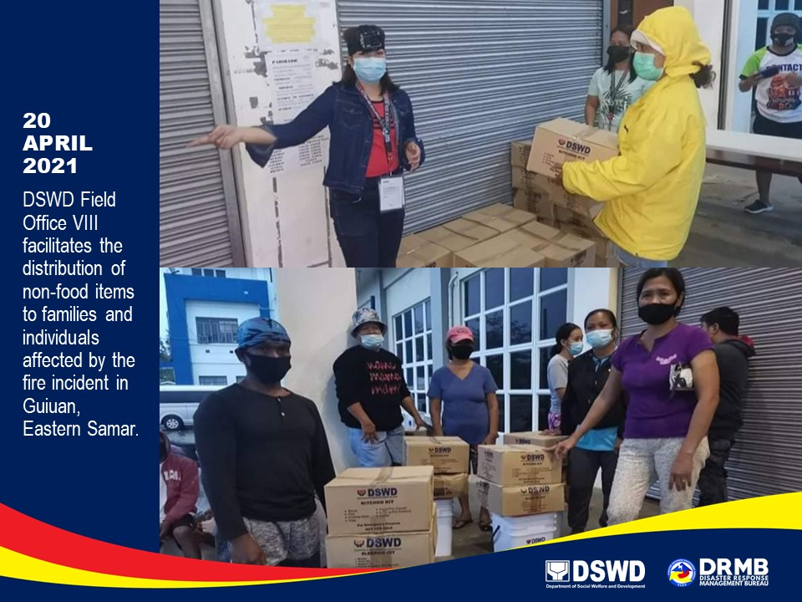
PHOTO DOCUMENTATION

