DSWD DROMIC Report on the Fire Incident in
Brgy. Ahin, Tinoc, Ifugao
04 April 2021, 6PM

This is the first and final report on the fire incident that occurred in Brgy. Ahin, Tinoc, Ifugao on 05 March 2021.
Source: DSWD-FO CAR

SUMMARY

- Status of Affected Families / Persons
A total of one (1) family or six (6) persons were affected by the fire incident in Brgy. Ahin, Tinoc, Ifugao (see Table 1).

Table 1. Number of Affected Families / Persons
REGION / PROVINCE / MUNICIPALITY |  | NUMBER OF AFFECTED
 |  | Barangays | Families | Persons
GRAND TOTAL |  | 1 | 1 | 6
CAR |  | 1 | 1 | 6
Ifugao |  | 1 | 1 | 6
 | Tinoc | 1 | 1 | 6
Source: DSWD-FO CAR

- Status of Displaced Families / Persons Outside Evacuation Center
There is one (1) family or six (6) persons taking temporary shelter with their relatives/friends (see Table 2).

Table 2. Number of Displaced Families / Persons Outside Evacuation Center
REGION / PROVINCE / MUNICIPALITY |  | NUMBER OF DISPLACED
 |  | OUTSIDE ECs
 |  | Families |  | Persons
 |  | CUM | NOW | CUM | NOW
GRAND TOTAL |  | 1 | 1 | 6 | 6
CAR |  | 1 | 1 | 6 | 6
Ifugao |  | 1 | 1 | 6 | 6
 | Tinoc | 1 | 6 | 6 | 6
Source: DSWD-FO CAR

- Damaged Houses
One (1) house was totally damaged by the fire (see Table 3).

Table 3. Number of Damaged Houses
REGION / PROVINCE / MUNICIPALITY |  | NO. OF DAMAGED HOUSES
 |  | Total | Totally | Partially
GRAND TOTAL |  | 1 | 1 | -
CAR |  | 1 | 1 | -
Ifugao |  | 1 | 1 | -
 | Tinoc | 1 | 1 | -
Source: DSWD-FO CAR

- Assistance Provided
A total of ₱7,636.68 worth of assistance was provided by DSWD to the affected family (see Table 4).

Table 4. Cost of Assistance Provided to Affected Families / Persons
REGION / PROVINCE / MUNICIPALITY |  | COST OF ASSISTANCE
 |  | DSWD | LGU | NGOs | OTHERS | GRAND TOTAL
GRAND TOTAL |  | 7,636.68 | - | - | - | 7,636.68
CAR |  | 7,636.68 | - | - | - | 7,636.68
Ifugao |  | 7,636.68 | - | - | - | 7,636.68
 | Tinoc | 7,636.68 | - | - | - | 7,636.68
Source: DSWD-FO CAR

SITUATIONAL REPORT

DSWD-FO CAR
DATE | SITUATIONS / ACTIONS UNDERTAKEN
31 March 2021 | - DSWD-FO CAR submitted their terminal report.  - DSWD-FO CAR provided a total of ₱7,636.68 worth of relief assistance to the affected family which consists of 2 family food packs, 1 family kit, 1 hygiene kit, 1 sleeping kit and 1 kitchen kit.  - DSWD-FO CAR also provided ₱5,000.00 financial assistance to the affected family.

*****
The Disaster Response Operations Monitoring and Information Center (DROMIC) of DSWD-DRMB continues to closely coordinate with DSWD-FO CAR for any request of Technical Assistance and Resource Augmentation (TARA).

Prepared by:

MARIE JOYCE G. RAFANAN

MARC LEO L. BUTAC
Releasing Officer

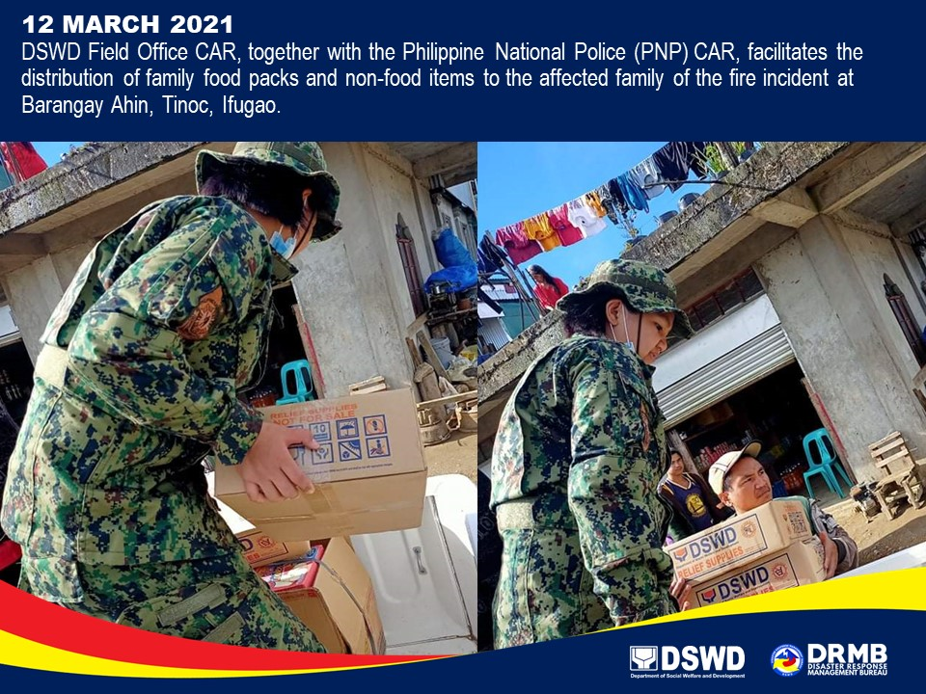
PHOTO DOCUMENTATION

