DSWD DROMIC Report on the Fire Incident
in Brgy. Pulpogan, Consolacion, Cebu
22 April 2021, 6PM

This is the first and final report on the fire incident that occurred in Sitio Palma, District 4, Brgy. Pulpogan, Consolacion, Cebu on 12 Apr 2021 at 12:18 PM. The fire was declared out at 2:28 PM.
Source: DSWD-FO VII

SUMMARY

- Status of Affected Families / Persons
A total of 42 families or 148 persons were affected by the fire incident in Sitio Palma, District 4, Brgy. Pulpogan, Consolacion, Cebu (see Table 1).

Table 1. Number of Affected Families / Persons
REGION / PROVINCE / MUNICIPALITY |  | NUMBER OF AFFECTED
 |  | Barangays | Families | Persons
GRAND TOTAL |  | 1 | 42 | 148
REGION VII |  | 1 | 42 | 148
Cebu |  | 1 | 42 | 148
 | Consolacion | 1 | 42 | 148
Source: DSWD-FO VII

- Status of Displaced Families / Persons Inside Evacuation Center
There are 42 families or 148 persons currently taking temporary shelter at the Bagong Lipunan Elementary School (see Table 2).

Table 2. Number of Displaced Families / Persons Inside Evacuation Center
REGION / PROVINCE / MUNICIPALITY |  | NUMBER OF EVACUATION CENTERS (ECs) |  | NUMBER OF DISPLACED
 |  |  |  | INSIDE ECs
 |  |  |  | Families |  | Persons
 |  | CUM | NOW | CUM | NOW | CUM | NOW
GRAND TOTAL |  | 1 | 1 | 42 | 42 | 148 | 148
REGION VII |  | 1 | 1 | 42 | 42 | 148 | 148
Cebu |  | 1 | 1 | 42 | 42 | 148 | 148
 | Consolacion | 1 | 1 | 42 | 42 | 148 | 148
Note: The LGU will continuously provide the needs of the affected families staying in the evacuation center.
Source: DSWD-FO VII

- Damaged Houses
A total of 27 houses were damaged; of which, 21 were totally damaged and 6 were partially damaged (see Table 3).

Table 3. Number of Damaged Houses
REGION / PROVINCE / MUNICIPALITY |  | NO. OF DAMAGED HOUSES
 |  | Total | Totally | Partially
GRAND TOTAL |  | 27 | 21 | 6
REGION VII |  | 27 | 21 | 6
Cebu |  | 27 | 21 | 6
 | Consolacion | 27 | 21 | 6
Source: DSWD-FO VII

- Assistance Provided
A total of ₱ 227,948.70 worth of assistance was provided by DSWD to the affected families (see Table 4).

Table 4. Cost of Assistance Provided to Affected Families / Persons
REGION / PROVINCE / MUNICIPALITY |  | COST OF ASSISTANCE
 |  | DSWD | LGU | NGOs | OTHERS | GRAND TOTAL
GRAND TOTAL |  | 227,948.70 | - | - | - | 227,948.70
REGION VII |  | 227,948.70 | - | - | - | 227,948.70
Cebu |  | 227,948.70 | - | - | - | 227,948.70
 | Consolacion | 227,948.70 | - | - | - | 227,948.70
Source: DSWD-FO VII

SITUATIONAL REPORT

DSWD-FO VII
DATE | SITUATIONS / ACTIONS UNDERTAKEN
19 April 2021 | - DSWD-FO VII submitted their terminal report.

*****
The Disaster Response Operations Monitoring and Information Center (DROMIC) of the DSWD-DRMB continues to closely coordinate with DSWD-FO VII for any request of Technical Assistance and Resource Augmentation (TARA).

Prepared by:

MARIE JOYCE G. RAFANAN

MARC LEO L. BUTAC
Releasing Officer

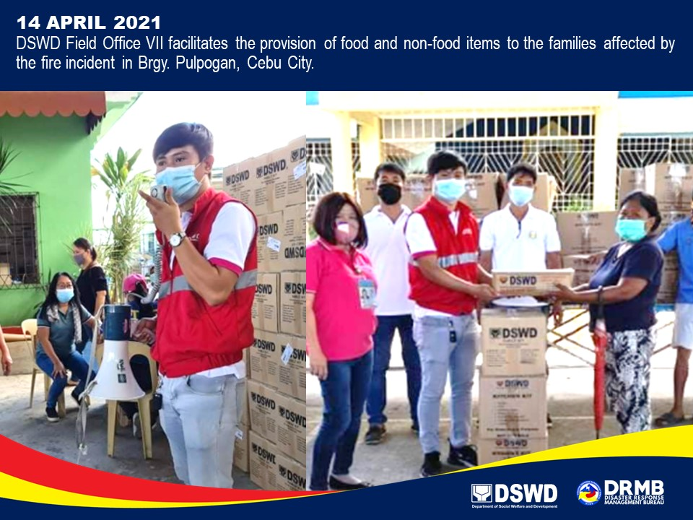
PHOTO DOCUMENTATION

