DSWD DROMIC Report on the Fire Incident in
Lower Pinget, Baguio City, Benguet
04 April 2021, 6PM

This is the first and final report on the fire incident that occurred in Lower Pinget, Baguio City, Benguet on 07 March 2021.
Source: DSWD-FO CAR

SUMMARY

- Status of Affected Families / Persons
A total of five (5) families or 11 persons were affected by the fire incident in Lower Pinget, Baguio City, Benguet (see Table 1).

Table 1. Number of Affected Families / Persons
REGION / PROVINCE / MUNICIPALITY |  | NUMBER OF AFFECTED
 |  | Barangays | Families | Persons
GRAND TOTAL |  | 1 | 5 | 11
CAR |  | 1 | 5 | 11
Benguet |  | 1 | 5 | 11
 | Baguio City | 1 | 5 | 11
Source: DSWD-FO CAR

- Damaged Houses
A total of three (3) houses were damaged; of which, one (1) was totally damaged and two (2) were partially damaged (see Table 2).

Table 2. Number of Damaged Houses
REGION / PROVINCE / MUNICIPALITY |  | NO. OF DAMAGED HOUSES
 |  | Total | Totally | Partially
GRAND TOTAL |  | 3 | 1 | 2
CAR |  | 3 | 1 | 2
Benguet |  | 3 | 1 | 2
 | Baguio City | 3 | 1 | 2
Source: DSWD-FO CAR

- Assistance Provided
A total of ₱38,131.00 worth of assistance was provided to the affected families; of which, ₱32,731.00 from DSWD and ₱5,400.00 from LGU (see Table 3).

Table 3. Cost of Assistance Provided to Affected Families / Persons
REGION / PROVINCE / MUNICIPALITY |  | COST OF ASSISTANCE
 |  | DSWD | LGU | NGOs | OTHERS | GRAND TOTAL
GRAND TOTAL |  | 32,731.00 | 5,400.00 | - | - | 38,131.00
CAR |  | 32,731.00 | 5,400.00 | - | - | 38,131.00
Benguet |  | 32,731.00 | 5,400.00 | - | - | 38,131.00
 | Baguio City | 32,731.00 | 5,400.00 | - | - | 38,131.00
Source: DSWD-FO CAR

SITUATIONAL REPORT

DSWD-FO CAR
DATE | SITUATIONS / ACTIONS UNDERTAKEN
29 March 2021 | - DSWD-FO CAR submitted their terminal report.  - One (1) individual is currently taking temporary shelter with his relatives/friends.  - DSWD-FO CAR provided a total of ₱32,731.00 worth of relief assistance to the affected families which consists of 10 family food packs, 5 hygiene kits, 5 sleeping kits, 5 family kits and 5 kitchen kits.

*****
The Disaster Response Operations Monitoring and Information Center (DROMIC) of DSWD-DRMB continues to closely coordinate with DSWD-FO CAR for any request of Technical Assistance and Resource Augmentation (TARA).

Prepared by:

MARIE JOYCE G. RAFANAN

MARC LEO L. BUTAC
Releasing Officer

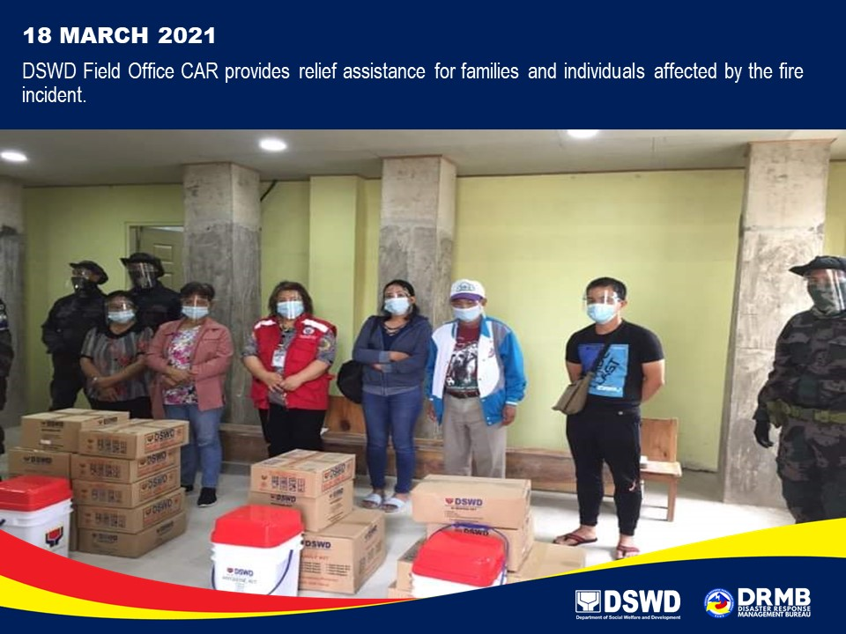
PHOTO DOCUMENTATION

