DSWD DROMIC Terminal Report on the Fire Incident
in Brgy. Mambaling, Cebu City
01 May 2021, 6PM

This is the final report on the fire incident that occurred in Brgy. Mambaling, Cebu City on 15 March 2021 at 5:22 AM. The fire was declared out at 8:18 AM.
Source: DSWD-FO VII

SUMMARY

- Status of Affected Families / Persons
A total of 121 families or 461 persons were affected by the fire incident in Brgy. Mambaling, Cebu City (see Table 1).

Table 1. Number of Affected Families / Persons
REGION / PROVINCE / MUNICIPALITY |  | NUMBER OF AFFECTED
 |  | Barangays | Families | Persons
GRAND TOTAL |  | 1 | 121 | 461
REGION VII |  | 1 | 121 | 461
Cebu |  | 1 | 121 | 461
 | Cebu City (capital) | 1 | 121 | 461
Source: DSWD-FO VII

- Status of Displaced Families / Persons Inside Evacuation Center
There are 49 families or 49 persons currently taking temporary shelter at the Sitio Viking Gymnasium (see Table 2).

Table 2. Number of Displaced Families / Persons Inside Evacuation Center
REGION / PROVINCE / MUNICIPALITY |  | NUMBER OF EVACUATION CENTERS (ECs) |  | NUMBER OF DISPLACED
 |  |  |  | INSIDE ECs
 |  |  |  | Families |  | Persons
 |  | CUM | NOW | CUM | NOW | CUM | NOW
GRAND TOTAL |  | 1 | 1 | 119 | 49 | 459 | 49
REGION VII |  | 1 | 1 | 119 | 49 | 459 | 49
Cebu |  | 1 | 1 | 119 | 49 | 459 | 49
 | Cebu City (capital) | 1 | 1 | 119 | 49 | 459 | 49
Note: The needs of the remaining 49 affected families staying inside EC shall be continuously provided by the LGU.
Source: DSWD-FO VII

- Damaged Houses
A total of 49 houses were damaged by the fire; of which, 43 were totally damaged and six (6) were partially damaged (see Table 3).

Table 3. Number of Damaged Houses
REGION / PROVINCE / MUNICIPALITY |  | NO. OF DAMAGED HOUSES
 |  | Total | Totally | Partially
GRAND TOTAL |  | 49 | 43 | 6
REGION VII |  | 49 | 43 | 6
Cebu |  | 49 | 43 | 6
 | Cebu City (capital) | 49 | 43 | 6
Source: DSWD-FO VII

- Assistance Provided
A total of ₱138,765.00 worth of assistance was provided by DSWD to the affected families (see Table 4).

Table 4. Cost of Assistance Provided to the Affected Families / Persons
REGION / PROVINCE / MUNICIPALITY |  | COST OF ASSISTANCE
 |  | DSWD | LGU | NGOs | OTHERS | GRAND TOTAL
GRAND TOTAL |  | 138,765.00 | - | - | - | 138,765.00
REGION VII |  | 138,765.00 | - | - | - | 138,765.00
Cebu |  | 138,765.00 | - | - | - | 138,765.00
 | Cebu City (capital) | 138,765.00 | - | - | - | 138,765.00
Source: DSWD-FO VII

SITUATIONAL REPORT
DSWD-FO VII
DATE | SITUATIONS / ACTIONS UNDERTAKEN
28 April 2021 | - DSWD-FO VII submitted their terminal report.  - DSWD-FO VII provided 319 family food packs to the affected families.  - DSWD-FO VII through AICS provided a total of ₱555,000.00 financial assistance to the affected families.

*****
The Disaster Response Operations Monitoring and Information Center (DROMIC) of the DSWD-DRMB is closely coordinating with DSWD-FO VII for any request of Technical Assistance and Resource Augmentation (TARA).

Prepared by:

MARIE JOYCE G. RAFANAN

LESLIE R. JAWILI
Releasing Officer

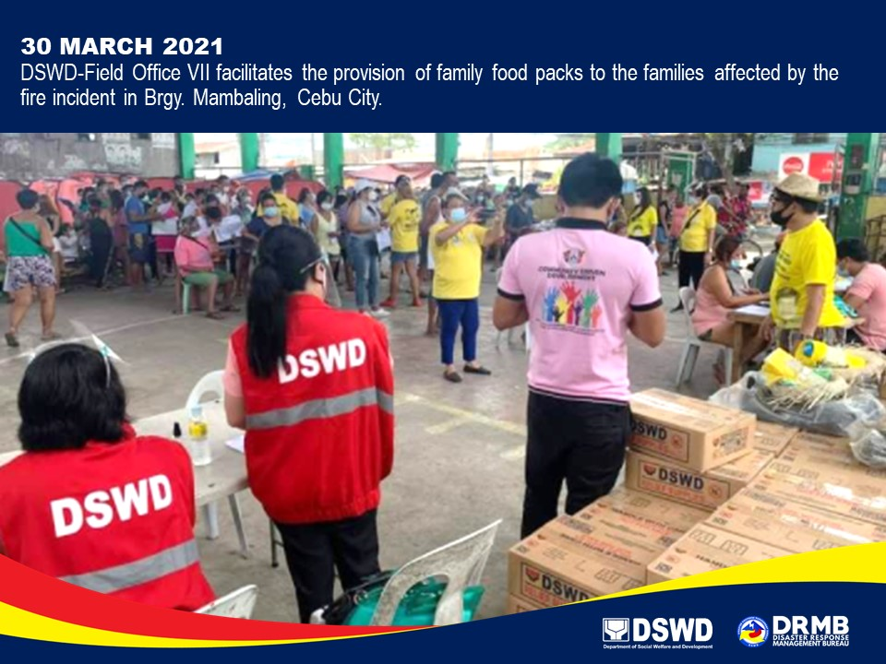
PHOTO DOCUMENTATION

