DSWD DROMIC Terminal Report on the Fire Incident
in Brgy. Sambag II, Cebu City
22 April 2021, 6PM

This is the final report on the fire incident that occurred in Brgy. Sambag II, Cebu City on 16 March 2021 at 2:53 PM. The fire was declared out at 4:31 PM.
Source: DSWD-FO VII

SUMMARY

- Status of Affected Families / Persons
A total of 147 families or 488 persons were affected by the fire incident in Brgy. Sambag II, Cebu City (see Table 1).

Table 1. Number of Affected Families / Persons
REGION / PROVINCE / MUNICIPALITY |  | NUMBER OF AFFECTED
 |  | Barangays | Families | Persons
GRAND TOTAL |  | 1 | 147 | 488
REGION VII |  | 1 | 147 | 488
Cebu |  | 1 | 147 | 488
 | Cebu City (capital) | 1 | 147 | 488
Source: DSWD-FO VII

- Status of Displaced Families / Persons Inside Evacuation Center
There are 147 families or 488 persons currently taking temporary shelter at the Gymnasium in Brgy. Sambag II, Cebu City (see Table 2).

Table 2. Number of Displaced Families / Persons Inside Evacuation Center
REGION / PROVINCE / MUNICIPALITY |  | NUMBER OF EVACUATION CENTERS (ECs) |  | NUMBER OF DISPLACED
 |  |  |  | INSIDE ECs
 |  |  |  | Families |  | Persons
 |  | CUM | NOW | CUM | NOW | CUM | NOW
GRAND TOTAL |  | 1 | 1 | 147 | 147 | 488 | 488
REGION VII |  | 1 | 1 | 147 | 147 | 488 | 488
Cebu |  | 1 | 1 | 147 | 147 | 488 | 488
 | Cebu City (capital) | 1 | 1 | 147 | 147 | 488 | 488
Note: The LGU will continuously provide the needs of the affected families staying in evacuation center.
Source: DSWD-FO VII

- Damaged Houses
A total of 69 houses were damaged; of which, 61 were totally damaged and 8 were partially damaged (see Table 3).

Table 3. Number of Damaged Houses
REGION / PROVINCE / MUNICIPALITY |  | NO. OF DAMAGED HOUSES
 |  | Total | Totally | Partially
GRAND TOTAL |  | 69 | 61 | 8
REGION VII |  | 69 | 61 | 8
Cebu |  | 69 | 61 | 8
 | Cebu City (capital) | 69 | 61 | 8
Source: DSWD-FO VII

- Assistance Provided
A total of ₱179,655.00 worth of assistance was provided by DSWD to the affected families (see Table 4).

Table 4. Cost of Assistance Provided to Affected Families / Persons
REGION / PROVINCE / MUNICIPALITY |  | COST OF ASSISTANCE
 |  | DSWD | LGU | NGOs | OTHERS | GRAND TOTAL
GRAND TOTAL |  | 179,655.00 | - | - | - | 179,655.00
REGION VII |  | 179,655.00 | - | - | - | 179,655.00
Cebu |  | 179,655.00 | - | - | - | 179,655.00
 | Cebu City (capital) | 179,655.00 | - | - | - | 179,655.00
Source: DSWD-FO VII

SITUATIONAL REPORT

DSWD-FO VII
DATE | SITUATIONS / ACTIONS UNDERTAKEN
19 April 2021 | - DSWD-FO VII submitted their terminal report.  - DSWD-FO VII provided a total of ₱179,655.00 worth of relief assistance to the affected families.  - DSWD-FO VII provided a total of ₱675,000.00 financial assistance to the affected families wherein each affected family received ₱5,000.00.  - The Cebu City government through its Department of Social Welfare Services (DSWS) distributed disaster kits and relief items to the affected families aside from the provision of food meals for three days.

*****
The Disaster Response Operations Monitoring and Information Center (DROMIC) of the DSWD-DRMB continues to closely coordinate with DSWD-FO VII for any request of Technical Assistance and Resource Augmentation (TARA).

Prepared by:

MARIE JOYCE G. RAFANAN

MARC LEO L. BUTAC
Releasing Officer

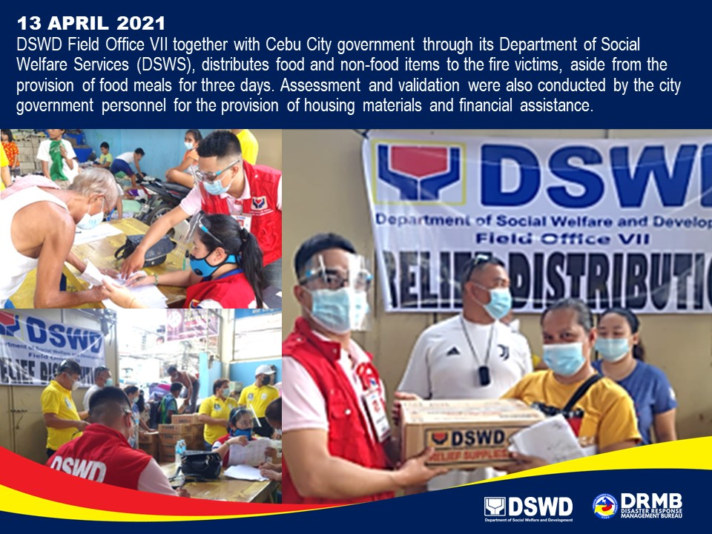
PHOTO DOCUMENTATION

