DSWD DROMIC Report #1 on Tropical Storm “Crising”
as of 14 May 2021, 6PM

Situation Overview
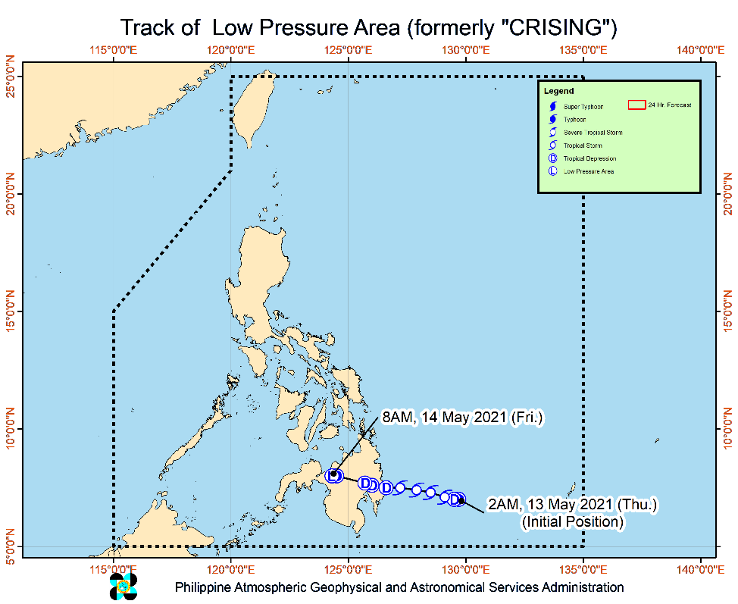
Issued at 11:00 AM, 14 May 2021, “CRISING” WEAKENS INTO A LOW PRESSURE AREA.

- "CRISING" weakened into a Low Pressure Area at 8:00 AM today. This LPA will continue moving westward or west northwestward and emerge over the Sulu Sea in the next 6 to 12 hours.
- All Tropical Cyclone Wind Signals are hereby lifted.
- Hazards affecting land areas
- Heavy Rainfall:
- Today, light to moderate with at times heavy rains may be experienced over Zamboanga Peninsula, Davao Oriental, Davao de Oro, Davao del Norte, Davao City, Davao del Sur, Cotabato, Maguindanao, Bukidnon, Lanao del Norte, Lanao del Sur, and Misamis Occidental.
- Under these conditions, isolated flash flooding and rain-induced landslides are possible during heavy or prolonged rainfall especially in areas that are highly or very highly susceptible to these hazards as identified in hazard maps. Adjacent or nearby areas may also experience flooding in the absence of such rainfall occurrence due to surface runoff or swelling of river channels.
- PAGASA Regional Services Divisions may issue local thunderstorm/rainfall advisories and heavy rainfall warnings while the Hydrometeorology Division and River Basin Flood Forecasting and Warning Centers may issue General Flood Advisories and Basin Flood Bulletins as appropriate.
At 10:00 AM today, the center of Low Pressure Area (formerly "CRISING") was estimated based on all available data in the vicinity of Piagapo, Lanao del Sur (08.0 °N, 124.2 °E )
Source: DOST-PAGASA Severe Weather Bulletin

- Status of Affected Families / Persons
A total of 178 families or 890 persons were affected in 5 barangays in Region XI (see Table 1).

Table 1. Number of Affected Families / Persons
REGION / PROVINCE / MUNICIPALITY |  | NUMBER OF AFFECTED
 |  | Barangays | Families | Persons
GRAND TOTAL |  | 5 | 178 | 890
REGION XI |  | 5 | 178 | 890
Davao Oriental |  | 5 | 178 | 890
 | Cateel | 4 | 78 | 390
 | City of Mati (capital) | 1 | 100 | 500
Note: Ongoing assessment and validation being conducted.
Source: DSWD-FO XI

- Status of Displaced Families / Persons Inside Evacuation Centers
There are 151 families or 755 persons currently taking temporary shelter in 3 evacuation centers in Region XI (see Table 2).

Table 2. Number of Displaced Families / Persons Inside Evacuation Centers
REGION / PROVINCE / MUNICIPALITY |  | NUMBER OF EVACUATION CENTERS (ECs) |  | NUMBER OF DISPLACED
 |  |  |  | INSIDE ECs
 |  |  |  | Families |  | Persons
 |  | CUM | NOW | CUM | NOW | CUM | NOW
GRAND TOTAL |  | 5 | 3 | 178 | 151 | 890 | 755
REGION XI |  | 5 | 3 | 178 | 151 | 890 | 755
Davao Oriental |  | 5 | 3 | 178 | 151 | 890 | 755
 | Cateel | 4 | 2 | 78 | 51 | 390 | 255
 | City of Mati (capital) | 1 | 1 | 100 | 100 | 500 | 500
Note: Ongoing assessment and validation being conducted.
Source: DSWD-FO XI

- Damaged Houses
There are 16 damaged houses; of which, one (1) was totally damaged and 15 were partially damaged (see Table 3).

Table 3. Number of Damaged Houses
REGION / PROVINCE / MUNICIPALITY |  | NO. OF DAMAGED HOUSES
 |  | Total | Totally | Partially
GRAND TOTAL |  | 16 | 1 | 15
REGION XI |  | 16 | 1 | 15
Davao Oriental |  | 16 | 1 | 15
 | Cateel | 16 | 1 | 15
Note: Ongoing assessment and validation being conducted.
Source: DSWD-FO XI

Situational Reports

DSWD-DRMB
DATE | SITUATIONS / ACTIONS UNDERTAKEN
14 May 2021 | - The Disaster Response Management Bureau (DRMB) is closely coordinating with the concerned field offices for significant disaster response updates  - All QRT members and emergency equipment are on standby and ready for deployment.  - DRMB participated in the Online Pre-Disaster Risk Assessment Meeting on Tropical Storm “Crising” on 13 May 2021 with other response cluster member agencies.
DSWD-FO MIMAROPA
DATE | SITUATIONS / ACTIONS UNDERTAKEN
14 May 2021 | - SWADT Offices are alerted to monitor daily local weather condition and related eventualities, and ensure provision of information to all concerned offices, divisions, sections, and units.  - On-call status of the expanded R/P/C/M QRTs together with special projects staff on a 24/7 basis for possible activation of Operation Center to respond in case any untoward incident and eventualities are reported.  - Standby logistical equipment and workforce through coordination with SWADT Offices and concerned LGUs on the management of stranded passengers, if any, in ports and terminals.  - Information and Communication Technology Management Unit (ICTMU) is on standby status to ensure robust communication system.  - DSWD-FO MIMAROPA is in close coordination with the Office of Civil Defense (OCD) and RDRRMC MIMAROPA for any updates for monitoring purposes and response mechanism for areas that will be affected.  - Continuous coordination with the Local SWDOs on the implementation of minimum health protocols related to Camp Coordination and Camp Management to prevent and mitigate the possible transmission of COVID19 and other illnesses during evacuation.

DSWD-FO VII
DATE | SITUATIONS / ACTIONS UNDERTAKEN
14 May 2021 | - Regional/Provincial/City/Municipal Quick Response Team is on standby alert and ready for mobilization for any assistance and augmentation support needed from the LGUs.  - City and Municipal Action Team and SWAD Offices were alerted and already requested to closely coordinate with their local counterparts and their respective LDRRMCs. Field staff requested to monitor AOR and provide reports and updates to the Regional ROMIC Focal for any impacts/effects.  - Continuous monitoring by the DSWD Regional DROMIC Focal for the latest weather updates from PAGASA and cascading the same for widest dissemination to Provincial /City/Municipal Action Teams.  - Regional Disaster Division is in closed coordination with OCD-7 and other members of the RDRRMC for any response mobilization activities/strategies. Regional QRT members on standby alert.  - Warehouses in the three island provinces are also on standby alert for any response activities.

DSWD-FO X
DATE | SITUATIONS / ACTIONS UNDERTAKEN
14 May 2021 | - DSWD-FO X has available operational vehicles/trucks and Telecommunications Equipment ready for deployment:  - 1 unit 6-Wheeler Isuzu Forward Aluminum Panel (12 Tons Loading Capacity)  - 1 unit 6-Wheeler Hiro Wingvan (8 tons Loading Capacity)  - 4 Samsung Grand Cellphones currently in use for the Regional Quick Response  Team for Covid-19 Response

DSWD-FO XI
DATE | SITUATIONS / ACTIONS UNDERTAKEN
14 May 2021 | - DSWD-FO XI attended the Pre-Disaster Risk Assessment (PDRA) Meeting and RDRRMC Meeting on 13 May 2021.  - DSWD-FO XI activated the QRT for possible deployment of personnel.  - DSWD-FO XI is continuously monitoring the areas affected by Tropical Storm “Crising.  - DSWD-FO XI is in constant coordination with the PDRRMO, CSWDO, PSWDO and SWADO for updates and for possible need for augmentation.

DSWD-FO CARAGA
DATE | SITUATIONS / ACTIONS UNDERTAKEN
13 May 2021 | - DSWD-FO CARAGA is continuously monitoring the weather updates.  - DSWD-FO CARAGA alerted the regional and provincial QRTs on the possible activation and deployment of teams  - Activation of DRMD Operation Center to monitor LGUs who could be affected of TS CRISING.  - DSWD-FO CARAGA QRTs are on standby for possible deployment.  - DSWD-FO CARAGA is continuously coordinating with SWADTLs and LSWDOs to monitor the situation in their respective area do responsibility.

*****
The Disaster Response Operations Monitoring and Information Center (DROMIC) of the DSWD-DRMB is closely monitoring the effects of Tropical Storm “Crising” and is coordinating with the concerned DSWD Field Offices for any significant updates.

Prepared by:

MARIE JOYCE G. RAFANAN

RODEL V. CABADDU
Releasing Officer

