DSWD DROMIC Report #1 on Tropical Storm “Dante”
as of 31 May 2021, 6PM

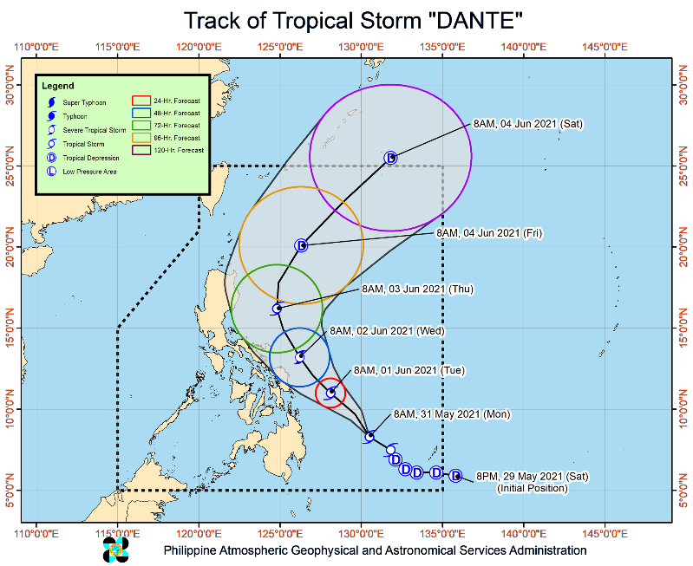
Situation Overview

Issued at 11:00 AM, 31 May 2021, TROPICAL STORM “DANTE” SLIGHTLY INTENSIFIES WHILE MOVING NORTHWESTWARD OVER THE PHILIPPINE SEA.

- Hazards affecting land areas
- Heavy Rainfall:
  - Today, light to moderate with at times heavy rains will be experienced over Caraga and Davao Region, SOCCSKSARGEN, Bukidnon, and Misamis Oriental due to the outer rainbands of "DANTE
  - Under these conditions, isolated to scattered flooding (including flash floods) and rain-induced landslides are possible, especially in areas that are highly or very highly susceptible to these hazards as identified in hazard maps. Adjacent or nearby areas may also experience flooding in the absence of such rainfall occurrence due to surface runoff or swelling of river channels
- Severe Wind:
  - The present track forecast shows that the hoisting of Tropical Cyclone Wind Signal (TCWS) over any land area in the country remains less likely. However, given the uncertainty in its track forecast, any further westward shift in the track forecast or expansion in its wind radius may lead to the hoisting of TCWS over the eastern portion of the country.
- TRACK AND INTENSITY OUTLOOK:
- On the forecast track, “DANTE” will likely remain over the Philippine Sea throughout the forecast period. The tropical storm is forecast to continue moving generally northwestward over the next two days. Afterwards, the tropical cyclone will turn north northwestward on Thursday and northeastward on Friday
- “DANTE” is forecast gradually intensify and may reach severe tropical storm category by Wednesday morning before weakening throughout the remainder of the forecast period.

At 10:00 AM today, the center of Tropical Storm “DANTE” was estimated based on all available data at 515 km East Northeast of Davao City or 445 km East of Hinatuan, Surigao del Sur (8.3°N, 130.4°E
Source: DOST-PAGASA Severe Weather Bulletin

- Status of Affected Families / Persons
A total of 160 families or 612 persons were affected in nine (9) barangays in Region XI (see Table 1).

Table 1. Number of Affected Families / Persons
REGION / PROVINCE / MUNICIPALITY |  | NUMBER OF AFFECTED
 |  | Barangays | Families | Persons
GRAND TOTAL |  | 9 | 160 | 612
REGION XI |  | 9 | 160 | 612
Davao del Sur |  | 9 | 160 | 612
 | Davao City | 9 | 160 | 612
Note: Ongoing assessment and validation being conducted.
Source: DSWD-FO XI

- Status of Displaced Families / Persons Inside Evacuation Centers
There are 158 families or 604 persons currently taking temporary shelter in 10 evacuation centers in Region XI (see Table 2).

Table 2. Number of Displaced Families / Persons Inside Evacuation Centers
REGION / PROVINCE / MUNICIPALITY |  | NUMBER OF EVACUATION CENTERS (ECs) |  | NUMBER OF DISPLACED
 |  |  |  | INSIDE ECs
 |  |  |  | Families |  | Persons
 |  | CUM | NOW | CUM | NOW | CUM | NOW
GRAND TOTAL |  | 10 | 10 | 158 | 158 | 604 | 604
REGION XI |  | 10 | 10 | 158 | 158 | 604 | 604
Davao del Sur |  | 10 | 10 | 158 | 158 | 604 | 604
 | Davao City | 10 | 10 | 158 | 158 | 604 | 604
Note: Ongoing assessment and validation being conducted.
Source: DSWD-FO XI

Situational Reports

DSWD-DRMB
DATE | SITUATIONS / ACTIONS UNDERTAKEN
31 May 2021 | - The Disaster Response Management Bureau (DRMB) is closely coordinating with the concerned field offices for significant reports on the status of affected families, assistance, and relief efforts.

DSWD-FO XI
DATE | SITUATIONS / ACTIONS UNDERTAKEN
31 May 2021 | - DSWD-FO XI is continuously coordinating with CDRRMO and CSWDO for any significant updates.

*****
The Disaster Response Operations Monitoring and Information Center (DROMIC) of the DSWD-DRMB is closely monitoring the effects of Typhoon “Dante” and is coordinating with the concerned DSWD Field Offices for any significant updates.

Prepared by: Releasing Officer:
MARIEL B. FERRARIZ RODEL V. CABADDU

