DSWD DROMIC Report #1 on the Fire Incident
in Brgy. Rio Tuba, Bataraza, Palawan
as of 01 May 2021, 6PM

SUMMARY

On 28 April 2021 at 5:30 PM, a fire incident occurred in Sitio Marabahay, Brgy. Rio Tuba, Bataraza, Palawan. The fire was put under control at 8 PM and declared out at 9 PM.
Source: DSWD-FO MIMAROPA

- Status of Affected Families / Persons
A total of 42 families or 160 persons were affected by the fire incident in Brgy. Rio Tuba, Bataraza, Palawan (see Table 1).

Table 1. Number of Affected Families / Persons
REGION / PROVINCE / MUNICIPALITY |  | NUMBER OF AFFECTED
 |  | Barangays | Families | Persons
GRAND TOTAL |  | 1 | 42 | 160
MIMAROPA |  | 1 | 42 | 160
Palawan |  | 1 | 42 | 160
 | Bataraza | 1 | 42 | 160
Note: Ongoing assessment and validation being conducted.
Source: DSWD-FO MIMAROPA

- Status of Displaced Families Inside Evacuation Center
There are 42 families or 160 persons currently taking temporary shelter at Rio Tuba National High School (see Table 2).

Table 2. Number of Displaced Families / Persons Inside Evacuation Center
REGION / PROVINCE / MUNICIPALITY |  | NUMBER OF EVACUATION CENTERS (ECs) |  | NUMBER OF DISPLACED
 |  |  |  | INSIDE ECs
 |  |  |  | Families |  | Persons
 |  | CUM | NOW | CUM | NOW | CUM | NOW
GRAND TOTAL |  | 1 | 1 | 42 | 42 | 160 | 160
REGION MIMAROPA |  | 1 | 1 | 42 | 42 | 160 | 160
Palawan |  | 1 | 1 | 42 | 42 | 160 | 160
 | Bataraza | 1 | 1 | 42 | 42 | 160 | 160
Note: Ongoing assessment and validation being conducted.
Source: DSWD-FO MIMAROPA

- Damaged Houses
A total of 33 houses were totally damaged by the fire (see Table 3).

Table 3. Number of Damaged Houses
REGION / PROVINCE / MUNICIPALITY |  | NO. OF DAMAGED HOUSES
 |  | Total | Totally | Partially
GRAND TOTAL |  | 33 | 33 | -
REGION MIMAROPA |  | 33 | 33 | -
Palawan |  | 33 | 33 | -
 | Bataraza | 33 | 33 | -
Note: Ongoing assessment and validation being conducted.
Source: DSWD-FO MIMAROPA

- Assistance Provided
A total of ₱146,694.00 worth of assistance was provided by DSWD to the affected families (see Table 4).

Table 4. Cost of Assistance Provided to the Affected Families / Persons
REGION / PROVINCE / MUNICIPALITY |  | COST OF ASSISTANCE
 |  | DSWD | LGU | NGOs | OTHERS | GRAND TOTAL
GRAND TOTAL |  | 146,694.00 | - | - | - | 146,694.00
REGION MIMAROPA |  | 146,694.00 | - | - | - | 146,694.00
Palawan |  | 146,694.00 | - | - | - | 146,694.00
 | Bataraza | 146,694.00 | - | - | - | 146,694.00
Source: DSWD-FO MIMAROPA

SITUATIONAL REPORT
DSWD-DRMB
DATE | SITUATIONS / ACTIONS UNDERTAKEN
01 May 2021 | - The Disaster Response Operations Monitoring and Information Center (DROMIC) of the DSWD-DRMB is closely coordinating with DSWD-FO MIMAROPA for significant reports on the status of affected families, assistance, and relief efforts.

DSWD-FO MIMAROPA
DATE | SITUATIONS / ACTIONS UNDERTAKEN
01 May 2021 | - DSWD-FO MIMAROPA provided a total of ₱146,694.00 worth of relief assistance which consists of 42 family food packs, 42 sleeping kits and 320 pieces of malong to the affected families.  - The MSWDO started the provision of Psychosocial Support to lessen the anxieties of the beneficiaries brought by the said incident.  - The MSWDO continuously assesses the other needs of the affected families.  - In compliance with minimum health standards, DSWD-FO MIMAROPA through the SWADT Palawan and LGU of Bataraza continuously monitor the situation of the displaced families to ensure protocols are imposed to mitigate the possible transmission of COVID-19 inside the evacuation center.

*****
The Disaster Response Operations Monitoring and Information Center (DROMIC) of the DSWD-DRMB is closely coordinating with DSWD-FO MIMAROPA for any significant disaster response updates.

Prepared by:

MARIE JOYCE G. RAFANAN

MARC LEO L. BUTAC
Releasing Officer

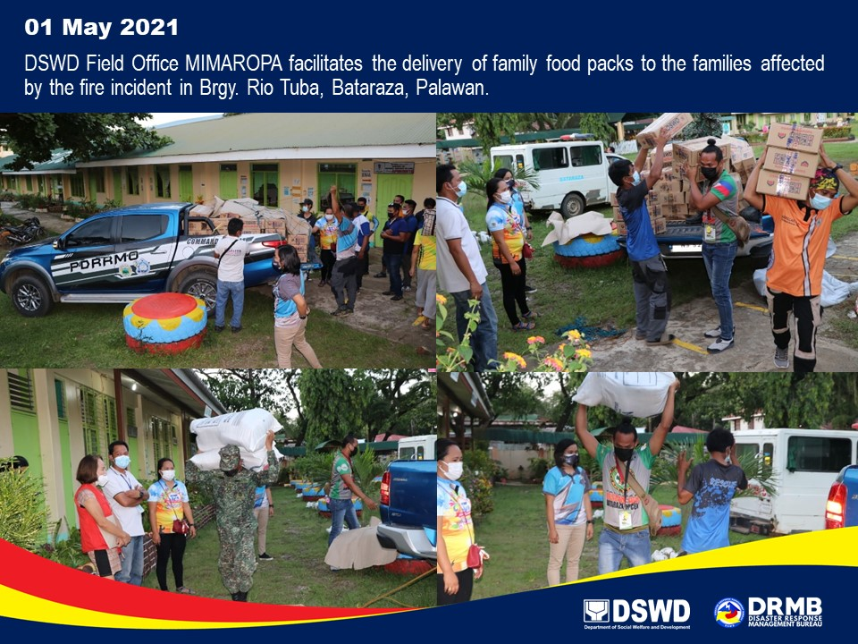
PHOTO DOCUMENTATION

