DSWD DROMIC Report #2 on Tropical Storm “Dante”
as of 01 June 2021, 6PM

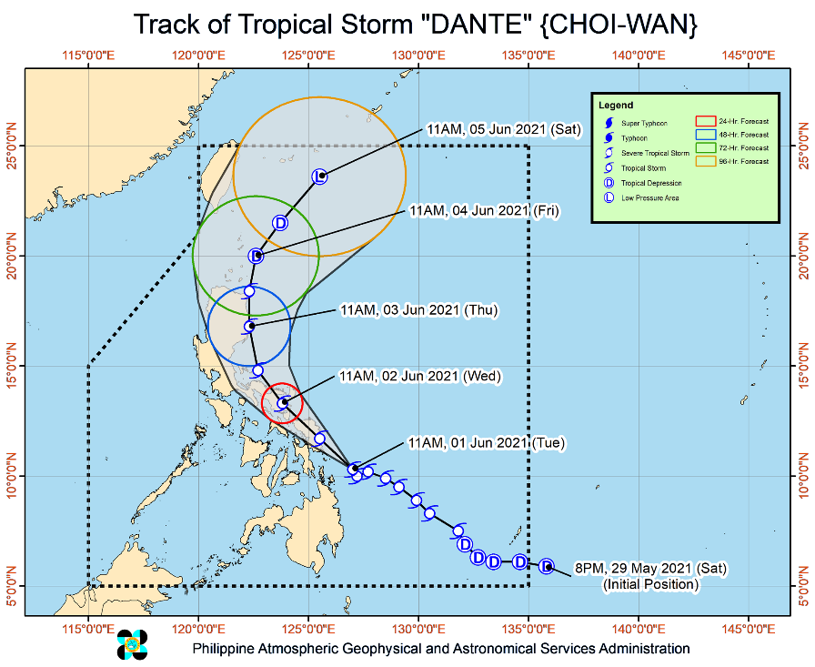
Situation Overview

Issued at 2:00 PM, 01 June 2021, TROPICAL STORM “DANTE” IS NOW MOVING NORTH NORTHWESTWARD TOWARDS THE SOUTHERN

PORTION OF EASTERN VISAYAS

HAZARDS AFFECTING LAND AREAS
- Heavy Rainfall:
Today through tomorrow morning, Tropical Storm “DANTE” is forecast to bring:
  - Moderate to heavy with at times intense rains over Surigao del Norte, Dinagat Islands, Leyte, Southern Leyte, Biliran, Samar, and Eastern Samar
  - Moderate to heavy rains over Surigao del Sur, Agusan del Norte, Northern Samar, Bohol, the northern portion of Cebu including Bantayan and Camotes Islands, Sorsogon, and Masbate.
  - Light to moderate with at times heavy rains are also likely over Catanduanes, Albay, Camarines Sur, Misamis Oriental, Agusan del Sur, Camiguin, Bukidnon, Davao Region, and SOCCSKSARGEN, and the rest of Central Visayas.
  - Under these conditions and considering antecedent rainfall, scattered flooding (including flash floods) and raininduced landslides are highly likely, especially in areas with high or very high susceptibility to these hazards as identified in hazard maps. Adjacent or nearby areas may also experience flooding in the absence of such rainfall occurrence due to surface runoff or swelling of river channels.
- Severe Wind:
  - The tropical storm will bring strong winds to gale-force winds over the areas where Tropical Cyclone Wind Signal #2 is hoisted. Such conditions may bring generally light to moderate damage to structures and vegetation.
  - Strong winds (strong breeze to near gale) which may cause generally very light damage to structures and vegetation will be experienced in areas where TCWS #1 is in effect.

HAZARDS AFFECTING COASTAL WATERS
- In the next 24 hours, rough to very rough seas will be experienced over the seaboards of areas where TCWS #2 is in effect, and the eastern seaboard of Caraga (2.5 to 4.5 m). Sea travel is risky for small seacrafts over these waters. Mariners without the proper experience should immediately seek safe harbor.
- Moderate to rough seas (1.2 to 3.0 m) are also expected over the eastern seaboard of Davao Oriental and the remaining seaboards of areas where TCWS #1 is in effect. Mariners of small seacrafts are advised to take precautionary measures when venturing out to sea. Inexperienced mariners should avoid navigating in these conditions.

TRACK AND INTENSITY OUTLOOK:

- “DANTE” will continue moving generally west northwestward or northwestward until tomorrow evening. On the forecast track, the center of the tropical storm is forecast to make its initial landfall over Eastern Samar or Leyte between tonight or tomorrow early morning. This tropical storm is forecast to maintain its strength prior to landfall. “DANTE” may weaken into a tropical depression on Friday and to Low Pressure Area on Saturday.

At 1:00 PM today, the center of Tropical Storm “DANTE” (CHOI-WAN) was estimated based on all available data at 220 km East Northeast of Maasin City, Southern Leyte or 125 km East Southeast of Guiuan, Eastern Samar (10.6°N, 126.8°E)
Source: DOST-PAGASA Severe Weather Bulletin

- Status of Affected Families / Persons
A total of 566 families or 2,642 persons were affected in 18 barangays in Regions XI and XII (see Table 1).

Table 1. Number of Affected Families / Persons
REGION / PROVINCE / MUNICIPALITY |  | NUMBER OF AFFECTED
 |  | Barangays | Families | Persons
GRAND TOTAL |  | 18 | 566 | 2,642
REGION XI |  | 9 | 160 | 612
Davao del Sur |  | 9 | 160 | 612
 | Davao City | 9 | 160 | 612
REGION XII |  | 9 | 406 | 2,030
South Cotabato |  | 9 | 406 | 2,030
 | Banga | 9 | 406 | 2,030
Note: Ongoing assessment and validation being conducted.
Source: DSWD-FOs XI and XII

- Status of Displaced Families / Persons Inside Evacuation Centers
A total of 158 families or 604 persons took temporary shelter in 10 evacuation centers in Region XI (see Table 2).

Table 2. Number of Displaced Families / Persons Inside Evacuation Centers
REGION / PROVINCE / MUNICIPALITY |  | NUMBER OF EVACUATION CENTERS (ECs) |  | NUMBER OF DISPLACED
 |  |  |  | INSIDE ECs
 |  |  |  | Families |  | Persons
 |  | CUM | NOW | CUM | NOW | CUM | NOW
GRAND TOTAL |  | 10 | - | 158 | - | 604 | -
REGION XI |  | 10 | - | 158 | - | 604 | -
Davao del Sur |  | 10 | - | 158 | - | 604 | -
 | Davao City | 10 | - | 158 | - | 604 | -
Note: Ongoing assessment and validation being conducted.
Source: DSWD-FO XI

- Assistance Provided
A total of ₱537,714.00 worth of assistance was provided to the affected families; of which, ₱334,714.00 from DSWD and ₱203,000.00 from LGU (see Table 3).

Table 3. Cost of Assistance Provided to Affected Families / Persons
REGION / PROVINCE / MUNICIPALITY |  | COST OF ASSISTANCE
 |  | DSWD | LGU | NGOs | OTHERS | GRAND TOTAL
GRAND TOTAL |  | 334,714.00 | 203,000.00 | - | - | 537,714.00
REGION XII |  | 334,714.00 | 203,000.00 | - | - | 537,714.00
South Cotabato |  | 334,714.00 | 203,000.00 | - | - | 537,714.00
 | Banga | 334,714.00 | 203,000.00 | - | - | 537,714.00
Source: DSWD-FO NCR

Situational Reports

DSWD-DRMB
DATE | SITUATIONS / ACTIONS UNDERTAKEN
01 June 2021 | - The Disaster Response Management Bureau (DRMB) is closely coordinating with the concerned field offices for significant reports on the status of affected families, assistance, and relief efforts.

DSWD-FO CAR
DATE | SITUATIONS / ACTIONS UNDERTAKEN
31 May 2021 | - DSWD-FO CAR is on standby for the possible effects of the weather disturbance.  - DSWD-FO CAR is closely monitoring the weather updates and information.  - DSWD-FO CAR DROMIC Preparedness for Response Report on the Possible Effects of TS DANTE.  - DSWD-FO CAR ensures availability of food and non-food items for resource augmentation as the need arises.  - DRR Focal persons in close coordination with LDRRMOs and MSWDOs for weather reports and updates.

DSWD-FO V
DATE | SITUATIONS / ACTIONS UNDERTAKEN
01 June 2021 | - DSWD-FO V shall continuously monitor weather updates and information.  - Resource Operation Section ensures the availability of family food packs and non-food items, as need arises.  - DSWD-FO V Quick Response Team (QRTs) are alerted.  - PAT and MAT members in the six (6) provinces are activated and instructed to coordinate with the P/MDRRMOs and C/MSWDOs for weather reports and updates.

DSWD-FO MIMAROPA
DATE | SITUATIONS / ACTIONS UNDERTAKEN
31 May 2021 | - SWADT Offices are alerted to monitor daily local weather condition and related eventualities, and ensure provision of information to all concerned offices, divisions, sections, and units.  - On-call status of the expanded R/P/C/M QRTs together with special projects staff on a 24/7 basis for possible activation of Operation Center to respond in case any untoward incident and eventualities are reported.  - Standby logistical equipment and workforce through coordination with SWADT Offices and concerned LGUs on the management of stranded passengers, if any, in ports and terminals.  - Information and Communication Technology Management Unit (ICTMU) is on standby status to ensure robust communication system.  - Close coordination with the Office of Civil Defense (OCD) and RDRRMC MIMAROPA for any updates for monitoring purposes and response mechanism for areas that will be affected.  - Continuous coordination with the Local SWDOs on the implementation of minimum health protocols related to Camp Coordination and Camp Management to prevent and mitigate the possible transmission of COVID19 and other illnesses during evacuation.

DSWD-FO VII
DATE | SITUATIONS / ACTIONS UNDERTAKEN
01 June 2021 | - Regional/Provincial/City/Municipal Quick Response Team is on standby alert and ready for mobilization for any assistance and augmentation support needed from the LGUs.  - City and Municipal Action Team and SWAD Offices were alerted and already requested to closely coordinate with their local counterparts and their respective LDRRMCs. Field staff requested to monitor AOR and provide reports and updates to the Regional DROMIC Focal for any impacts/effects.  - Continuous monitoring by the DSWD Regional DROMIC Focal for the latest weather updates from PAGASA and cascading the same for widest dissemination to Provincial /City/Municipal Action Teams.  - Regional Disaster Division is in close coordination with OCD-7 and other members of the RDRRMC for any response mobilization activities/strategies. Regional QRT members on standby alert.  - Warehouses in the three island provinces are also on standby alert for any response activities. Repacking of goods is continuously being done to replenish stocks and maintain the needed quantity of stockpile of goods. Volunteers from the AFP including DSWD Regional staff and personnel came to assist the Labangaon warehouse.  - Participation/Presentation of DSWD-7 Preparedness Measures during the Emergency Response and Preparedness meeting convened by OCD-7 at 2:00 pm today.  - As per Memo No. 11 s2021, the RDRRMC-7 is now on Blue Alert Status.

DSWD-FO VIII
DATE | SITUATIONS / ACTIONS UNDERTAKEN
01 June 2021 | - DSWD-FO VIII prepositioned Family Food Packs (FFPs) in Samar Island, Biliran and Southern Leyte which can be distributed immediately by the P/C/MATs to Local Government Units that need augmentation support.  - DSWD-FO VIII communicated SWAD Teams and City/Municipal Actions Teams to be alerted on the weather disturbance.  - DSWD-FO VIII monitored the weather situation through watching the live updates of PAGASA regarding the weather disturbances.  - DSWD-FO VIII activated QRT of DSWD in preparation for the possible impact of the tropical storm.  - SFO Northern Samar attended their PDRA Meeting last May 31, 2021.  - Coordination with DRMD PDOs regarding updates on the weather status in different provinces of Eastern Visayas.  - Continuous reconditioning of good and repacking of FFPs in preparation for TS Dante.  - Established DROMIC Tool for Tropical Storm Dante in the live spreadsheet for monitoring and reporting.

DSWD-FO X
DATE | SITUATIONS / ACTIONS UNDERTAKEN
01 June 2021 | - DSWD-FO X continues to monitor the present weather condition within the Philippine Area of Responsibility and is in close coordination and monitoring with our SWADTL in each Provinces and LDRRMOs/MSWDOs for more information and updates.

DSWD-FO XI
DATE | SITUATIONS / ACTIONS UNDERTAKEN
31 May 2021 | - DSWD-FO XI attended the PDRA Meeting on 31 May 2021.  - DSWD-FO XI conducted ocular visit to the evacuation centers.  - DSWD-FO XI is continuously coordinating with CDRRMO and CSWDO for any significant updates.

DSWD-FO XII
DATE | SITUATIONS / ACTIONS UNDERTAKEN
31 May 2021 | - DSWD-FO XII released 500 family food packs, 146 malong, and 146 mats for the affected families in LGU of Banga.  - DSWD-FO XII DRMD staff monitored the incident through phone call in close coordination with the MSWDO of Banga for possible Technical Assistance and Resource Augmentation.

DSWD-FO Caraga
DATE | SITUATIONS / ACTIONS UNDERTAKEN
01 June 2021 | - DSWD-FO Caraga alerted the regional and provincial QRTs on the activation and deployment of teams.  - DSWD-FO Caraga has 2 smartphones available to be utilized for EOC operation.  - DSWD-FO Caraga has 1 wingvan and 1 disaster vehicle to be used for logistical support.  - DSWD-FO Caraga is continuously coordinating with SWADTLs and LSWDOs to monitor the situation in their respective area of responsibility.

*****
The Disaster Response Operations Monitoring and Information Center (DROMIC) of the DSWD-DRMB is closely monitoring the effects of Tropical Storm “Dante” and is coordinating with the concerned DSWD Field Offices for any significant updates.

Prepared by:
MARIEL B. FERRARIZ
MARIE JOYCE G. RAFANAN

LESLIE R. JAWILI
Releasing Officer

