DSWD DROMIC Terminal Report on the Fire Incident
in Brgy. Rio Tuba, Bataraza, Palawan
14 May 2021, 6PM

This is the final report on the fire incident that occurred in Sitio Marabahay, Brgy. Rio Tuba, Bataraza, Palawan on 28 April 2021 at 5:30 PM. The fire was put under control at 8 PM and declared out at 9 PM.
Source: DSWD-FO MIMAROPA

SUMMARY

- Status of Affected Families / Persons
A total of 43 families or 167 persons were affected by the fire incident in Brgy. Rio Tuba, Bataraza, Palawan (see Table 1).

Table 1. Number of Affected Families / Persons
REGION / PROVINCE / MUNICIPALITY |  | NUMBER OF AFFECTED
 |  | Barangays | Families | Persons
GRAND TOTAL |  | 1 | 43 | 167
MIMAROPA |  | 1 | 43 | 167
Palawan |  | 1 | 43 | 167
 | Bataraza | 1 | 43 | 167
Source: DSWD-FO MIMAROPA

- Status of Displaced Families Inside Evacuation Center
There are 43 families or 167 persons currently taking temporary shelter at the Rio Tuba National High School (see Table 2).

Table 2. Number of Displaced Families / Persons Inside Evacuation Center
REGION / PROVINCE / MUNICIPALITY |  | NUMBER OF EVACUATION CENTERS (ECs) |  | NUMBER OF DISPLACED
 |  |  |  | INSIDE ECs
 |  |  |  | Families |  | Persons
 |  | CUM | NOW | CUM | NOW | CUM | NOW
GRAND TOTAL |  | 1 | 1 | 43 | 43 | 167 | 167
REGION MIMAROPA |  | 1 | 1 | 43 | 43 | 167 | 167
Palawan |  | 1 | 1 | 43 | 43 | 167 | 167
 | Bataraza | 1 | 1 | 43 | 43 | 167 | 167
Note: The LGU will continuously provide the needs of the affected families staying in the evacuation center.
Source: DSWD-FO MIMAROPA

- Damaged Houses
A total of 34 houses were totally damaged by the fire (see Table 3).

Table 3. Number of Damaged Houses
REGION / PROVINCE / MUNICIPALITY |  | NO. OF DAMAGED HOUSES
 |  | Total | Totally | Partially
GRAND TOTAL |  | 34 | 34 | -
REGION MIMAROPA |  | 34 | 34 | -
Palawan |  | 34 | 34 | -
 | Bataraza | 34 | 34 | -
Source: DSWD-FO MIMAROPA

- Assistance Provided
A total of ₱905,901.00 worth of assistance was provided to the affected families; of which, ₱147,901.00 from DSWD, ₱88,100.00 from LGU, ₱171,100.00 from NGOs and ₱498,800.00 from other Partners (see Table 4).

Table 4. Cost of Assistance Provided to the Affected Families / Persons
REGION / PROVINCE / MUNICIPALITY |  | COST OF ASSISTANCE
 |  | DSWD | LGU | NGOs | OTHERS | GRAND TOTAL
GRAND TOTAL |  | 147,901.00 | 88,100.00 | 171,100.00 | 498,800.00 | 905,901.00
REGION MIMAROPA |  | 147,901.00 | 88,100.00 | 171,100.00 | 498,800.00 | 905,901.00
Palawan |  | 147,901.00 | 88,100.00 | 171,100.00 | 498,800.00 | 905,901.00
 | Bataraza | 147,901.00 | 88,100.00 | 171,100.00 | 498,800.00 | 905,901.00
Source: DSWD-FO MIMAROPA

SITUATIONAL REPORT

DSWD-FO MIMAROPA
DATE | SITUATIONS / ACTIONS UNDERTAKEN
11 May 2021 | - DSWD-FO MIMAROPA submitted their terminal report.  - DSWD-FO MIMAROPA provided a total of ₱147,901.00 worth of relief assistance to the affected families which consists of 43 family food packs, 43 sleeping kits and 320 pieces of malong.  - DSWD-FO MIMAROPA through its AICS provided a total of ₱279,500.00 financial assistance to the affected families.

*****
The Disaster Response Operations Monitoring and Information Center (DROMIC) of DSWD-DRMB continues to closely coordinate with DSWD-FO MIMAROPA for any request of Technical Assistance and Resource Augmentation (TARA).

Prepared by:

MARIE JOYCE G. RAFANAN

MARC LEO L. BUTAC
Releasing Officer

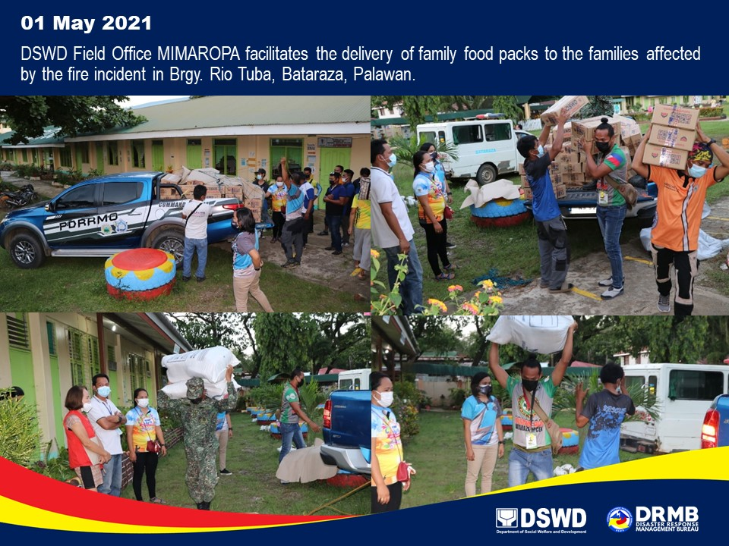
PHOTO DOCUMENTATION

