DSWD DROMIC Report #1 on the
Mw 5.7 Earthquake Incident in Kadingilan, Bukidnon
as of 25 June 2021, 6PM

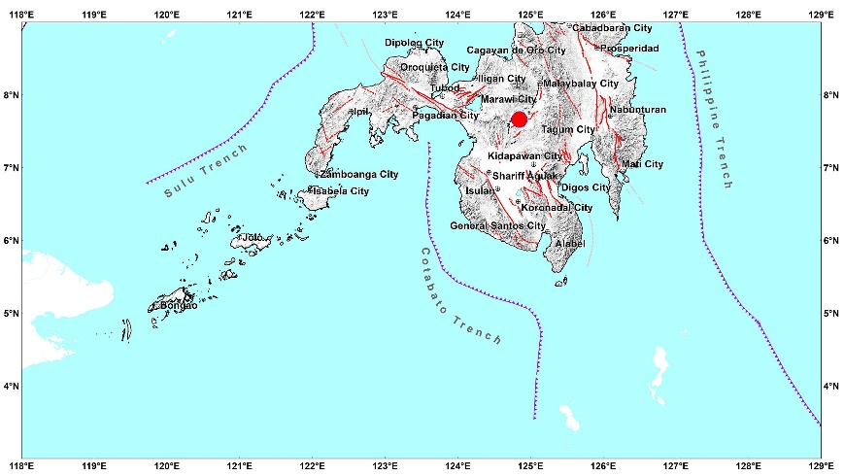

Situation Overview

On 14 June 2021 at 10:38 PM, a 5.7 magnitude earthquake jolted the municipality of Kadingilan, Bukidnon (07.66°N, 124.85°E - 010 km N 44° W) with a tectonic origin and a depth of focus of 12 km. The earthquake was also felt in the neighboring municipalities of Bukidnon.

Date/Time: | 14 Jun 2021 - 10:38:40 PM
Reported Intensities: | Intensity VI- Kadingilan and Pangantucan, Bukidnon  Intensity V - Damulog and Don Carlos, Bukidnon; Wao, Lanao del Sur  Intensity IV - Kalilangan, Kitaotao, Kibawe, Maramag, Quezon, Libona and Talakag, Bukidnon; Cotabato City; Marawi City; Marantao, Lanao del Sur; City of Iligan; Cagayan de Oro City; Banisilan and Pikit, Cotabato  Intensity III - Malaybalay, Baungon, Cabanglasan, Impasug-ong, Malitbog, San Fernando, Lantapan, and Manolo Fortich, Bukidnon; City of El Salvador, Misamis Oriental; Pagadian City; Davao City; Tagum City; Pigcawayan, Cotabato  Intensity II - Arakan and M'lang, Cotabato; Kidapawan City; Dipolog City; Datu Piang, Maguindanao; City of Bayugan, Agusan del Sur; Opol, Misamis Oriental; Monkayo, Davao de Oro  Intensity I- Mambajao, Camiguin; Butuan City
Expecting Damage: | YES
Expecting Aftershocks: | YES
Source: DOST-PHIVOLCS Earthquake Bulletin

- Status of Affected Families / Persons
There were 962 families or 4,810 persons affected by the earthquake incident in 28 barangays in Region X see Table 1).

Table 1. Number of Affected Families / Persons
REGION / PROVINCE / MUNICIPALITY |  | NUMBER OF AFFECTED
 |  | Barangays | Families | Persons
GRAND TOTAL |  | 28 | 962 | 4,810
REGION X |  | 28 | 962 | 4,810
Bukidnon |  | 28 | 962 | 4,810
 | Don Carlos | 15 | 681 | 3,405
 | Kadingilan | 5 | 86 | 430
 | Pangantucan | 8 | 195 | 975
Note: Ongoing assessment and validation being conducted.
Source: DSWD-FO X
- Damaged Houses
There were 962 damaged houses; of which, 22 were totally damaged and 940 were partially damaged (see Table 2).

Table 2. Number of Damaged Houses
REGION / PROVINCE / MUNICIPALITY |  | NO. OF DAMAGED HOUSES
 |  | Total | Totally | Partially
GRAND TOTAL |  | 962 | 22 | 940
REGION X |  | 962 | 22 | 940
Bukidnon |  | 962 | 22 | 940
 | Don Carlos | 681 | 22 | 659
 | Kadingilan | 86 | - | 86
 | Pangantucan | 195 | - | 195
Note: Ongoing assessment and validation being conducted.
Source: DSWD-FO X

- Assistance Provided
A total of ₱129,000.00 worth of assistance was provided by LGU to the affected families (see Table 3).

Table 3. Cost of Assistance Provided to Affected Families / Persons
REGION / PROVINCE / MUNICIPALITY |  | COST OF ASSISTANCE
 |  | DSWD | LGU | NGOs | OTHERS | GRAND TOTAL
GRAND TOTAL |  | - | 129,000.00 | - | - | 129,000.00
REGION X |  | - | 129,000.00 | - | - | 129,000.00
Bukidnon |  | - | 129,000.00 | - | - | 129,000.00
 | Kadingilan | - | 129,000.00 | - | - | 129,000.00
Source: DSWD-FO X

Situational Reports

DSWD-DRMB
DATE | SITUATIONS / ACTIONS UNDERTAKEN
25 June 2021 | - The Disaster Response Operations Monitoring and Information Center (DROMIC) of the DSWD-DRMB is closely coordinating with DSWD-FO X for significant reports on the status of affected families, assistance, and relief efforts.

DSWD-FO X
DATE | SITUATIONS / ACTIONS UNDERTAKEN
24 June 2021 | - DSWD-FO X through the Disaster Response Management Division is continuously coordinating with the LGUs affected for possible augmentation assistance needed by the affected families.

*****
The Disaster Response Operations Monitoring and Information Center (DROMIC) of the DSWD-DRMB is closely coordinating with DSWD-FO X for any significant updates and actions taken relative to the Mw 5.7 Earthquake incident in Kadingilan, Bukidnon.

Prepared by:

MARIE JOYCE G. RAFANAN

LESLIE R. JAWILI
Releasing Officer

