DSWD DROMIC Report #3 on Tropical Storm “Dante”
as of 02 June 2021, 6PM

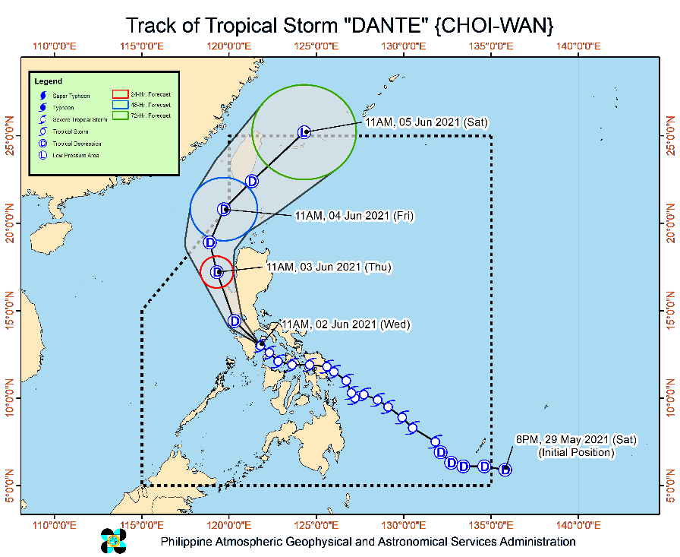
Situation Overview

Issued at 2:00 PM, 02 June 2021, TROPICAL STORM “DANTE” CONTINUES TO MOVE NORTHWESTWARD TOWARDS THE SOUTHWESTERN

PORTION OF BATANGAS-NORTHEASTERN PORTION OF ORIENTAL MINDORO.

HAZARDS AFFECTING LAND AREAS
- Heavy Rainfall:
Today through tomorrow morning, Tropical Storm “DANTE” is forecast to bring:
  - Moderate to heavy with at times intense rains over CALABARZON, Romblon, Marinduque, Occidental Mindoro, Oriental Mindoro, Aklan, Antique, Capiz, Bataan, Zambales, and Pangasinan.
  - Moderate to heavy rains over the rest of Central Luzon, Metro Manila, the northern portion of Palawan including Calamian, Cuyo, and Cagayancillo Islands, Iloilo, and Guimaras.
  - Light to moderate with at times heavy rains over Bicol Region, Benguet, Nueva Vizcaya, Quirino, Negros Occidental, and the rest of MIMAROPA.
  - Under these conditions and considering antecedent rainfall, scattered to widespread flooding (including flash floods) and rain-induced landslides are expected, especially in areas with high or very high susceptibility to these hazards as identified in hazard maps. Adjacent or nearby areas may also experience flooding in the absence of such rainfall occurrence due to surface runoff or swelling of river channels.
- Severe Winds:
  - Strong winds to gale-force winds are possible over the areas where Tropical Cyclone Wind Signal #2 is hoisted. Such conditions may bring generally light to moderate damage to structures and vegetation.
  - Strong winds (strong breeze to near gale) which may cause generally very light damage to structures and vegetation
may be experienced in areas where TCWS #1 is in effect.

HAZARDS AFFECTING COASTAL WATERS
- In the next 24 hours, rough to very rough seas (2.5 to 4.0 m) will be experienced over the seaboards of areas where TCWS #2 is in effect and the seaboards of Bicol Region. Sea travel is risky for small seacrafts over these waters. Mariners without the proper experience should immediately seek safe harbor.
- Moderate to rough seas (1.2 to 3.0 m) over the seaboard of areas where TCWS #1 is in effect, the remaining seaboards of Visayas, the seaboard of Caraga, the northern seaboard of Northern Mindanao, and the eastern seaboard of Davao Oriental. Mariners of small seacrafts are advised to take precautionary measures when venturing out to sea. Inexperienced mariners should avoid navigating in these conditions.
TRACK AND INTENSITY OUTLOOK:
- “DANTE” will continue moving generally northwestward and may pass near or in the vicinity of Oriental Mindoro or the southwestern portion of Batangas before turning north northwestward making another landfall over Bataan tonight. It will then traverse or pass near Zambales and Pangasinan tomorrow morning.
- This tropical storm is forecast to maintain its strength until it makes landfall over mainland Luzon. Further land interaction with the rugged terrain of mainland Luzon will weaken “DANTE” into a tropical depression tonight or tomorrow morning.

At 1:00 PM today, the center of Tropical Storm “DANTE” (CHOI-WAN) was estimated based on all available data over the over the coastal waters of Pola, Oriental Mindoro or 45 km East Southeast of Calapan City, Oriental Mindoro (13.2°N, 121.5°E).
Source: DOST-PAGASA Severe Weather Bulletin

- Status of Affected Families / Persons
A total of 9,831 families or 45,456 persons were affected in 89 barangays in Regions XI, XII and Caraga (see Table 1).

Table 1. Number of Affected Families / Persons
REGION / PROVINCE / MUNICIPALITY |  | NUMBER OF AFFECTED
 |  | Barangays | Families | Persons
GRAND TOTAL |  | 89 | 9,831 | 45,456
REGION XI |  | 23 | 6,225 | 30,828
Davao de Oro |  | 7 | 94 | 361
 | Compostela | 3 | 11 | 48
 | Maco | 1 | 5 | 25
 | Mawab | 1 | 1 | 5
 | Nabunturan (capital) | 2 | 77 | 283
Davao del Norte |  | 7 | 5,971 | 29,855
 | Carmen | 7 | 5,971 | 29,855
Davao del Sur |  | 9 | 160 | 612
 | Davao City | 9 | 160 | 612
REGION XII |  | 9 | 406 | 2,030
South Cotabato |  | 9 | 406 | 2,030
 | Banga | 9 | 406 | 2,030
CARAGA |  | 57 | 3,200 | 12,598
Agusan del Norte |  | 36 | 2,394 | 9,555
 | Butuan City (capital) | 9 | 1,261 | 4,530
 | City of Cabadbaran | 11 | 499 | 2,511
 | Jabonga | 10 | 437 | 1,588
 | Tubay | 6 | 197 | 926
Dinagat Island |  | 5 | 116 | 324
 | San Jose (capital) | 5 | 116 | 324
Surigao del Norte |  | 16 | 690 | 2,719
 | Bacuag | 4 | 233 | 820
 | Mainit | 6 | 236 | 1,137
 | Malimono | 5 | 205 | 721
 | Santa Monica (Sapao) | 1 | 16 | 41
Note: Ongoing assessment and validation being conducted.
Source: DSWD-FOs XI, XII and Caraga

- Status of Displaced Families / Persons
- Inside Evacuation Centers
There are 3,090 families or 12,071 persons currently taking temporary shelter in 94 evacuation centers in Region XI and Caraga (see Table 2).

Table 2. Number of Displaced Families / Persons Inside Evacuation Centers
REGION / PROVINCE / MUNICIPALITY |  | NUMBER OF EVACUATION CENTERS (ECs) |  | NUMBER OF DISPLACED
 |  |  |  | INSIDE ECs
 |  |  |  | Families |  | Persons
 |  | CUM | NOW | CUM | NOW | CUM | NOW
GRAND TOTAL |  | 104 | 94 | 3,248 | 3,090 | 12,675 | 12,071
REGION XI |  | 14 | 4 | 269 | 111 | 1,057 | 453
Davao de Oro |  | 2 | 2 | 77 | 77 | 283 | 283
 | Nabunturan (capital) | 2 | 2 | 77 | 77 | 283 | 283
Davao del Norte |  | 2 | 2 | 34 | 34 | 170 | 170
 | Carmen | 2 | 2 | 34 | 34 | 170 | 170
Davao del Sur |  | 10 | - | 158 | - | 604 | -
 | Davao City | 10 | - | 158 | - | 604 | -
CARAGA |  | 90 | 90 | 2,979 | 2,979 | 11,618 | 11,618
Agusan del Norte |  | 56 | 56 | 2,381 | 2,381 | 9,496 | 9,496
 | Butuan City (capital) | 16 | 16 | 1,261 | 1,261 | 4,530 | 4,530
 | City of Cabadbaran | 13 | 13 | 499 | 499 | 2,511 | 2,511
 | Jabonga | 20 | 20 | 424 | 424 | 1,529 | 1,529
 | Tubay | 7 | 7 | 197 | 197 | 926 | 926
Dinagat Island |  | 4 | 4 | 116 | 116 | 324 | 324
 | San Jose (capital) | 4 | 4 | 116 | 116 | 324 | 324
Surigao del Norte |  | 30 | 30 | 482 | 482 | 1,798 | 1,798
 | Bacuag | 13 | 13 | 171 | 171 | 558 | 558
 | Mainit | 4 | 4 | 106 | 106 | 522 | 522
 | Malimono | 11 | 11 | 189 | 189 | 677 | 677
 | Santa Monica (Sapao) | 2 | 2 | 16 | 16 | 41 | 41
Note: Ongoing assessment and validation being conducted.
Source: DSWD-FOs XI and Caraga

- Outside Evacuation Centers
There are 221 families or 980 persons temporarily staying with their relatives and/or friends in Region Caraga (see Table 3).

Table 3. Number of Displaced Families / Persons Outside Evacuation Centers
REGION / PROVINCE / MUNICIPALITY |  | NUMBER OF DISPLACED
 |  | OUTSIDE ECs
 |  | Families |  | Persons
 |  | CUM | NOW | CUM | NOW
GRAND TOTAL |  | 221 | 221 | 980 | 980
CARAGA |  | 221 | 221 | 980 | 980
Agusan del Norte |  | 13 | 13 | 59 | 59
 | Jabonga | 13 | 13 | 59 | 59
Surigao del Norte |  | 208 | 208 | 921 | 921
 | Bacuag | 62 | 62 | 262 | 262
 | Mainit | 130 | 130 | 615 | 615
 | Malimono | 16 | 16 | 44 | 44
Note: Ongoing assessment and validation being conducted.
Source: DSWD-FO Caraga

- Damaged Houses
There were six (6) damaged houses; of which, three (3) were totally damaged and three (3) were partially damaged (see Table 4).

Table 4. Number of Damaged Houses
REGION / PROVINCE / MUNICIPALITY |  | NO. OF DAMAGED HOUSES
 |  | Total | Totally | Partially
GRAND TOTAL |  | 6 | 3 | 3
REGION XI |  | 6 | 3 | 3
Davao de Oro |  | 6 | 3 | 3
 | Maco | 5 | 2 | 3
 | Mawab | 1 | 1 | -
Note: Ongoing assessment and validation being conducted.
Source: DSWD-FO XI

- Assistance Provided
A total of ₱1,120,764.00 worth of assistance was provided to the affected families; of which, ₱334,714.00 from DSWD and ₱786,050.00 from LGUs (see Table 5).

Table 5. Cost of Assistance Provided to Affected Families / Persons
REGION / PROVINCE / MUNICIPALITY |  | COST OF ASSISTANCE
 |  | DSWD | LGUs | NGOs | OTHERS | GRAND TOTAL
GRAND TOTAL |  | 334,714.00 | 786,050.00 | - | - | 1,120,764.00
REGION XII |  | 334,714.00 | 203,000.00 | - | - | 537,714.00
South Cotabato |  | 334,714.00 | 203,000.00 | - | - | 537,714.00
 | Banga | 334,714.00 | 203,000.00 | - | - | 537,714.00
CARAGA |  | - | 583,050.00 | - | - | 583,050.00
Agusan del Norte |  | - | 583,050.00 | - | - | 583,050.00
 | Butuan City (capital) | - | 583,050.00 | - | - | 583,050.00
Source: DSWD-FOs XII and Caraga

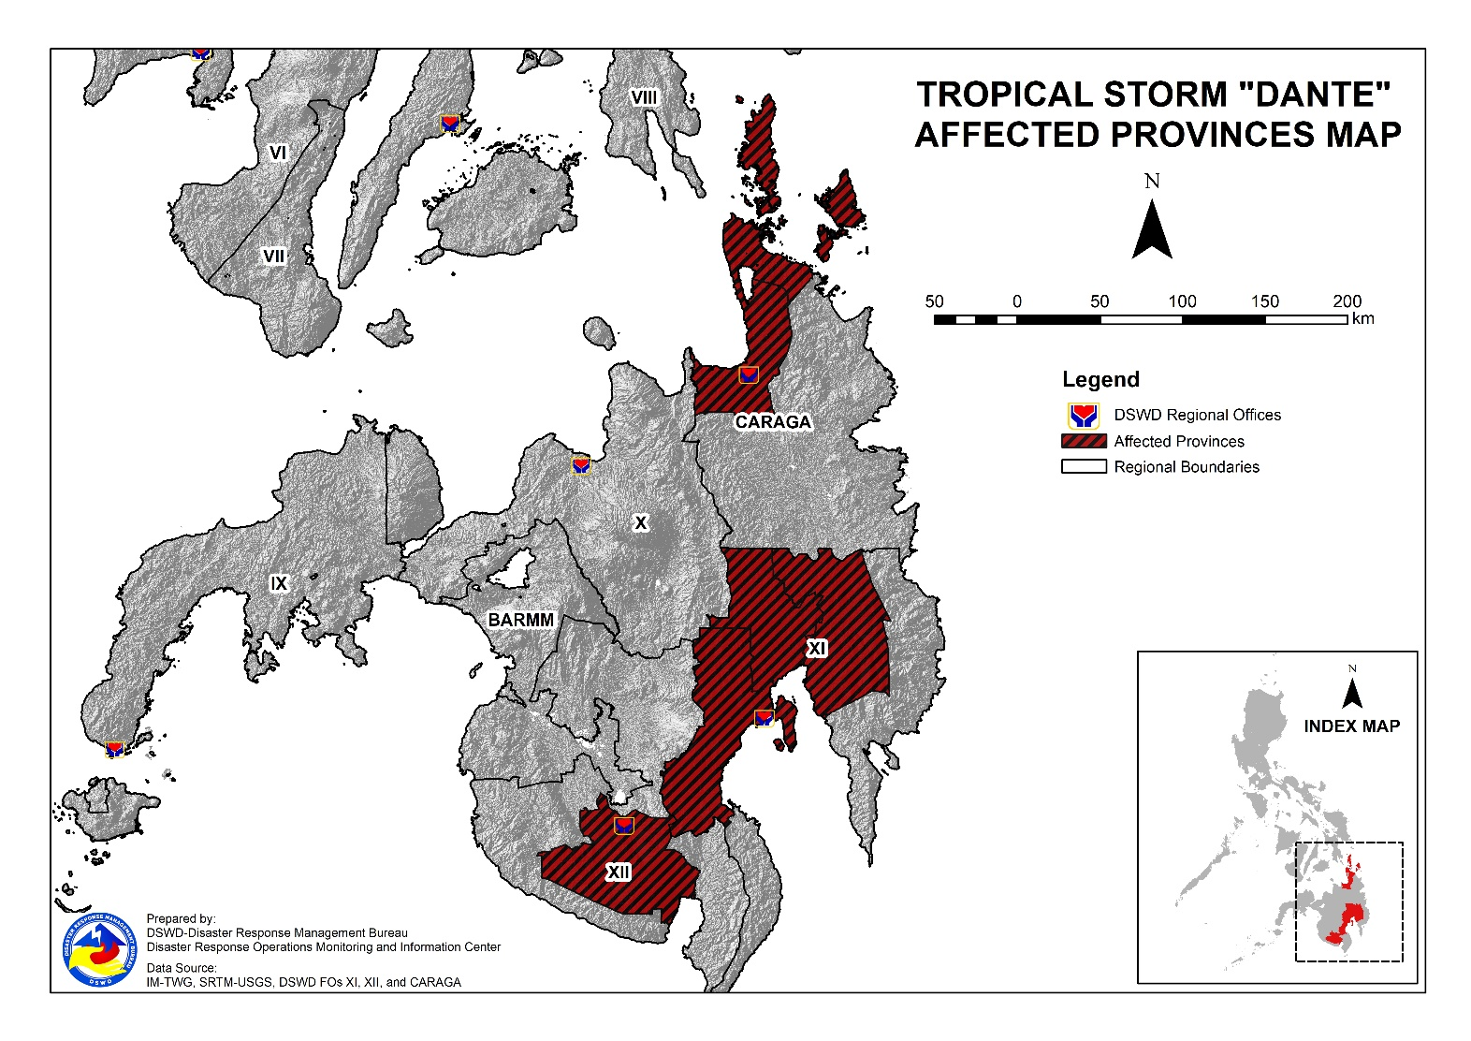
DSWD DISASTER RESPONSE INFORMATION

Situational Reports

DSWD-DRMB
DATE | SITUATIONS / ACTIONS UNDERTAKEN
02 June 2021 | - The Disaster Response Management Bureau (DRMB) is closely coordinating with the concerned field offices for significant reports on the status of affected families, assistance, and relief efforts.

DSWD-FO NCR
DATE | SITUATIONS / ACTIONS UNDERTAKEN
02 June 2021 | - Daily monitoring of weather conditions and other emergencies through telephone, internet, cell phone, etc. by the Disaster Response Management Division Staff and Quick Response Team Leaders.  - Continuous provision of Disaster Assistance Family Access Card to requesting LGUs  - The Quick Response Teams of FO-NCR composed of organic staff from the Field Office and Centers and Residential Care Facilities (C/RCFs) are activated and on standby in response to any eventualities. The assignment of said staff is scheduled per day.  - DSWD-FO NCR has established its EOC located at Room 109, FO-NCR, Sampaloc, Manila.

DSWD-FO CAR
DATE | SITUATIONS / ACTIONS UNDERTAKEN
31 May 2021 | - DSWD-FO CAR is on standby for the possible effects of the weather disturbance.  - DSWD-FO CAR is closely monitoring the weather updates and information.  - DSWD-FO CAR DROMIC Preparedness for Response Report on the Possible Effects of TS DANTE.  - DSWD-FO CAR ensures availability of food and non-food items for resource augmentation as the need arises.  - DRR Focal persons in close coordination with LDRRMOs and MSWDOs for weather reports and updates.

DSWD-FO CALABARZON
DATE | SITUATIONS / ACTIONS UNDERTAKEN
02 June 2021 | - DSWD-FO CALABARZON Emergency Operations Center (EOC) has been placed on heightened alert status to monitor the possible effects of Tropical Cyclone “Dante”.  - DSWD-FO CALABARZON EOC has constant communication with the Local Social Welfare and Development Offices (LSWDOs) with pre-disaster assessments being conducted.  - DSWD-FO CALABARZON DRMD conducted close coordination with the Local Government Units (LGUs) with regards to the preparedness efforts undertaken in the Flood, Landslide and Storm Surge prone areas.  - DSWD-FO CALABARZON coordinated with SWAD Team Leaders and Provincial Action Team of the CALABARZON and advised them to monitor and coordinate with the LGUs to gather reports on the possible effects of Tropical Cyclone “Dante”.  - DSWD-FO CALABARZON coordinated with LSWDOs and LDRRMOs and advised them to be on standby alert and prepare their respective evacuation centers, and family food packs should need arises.  - DSWD-FO CALABARZON coordinated with RDRRMC IV-A OpCen for updates on the preparedness level of the members of the Response Cluster of the region.  - DSWD-FO CALABARZON has informed member agencies of the response cluster to be on-stand-by alert status and ready for mobilization in case situation arises.

DSWD-FO MIMAROPA
DATE | SITUATIONS / ACTIONS UNDERTAKEN
31 May 2021 | - SWADT Offices are alerted to monitor daily local weather condition and related eventualities, and ensure provision of information to all concerned offices, divisions, sections, and units.  - On-call status of the expanded R/P/C/M QRTs together with special projects staff on a 24/7 basis for possible activation of Operation Center to respond in case any untoward incident and eventualities are reported.  - Standby logistical equipment and workforce through coordination with SWADT Offices and concerned LGUs on the management of stranded passengers, if any, in ports and terminals.  - Information and Communication Technology Management Unit (ICTMU) is on standby status to ensure robust communication system.  - Close coordination with the Office of Civil Defense (OCD) and RDRRMC MIMAROPA for any updates for monitoring purposes and response mechanism for areas that will be affected.  - Continuous coordination with the Local SWDOs on the implementation of minimum health protocols related to Camp Coordination and Camp Management to prevent and mitigate the possible transmission of COVID19 and other illnesses during evacuation.

DSWD-FO V
DATE | SITUATIONS / ACTIONS UNDERTAKEN
02 June 2021 | - A total of 457 families or 1,768 persons have pre-emptively evacuated in 23 evacuation centers while 759 families or 3,042 persons took pre-emptive evacuation in their relatives/and or friends’ houses.  REGION / PROVINCE / MUNICIPALITY NUMBER OF EVACUATION CENTERS (ECs) NUMBER OF DISPLACED  INSIDE ECs OUTSIDE ECs  Families Persons Families Persons  NOW NOW NOW NOW NOW  REGION V 23 457 1,768 759 3,042  Albay 22 442 1,706 759 3,042  Camalig 1 5 16 141 689  Guinobatan 4 122 434 - -  Jovellar 1 26 105 14 57  City of Ligao 7 72 291 - -  Malilipot 4 120 464 594 2,266  Santo Domingo (Libog) 2 10 35 10 30  City of Tabaco 2 37 151 - -  Tiwi 1 50 210 - -  Camarines Sur 1 15 62 - -  Sagñay 1 15 62 - -  - DRMD team are activated and are now on duty at DSWD 5 Operation Center.  - Resource Operation Section ensures the availability of family food packs and non-food items, as need arises.  - DSWD-FO V Quick Response Team (QRTs) are alerted ready for augmentation.  - PAT and MAT members in the six (6) provinces are activated and instructed to coordinate with the P/MDRRMOs and C/MSWDOs for weather reports and updates.

DSWD-FO VI
DATE | SITUATIONS / ACTIONS UNDERTAKEN
02 June 2021 | - DSWD-FO VI issued Memorandum on the activation of QRT and elevation of status to Red Alert.  - Close Coordination to Provincial DROMIC Counterpart on the submission of DROMIC report.  - Real time Monitoring of weather report and information dissemination.  - On-going repacking of family food packs in the regional warehouse.  - QRT Isabela, Negros Occidental augmented last June 01, 2021 in the MSWDO since MSWDO staff are currently under quarantine.  - The Disaster Response Management Division is closely coordinating with PSWDO for significant reports on the status of affected families, assistance, and relief efforts.  - Provision of technical assistance on DROMIC Report Writing.

DSWD-FO VII
DATE | SITUATIONS / ACTIONS UNDERTAKEN
02 June 2021 | - A total of 40 families or 162 persons have pre-emptively evacuated in five (5) evacuation centers in Region VII.  REGION / PROVINCE / MUNICIPALITY NUMBER OF EVACUATION CENTERS (ECs) NUMBER OF DISPLACED  INSIDE ECs  Families Persons  NOW NOW NOW  REGION VII 5 40 162  Bohol 3 14 41  Candijay 3 14 41  Cebu 2 26 121  Compostela 1 1 8  Tuburan 1 25 113  - Activation of the DSWD FO7 QRT following a meeting with the Team Leaders and ARDO Shalaine Marie S. Lucero. The coordination meeting was convened by the DRMD in preparation for the possible impacts and/or augmentation activities to the LGUs. Among the agreements made is the mobilization of Regional staff and center-based clients for the repacking of goods at the warehouse located in Labangon, Cebu City.  - As the Vice-Chair of the Response Cluster, DSWD-7 shared its preparedness measures including its Food and Non-Food Relief Stockpile Status during the ERP meeting convened by the RDRRMC at 2:00 PM on 01 June.  - Regional/Provincial/City/Municipal Quick Response Team remains on standby alert and ready for mobilization.  - City and Municipal Action Team and SWAD Offices is coordinating with their local counterparts and their respective LDRRMCs for any weather related incidents, impacts/effects. Warehouses in the three island provinces remain on standby alert for any response activities. Repacking of relief goods is continuously being conducted.

DSWD-FO VIII
DATE | SITUATIONS / ACTIONS UNDERTAKEN
01 June 2021 | - DSWD-FO VIII prepositioned Family Food Packs (FFPs) in Samar Island, Biliran and Southern Leyte which can be distributed immediately by the P/C/MATs to Local Government Units that need augmentation support.  - DSWD-FO VIII communicated SWAD Teams and City/Municipal Actions Teams to be alerted on the weather disturbance.  - DSWD-FO VIII monitored the weather situation through watching the live updates of PAGASA regarding the weather disturbances.  - DSWD-FO VIII activated QRT of DSWD in preparation for the possible impact of the tropical storm.  - SFO Northern Samar attended their PDRA Meeting last May 31, 2021.  - Coordination with DRMD PDOs regarding updates on the weather status in different provinces of Eastern Visayas.  - Continuous reconditioning of good and repacking of FFPs in preparation for TS Dante.  - Established DROMIC Tool for Tropical Storm Dante in the live spreadsheet for monitoring and reporting.

DSWD-FO X
DATE | SITUATIONS / ACTIONS UNDERTAKEN
02 June 2021 | - A total of 14 families or 57 persons have pre-emptively evacuated in Mahinog, Camiguin. All of these families have returned home.  - DSWD-FO X is closely monitoring the current weather disturbance brought about by TS Dante.

DSWD-FO XI
DATE | SITUATIONS / ACTIONS UNDERTAKEN
02 June 2021 | - DSWD-FO XI is continuously coordinating with CDRRMO and CSWDO for any significant updates.
DSWD-FO XII
DATE | SITUATIONS / ACTIONS UNDERTAKEN
31 May 2021 | - DSWD-FO XII released 500 family food packs, 146 malong, and 146 mats for the affected families in LGU of Banga.  - DSWD-FO XII DRMD staff monitored the incident through phone call in close coordination with the MSWDO of Banga for possible Technical Assistance and Resource Augmentation.

DSWD-FO Caraga
DATE | SITUATIONS / ACTIONS UNDERTAKEN
02 June 2021 | - DSWD-FO Caraga is continuously monitoring the weather updates.  - DSWD-FO Caraga activated its Quick Response Team (QRT) to render duty in the Emergency Operation Center (EOC) in a 24/7 basis.  - DSWD-FO Caraga has 2 smartphones available to be utilized for EOC operation.  - DSWD-FO Caraga has 1 wingvan and 1 disaster vehicle to be used for logistical support.  - DSWD-FO Caraga is continuously coordinating with SWADTLs and LSWDOs to monitor the situation in their respective area of responsibility.

*****
The Disaster Response Operations Monitoring and Information Center (DROMIC) of the DSWD-DRMB is closely monitoring the effects of Tropical Storm “Dante” and is coordinating with the concerned DSWD Field Offices for any significant updates.

Prepared by:
MARIE JOYCE G. RAFANAN

LESLIE R. JAWILI
Releasing Officer

