DSWD DROMIC Report #4 on Tropical Storm “Dante”
as of 03 June 2021, 6PM

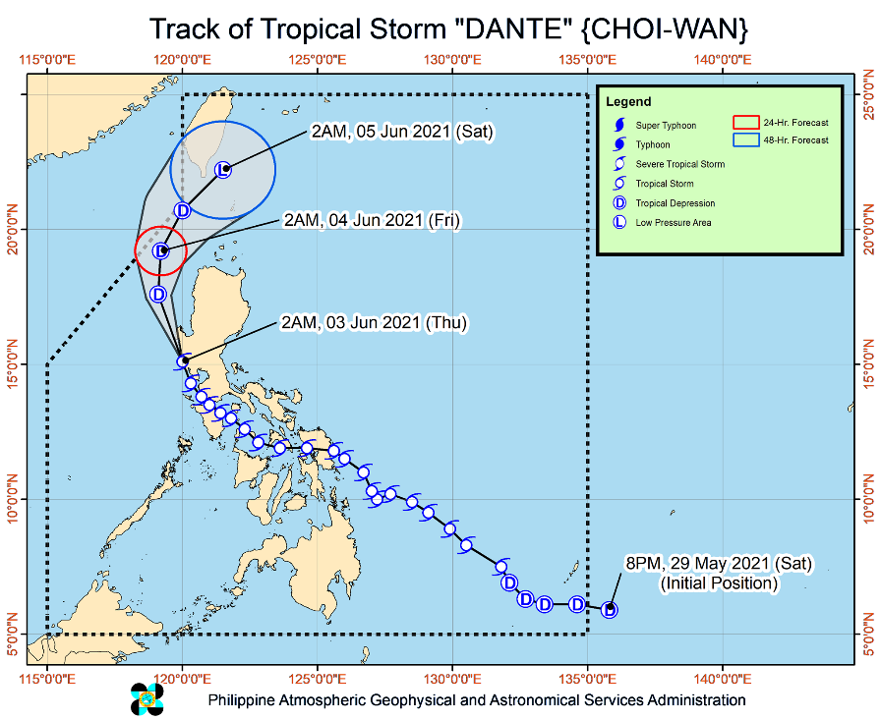
Situation Overview

Issued at 5:00 PM, 03 June 2021, TROPICAL STORM “DANTE” DECCELERATES AS IT MOVES NORTHWESTWARD OVER THE WEST

PHILIPPINE SEA

HAZARDS AFFECTING COASTAL WATERS

- Gale warning remains in effect over the northern and western seaboards of Northern Luzon (2.6 to 4.5 m). Sea travel is risky for small sea crafts over these waters.
- Moderate to rough seas (1.5 to 3.5 m) will be experienced over the western seaboard of Northern Luzon. Mariners of small seacrafts are advised to take precautionary measures when venturing out to sea. Inexperienced mariners should avoid navigating in these conditions.
TRACK AND INTENSITY OUTLOOK:
- This tropical storm is forecast to move generally northward or north northeastward in the next 12 hours exiting the northwestern boundary of the Philippine Area of Responsibility (PAR) between tonight and tomorrow early morning. Afterwards, it will re-enter the PAR tomorrow afternoon while moving northeastward over the Bashi Channel.
- DANTE” is forecast to remain tropical storm in the next 12 hours. It will weaken into a tropical depression tomorrow and into a remnant low on Saturday.

At 4:00 PM the center of Tropical Storm “DANTE” (CHOI-WAN) was estimated based on all available data 255 km West of Sinait, Ilocos Sur (17.7°N, 118.0°E).
Source: DOST-PAGASA Severe Weather Bulletin

- Status of Affected Families / Persons
A total of 12,260 families or 55,226 persons were affected in 117 barangays in Regions MIMAROPA, VI, VII, XI, XII and Caraga (see Table 1).

Table 1. Number of Affected Families / Persons
REGION / PROVINCE / MUNICIPALITY |  | NUMBER OF AFFECTED
 |  | Barangays | Families | Persons
GRAND TOTAL |  | 177 | 12,260 | 55,226
REGION MIMAROPA |  | 16 | 147 | 565
Marinduque |  | 4 | 37 | 121
 | Boac (capital) | 2 | 29 | 101
 | Mogpog | 1 | 2 | 4
 | Santa Cruz | 1 | 6 | 16
Romblon |  | 12 | 110 | 444
 | Banton | 1 | 3 | 15
 | Cajidiocan | 1 | 3 | 13
 | Corcuera | 1 | 3 | 15
 | Looc | 3 | 15 | 64
 | Magdiwang | 1 | 7 | 35
 | Odiongan | 5 | 79 | 302
REGION VI |  | 28 | 677 | 2,313
Aklan |  | 7 | 8 | 25
 | New Washington | 2 | 2 | 5
 | Buruanga | 1 | 2 | 6
 | Malay | 4 | 4 | 14
Capiz |  | 4 | 38 | 139
 | President Roxas | 4 | 38 | 139
Iloilo |  | 1 | 49 | 260
 | Balasan | 1 | 49 | 260
Negros Occidental |  | 16 | 582 | 1,889
 | Binalbagan | 3 | 470 | 1,402
 | City of Himamaylan | 5 | 38 | 190
 | Hinoba-an (Asia) | 3 | 24 | 135
 | Isabela | 3 | 34 | 111
 | City of Talisay | 2 | 16 | 51
REGION VII |  | 21 | 411 | 1,469
Bohol |  | 2 | 18 | 41
 | Loboc | 2 | 18 | 41
Cebu |  | 18 | 387 | 1,398
 | Compostela | 1 | 7 | 26
 | Danao City | 5 | 120 | 522
 | Liloan | 2 | 27 | 103
 | Mandaue City | 1 | 9 | 33
 | Tuburan | 9 | 224 | 714
Negros Oriental |  | 1 | 6 | 30
 | Basay | 1 | 6 | 30
REGION VIII |  | 17 | 638 | 3,183
Biliran |  | 1 | 15 | 68
 | Naval (capital) | 1 | 15 | 68
Leyte |  | 2 | 45 | 225
 | Matalom | 2 | 45 | 225
Southern Leyte |  | 14 | 578 | 2,890
 | City of Maasin (capital) | 14 | 578 | 2,890
REGION XI |  | 23 | 6,225 | 30,828
Davao de Oro |  | 7 | 94 | 361
 | Compostela | 3 | 11 | 48
 | Maco | 1 | 5 | 25
 | Mawab | 1 | 1 | 5
 | Nabunturan (capital) | 2 | 77 | 283
Davao del Norte |  | 7 | 5,971 | 29,855
 | Carmen | 7 | 5,971 | 29,855
Davao del Sur |  | 9 | 160 | 612
 | Davao City | 9 | 160 | 612
REGION XII |  | 9 | 406 | 2,030
South Cotabato |  | 9 | 406 | 2,030
 | Banga | 9 | 406 | 2,030
CARAGA |  | 63 | 3,756 | 14,838
Agusan del Norte |  | 42 | 2,950 | 11,795
 | Butuan City (capital) | 10 | 1,301 | 4,854
 | City of Cabadbaran | 11 | 499 | 2,511
 | Jabonga | 10 | 437 | 1,588
 | Remedios T. Romualdez | 5 | 516 | 1,916
 | Tubay | 6 | 197 | 926
Dinagat Island |  | 5 | 116 | 324
 | San Jose (capital) | 5 | 116 | 324
Surigao del Norte |  | 16 | 690 | 2,719
 | Bacuag | 4 | 233 | 820
 | Mainit | 6 | 236 | 1,137
 | Malimono | 5 | 205 | 721
 | Santa Monica (Sapao) | 1 | 16 | 41
Note: Ongoing assessment and validation being conducted.
Source: DSWD-FOs XI, XII and Caraga

- Status of Displaced Families / Persons
- Inside Evacuation Centers
There are 4,439 families or 16,680 persons currently taking temporary shelter in 140 evacuation centers in Regions MIMAROPA, VI, XI and Caraga (see Table 2).

Table 2. Number of Displaced Families / Persons Inside Evacuation Centers
REGION / PROVINCE / MUNICIPALITY |  | NUMBER OF EVACUATION CENTERS (ECs) |  | NUMBER OF DISPLACED
 |  |  |  | INSIDE ECs
 |  |  |  | Families |  | Persons
 |  | CUM | NOW | CUM | NOW | CUM | NOW
GRAND TOTAL |  | 176 | 140 | 5,462 | 4,439 | 21,572 | 16,680
REGION MIMAROPA |  | 9 | 8 | 26 | 20 | 115 | 83
Romblon |  | 9 | 8 | 26 | 20 | 115 | 83
 | Corcuera | 1 | 1 | 3 | 3 | 15 | 15
 | Looc | 3 | 2 | 8 | 2 | 44 | 12
 | Magdiwang | 1 | 1 | 7 | 7 | 35 | 35
 | Odiongan | 4 | 4 | 8 | 8 | 21 | 21
REGION VI |  | 23 | 23 | 670 | 670 | 2,286 | 2,286
Aklan |  | 6 | 6 | 7 | 7 | 22 | 22
 | New Washington | 1 | 1 | 1 | 1 | 2 | 2
 | Buruanga | 1 | 1 | 2 | 2 | 6 | 6
 | Malay | 4 | 4 | 4 | 4 | 14 | 14
Capiz |  | 4 | 4 | 32 | 32 | 115 | 115
 | President Roxas | 4 | 4 | 32 | 32 | 115 | 115
Iloilo |  | 1 | 1 | 49 | 49 | 260 | 260
 | Balasan | 1 | 1 | 49 | 49 | 260 | 260
Negros Occidental |  | 12 | 12 | 582 | 582 | 1,889 | 1,889
 | Binalbagan | 1 | 1 | 470 | 470 | 1,402 | 1,402
 | City of Himamaylan | 5 | 5 | 38 | 38 | 190 | 190
 | Hinoba-an (Asia) | 2 | 2 | 24 | 24 | 135 | 135
 | Isabela | 2 | 2 | 34 | 34 | 111 | 111
 | City of Talisay | 2 | 2 | 16 | 16 | 51 | 51
REGION VII |  | 21 | 10 | 384 | 103 | 1,366 | -
Bohol |  | 1 | - | 18 | - | 41 | -
 | Loboc | 1 | - | 18 | - | 41 | -
Cebu |  | 19 | 10 | 360 | 103 | 1,295 | -
 | Compostela | 2 | 2 | 7 | - | 26 | -
 | Danao City | 6 | - | 120 | - | 522 | -
 | Liloan | 2 | - | - | 103 | - | -
 | Mandaue City | 1 | - | 9 | - | 33 | -
 | Tuburan | 8 | 8 | 224 | - | 714 | -
Negros Oriental |  | 1 | - | 6 | - | 30 | -
 | Basay | 1 | - | 6 | - | 30 | -
REGION VIII |  | 14 | - | 578 | - | 2,890 | -
Southern Leyte |  | 14 | - | 578 | - | 2,890 | -
 | City of Maasin (capital) | 14 | - | 578 | - | 2,890 | -
REGION XI |  | 14 | 4 | 269 | 111 | 1,057 | 453
Davao de Oro |  | 2 | 2 | 77 | 77 | 283 | 283
 | Nabunturan (capital) | 2 | 2 | 77 | 77 | 283 | 283
Davao del Norte |  | 2 | 2 | 34 | 34 | 170 | 170
 | Carmen | 2 | 2 | 34 | 34 | 170 | 170
Davao del Sur |  | 10 | - | 158 | - | 604 | -
 | Davao City | 10 | - | 158 | - | 604 | -
CARAGA |  | 95 | 95 | 3,535 | 3,535 | 13,858 | 13,858
Agusan del Norte |  | 61 | 61 | 2,937 | 2,937 | 11,736 | 11,736
 | Butuan City (capital) | 17 | 17 | 1,301 | 1,301 | 4,854 | 4,854
 | City of Cabadbaran | 13 | 13 | 499 | 499 | 2,511 | 2,511
 | Jabonga | 20 | 20 | 424 | 424 | 1,529 | 1,529
 | Remedios T. Romualdez | 4 | 4 | 516 | 516 | 1,916 | 1,916
 | Tubay | 7 | 7 | 197 | 197 | 926 | 926
Dinagat Island |  | 4 | 4 | 116 | 116 | 324 | 324
 | San Jose (capital) | 4 | 4 | 116 | 116 | 324 | 324
Surigao del Norte |  | 30 | 30 | 482 | 482 | 1,798 | 1,798
 | Bacuag | 13 | 13 | 171 | 171 | 558 | 558
 | Mainit | 4 | 4 | 106 | 106 | 522 | 522
 | Malimono | 11 | 11 | 189 | 189 | 677 | 677
 | Santa Monica (Sapao) | 2 | 2 | 16 | 16 | 41 | 41
Note: Ongoing assessment and validation being conducted.
Source: DSWD-FOs XI and Caraga

- Outside Evacuation Centers
There are 346 families or 1,444 persons temporarily staying with their relatives and/or friends in Regions MIMAROPA, VI and Caraga (see Table 3).

Table 3. Number of Displaced Families / Persons Outside Evacuation Centers
REGION / PROVINCE / MUNICIPALITY |  | NUMBER OF DISPLACED
 |  | OUTSIDE ECs
 |  | Families |  | Persons
 |  | CUM | NOW | CUM | NOW
GRAND TOTAL |  | 349 | 346 | 1,457 | 1,444
REGION MIMAROPA |  | 121 | 118 | 450 | 437
Marinduque |  | 37 | 37 | 121 | 121
 | Boac (capital) | 29 | 29 | 101 | 101
 | Mogpog | 2 | 2 | 4 | 4
 | Santa Cruz | 6 | 6 | 16 | 16
Romblon |  | 84 | 81 | 329 | 316
 | Banton | 3 | 3 | 15 | 15
 | Cajidiocan | 3 | - | 13 | -
 | Looc | 7 | 7 | 20 | 20
 | Odiongan | 71 | 71 | 281 | 281
REGION VI |  | 7 | 7 | 27 | 27
Aklan |  | 1 | 1 | 3 | 3
 | New Washington | 1 | 1 | 3 | 3
Capiz |  | 6 | 6 | 24 | 24
 | President Roxas | 6 | 6 | 24 | 24
CARAGA |  | 221 | 221 | 980 | 980
Agusan del Norte |  | 13 | 13 | 59 | 59
 | Jabonga | 13 | 13 | 59 | 59
Surigao del Norte |  | 208 | 208 | 921 | 921
 | Bacuag | 62 | 62 | 262 | 262
 | Mainit | 130 | 130 | 615 | 615
 | Malimono | 16 | 16 | 44 | 44
Note: Ongoing assessment and validation being conducted.
Source: DSWD-FO Caraga

- Damaged Houses
There were 12 damaged houses; of which, three (3) were totally damaged and nine (9) were partially damaged (see Table 4).

Table 4. Number of Damaged Houses
REGION / PROVINCE / MUNICIPALITY |  | NO. OF DAMAGED HOUSES
 |  | Total | Totally | Partially
GRAND TOTAL |  | 12 | 3 | 9
REGION VI |  | 1 | - | 1
Aklan |  | 1 | - | 1
 | New Washington | 1 | - | 1
REGION VIII |  | 5 | - | 5
Leyte |  | 5 | - | 5
 | Matalom | 5 | - | 5
REGION XI |  | 6 | 3 | 3
Davao de Oro |  | 6 | 3 | 3
 | Maco | 5 | 2 | 3
 | Mawab | 1 | 1 | -
Note: Ongoing assessment and validation being conducted.
Source: DSWD-FO XI

- Assistance Provided
A total of ₱1,619,087.12 worth of assistance was provided to the affected families; of which, ₱763,163.12 from DSWD and ₱855,924.00 from LGUs (see Table 5).

Table 5. Cost of Assistance Provided to Affected Families / Persons
REGION / PROVINCE / MUNICIPALITY |  | COST OF ASSISTANCE
 |  | DSWD | LGU | NGOs | OTHERS | GRAND TOTAL
GRAND TOTAL |  | 763,163.12 | 855,924.00 | - | - | 1,619,087.12
REGION VI |  | - | 5,524.00 | - | - | 5,524.00
Aklan |  | - | 5,524.00 | - | - | 5,524.00
 | Malay | - | 5,524.00 | - | - | 5,524.00
REGION XII |  | 334,714.00 | 203,000.00 | - | - | 537,714.00
South Cotabato |  | 334,714.00 | 203,000.00 | - | - | 537,714.00
 | Banga | 334,714.00 | 203,000.00 | - | - | 537,714.00
CARAGA |  | 428,449.12 | 647,400.00 | - | - | 1,075,849.12
Agusan del Norte |  | 428,449.12 | 647,400.00 | - | - | 1,075,849.12
 | Butuan City (capital) | 428,449.12 | 647,400.00 | - | - | 1,075,849.12
Source: DSWD-FOs XII and Caraga

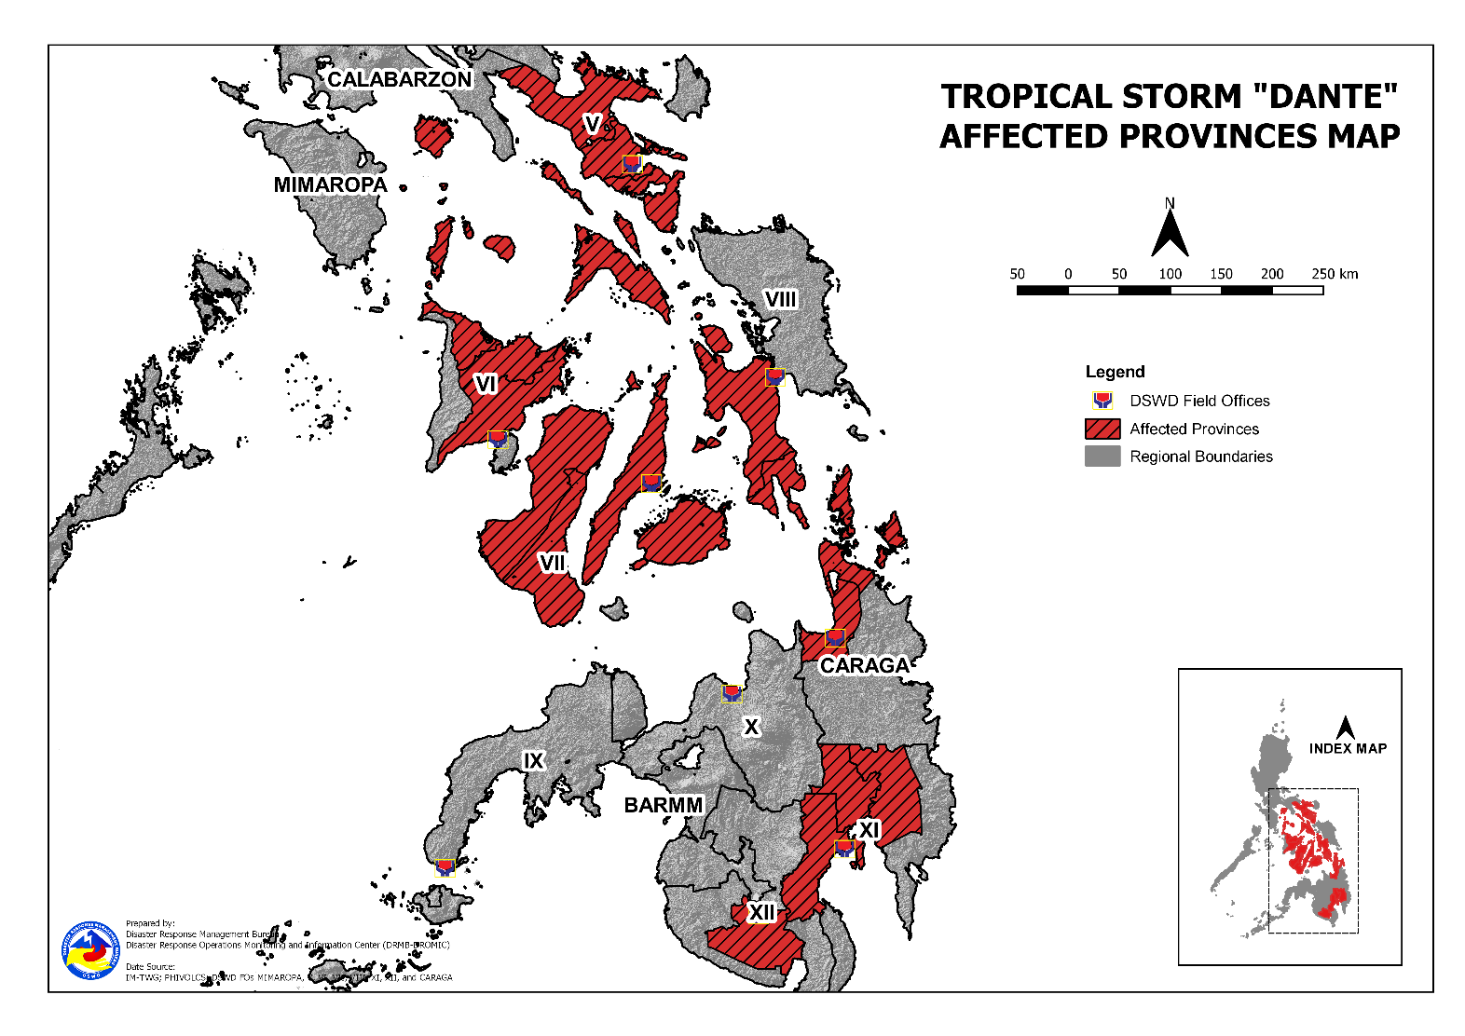
DSWD DISASTER RESPONSE INFORMATION

Situational Reports

DSWD-DRMB
DATE | SITUATIONS / ACTIONS UNDERTAKEN
03 June 2021 | - The Disaster Response Management Bureau (DRMB) is closely coordinating with the concerned field offices for significant reports on the status of affected families, assistance, and relief efforts.

DSWD-FO NCR
DATE | SITUATIONS / ACTIONS UNDERTAKEN
02 June 2021 | - DSWD-FO NCR submitted their terminal report.

DSWD-FO CAR
DATE | SITUATIONS / ACTIONS UNDERTAKEN
31 May 2021 | - DSWD-FO CAR is on standby for the possible effects of the weather disturbance.  - DSWD-FO CAR is closely monitoring the weather updates and information.  - DSWD-FO CAR DROMIC Preparedness for Response Report on the Possible Effects of TS DANTE.  - DSWD-FO CAR ensures availability of food and non-food items for resource augmentation as the need arises.  - DRR Focal persons in close coordination with LDRRMOs and MSWDOs for weather reports and updates.

DSWD-FO III
DATE | SITUATIONS / ACTIONS UNDERTAKEN
02 June 2021 | - DSWD-FO III activated Rapid Deployment Team-Disaster Response Management Division of DSWD Field Office and DSWD Provincial Extension Office Quick Response Team.  - DSWD-FO III Participated during the conduct of Pre-Disaster Risk Assessment with RDRRMC Members.  - DSWD-FO III is in continuous monitoring of weather updates in coordination with the DPEO’s and concerned LGUs.

DSWD-FO CALABARZON
DATE | SITUATIONS / ACTIONS UNDERTAKEN
02 June 2021 | - DSWD-FO CALABARZON Emergency Operations Center (EOC) has been placed on heightened alert status to monitor the possible effects of Tropical Cyclone “Dante”.  - DSWD-FO CALABARZON EOC has constant communication with the Local Social Welfare and Development Offices (LSWDOs) with pre-disaster assessments being conducted.  - DSWD-FO CALABARZON DRMD conducted close coordination with the Local Government Units (LGUs) with regards to the preparedness efforts undertaken in the Flood, Landslide and Storm Surge prone areas.  - DSWD-FO CALABARZON coordinated with SWAD Team Leaders and Provincial Action Team of the CALABARZON and advised them to monitor and coordinate with the LGUs to gather reports on the possible effects of Tropical Cyclone “Dante”.  - DSWD-FO CALABARZON coordinated with LSWDOs and LDRRMOs and advised them to be on standby alert and prepare their respective evacuation centers, and family food packs should need arises.  - DSWD-FO CALABARZON coordinated with RDRRMC IV-A OpCen for updates on the preparedness level of the members of the Response Cluster of the region.  - DSWD-FO CALABARZON has informed member agencies of the response cluster to be on-stand-by alert status and ready for mobilization in case situation arises.

DSWD-FO MIMAROPA
DATE | SITUATIONS / ACTIONS UNDERTAKEN
03 June 2021 | - 23 out of 41 total number of activated evacuation center are private houses whose owners pledged/committed to utilize their houses as temporary shelter during disaster phase and tied up with BLGU thru a forged MOU/MOA;  - As of this moment, the Disaster Response Management Division and SWADT offices have not yet received any letter-request from the LGUs for relief augmentation to affected populace;  - Activated operation center and on-call status of all P/C/M Quick Response Team in Five (5) provinces of MIMAROPA to monitor situational reports and eventualities in their area;  - Disaster Response Management Division and SWADT Offices are alerted and continuously coordinating with affected LGU and other concerned agencies on the condition and situation of displaced families/individuals;  - Close coordination with the Office of Civil Defense (OCD) and RDRRMC MIMAROPA on any warning signal updates for monitoring purposes and response mechanisms for areas that will be affected.

DSWD-FO V
DATE | SITUATIONS / ACTIONS UNDERTAKEN
02 June 2021 | - A total of 1,066 families or 3,908 persons have pre-emptively evacuated in 63 evacuation centers while 1,338 families or 5,031 persons took pre-emptive evacuation in their relatives/and or friends’ houses.  - DRMD team are activated and are now on duty at DSWD 5 Operation Center.  - Resource Operation Section ensures the availability of family food packs and non-food items, as need arises.  - DSWD-FO V Quick Response Team (QRTs) are alerted ready for augmentation.  - PAT and MAT members in the six (6) provinces are activated and instructed to coordinate with the P/MDRRMOs and C/MSWDOs for weather reports and updates.

DSWD-FO VI
DATE | SITUATIONS / ACTIONS UNDERTAKEN
03 June 2021 | - DSWD-FO VI issued Memorandum on the activation of QRT and elevation of status to Red Alert.  - Close Coordination to Provincial DROMIC Counterpart on the submission of DROMIC report.  - Real time Monitoring of weather report and information dissemination.  - On-going repacking of family food packs in the regional warehouse.  - QRT Isabela, Negros Occidental augmented last June 01, 2021 in the MSWDO since MSWDO staff are currently under quarantine.  - The Disaster Response Management Division is closely coordinating with PSWDO for significant reports on the status of affected families, assistance, and relief efforts.  - Provision of technical assistance on DROMIC Report Writing.

DSWD-FO VII
DATE | SITUATIONS / ACTIONS UNDERTAKEN
02 June 2021 | - A total of 17 families or 53 persons have pre-emptively evacuated in four (4) evacuation centers in Region VII.  - Regional/Provincial/City/Municipal Quick Response Team remains on standby alert and ready for mobilization.  - Warehouses in the three island provinces remain on alert for any response activities. Repacking of relief goods is continuously being conducted with the help of volunteers coming from the AFP, PA and PCG including Regional staff and personnel and center-based clients.

DSWD-FO VIII
DATE | SITUATIONS / ACTIONS UNDERTAKEN
02 June 2021 | - DSWD-FO VIII prepositioned Family Food Packs (FFPs) in Samar Island, Biliran and Southern Leyte which can be distributed immediately by the P/C/MATs to Local Government Units that need augmentation support.  - DSWD-FO VIII communicated SWAD Teams and City/Municipal Actions Teams to be alerted on the weather disturbance.  - DSWD-FO VIII monitored the weather situation through watching the live updates of PAGASA regarding the weather disturbances.  - SFO Northern Samar attended their PDRA Meeting last May 31, 2021.

DSWD-FO X
DATE | SITUATIONS / ACTIONS UNDERTAKEN
02 June 2021 | - A total of 14 families or 57 persons have pre-emptively evacuated in Mahinog, Camiguin. All of these families have returned home.  - DSWD-FO X is closely monitoring the current weather disturbance brought about by TS Dante.

DSWD-FO XI
DATE | SITUATIONS / ACTIONS UNDERTAKEN
02 June 2021 | - DSWD-FO XI is continuously coordinating with CDRRMO and CSWDO for any significant updates.

DSWD-FO XII
DATE | SITUATIONS / ACTIONS UNDERTAKEN
31 May 2021 | - DSWD-FO XII released 500 family food packs, 146 malong, and 146 mats for the affected families in LGU of Banga.  - DSWD-FO XII DRMD staff monitored the incident through phone call in close coordination with the MSWDO of Banga for possible Technical Assistance and Resource Augmentation.

DSWD-FO Caraga
DATE | SITUATIONS / ACTIONS UNDERTAKEN
02 June 2021 | - DSWD-FO Caraga is continuously monitoring the weather updates.  - DSWD-FO Caraga activated its Quick Response Team (QRT) to render duty in the Emergency Operation Center (EOC) in a 24/7 basis.  - DSWD-FO Caraga facilitated the release and delivery of 1,000 Family Food Packs amounting to PhP 428,449.12 for the flood affected families in Butuan City.  - DSWD-FO Caraga is continuously coordinating with SWADTLs and LSWDOs to monitor the situation in their respective area of responsibility.

*****
The Disaster Response Operations Monitoring and Information Center (DROMIC) of the DSWD-DRMB is closely monitoring the effects of Tropical Storm “Dante” and is coordinating with the concerned DSWD Field Offices for any significant updates.

Prepared by:
MARIEL B. FERRARIZ
JEM ERIC F. FAMORCAN
DIANE C. PELEGRINO

RODEL V. CABADDU
Releasing Officer

PHOTO DOCUMENTATION

