DSWD DROMIC Report #5 on Tropical Storm “Dante”
as of 04 June 2021, 6PM

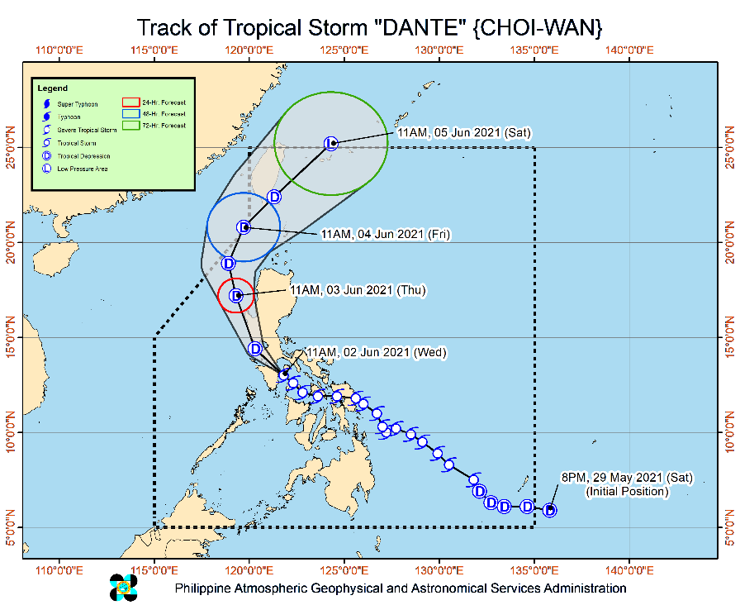
Situation Overview

Issued at 11:00 AM, 04 June 2021, TROPICAL STORM “DANTE” DECCELERATES WHILE MOVING NORTH NORTHEASTWARD TOWARDS

SOUTHERN TAIWAN.

HAZARDS AFFECTING COASTAL WATERS:
- A Gale Warning remains in effect over the northern and western seaboards of Northern Luzon (2.5 to 4.5 m) due to rough to very rough seas. Sea travel is risky for small seacrafts over these waters. Mariners without the proper experience should immediately seek safe harbor. For more information, refer to Gale Warning #3 issued at 5:00 AM today.

TRACK AND INTENSITY OUTLOOK:
- “DANTE” is forecast to move generally north northeastward or northeastward throughout the forecast period. On the forecast track, its center will re-enter the PAR this afternoon or evening and make a close approach or landfall in the vicinity of southern Taiwan (i.e., Pingtung County area) tonight. Afterwards, “DANTE” will continue moving northeastward towards the East China Sea.
- “DANTE” is forecast to weaken into a tropical depression prior to its landfall or close approach over the southern portion of Taiwan tonight. This tropical cyclone is forecast to transition into an extratropical cyclone tomorrow over the East China Sea.

At 10:00 AM, The center of Tropical Storm “DANTE” (CHOI-WAN) was estimated based on all available data 315 km West Northwest of Calayan, Cagayan or 340 km West of Basco, Batanes (OUTSIDE PAR) (20.4°N, 118.7°E)
Source: DOST-PAGASA Severe Weather Bulletin

- Status of Affected Families / Persons
A total of 22,892 families or 93,683 persons were affected in 284 barangays in Regions III, CALABARZON, MIMAROPA, VI, VII, VIII, XI, XII and Caraga (see Table 1).

Table 1. Number of Affected Families / Persons
REGION / PROVINCE / MUNICIPALITY |  | NUMBER OF AFFECTED
 |  | Barangays | Families | Persons
GRAND TOTAL |  | 284 | 22,892 | 93,683
REGION III |  | 9 | 40 | 166
Bataan |  | 7 | 35 | 150
 | Mariveles | 4 | 20 | 86
 | Orani | 1 | 4 | 18
 | Orion | 2 | 11 | 46
Bulacan |  | 1 | 1 | 3
 | Paombong | 1 | 1 | 3
Zambales |  | 1 | 4 | 13
 | San Marcelino | 1 | 4 | 13
CALABARZON |  | 11 | 53 | 233
Batangas |  | 9 | 40 | 183
 | Calatagan | 7 | 20 | 84
 | Nasugbu | 1 | 9 | 41
 | Santa Teresita | 1 | 11 | 58
Laguna |  | 2 | 13 | 50
 | Los Baños | 1 | 6 | 28
 | Paete | 1 | 7 | 22
REGION MIMAROPA |  | 49 | 398 | 1,209
Marinduque |  | 26 | 238 | 555
 | Boac (capital) | 4 | 47 | 118
 | Buenavista | 8 | 58 | 177
 | Mogpog | 3 | 14 | 55
 | Santa Cruz | 4 | 15 | 44
 | Torrijos | 2 | 51 | 161
Occidental Mindoro |  | 9 | 42 | 175
 | Lubang | 1 | 10 | 31
 | Sablayan | 1 | 3 | 7
 | San Jose | 6 | 28 | 132
 | Santa Cruz | 1 | 1 | 5
Romblon |  | 14 | 118 | 479
 | Banton | 1 | 3 | 15
 | Cajidiocan | 1 | 3 | 13
 | Corcuera | 1 | 3 | 15
 | Ferrol | 1 | 2 | 10
 | Looc | 3 | 15 | 64
 | Magdiwang | 1 | 7 | 35
 | Odiongan | 6 | 85 | 327
REGION VI |  | 42 | 1,357 | 5,263
Aklan |  | 7 | 9 | 32
 | New Washington | 2 | 2 | 5
 | Buruanga | 1 | 2 | 6
 | Malay | 4 | 5 | 21
Capiz |  | 7 | 252 | 1,004
 | President Roxas | 7 | 252 | 1,004
Iloilo |  | 10 | 459 | 1,632
 | Balasan | 10 | 459 | 1,632
Negros Occidental |  | 18 | 637 | 2,595
 | Binalbagan | 4 | 300 | 1,152
 | City of Himamaylan | 5 | 38 | 190
 | Hinoba-an (Asia) | 4 | 249 | 1,091
 | Isabela | 3 | 34 | 111
 | City of Talisay | 2 | 16 | 51
REGION VII |  | 21 | 411 | 1,469
Bohol |  | 2 | 18 | 41
 | Loboc | 2 | 18 | 41
Cebu |  | 18 | 387 | 1,398
 | Compostela | 1 | 7 | 26
 | Danao City | 5 | 120 | 522
 | Liloan | 2 | 27 | 103
 | Mandaue City | 1 | 9 | 33
 | Tuburan | 9 | 224 | 714
Negros Oriental |  | 1 | 6 | 30
 | Basay | 1 | 6 | 30
REGION VIII |  | 49 | 9,418 | 34,155
Biliran |  | 8 | 120 | 580
 | Naval (capital) | 4 | 32 | 140
 | Biliran | 4 | 88 | 440
Eastern Samar |  | 16 | 8,217 | 29,047
 | Arteche | 15 | 4,069 | 12,771
 | Balangiga | 1 | 4,148 | 16,276
Leyte |  | 2 | 45 | 225
 | Matalom | 2 | 45 | 225
Southern Leyte |  | 23 | 1,036 | 4,303
 | City of Maasin (capital) | 23 | 1,036 | 4,303
REGION XI |  | 23 | 6,225 | 30,828
Davao de Oro |  | 7 | 94 | 361
 | Compostela | 3 | 11 | 48
 | Maco | 1 | 5 | 25
 | Mawab | 1 | 1 | 5
 | Nabunturan (capital) | 2 | 77 | 283
Davao del Norte |  | 7 | 5,971 | 29,855
 | Carmen | 7 | 5,971 | 29,855
Davao del Sur |  | 9 | 160 | 612
 | Davao City | 9 | 160 | 612
REGION XII |  | 9 | 406 | 2,030
South Cotabato |  | 9 | 406 | 2,030
 | Banga | 9 | 406 | 2,030
CARAGA |  | 71 | 4,584 | 18,330
Agusan del Norte |  | 45 | 3,442 | 13,831
 | Butuan City (capital) | 10 | 1,338 | 4,980
 | City of Cabadbaran | 14 | 765 | 3,824
 | Jabonga | 10 | 518 | 1,847
 | Remedios T. Romualdez | 5 | 624 | 2,254
 | Tubay | 6 | 197 | 926
Dinagat Island |  | 8 | 352 | 1,294
 | Dinagat | 1 | 57 | 127
 | San Jose (capital) | 6 | 141 | 397
 | Tubajon | 1 | 154 | 770
Surigao del Norte |  | 18 | 790 | 3,205
 | Bacuag | 4 | 233 | 820
 | Mainit | 7 | 332 | 1,617
 | Malimono | 5 | 205 | 721
 | San Benito | 1 | 4 | 6
 | Santa Monica (Sapao) | 1 | 16 | 41
Note: Ongoing assessment and validation being conducted.
Source: DSWD-Field Offices

- Status of Displaced Families / Persons
- Inside Evacuation Centers
There are 732 families or 2,753 persons currently taking temporary shelter in 50 evacuation centers in Regions CALABARZON, VI, VII and Caraga (see Table 2).

Table 2. Number of Displaced Families / Persons Inside Evacuation Centers
REGION / PROVINCE / MUNICIPALITY |  | NUMBER OF EVACUATION CENTERS (ECs) |  | NUMBER OF DISPLACED
 |  |  |  | INSIDE ECs
 |  |  |  | Families |  | Persons
 |  | CUM | NOW | CUM | NOW | CUM | NOW
GRAND TOTAL |  | 248 | 50 | 6,574 | 732 | 24,361 | 2,753
REGION III |  | 10 | - | 40 | - | 166 | -
Bataan |  | 7 | - | 35 | - | 150 | -
 | Mariveles | 4 | - | 20 | - | 86 | -
 | Orani | 1 | - | 4 | - | 18 | -
 | Orion | 2 | - | 11 | - | 46 | -
Bulacan |  | 1 | - | 1 | - | 3 | -
 | Paombong | 1 | - | 1 | - | 3 | -
Zambales |  | 2 | - | 4 | - | 13 | -
 | San Marcelino | 2 | - | 4 | - | 13 | -
CALABARZON |  | 10 | 9 | 44 | 42 | 192 | 184
Batangas |  | 8 | 7 | 31 | 29 | 142 | 134
 | Calatagan | 7 | 6 | 20 | 18 | 84 | 76
 | Santa Teresita | 1 | 1 | 11 | 11 | 58 | 58
Laguna |  | 2 | 2 | 13 | 13 | 50 | 50
 | Los Baños | 1 | 1 | 6 | 6 | 28 | 28
 | Paete | 1 | 1 | 7 | 7 | 22 | 22
REGION MIMAROPA |  | 23 | - | 70 | - | 308 | -
Occidental Mindoro |  | 12 | - | 36 | - | 158 | -
 | Lubang | 1 | - | 6 | - | 20 | -
 | Sablayan | 1 | - | 3 | - | 7 | -
 | San Jose | 9 | - | 26 | - | 126 | -
 | Santa Cruz | 1 | - | 1 | - | 5 | -
Romblon |  | 11 | - | 34 | - | 150 | -
 | Corcuera | 1 | - | 3 | - | 15 | -
 | Ferrol | 1 | - | 2 | - | 10 | -
 | Looc | 3 | - | 8 | - | 44 | -
 | Magdiwang | 1 | - | 7 | - | 35 | -
 | Odiongan | 5 | - | 14 | - | 46 | -
REGION VI |  | 38 | 30 | 690 | 519 | 2,872 | 2,193
Aklan |  | 6 | 4 | 7 | 4 | 22 | 12
 | New Washington | 1 | 1 | 1 | 1 | 2 | 2
 | Buruanga | 1 | - | 2 | - | 6 | -
 | Malay | 4 | 3 | 4 | 3 | 14 | 10
Capiz |  | 4 | - | 52 | - | 195 | -
 | President Roxas | 4 | - | 52 | - | 195 | -
Iloilo |  | 1 | - | 100 | - | 389 | -
 | Balasan | 1 | - | 100 | - | 389 | -
Negros Occidental |  | 27 | 26 | 531 | 515 | 2,266 | 2,181
 | Binalbagan | 15 | 15 | 300 | 300 | 1,440 | 1,440
 | City of Himamaylan | 5 | 5 | 38 | 38 | 190 | 190
 | Hinoba-an (Asia) | 3 | 2 | 143 | 127 | 474 | 389
 | Isabela | 2 | 2 | 34 | 34 | 111 | 111
 | City of Talisay | 2 | 2 | 16 | 16 | 51 | 51
REGION VII |  | 21 | 10 | 384 | 103 | 1,366 | -
Bohol |  | 1 | - | 18 | - | 41 | -
 | Loboc | 1 | - | 18 | - | 41 | -
Cebu |  | 19 | 10 | 360 | 103 | 1,295 | -
 | Compostela | 2 | 2 | 7 | - | 26 | -
 | Danao City | 6 | - | 120 | - | 522 | -
 | Mandaue City | 1 | - | 9 | - | 33 | -
 | Tuburan | 8 | 8 | 224 | - | 714 | -
Negros Oriental |  | 1 | - | 6 | - | 30 | -
 | Basay | 1 | - | 6 | - | 30 | -
REGION VIII |  | 23 | - | 735 | - | 1,009 | -
Southern Leyte |  | 23 | - | 735 | - | 1,009 | -
 | City of Maasin (capital) | 23 | - | 735 | - | 1,009 | -
REGION XI |  | 14 | - | 269 | - | 1,057 | 135
Davao de Oro |  | 2 | - | 77 | - | 283 | -
 | Nabunturan (capital) | 2 | - | 77 | - | 283 | -
Davao del Norte |  | 2 | - | 34 | - | 170 | 135
 | Carmen | 2 | - | 34 | - | 170 | 135
Davao del Sur |  | 10 | - | 158 | - | 604 | -
 | Davao City | 10 | - | 158 | - | 604 | -
CARAGA |  | 109 | 1 | 4,342 | 68 | 17,391 | 241
Agusan del Norte |  | 66 | 1 | 3,348 | 68 | 13,513 | 241
 | Butuan City (capital) | 17 | 1 | 1,338 | 68 | 4,980 | 241
 | City of Cabadbaran | 17 | - | 765 | - | 3,824 | -
 | Jabonga | 20 | - | 424 | - | 1,529 | -
 | Remedios T. Romualdez | 5 | - | 624 | - | 2,254 | -
 | Tubay | 7 | - | 197 | - | 926 | -
Dinagat Island |  | 10 | - | 352 | - | 1,294 | -
 | Dinagat | 1 | - | 57 | - | 127 | -
 | San Jose (capital) | 6 | - | 141 | - | 397 | -
 | Tubajon | 3 | - | 154 | - | 770 | -
Surigao del Norte |  | 33 | - | 642 | - | 2,584 | -
 | Bacuag | 13 | - | 171 | - | 558 | -
 | Mainit | 6 | - | 262 | - | 1,302 | -
 | Malimono | 11 | - | 189 | - | 677 | -
 | San Benito | 1 | - | 4 | - | 6 | -
 | Santa Monica (Sapao) | 2 | - | 16 | - | 41 | -
Note: Ongoing assessment and validation being conducted.
Source: DSWD-Field Offices

- Outside Evacuation Centers
There are 150 families or 575 persons temporarily staying with their relatives and/or friends in Regions CALABARZON, MIMAROPA, VI and Caraga (see Table 3).

Table 3. Number of Displaced Families / Persons Outside Evacuation Centers
REGION / PROVINCE / MUNICIPALITY |  | NUMBER OF DISPLACED
 |  | OUTSIDE ECs
 |  | Families |  | Persons
 |  | CUM | NOW | CUM | NOW
GRAND TOTAL |  | 917 | 150 | 3,312 | 575
CALABARZON |  | 9 | 9 | 41 | 41
Batangas |  | 9 | 9 | 41 | 41
 | Nasugbu | 9 | 9 | 41 | 41
REGION MIMAROPA |  | 215 | 14 | 700 | 35
Marinduque |  | 125 | 12 | 354 | 29
 | Boac (capital) | 46 | - | 117 | -
 | Gasan | 12 | 12 | 29 | 29
 | Mogpog | 13 | - | 50 | -
 | Santa Cruz | 14 | - | 41 | -
 | Torrijos | 40 | - | 117 | -
Occidental Mindoro |  | 6 | 2 | 17 | 6
 | Lubang | 4 | - | 11 | -
 | San Jose | 2 | 2 | 6 | 6
Romblon |  | 84 | - | 329 | -
 | Banton | 3 | - | 15 | -
 | Cajidiocan | 3 | - | 13 | -
 | Looc | 7 | - | 20 | -
 | Odiongan | 71 | - | 281 | -
REGION VI |  | 470 | 111 | 1,698 | 455
Aklan |  | 2 | 2 | 10 | 10
 | New Washington | 1 | 1 | 3 | 3
 | Malay | 1 | 1 | 7 | 7
Capiz |  | 109 | 109 | 445 | 445
 | President Roxas | 109 | 109 | 445 | 445
Iloilo |  | 359 | - | 1,243 | -
 | Balasan | 359 | - | 1,243 | -
CARAGA |  | 223 | 16 | 873 | 44
Agusan del Norte |  | 75 | - | 252 | -
 | Jabonga | 75 | - | 252 | -
Surigao del Norte |  | 148 | 16 | 621 | 44
 | Bacuag | 62 | - | 262 | -
 | Mainit | 70 | - | 315 | -
 | Malimono | 16 | 16 | 44 | 44
Note: Ongoing assessment and validation being conducted.
Source: DSWD-Field Offices

- Damaged Houses
There were 81 damaged houses; of which, 41 were totally damaged and 40 were partially damaged (see Table 4).

Table 4. Number of Damaged Houses
REGION / PROVINCE / MUNICIPALITY |  | NO. OF DAMAGED HOUSES
 |  | Total | Totally | Partially
GRAND TOTAL |  | 81 | 41 | 40
REGION VI |  | 63 | 34 | 29
Aklan |  | 1 | - | 1
 | New Washington | 1 | - | 1
Negros Occidental |  | 62 | 34 | 28
 | Hinoba-an (Asia) | 62 | 34 | 28
REGION VIII |  | 12 | 4 | 8
Biliran |  | 7 | 4 | 3
 | Naval (capital) | 7 | 4 | 3
Leyte |  | 5 | - | 5
 | Matalom | 5 | - | 5
REGION XI |  | 6 | 3 | 3
Davao de Oro |  | 6 | 3 | 3
 | Maco | 5 | 2 | 3
 | Mawab | 1 | 1 | -
Note: Ongoing assessment and validation being conducted.
Source: DSWD-Field Offices

- Assistance Provided
A total of ₱1,925,967.26 worth of assistance was provided to the affected families; of which, ₱895,477.26 from DSWD and ₱1,030,490.00 from LGUs (see Table 5).

Table 5. Cost of Assistance Provided to Affected Families / Persons
REGION / PROVINCE / MUNICIPALITY |  | COST OF ASSISTANCE
 |  | DSWD | LGUs | NGOs | OTHERS | GRAND TOTAL
GRAND TOTAL |  | 895,477.26 | 1,030,490.00 | - | - | 1,925,967.26
REGION III |  | - | 15,450.00 | - | - | 15,450.00
Bataan |  | - | 14,950.00 | - | - | 14,950.00
 | Mariveles | - | 10,000.00 | - | - | 10,000.00
 | Orion | - | 4,950.00 | - | - | 4,950.00
Bulacan |  | - | 500.00 | - | - | 500.00
 | Paombong | - | 500.00 | - | - | 500.00
REGION MIMAROPA |  | 5,250.00 | - | - | - | 5,250.00
Romblon |  | 5,250.00 | - | - | - | 5,250.00
 | Magdiwang | 5,250.00 | - | - | - | 5,250.00
REGION VI |  | - | 6,840.00 | - | - | 6,840.00
Aklan |  | - | 6,840.00 | - | - | 6,840.00
 | Malay | - | 6,840.00 | - | - | 6,840.00
REGION XII |  | 334,714.00 | 203,000.00 | - | - | 537,714.00
South Cotabato |  | 334,714.00 | 203,000.00 | - | - | 537,714.00
 | Banga | 334,714.00 | 203,000.00 | - | - | 537,714.00
CARAGA |  | 555,513.26 | 805,200.00 | - | - | 1,360,713.26
Agusan del Norte |  | 555,513.26 | 805,200.00 | - | - | 1,360,713.26
 | Butuan City (capital) | 555,513.26 | 805,200.00 | - | - | 1,360,713.26
Source: DSWD-Field Offices

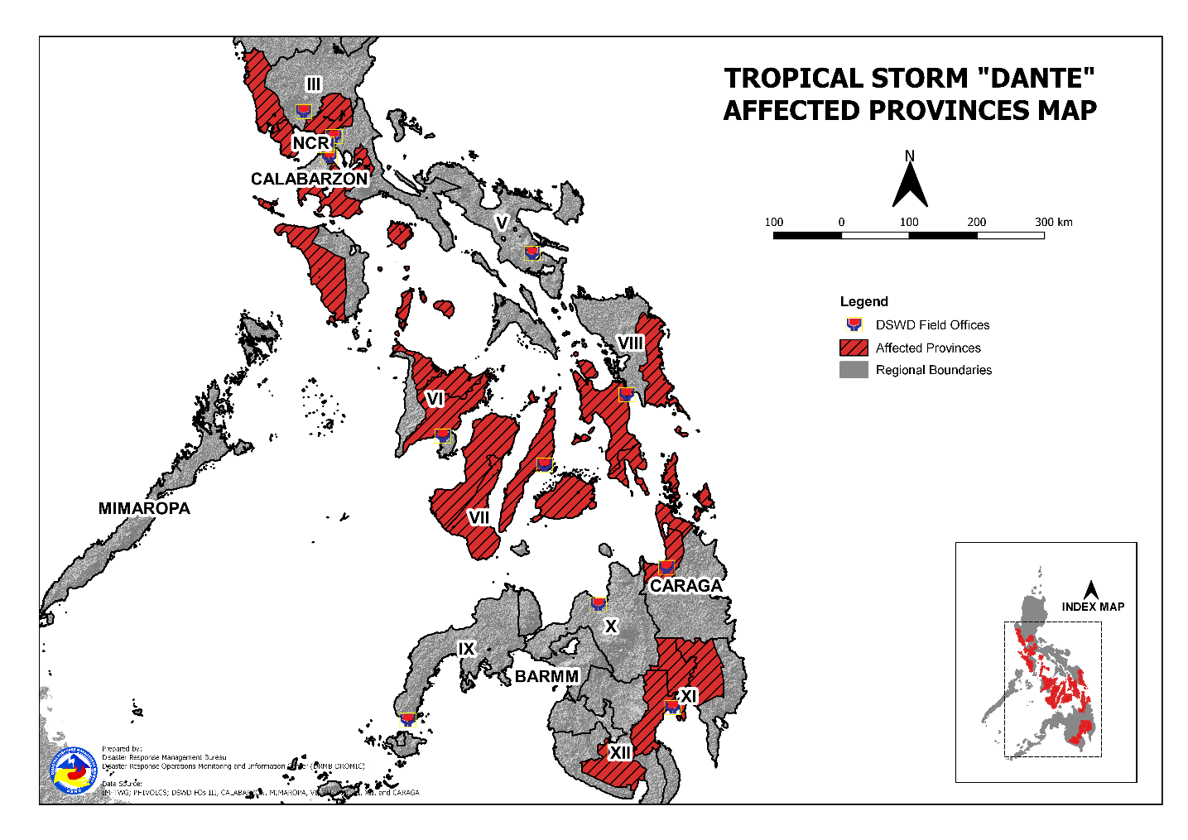
DSWD DISASTER RESPONSE INFORMATION

Situational Reports

DSWD-DRMB
DATE | SITUATIONS / ACTIONS UNDERTAKEN
04 June 2021 | - The Disaster Response Management Bureau (DRMB) is closely coordinating with the concerned field offices for significant reports on the status of affected families, assistance, and relief efforts.

DSWD-FO NCR
DATE | SITUATIONS / ACTIONS UNDERTAKEN
02 June 2021 | - DSWD-FO NCR submitted their terminal report.

DSWD-FO CAR
DATE | SITUATIONS / ACTIONS UNDERTAKEN
03 June 2021 | - DSWD-FO CAR ensures above 1,000 prepositioning of FFPs to satellite warehouses in the 6 Provinces of CAR.  - DSWD-FO CAR is on standby for the possible effects of the weather disturbance.  - DSWD-FO CAR is closely monitoring the weather updates and information.  - DSWD-FO CAR ensures availability of food and non-food items for resource augmentation as the need arises.  - DRR Focal persons in close coordination with LDRRMOs and MSWDOs for weather reports and updates.

DSWD-FO I
DATE | SITUATIONS / ACTIONS UNDERTAKEN
03 June 2021 | - DSWD-FO I is closely monitoring the movement of Tropical Storm. DANTE" through the Department of Science and Technology - Philippine Atmospheric, Geophysical and Astronomical Services Administration (DOST - PAGASA) and in close coordination with the Regional Disaster Risk Reduction and ftlanagement Council 1 (RDRRIVICI). Likewise, Provincial Operations Offices (POOs) are in close coordination with the different Provincial/CityiMunicipal Disaster Risk Reduction and Management Councils (P/C/MDRRMCs) and Provincial lCityl ltlunicipality Social Welfare and Development Offices (PlCihISWDOs) to monitor the adverse effects that might be brought by the weather disturbance.  - DSWD-FO I lncident Management Team (ltUT) is still activated and on duty while other DSWD staff are on standby for possible augmentation. Likewise, the Field Office ensures availability and readiness of resources.

DSWD-FO III
DATE | SITUATIONS / ACTIONS UNDERTAKEN
04 June 2021 | - DSWD-FO III submitted their terminal report.

DSWD-FO CALABARZON
DATE | SITUATIONS / ACTIONS UNDERTAKEN
03 June 2021 | - DSWD-FO CALABARZON Emergency Operations Center (EOC) has been placed on heightened alert status to monitor the possible effects of Tropical Cyclone “Dante”.  - Member of the Regional and Provincial Quick Response Teams (R|QRTs) were advised to be on standby alert status and ready for deployment for the conduct of Rapid Assessment and Needs Analysis (RDANA) should need arises.  - DSWD-FO CALABARZON through the DRMD requested the LGUs conducting Damage Assessment and Needs Analysis, to provide the DSWD FO IV-A EOC there reports for identification of possible assistance to the affected LGUs.  - DSWD-FO CALABARZON DRMD stands ready to support and facilitate assistance, if and when requested by Regional Disaster Risk Reduction and Management Council (RDRRMC) IV-A and Local Government Units (LGUs).  - DSWD-FO CALABARZON conducted Executive Briefing for Tropical Storm “Dante” to facilitate strategic coordination between members of the Response Cluster that may provide the logistical requirements for the delivery of assistance to the affected LGUs.  - DSWD-FO CALABARZON DRMD is closely coordinating with Local Social Welfare and Development Office (LSWDOs) in affected areas to collect information on the situation and needs on the ground.  - DSWD-FO CALABARZON DRMD requested the LGUs with reported damage houses to share their detailed assessment to the Field Office.  - DSWD-FO CALABARZON DRMD requested the LGUs to document their Humanitarian Assistance and Disaster Relief (HADR) and conduct After Action Review (AAR) to document their best practices in responding to hydrometeorological hazard during COVID-19 pandemic.

DSWD-FO MIMAROPA
DATE | SITUATIONS / ACTIONS UNDERTAKEN
04 June 2021 | - A total of 125 families or 402 persons have pre-emptively evacuated in 69 evacuation centers in Region MIMAROPA.  - All Evacuation Centers from the Provinces of Marinduque, Romblon and Occidental Mindoro were already closed.  - 54 out of 92 total number of activated evacuation center are private houses whose owners pledged/committed to utilize their houses as temporary shelter during disaster phase and tied up with BLGU thru a forged MOU/MOA.  - The Disaster Response Management Division and SWADT offices have not yet received any letter-request from the LGUs for relief augmentation to affected populace.  - With ongoing validation of final figure and close coordination with LGUs regarding their rehabilitation plan for inclusion to terminal report.  - With this progress, the DSWD FO MIMAROPA is now deactivating its Emergency Operation Center. However, the DRMD and its Provincial staff are still monitoring the situation and eventualities on the affected Provinces and populace.
DSWD-FO V
DATE | SITUATIONS / ACTIONS UNDERTAKEN
04 June 2021 | - A total of 1,073 families or 3,945 persons took pre-emptive evacuation in 65 evacuation centers (ECs) in Region V; of which, 38 families are currently staying in six (6) ECs while 150 families or 506 persons are temporarily staying with their relatives/and or friends.  - DRMD team are activated and are now on duty at DSWD 5 Operation Center.  - Resource Operation Section ensures the availability of family food packs and non-food items, as need arises.  - DSWD-FO V Quick Response Team (QRTs) are alerted ready for augmentation.  - PAT and MAT members in the six (6) provinces are activated and instructed to coordinate with the P/MDRRMOs and C/MSWDOs for weather reports and updates.

DSWD-FO VI
DATE | SITUATIONS / ACTIONS UNDERTAKEN
03 June 2021 | - DSWD-FO VI issued Memorandum on the activation of QRT and elevation of status to Red Alert.  - Close Coordination to Provincial DROMIC Counterpart on the submission of DROMIC report.  - Real time Monitoring of weather report and information dissemination.  - On-going repacking of family food packs in the regional warehouse.  - QRT Isabela, Negros Occidental augmented last June 01, 2021 in the MSWDO since MSWDO staff are currently under quarantine.  - The Disaster Response Management Division is closely coordinating with PSWDO for significant reports on the status of affected families, assistance, and relief efforts.  - Provision of technical assistance on DROMIC Report Writing.

DSWD-FO VII
DATE | SITUATIONS / ACTIONS UNDERTAKEN
02 June 2021 | - A total of 17 families or 53 persons have pre-emptively evacuated in four (4) evacuation centers in Region VII.  - Regional/Provincial/City/Municipal Quick Response Team remains on standby alert and ready for mobilization.  - Warehouses in the three island provinces remain on alert for any response activities. Repacking of relief goods is continuously being conducted with the help of volunteers coming from the AFP, PA and PCG including Regional staff and personnel and center-based clients.

DSWD-FO VIII
DATE | SITUATIONS / ACTIONS UNDERTAKEN
03 June 2021 | - A total of 578 families or 2,029 persons have pre-emptively evacuated in 44 evacuation centers in Region VIII. All of these families have returned home.  - DSWD-FO VIII prepositioned Family Food Packs (FFPs) in Samar Island, Biliran and Southern Leyte which can be distributed immediately by the P/C/MATs to Local Government Units that need augmentation support.  - DSWD-FO VIII communicated SWAD Teams and City/Municipal Actions Teams to be alerted on the weather disturbance.  - DSWD-FO VIII monitored the weather situation through watching the live updates of PAGASA regarding the weather disturbances.  - Relief operations initiated by M/CSWDOs in some affected barangays in different LGUs. SFO Teams continues to coordinate with P/C/MDRRMOs and P/C/MSWDO and monitor updates through text messages and calls.

DSWD-FO X
DATE | SITUATIONS / ACTIONS UNDERTAKEN
03 June 2021 | - A total of 14 families or 57 persons have pre-emptively evacuated in Mahinog, Camiguin. All of these families have returned home.  - DSWD-FO X is closely monitoring the current weather disturbance brought about by TS Dante.

DSWD-FO XI
DATE | SITUATIONS / ACTIONS UNDERTAKEN
03 June 2021 | - DSWD-FO XI is continuously coordinating with CDRRMO and CSWDO for any significant updates.

DSWD-FO XII
DATE | SITUATIONS / ACTIONS UNDERTAKEN
31 May 2021 | - DSWD-FO XII released 500 family food packs, 146 malong, and 146 mats for the affected families in LGU of Banga.  - DSWD-FO XII DRMD staff monitored the incident through phone call in close coordination with the MSWDO of Banga for possible Technical Assistance and Resource Augmentation.

DSWD-FO Caraga
DATE | SITUATIONS / ACTIONS UNDERTAKEN
03 June 2021 | - DSWD-FO Caraga facilitated the release and delivery of additional 301 Family Food Packs amounting to ₱127,064.14 for the flood affected families in Butuan City.  - DSWD-FO Caraga is continuously coordinating with SWADTLs and LSWDOs to monitor the situation in their respective area of responsibility.

*****
The Disaster Response Operations Monitoring and Information Center (DROMIC) of the DSWD-DRMB is closely monitoring the effects of Tropical Storm “Dante” and is coordinating with the concerned DSWD Field Offices for any significant updates.

Prepared by:
MARIEL B. FERRARIZ
DIANE C. PELEGRINO
MARIE JOYCE G. RAFANAN

LESLIE R. JAWILI
Releasing Officer

