DSWD DROMIC Report #6 on Tropical Storm “Dante”
as of 05 June 2021, 6PM

Situation Overview
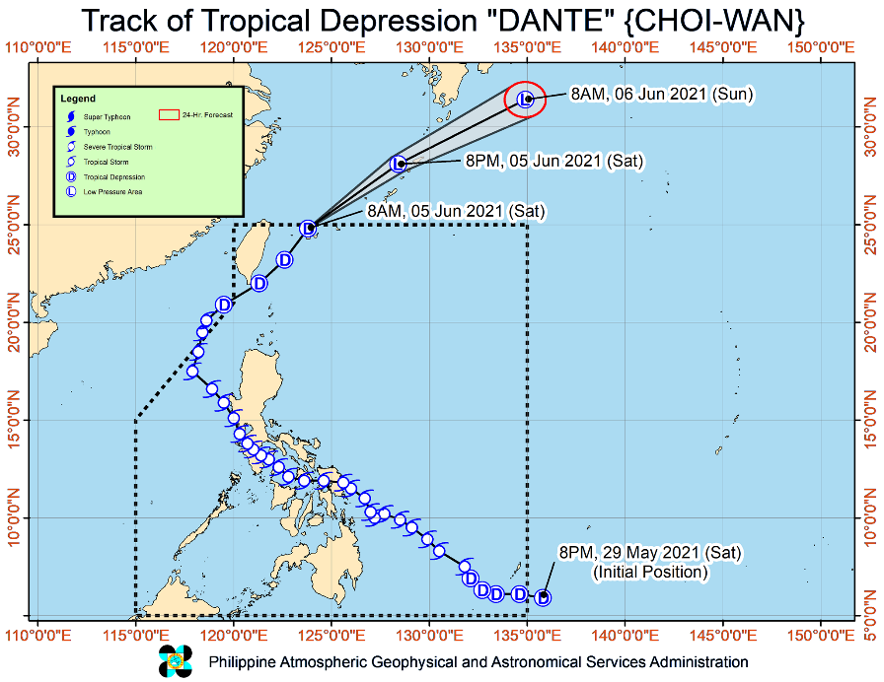

Issued at 11:00 AM, 05 June 2021, TROPICAL DEPRESSION “DANTE” IS NOW OUTSIDE THE PHILIPPINE AREA OF RESPONSIBILITY (PAR).

HAZARDS AFFECTING COASTAL WATERS:
- Under the influence of Tropical Depression “DANTE”, moderate to rough seas (1.2 to 3.0 m) will be experienced over the
northern seaboard of Northern Luzon. Mariners of small seacrafts are advised to take precautionary measures when
venturing out to sea. Inexperienced mariners should avoid navigating in these conditions.

TRACK AND INTENSITY OUTLOOK:
- “DANTE” left the northern boundary of the PAR at 9:30 AM today. This tropical depression will continue moving generally, northeastward in the next 12 hours heading towards Ryukyu Islands and will turn east northeastward tomorrow morning.
- “DANTE” is forecast to transition into an extratropical cyclone within the next 12 to 24 hours as it interacts with the baroclinic zone of Mei-yu Front over the East China Sea.

The center of Tropical Depression “DANTE” (CHOIWAN) was estimated based on all available data at
600 km North Northeast of Itbayat, Batanes (25.6°N, 124.5°E).
Source: DOST-PAGASA Severe Weather Bulletin

- Status of Affected Families / Persons
A total of 29,170 families or 122,042 persons were affected in 467 barangays in Regions III, CALABARZON, MIMAROPA, VI, VII, VIII, XI, XII and Caraga (see Table 1).

Table 1. Number of Affected Families / Persons
REGION / PROVINCE / MUNICIPALITY |  | NUMBER OF AFFECTED
 |  | Barangays | Families | Persons
GRAND TOTAL |  | 467 | 29,170 | 122,042
REGION III |  | 9 | 40 | 166
Bataan |  | 7 | 35 | 150
 | Mariveles | 4 | 20 | 86
 | Orani | 1 | 4 | 18
 | Orion | 2 | 11 | 46
Bulacan |  | 1 | 1 | 3
 | Paombong | 1 | 1 | 3
Zambales |  | 1 | 4 | 13
 | San Marcelino | 1 | 4 | 13
CALABARZON |  | 116 | 652 | 2,678
Batangas |  | 114 | 639 | 2,628
 | Balayan | 16 | 140 | 522
 | Batangas City (capital) | 1 | 2 | 8
 | Calaca | 32 | 87 | 345
 | Calatagan | 13 | 58 | 208
 | Laurel | 1 | 1 | 5
 | Lian | 11 | 126 | 539
 | Nasugbu | 17 | 152 | 676
 | Santa Teresita | 1 | 11 | 58
 | Taysan | 1 | 2 | 13
 | Tingloy | 5 | 10 | 43
 | Tuy | 16 | 50 | 211
Laguna |  | 2 | 13 | 50
 | Los Baños | 1 | 6 | 28
 | Paete | 1 | 7 | 22
REGION MIMAROPA |  | 49 | 398 | 1,209
Marinduque |  | 26 | 238 | 555
 | Boac (capital) | 4 | 47 | 118
 | Buenavista | 8 | 58 | 177
 | Mogpog | 3 | 14 | 55
 | Santa Cruz | 4 | 15 | 44
 | Torrijos | 2 | 51 | 161
Occidental Mindoro |  | 9 | 42 | 175
 | Lubang | 1 | 10 | 31
 | Sablayan | 1 | 3 | 7
 | San Jose | 6 | 28 | 132
 | Santa Cruz | 1 | 1 | 5
Romblon |  | 14 | 118 | 479
 | Banton | 1 | 3 | 15
 | Cajidiocan | 1 | 3 | 13
 | Corcuera | 1 | 3 | 15
 | Ferrol | 1 | 2 | 10
 | Looc | 3 | 15 | 64
 | Magdiwang | 1 | 7 | 35
 | Odiongan | 6 | 85 | 327
REGION V |  | 30 | 467 | 1,780
Masbate |  | 30 | 467 | 1,780
 | Balud | 1 | 11 | 48
 | Esperanza | 18 | 338 | 1,284
 | Mandaon | 1 | 3 | 12
 | Pio V. Corpuz (Limbuhan) | 10 | 115 | 436
REGION VI |  | 47 | 4,301 | 19,390
Aklan |  | 7 | 9 | 32
 | New Washington | 2 | 2 | 5
 | Buruanga | 1 | 2 | 6
 | Malay | 4 | 5 | 21
Capiz |  | 7 | 677 | 2,677
 | President Roxas | 7 | 677 | 2,677
Iloilo |  | 10 | 459 | 1,632
 | Balasan | 10 | 459 | 1,632
Negros Occidental |  | 23 | 3,156 | 15,049
 | Binalbagan | 4 | 300 | 1,152
 | City of Himamaylan | 9 | 2,509 | 12,494
 | Hinoba-an (Asia) | 4 | 249 | 1,091
 | Isabela | 4 | 82 | 261
 | City of Talisay | 2 | 16 | 51
REGION VII |  | 30 | 550 | 2,095
Bohol |  | 9 | 155 | 659
 | Loay | 7 | 141 | 618
 | Loboc | 2 | 14 | 41
Cebu |  | 20 | 389 | 1,412
 | Compostela | 3 | 7 | 26
 | Danao City | 5 | 120 | 522
 | Liloan | 2 | 27 | 103
 | Mandaue City | 1 | 11 | 47
 | Tuburan | 9 | 224 | 714
Negros Oriental |  | 1 | 6 | 24
 | Basay | 1 | 6 | 24
REGION VIII |  | 80 | 11,121 | 42,191
Biliran |  | 31 | 1,601 | 7,220
 | Kawayan | 12 | 160 | 769
 | Naval (capital) | 4 | 32 | 140
 | Biliran | 5 | 512 | 1,825
 | Cabucgayan | 8 | 862 | 4,310
 | Culaba | 1 | 1 | 6
 | Maripipi | 1 | 34 | 170
Eastern Samar |  | 16 | 8,217 | 29,047
 | Arteche | 15 | 4,069 | 12,771
 | Balangiga | 1 | 4,148 | 16,276
Leyte |  | 3 | 46 | 228
 | Calubian | 1 | 1 | 3
 | Matalom | 2 | 45 | 225
Western Samar |  | 7 | 221 | 1,095
 | San Jorge | 1 | 3 | 17
 | Tarangnan | 1 | 6 | 18
 | City of Catbalogan (capital) | 5 | 212 | 1,060
Southern Leyte |  | 23 | 1,036 | 4,601
 | City of Maasin (capital) | 23 | 1,036 | 4,601
REGION XI |  | 23 | 6,225 | 30,828
Davao de Oro |  | 7 | 94 | 361
 | Compostela | 3 | 11 | 48
 | Maco | 1 | 5 | 25
 | Mawab | 1 | 1 | 5
 | Nabunturan (capital) | 2 | 77 | 283
Davao del Norte |  | 7 | 5,971 | 29,855
 | Carmen | 7 | 5,971 | 29,855
Davao del Sur |  | 9 | 160 | 612
 | Davao City | 9 | 160 | 612
REGION XII |  | 9 | 406 | 2,030
South Cotabato |  | 9 | 406 | 2,030
 | Banga | 9 | 406 | 2,030
CARAGA |  | 74 | 5,010 | 19,675
Agusan del Norte |  | 46 | 3,818 | 14,926
 | Butuan City (capital) | 10 | 1,338 | 4,980
 | City of Cabadbaran | 15 | 912 | 4,560
 | Jabonga | 10 | 518 | 1,847
 | Remedios T. Romualdez | 5 | 624 | 2,254
 | Tubay | 6 | 426 | 1,285
Dinagat Island |  | 8 | 352 | 1,294
 | Dinagat | 1 | 57 | 127
 | San Jose (capital) | 6 | 141 | 397
 | Tubajon | 1 | 154 | 770
Surigao del Norte |  | 20 | 840 | 3,455
 | Bacuag | 4 | 233 | 820
 | Mainit | 9 | 382 | 1,867
 | Malimono | 5 | 205 | 721
 | San Benito | 1 | 4 | 6
 | Santa Monica (Sapao) | 1 | 16 | 41
Note: Ongoing assessment and validation being conducted.
Source: DSWD-Field Offices

- Status of Displaced Families / Persons
- Inside Evacuation Centers
There are 241 families or 861 persons currently taking temporary shelter in six (6) evacuation centers in Regions VI and Caraga (see Table 2).

Table 2. Number of Displaced Families / Persons Inside Evacuation Centers
REGION / PROVINCE / MUNICIPALITY |  | NUMBER OF EVACUATION CENTERS (ECs) |  | NUMBER OF DISPLACED
 |  |  |  | INSIDE ECs
 |  |  |  | Families |  | Persons
 |  | CUM | NOW | CUM | NOW | CUM | NOW
GRAND TOTAL |  | 283 | 6 | 7,221 | 241 | 26,359 | 861
REGION III |  | 10 | - | 40 | - | 166 | -
Bataan |  | 7 | - | 35 | - | 150 | -
 | Mariveles | 4 | - | 20 | - | 86 | -
 | Orani | 1 | - | 4 | - | 18 | -
 | Orion | 2 | - | 11 | - | 46 | -
Bulacan |  | 1 | - | 1 | - | 3 | -
 | Paombong | 1 | - | 1 | - | 3 | -
Zambales |  | 2 | - | 4 | - | 13 | -
 | San Marcelino | 2 | - | 4 | - | 13 | -
CALABARZON |  | 10 | - | 73 | - | 281 | -
Batangas |  | 8 | - | 60 | - | 231 | -
 | Calatagan | 7 | - | 49 | - | 173 | -
 | Santa Teresita | 1 | - | 11 | - | 58 | -
Laguna |  | 2 | - | 13 | - | 50 | -
 | Los Baños | 1 | - | 6 | - | 28 | -
 | Paete | 1 | - | 7 | - | 22 | -
REGION MIMAROPA |  | 23 | - | 70 | - | 308 | -
Occidental Mindoro |  | 12 | - | 36 | - | 158 | -
 | Lubang | 1 | - | 6 | - | 20 | -
 | Sablayan | 1 | - | 3 | - | 7 | -
 | San Jose | 9 | - | 26 | - | 126 | -
 | Santa Cruz | 1 | - | 1 | - | 5 | -
Romblon |  | 11 | - | 34 | - | 150 | -
 | Corcuera | 1 | - | 3 | - | 15 | -
 | Ferrol | 1 | - | 2 | - | 10 | -
 | Looc | 3 | - | 8 | - | 44 | -
 | Magdiwang | 1 | - | 7 | - | 35 | -
 | Odiongan | 5 | - | 14 | - | 46 | -
REGION V |  | 15 | - | 84 | - | 276 | -
Masbate |  | 15 | - | 84 | - | 276 | -
 | Balud | 2 | - | 18 | - | 55 | -
 | Esperanza | 4 | - | 20 | - | 59 | -
 | Mandaon | 1 | - | 3 | - | 12 | -
 | Pio V. Corpuz (Limbuhan) | 8 | - | 43 | - | 150 | -
REGION VI |  | 43 | 5 | 697 | 173 | 2,856 | 485
Aklan |  | 6 | - | 7 | - | 22 | -
 | New Washington | 1 | - | 1 | - | 2 | -
 | Buruanga | 1 | - | 2 | - | 6 | -
 | Malay | 4 | - | 4 | - | 14 | -
Capiz |  | 4 | - | 52 | - | 195 | -
 | President Roxas | 4 | - | 52 | - | 195 | -
Iloilo |  | 1 | - | 100 | - | 389 | -
 | Balasan | 1 | - | 100 | - | 389 | -
Negros Occidental |  | 32 | 5 | 538 | 173 | 2,250 | 485
 | Binalbagan | 15 | 3 | 300 | 46 | 1,440 | 96
 | City of Himamaylan | 9 | - | 45 | - | 174 | -
 | Hinoba-an (Asia) | 3 | 2 | 143 | 127 | 474 | 389
 | Isabela | 3 | - | 34 | - | 111 | -
 | City of Talisay | 2 | - | 16 | - | 51 | -
REGION VII |  | 27 | - | 459 | - | 1,691 | -
Bohol |  | 6 | - | 64 | - | 255 | -
 | Loay | 5 | - | 50 | - | 214 | -
 | Loboc | 1 | - | 14 | - | 41 | -
Cebu |  | 20 | - | 389 | - | 1,412 | -
 | Compostela | 3 | - | 7 | - | 26 | -
 | Danao City | 6 | - | 120 | - | 522 | -
 | Liloan | 2 | - | 27 | - | 103 | -
 | Mandaue City | 1 | - | 11 | - | 47 | -
 | Tuburan | 8 | - | 224 | - | 714 | -
Negros Oriental |  | 1 | - | 6 | - | 24 | -
 | Basay | 1 | - | 6 | - | 24 | -
REGION VIII |  | 26 | - | 742 | - | 922 | -
Leyte |  | 3 | - | 4 | - | 17 | -
 | Matalom | 3 | - | 4 | - | 17 | -
Southern Leyte |  | 23 | - | 738 | - | 905 | -
 | City of Maasin (capital) | 23 | - | 738 | - | 905 | -
REGION XI |  | 14 | - | 269 | - | 1,057 | 135
Davao de Oro |  | 2 | - | 77 | - | 283 | -
 | Nabunturan (capital) | 2 | - | 77 | - | 283 | -
Davao del Norte |  | 2 | - | 34 | - | 170 | 135
 | Carmen | 2 | - | 34 | - | 170 | 135
Davao del Sur |  | 10 | - | 158 | - | 604 | -
 | Davao City | 10 | - | 158 | - | 604 | -
CARAGA |  | 115 | 1 | 4,787 | 68 | 18,802 | 241
Agusan del Norte |  | 70 | 1 | 3,743 | 68 | 14,674 | 241
 | Butuan City (capital) | 17 | 1 | 1,338 | 68 | 4,980 | 241
 | City of Cabadbaran | 21 | - | 912 | - | 4,560 | -
 | Jabonga | 20 | - | 443 | - | 1,595 | -
 | Remedios T. Romualdez | 5 | - | 624 | - | 2,254 | -
 | Tubay | 7 | - | 426 | - | 1,285 | -
Dinagat Island |  | 10 | - | 352 | - | 1,294 | -
 | Dinagat | 1 | - | 57 | - | 127 | -
 | San Jose (capital) | 6 | - | 141 | - | 397 | -
 | Tubajon | 3 | - | 154 | - | 770 | -
Surigao del Norte |  | 35 | - | 692 | - | 2,834 | -
 | Bacuag | 13 | - | 171 | - | 558 | -
 | Mainit | 8 | - | 312 | - | 1,552 | -
 | Malimono | 11 | - | 189 | - | 677 | -
 | San Benito | 1 | - | 4 | - | 6 | -
 | Santa Monica (Sapao) | 2 | - | 16 | - | 41 | -
Note: Ongoing assessment and validation being conducted.
Source: DSWD-Field Offices

- Outside Evacuation Centers
There are 14 families or 35 persons temporarily staying with their relatives and/or friends in Region MIMAROPA (see Table 3).

Table 3. Number of Displaced Families / Persons Outside Evacuation Centers
REGION / PROVINCE / MUNICIPALITY |  | NUMBER OF DISPLACED
 |  | OUTSIDE ECs
 |  | Families |  | Persons
 |  | CUM | NOW | CUM | NOW
GRAND TOTAL |  | 4,264 | 14 | 19,184 | 35
CALABARZON |  | 579 | - | 2,397 | -
Batangas |  | 579 | - | 2,397 | -
 | Balayan | 140 | - | 522 | -
 | Batangas City (capital) | 2 | - | 8 | -
 | Calaca | 87 | - | 345 | -
 | Calatagan | 9 | - | 35 | -
 | Laurel | 1 | - | 5 | -
 | Lian | 126 | - | 539 | -
 | Nasugbu | 152 | - | 676 | -
 | Taysan | 2 | - | 13 | -
 | Tingloy | 10 | - | 43 | -
 | Tuy | 50 | - | 211 | -
REGION MIMAROPA |  | 215 | 14 | 700 | 35
Marinduque |  | 125 | 12 | 354 | 29
 | Boac (capital) | 46 | - | 117 | -
 | Gasan | 12 | 12 | 29 | 29
 | Mogpog | 13 | - | 50 | -
 | Santa Cruz | 14 | - | 41 | -
 | Torrijos | 40 | - | 117 | -
Occidental Mindoro |  | 6 | 2 | 17 | 6
 | Lubang | 4 | - | 11 | -
 | San Jose | 2 | 2 | 6 | 6
Romblon |  | 84 | - | 329 | -
 | Banton | 3 | - | 15 | -
 | Cajidiocan | 3 | - | 13 | -
 | Looc | 7 | - | 20 | -
 | Odiongan | 71 | - | 281 | -
REGION V |  | 222 | - | 792 | -
Masbate |  | 222 | - | 792 | -
 | Esperanza | 150 | - | 506 | -
 | Pio V. Corpuz (Limbuhan) | 72 | - | 286 | -
REGION VI |  | 2,934 | - | 14,018 | -
Aklan |  | 2 | - | 10 | -
 | New Washington | 1 | - | 3 | -
 | Malay | 1 | - | 7 | -
Capiz |  | 109 | - | 445 | -
 | President Roxas | 109 | - | 445 | -
Iloilo |  | 359 | - | 1,243 | -
 | Balasan | 359 | - | 1,243 | -
Negros Occidental |  | 2,464 | - | 12,320 | -
 | City of Himamaylan | 2,464 | - | 12,320 | -
REGION VII |  | 91 | - | 404 | -
Bohol |  | 91 | - | 404 | -
 | Loay | 91 | - | 404 | -
CARAGA |  | 223 | - | 873 | -
Agusan del Norte |  | 75 | - | 252 | -
 | Jabonga | 75 | - | 252 | -
Surigao del Norte |  | 148 | - | 621 | -
 | Bacuag | 62 | - | 262 | -
 | Mainit | 70 | - | 315 | -
 | Malimono | 16 | - | 44 | -
Note: Ongoing assessment and validation being conducted.
Source: DSWD-Field Offices

- Damaged Houses
There were 3,209 damaged houses; of which, 147 were totally damaged and 3,062 were partially damaged (see Table 4).

Table 4. Number of Damaged Houses
REGION / PROVINCE / MUNICIPALITY |  | NO. OF DAMAGED HOUSES
 |  | Total | Totally | Partially
GRAND TOTAL |  | 3,209 | 147 | 3,062
REGION V |  | 295 | 31 | 264
Masbate |  | 295 | 31 | 264
 | Esperanza | 292 | 28 | 264
 | Mandaon | 3 | 3 | -
REGION VI |  | 2,577 | 81 | 2,496
Aklan |  | 1 | - | 1
 | New Washington | 1 | - | 1
Negros Occidental |  | 2,576 | 81 | 2,495
 | City of Himamaylan | 2,509 | 45 | 2,464
 | Hinoba-an (Asia) | 62 | 34 | 28
 | Isabela | 5 | 2 | 3
REGION VIII |  | 328 | 32 | 296
Biliran |  | 297 | 30 | 267
 | Kawayan | 160 | 4 | 156
 | Naval (capital) | 7 | 4 | 3
 | Biliran | 90 | 20 | 70
 | Cabucgayan | 4 | 1 | 3
 | Culaba | 1 | - | 1
 | Maripipi | 35 | 1 | 34
Leyte |  | 31 | 2 | 29
 | Calubian | 1 | 1 | -
 | Matalom | 30 | 1 | 29
REGION XI |  | 6 | 3 | 3
Davao de Oro |  | 6 | 3 | 3
 | Maco | 5 | 2 | 3
 | Mawab | 1 | 1 | -
CARAGA |  | 3 | - | 3
Agusan del Norte |  | 3 | - | 3
 | Tubay | 3 | - | 3
Note: Ongoing assessment and validation being conducted.
Source: DSWD-Field Offices

- Assistance Provided
A total of ₱2,387,084.44 worth of assistance was provided to the affected families; of which, ₱911,096.44 from DSWD and ₱1,475,988.00 from LGUs (see Table 5).

Table 5. Cost of Assistance Provided to Affected Families / Persons
REGION / PROVINCE / MUNICIPALITY |  | COST OF ASSISTANCE
 |  | DSWD | LGUs | NGOs | OTHERS | GRAND TOTAL
GRAND TOTAL |  | 911,096.44 | 1,475,988.00 | - | - | 2,387,084.44
REGION III |  | - | 15,450.00 | - | - | 15,450.00
Bataan |  | - | 14,950.00 | - | - | 14,950.00
 | Mariveles | - | 10,000.00 | - | - | 10,000.00
 | Orion | - | 4,950.00 | - | - | 4,950.00
Bulacan |  | - | 500.00 | - | - | 500.00
 | Paombong | - | 500.00 | - | - | 500.00
CALABARZON |  | - | 25,000.00 | - | - | 25,000.00
Batangas |  | - | 25,000.00 | - | - | 25,000.00
 | Batangas City (capital) | - | 25,000.00 | - | - | 25,000.00
REGION MIMAROPA |  | 5,250.00 | - | - | - | 5,250.00
Romblon |  | 5,250.00 | - | - | - | 5,250.00
 | Magdiwang | 5,250.00 | - | - | - | 5,250.00
REGION VI |  | - | 273,978.00 | - | - | 273,978.00
Aklan |  | - | 8,578.00 | - | - | 8,578.00
 | New Washington | - | 600.00 | - | - | 600.00
 | Buruanga | - | 1,138.00 | - | - | 1,138.00
 | Malay | - | 6,840.00 | - | - | 6,840.00
Capiz |  | - | 135,400.00 | - | - | 135,400.00
 | President Roxas | - | 135,400.00 | - | - | 135,400.00
Negros Occidental |  | - | 130,000.00 | - | - | 130,000.00
 | City of Himamaylan | - | 130,000.00 | - | - | 130,000.00
REGION XII |  | 334,714.00 | 203,000.00 | - | - | 537,714.00
South Cotabato |  | 334,714.00 | 203,000.00 | - | - | 537,714.00
 | Banga | 334,714.00 | 203,000.00 | - | - | 537,714.00
CARAGA |  | 571,132.44 | 958,560.00 | - | - | 1,529,692.44
Agusan del Norte |  | 571,132.44 | 958,560.00 | - | - | 1,529,692.44
 | Butuan City (capital) | 571,132.44 | 805,200.00 | - | - | 1,376,332.44
 | Tubay | - | 153,360.00 | - | - | 153,360.00
Source: DSWD-Field Offices

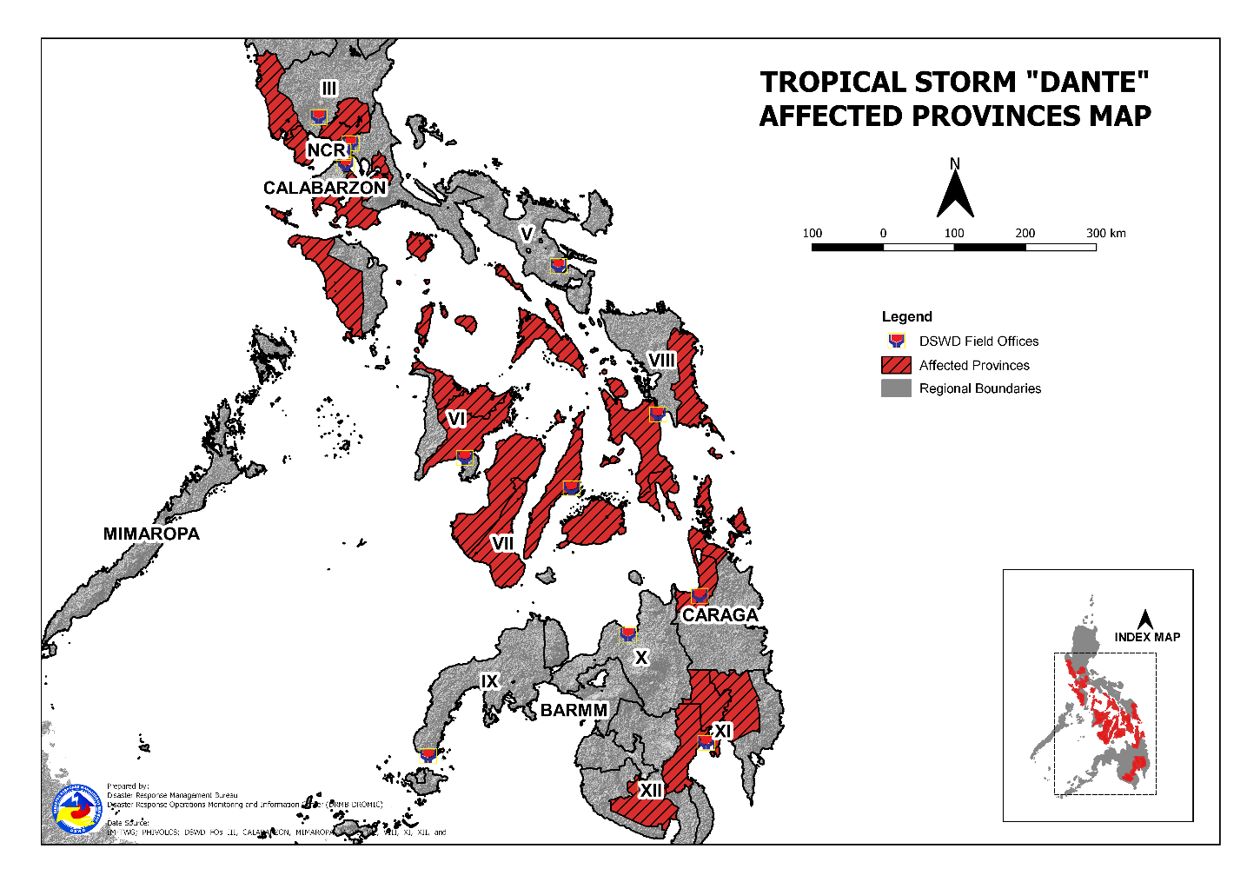
DSWD DISASTER RESPONSE INFORMATION

Situational Reports

DSWD-DRMB
DATE | SITUATIONS / ACTIONS UNDERTAKEN
05 June 2021 | - The Disaster Response Management Bureau (DRMB) is closely coordinating with the concerned field offices for significant reports on the status of affected families, assistance, and relief efforts.

DSWD-FO NCR
DATE | SITUATIONS / ACTIONS UNDERTAKEN
02 June 2021 | - DSWD-FO NCR submitted their terminal report.

DSWD-FO CAR
DATE | SITUATIONS / ACTIONS UNDERTAKEN
03 June 2021 | - DSWD-FO CAR ensures above 1,000 prepositioning of FFPs to satellite warehouses in the 6 Provinces of CAR.  - DSWD-FO CAR is on standby for the possible effects of the weather disturbance.  - DSWD-FO CAR is closely monitoring the weather updates and information.  - DSWD-FO CAR ensures availability of food and non-food items for resource augmentation as the need arises.  - DRR Focal persons in close coordination with LDRRMOs and MSWDOs for weather reports and updates.

DSWD-FO I
DATE | SITUATIONS / ACTIONS UNDERTAKEN
03 June 2021 | - DSWD-FO I is closely monitoring the movement of Tropical Storm. DANTE" through the Department of Science and Technology - Philippine Atmospheric, Geophysical and Astronomical Services Administration (DOST - PAGASA) and in close coordination with the Regional Disaster Risk Reduction and ftlanagement Council 1 (RDRRIVICI). Likewise, Provincial Operations Offices (POOs) are in close coordination with the different Provincial/CityiMunicipal Disaster Risk Reduction and Management Councils (P/C/MDRRMCs) and Provincial lCityl ltlunicipality Social Welfare and Development Offices (PlCihISWDOs) to monitor the adverse effects that might be brought by the weather disturbance.  - DSWD-FO I lncident Management Team (ltUT) is still activated and on duty while other DSWD staff are on standby for possible augmentation. Likewise, the Field Office ensures availability and readiness of resources.

DSWD-FO III
DATE | SITUATIONS / ACTIONS UNDERTAKEN
04 June 2021 | - DSWD-FO III submitted their terminal report.

DSWD-FO CALABARZON
DATE | SITUATIONS / ACTIONS UNDERTAKEN
04 June 2021 | - DSWD-FO CALABARZON Emergency Operations Center (EOC) has lowered its alert level in connection with TS “Dante”.  - DSWD-FO CALABARZON stands ready to support and facilitate assistance, if and when requested by Regional Disaster Risk Reduction and Management Council (RDRRMC) IV-A and Local Government Units (LGUs).  - DSWD-FO CALABARZON DRMD requested LGUs with reported affected population to provide, life-saving assistance to those in the most urgent need and ensure to deliver assistance in a manner that minimizes the risk of COVID-19 to the disaster-affected people.  - DSWD-FO CALABARZON advised the Local Social Welfare and Development Offices (LSWDOs) of the affected LGUs to conduct an after action review (AAR) to ensure that COVID-19 guidelines are incorporated in their response protocols.  - DSWD-FO CALABARZON DRMD maintained coordination with the RDRRMC IV-A and Response Pillar cluster leads for any monitored incidents in the CALABARZON region in connection with the weather disturbance.

DSWD-FO MIMAROPA
DATE | SITUATIONS / ACTIONS UNDERTAKEN
04 June 2021 | - A total of 125 families or 402 persons have pre-emptively evacuated in 69 evacuation centers in Region MIMAROPA.  - All Evacuation Centers from the Provinces of Marinduque, Romblon and Occidental Mindoro were already closed.  - 54 out of 92 total number of activated evacuation center are private houses whose owners pledged/committed to utilize their houses as temporary shelter during disaster phase and tied up with BLGU thru a forged MOU/MOA.  - The Disaster Response Management Division and SWADT offices have not yet received any letter-request from the LGUs for relief augmentation to affected populace.  - With ongoing validation of final figure and close coordination with LGUs regarding their rehabilitation plan for inclusion to terminal report.  - With this progress, the DSWD FO MIMAROPA is now deactivating its Emergency Operation Center. However, the DRMD and its Provincial staff are still monitoring the situation and eventualities on the affected Provinces and populace.

DSWD-FO V
DATE | SITUATIONS / ACTIONS UNDERTAKEN
04 June 2021 | - A total of 989 families or 3,669 persons took pre-emptive evacuation in 50 evacuation centers (ECs) in Region V; while 1,127 families or 4,291 persons sought temporary shelter with their relatives/and or friends. All of these families have returned home.  - DRMD team are activated and are now on duty at DSWD 5 Operation Center.  - Resource Operation Section ensures the availability of family food packs and non-food items, as need arises.  - DSWD-FO V Quick Response Team (QRTs) are alerted ready for augmentation.  - PAT and MAT members in the six (6) provinces are activated and instructed to coordinate with the P/MDRRMOs and C/MSWDOs for weather reports and updates.

DSWD-FO VI
DATE | SITUATIONS / ACTIONS UNDERTAKEN
04 June 2021 | - DSWD-FO VI issued Memorandum on the activation of QRT and elevation of status to Red Alert.  - Close Coordination to Provincial DROMIC Counterpart on the submission of DROMIC report.  - Real time Monitoring of weather report and information dissemination.  - On-going repacking of family food packs in the regional warehouse.  - QRT Isabela, Negros Occidental augmented last June 01, 2021 in the MSWDO since MSWDO staff are currently under quarantine.  - The Disaster Response Management Division is closely coordinating with PSWDO for significant reports on the status of affected families, assistance, and relief efforts.  - Provision of technical assistance on DROMIC Report Writing.

DSWD-FO VII
DATE | SITUATIONS / ACTIONS UNDERTAKEN
04 June 2021 | - A total of 17 families or 53 persons have pre-emptively evacuated in four (4) evacuation centers in Region VII. All of these families have returned home.  - DSWD-FO VII DRMD received request for augmentation support from LGU Loay. Disaster Response Section already coordinating with the MSWDO and processing request.  - DSWD-FO QRT was deactivated.  - Continuous repacking at the warehouses for stock replenishment with the help from the PCG and FO staff and personnel.

DSWD-FO VIII
DATE | SITUATIONS / ACTIONS UNDERTAKEN
04 June 2021 | - A total of 700 families or 2,588 persons have pre-emptively evacuated in 50 evacuation centers in Region VIII. All of these families have returned home.  - DSWD-FO VIII prepositioned Family Food Packs (FFPs) in Samar Island, Biliran and Southern Leyte which can be distributed immediately by the P/C/MATs to Local Government Units that need augmentation support.  - DSWD-FO VIII communicated SWAD Teams and City/Municipal Actions Teams to be alerted on the weather disturbance.  - DSWD-FO VIII monitored the weather situation through watching the live updates of PAGASA regarding the weather disturbances.  - Relief operations initiated by M/CSWDOs in some affected barangays in different LGUs. SFO Teams continues to coordinate with P/C/MDRRMOs and P/C/MSWDO and monitor updates through text messages and calls.

DSWD-FO X
DATE | SITUATIONS / ACTIONS UNDERTAKEN
03 June 2021 | - A total of 14 families or 57 persons have pre-emptively evacuated in Mahinog, Camiguin. All of these families have returned home.  - DSWD-FO X is closely monitoring the current weather disturbance brought about by TS Dante.

DSWD-FO XI
DATE | SITUATIONS / ACTIONS UNDERTAKEN
03 June 2021 | - DSWD-FO XI is continuously coordinating with CDRRMO and CSWDO for any significant updates.

DSWD-FO XII
DATE | SITUATIONS / ACTIONS UNDERTAKEN
31 May 2021 | - DSWD-FO XII released 500 family food packs, 146 malong, and 146 mats for the affected families in LGU of Banga.  - DSWD-FO XII DRMD staff monitored the incident through phone call in close coordination with the MSWDO of Banga for possible Technical Assistance and Resource Augmentation.

DSWD-FO Caraga
DATE | SITUATIONS / ACTIONS UNDERTAKEN
04 June 2021 | - DSWD-FO Caraga facilitated the release and delivery of 1,338 Family Food Packs amounting to ₱571,132.44 for the flood affected families in Butuan City.  - DSWD-FO Caraga is continuously coordinating with SWADTLs and LSWDOs to monitor the situation in their respective area of responsibility.

*****
The Disaster Response Operations Monitoring and Information Center (DROMIC) of the DSWD-DRMB is closely monitoring the effects of Tropical Storm “Dante” and is coordinating with the concerned DSWD Field Offices for any significant updates.

Prepared by:
MARIEL B. FERRARIZ
DIANE C. PELEGRINO
MARIE JOYCE G. RAFANAN

LESLIE R. JAWILI
Releasing Officer

PHOTO DOCUMENTATION
