DSWD DROMIC Report #01 on the Taal Volcano Eruption
as of 03 July 2021, 6PM

Situation Overview

On 01 July 2021 at 3:37 PM, the Philippine Institute of Volcanology and Seismology (PHIVOLCS) has raised alert level 3 over Taal Volcano after a phreatomagmatic eruption from the main crater occurred at 3:16 PM. Communities around the Taal Lake shores were advised to remain vigilant, take precautionary measures against possible airborne ash and vog and calmly prepare for possible evacuation should unrest intensify.
Source: Philippine Institute of Volcanology and Seismology (PHIVOLCS)

- Status of Affected Families / Persons
A total of 376 families or 1,495 persons were affected by the Taal Volcano eruption in CALABARZON (see Table 1).

Table 1. Number of Affected Families / Persons
REGION / PROVINCE / MUNICIPALITY |  | NUMBER OF AFFECTED
 |  | Barangays | Families | Persons
GRAND TOTAL |  | 26 | 376 | 1,495
CALABARZON |  | 26 | 376 | 1,495
Batangas |  | 26 | 376 | 1,495
 | Agoncillo | 2 | 14 | 54
 | Balayan | 2 | 4 | 22
 | Balete | 1 | 32 | 145
 | Batangas City (capital) | 4 | 5 | 26
 | Bauan | 2 | 7 | 19
 | Calaca | 1 | 14 | 48
 | Calatagan | 3 | 5 | 21
 | Cuenca | 1 | 5 | 21
 | Ibaan | 1 | 2 | 9
 | Laurel | 5 | 262 | 1,014
 | Nasugbu | 1 | 22 | 93
 | San Jose | 2 | 2 | 9
 | Santo Tomas | 1 | 2 | 14
Note: Ongoing assessment and validation are continuously being conducted.
Sources: DSWD-FO CALABARZON

- Status of Displaced Families / Persons
- Inside Evacuation Centers
There are 330 families or 1,306 persons taking temporary shelter in 12 evacuation centers in CALABARZON (see Table 2).

Table 2. Number of Displaced Families / Persons Inside Evacuation Centers
REGION / PROVINCE / MUNICIPALITY |  | NUMBER OF EVACUATION CENTERS (ECs) |  | NUMBER OF DISPLACED
 |  |  |  | INSIDE ECs
 |  |  |  | Families |  | Persons
 |  | CUM | NOW | CUM | NOW | CUM | NOW
GRAND TOTAL |  | 12 | 12 | 330 | 330 | 1,306 | 1,306
CALABARZON |  | 12 | 12 | 330 | 330 | 1,306 | 1,306
Batangas |  | 12 | 12 | 330 | 330 | 1,306 | 1,306
 | Agoncillo | 2 | 2 | 14 | 14 | 54 | 54
 | Balete | 1 | 1 | 32 | 32 | 145 | 145
 | Laurel | 7 | 7 | 262 | 262 | 1,014 | 1,014
 | Nasugbu | 2 | 2 | 22 | 22 | 93 | 93
Note: Ongoing assessment and validation are continuously being conducted.
Sources: DSWD-FO CALABARZON

- Outside Evacuation Centers
There are 46 families or 189 persons currently staying with their relatives and/or friends (see Table 3).

Table 3. Number of Displaced Families / Persons Outside Evacuation Centers
REGION / PROVINCE / MUNICIPALITY |  | NUMBER OF DISPLACED
 |  | OUTSIDE ECs
 |  | Families |  | Persons
 |  | CUM | NOW | CUM | NOW
GRAND TOTAL |  | 46 | 46 | 189 | 189
CALABARZON |  | 46 | 46 | 189 | 189
Batangas |  | 46 | 46 | 189 | 189
 | Balayan | 4 | 4 | 22 | 22
 | Batangas City (capital) | 5 | 5 | 26 | 26
 | Bauan | 7 | 7 | 19 | 19
 | Calaca | 14 | 14 | 48 | 48
 | Calatagan | 5 | 5 | 21 | 21
 | Cuenca | 5 | 5 | 21 | 21
 | Ibaan | 2 | 2 | 9 | 9
 | San Jose | 2 | 2 | 9 | 9
 | Santo Tomas | 2 | 2 | 14 | 14
Note: Ongoing assessment and validation are continuously being conducted.
Sources: DSWD-FO CALABARZON

DSWD DISASTER RESPONSE INFORMATION
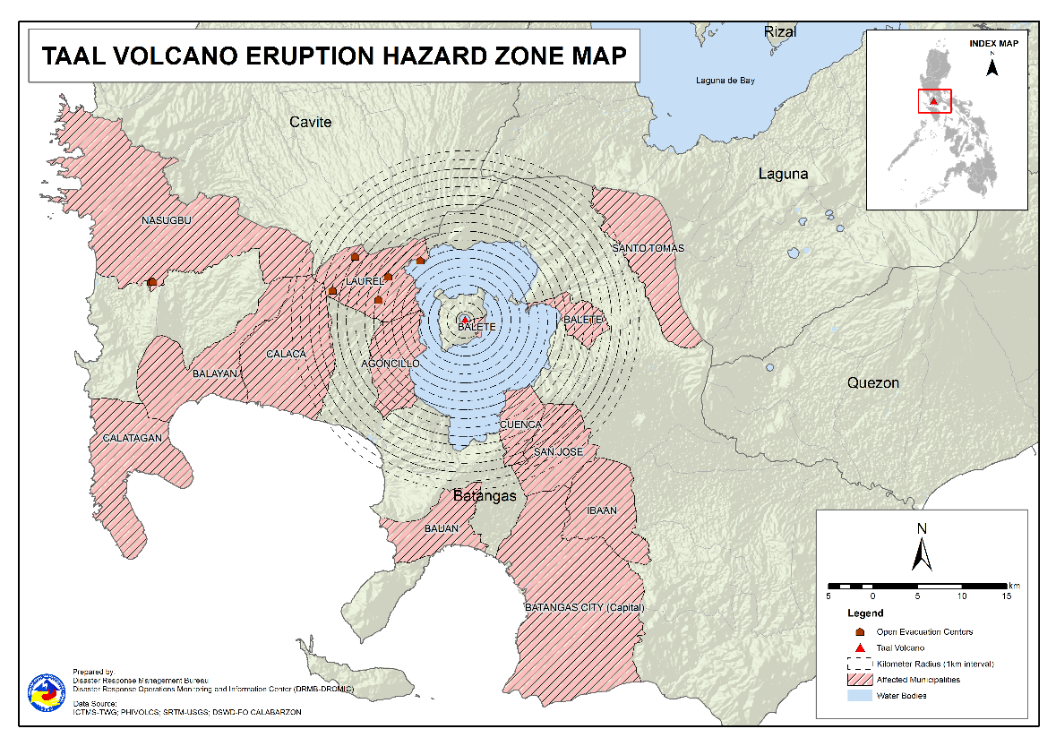

Situational Reports

DSWD-DRMB
DATE | SITUATIONS / ACTIONS UNDERTAKEN
03 July 2021 | - The Disaster Response Management Bureau (DRMB) is closely coordinating with DSWD-FO CALABARZON for significant reports on the status of affected families, assistance, and relief efforts.

DSWD-NRLMB
DATE | SITUATIONS / ACTIONS UNDERTAKEN
02 July 2021 | - The National Resource and Logistics Management Bureau (NRLMB) augmented food and non-food items (FNIs) to DSWD-FO CALABARZON amounting to a total of ₱14,816,825.00  Items UOM QUANTITY Unit Cost Total Cost  Family Food Packs packs 8,500 778.45 ₱6,616,825.00  Family Tent set 500 16,400.00 ₱8,200,000.00  Total Price ₱14,816,825.00

DSWD-FO CALABARZON
DATE | SITUATIONS / ACTIONS UNDERTAKEN
02 July 2021 | - DSWD-FO CALABARZON Emergency Operations Center (EOC) is maintained on heightened alert status to collect information – from the Local Government Units (LGUs) and Local Social Welfare and Development Offices (LSWDOs) in connection with their preparedness for response efforts.  - DSWD Secretary Rolando Joselito D. Bautista together with Undersecretary for Disaster Response Management Group, Felicisimo C. Budiongan; Dir. Clifford Cyril Y. Riveral of Disaster Response Management Bureau (DRMB); and Dir. Emmanuel P. Privado of National Resource and Logistics Management Bureau (NRLMB) conducted ocular visits to the evacuation areas in Laurel and Agoncillo, Batangas.  - Ms. Mylah S. Gatchalian, Assistant Regional Director for Administration represented DSWD-FO CALABARZON in the RDRRMC IV-A Response Cluster meeting through virtual teleconference. The meeting served as a venue to discuss the response activities conducted by the lead cluster in the last 24 hours.  - The members of the Regional Quick Response Teams (QRT) were deployed to the evacuation centers in Agoncillo and Laurel, Batangas to conduct Rapid Damage Assessment and Needs Analysis (RDANA) and identify the immediate needs of the IDPs.  - DSWD-FO CALABARZON EOC coordinated with NRLMB for the delivery of 3,500 family food packs (FFPs) and 300 family tents to Batangas Provincial Social Welfare and Development Office (PSWDO).  - DSWD-FO CALABARZON through its Disaster Response Management Division (DRMD) coordinated with the Logistics Cluster for the provision of appropriate vehicle to transport 500 modular tents to the evacuation centers.

*****
The Disaster Response Operations Monitoring and Information Center (DROMIC) of the DSWD-DRMB is closely coordinating with the concerned DSWD Field Office CALABARZON for any significant disaster response updates.

Prepared by:  MARIEL B. FERRARIZ  DIANE C. PELEGRINO  AARON JOHN B. PASCUA | Released by:  MARC LEO L. BUTAC

