DSWD DROMIC Report #02 on the Taal Volcano Eruption
as of 05 July 2021, 6PM

- Situation Overview

On 01 July 2021 at 3:37 PM, the Philippine Institute of Volcanology and Seismology (PHIVOLCS) has raised alert level 3 over Taal Volcano after a phreatomagmatic eruption from the main crater occurred at 3:16 PM. Communities around the Taal Lake shores were advised to remain vigilant, take precautionary measures against possible airborne ash and vog and calmly prepare for possible evacuation should unrest intensify.
Source: Philippine Institute of Volcanology and Seismology (PHIVOLCS)

- Status of Affected Areas and Population

A total of 1,209 families or 4,619 persons were affected by the Taal Volcano eruption in 61 Barangays in CALABARZON (see Table 1).

Table 1. Number of Affected Families / Persons
REGION / PROVINCE / MUNICIPALITY |  | NUMBER OF AFFECTED
 |  | Barangays | Families | Persons
GRAND TOTAL |  | 61 | 1,209 | 4,619
CALABARZON |  | 61 | 1,209 | 4,619
Batangas |  | 61 | 1,209 | 4,619
 | Agoncillo | 11 | 164 | 649
 | Balete | 2 | 64 | 236
 | Cuenca | 1 | 20 | 59
 | Laurel | 10 | 684 | 2,660
 | Lemery | 7 | 25 | 98
 | Mataas Na Kahoy | 1 | 4 | 9
 | San Jose | 1 | 2 | 9
 | San Nicolas | 8 | 54 | 208
 | Taal | 6 | 14 | 47
 | Talisay | 5 | 10 | 38
 | City of Tanauan | 9 | 168 | 606
Note: Ongoing assessment and validation are continuously being conducted.
Sources: DSWD-FO CALABARZON

- Status of Displaced Population

- Inside Evacuation Centers

There are 507 families or 1,970 persons currently taking temporary shelter in 14 evacuation centers in CALABARZON (see Table 2):

Table 2. Number of Displaced Families / Persons Inside Evacuation Centers
REGION / PROVINCE / MUNICIPALITY |  | NUMBER OF EVACUATION CENTERS (ECs) |  | NUMBER OF DISPLACED
 |  |  |  | INSIDE ECs
 |  |  |  | Families |  | Persons
 |  | CUM | NOW | CUM | NOW | CUM | NOW
GRAND TOTAL |  | 14 | 14 | 521 | 507 | 2,038 | 1,970
CALABARZON |  | 14 | 14 | 521 | 507 | 2,038 | 1,970
Batangas |  | 14 | 14 | 521 | 507 | 2,038 | 1,970
 | Agoncillo | 2 | 2 | 29 | 29 | 137 | 137
 | Balete | 1 | 1 | 63 | 63 | 231 | 231
 | Laurel | 9 | 9 | 378 | 371 | 1,479 | 1,435
 | Nasugbu | 2 | 2 | 51 | 44 | 191 | 167
Note: Ongoing assessment and validation are continuously being conducted.
Sources: DSWD-FO CALABARZON

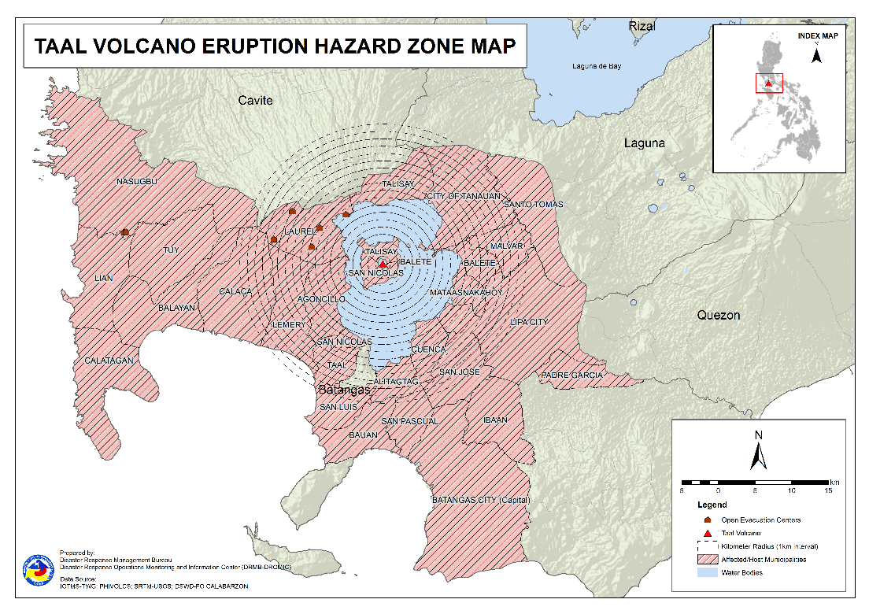

- Outside Evacuation Centers

There are 679 families or 2,554 persons temporarily staying with their relatives and/or friends in CALABARZON (see Table 3):

Table 3. Number of Displaced Families / Persons Outside Evacuation Centers
REGION / PROVINCE / MUNICIPALITY |  | NUMBER OF DISPLACED
 |  | OUTSIDE ECs
 |  | Families |  | Persons
 |  | CUM | NOW | CUM | NOW
GRAND TOTAL |  | 688 | 679 | 2,581 | 2,554
CALABARZON |  | 688 | 679 | 2,581 | 2,554
Batangas |  | 688 | 679 | 2,581 | 2,554
 | Agoncillo | 66 | 63 | 270 | 261
 | Alitagtag | 15 | 15 | 51 | 51
 | Balayan | 27 | 26 | 112 | 111
 | Balete | 1 | 1 | 3 | 3
 | Batangas City (capital) | 19 | 19 | 69 | 69
 | Bauan | 63 | 58 | 205 | 191
 | Calaca | 14 | 14 | 48 | 48
 | Calatagan | 22 | 22 | 94 | 91
 | Cuenca | 20 | 20 | 59 | 59
 | Ibaan | 4 | 4 | 16 | 16
 | Laurel | 209 | 209 | 765 | 765
 | Lian | 3 | 3 | 4 | 4
 | Lipa City | 4 | 4 | 9 | 9
 | Malvar | 7 | 7 | 19 | 19
 | Nasugbu | 1 | 1 | 13 | 13
 | Padre Garcia | 1 | 1 | 3 | 3
 | San Jose | 17 | 17 | 67 | 67
 | San Luis | 12 | 12 | 48 | 48
 | San Nicolas | 7 | 7 | 31 | 31
 | San Pascual | 2 | 2 | 6 | 6
 | Santo Tomas | 31 | 31 | 166 | 166
 | Taal | 7 | 7 | 20 | 20
 | Talisay | 3 | 3 | 17 | 17
 | City of Tanauan | 130 | 130 | 464 | 464
 | Tuy | 3 | 3 | 22 | 22
Note: Ongoing assessment and validation are continuously being conducted.
Sources: DSWD-FO CALABARZON

- Total Displaced Population

A total of 891 families or 3,385 persons are displaced in CALABARZON due to Taal Volcano eruption (see Table 4):

Table 4. Total Number of Displaced Families / Persons
REGION / PROVINCE / MUNICIPALITY |  | TOTAL DISPLACED
 |  | Families |  | Persons
 |  | Total Families |  | Total Persons
 |  | CUM | NOW | CUM | NOW
GRAND TOTAL |  | 901 | 891 | 3,438 | 3,385
CALABARZON |  | 901 | 891 | 3,438 | 3,385
Batangas |  | 901 | 891 | 3,438 | 3,385
 | Agoncillo | 95 | 92 | 407 | 398
 | Balete | 63 | 63 | 231 | 231
 | Cuenca | 20 | 20 | 59 | 59
 | Laurel | 587 | 580 | 2,244 | 2,200
 | San Jose | 2 | 2 | 9 | 9
 | San Nicolas | 4 | 4 | 20 | 20
 | Talisay | 3 | 3 | 12 | 12
 | City of Tanauan | 127 | 127 | 456 | 456
Note: Ongoing assessment and validation are continuously being conducted.
Sources: DSWD-FO CALABARZON

- Response Actions and Interventions

- Standby Funds and Prepositioned Relief Stockpile

Office | QRF /  Standby Funds | FFPs |  | Other F/NFIs | Total
 |  | No. | Cost
DSWD-CO | 156,765,441.32 | - | - | - | 156,765,441.32
NROC | - | 32,001 | 24,794,388.20 | 265,035,053.81 | 289,829,442.01
VDRC | - | 741 | 329,745.00 | 39,223,439.05 | 39,553,184.05
DSWD-FO IV-A | 3,000,000.00 | 3,983 | 1,936,904.00 | 19,200,216.68 | 24,137,120.68
Other DSWD-FOs | 36,926,915.97 | 259,047 | 129,991,479.08 | 393,207,667.91 | 560,126,062.96
Total | 196,692,357.29 | 295,772 | 157,052,516.28 | 716,666,377.45 | 1,070,411,251.02

- Standby Funds

- ₱156.8 million Quick Response Fund (QRF) at the DSWD-Central Office. Request for replenishment in the amount of ₱662.5 million dated 16 June 2021 is currently on process for release of SARO by the Department of Budget and Management (DBM).
- ₱3 million at DSWD-FO CALABARZON.
- ₱36.9 million in other DSWD-FOs which may support the relief needs of the displaced families due to Taal Volcano eruption through inter-FO augmentation.

- Prepositioned FFPs and Other Relief Items

- 32,742 FFPs available in Disaster Response Centers; of which, 32,001 FFPs are at the National Resource Operations Center (NROC), Pasay City and 741 FFPs are at the Visayas Disaster Response Center (VDRC), Cebu City.
- 3,983 FFPs at DSWD-FO CALABARZON.
- 259,047 FFPs in other DSWD-FOs which may support the relief needs of the displaced families due to Taal Volcano Eruption through inter-FO augmentation.
- ₱157 million worth of other food and non-food items (FNIs) at NROC, VDRC and DSWD-FO warehouse countrywide.

- Food and Non-Food Items (NFIs)

- NRLMB augmentation support to DSWD-FO CALABARZON amounting to ₱39,974,325.00.
- A total of 8,500 FFPs (₱6,616,825.00) and 500 family tents (₱8,200,000.00) out of total number of augmentation support provided by NRLMB to DSWD-FO CALABARZON were directly delivered to the Provincial Social Welfare Office (PSWDO) of Batangas for the needs of the displaced families.
- 5,000 Family kits (₱11,440,000.00) and 2,000 hygiene kits (₱2,947,000.00) are in-transit to Batangas Sports Complex, Batangas City and Laurel, Batangas, respectively.
- 3,000 Hygiene kits (₱4,420,500.00) and 5,000 sleeping kits (₱6,350,000.00) are for delivery to Batangas Provincial Sports Complex, Batangas City.

- Camp Coordination and Camp Management (CCCM)

- Deployment of Quick Response Teams (QRTs) by the DSWD-FO CALABARZON in the evacuation centers in Agoncillo and Laurel, Batangas to conduct rapid needs assessment.

- Ocular visit by Secretary Rolando Joselito D. Bautista and other officials and staffs from DSWD-Central Office and DSWD-FO CALABARZON on 02 July 2021 in various evacuation centers in Agoncillo and Laurel, Batangas to assess the needs of the displaced families.

- Provision of 500 modular tents donated by the International Organization for Migration (IOM) amounting to ₱2,500,000.00 at ₱5,000.00 each currently being facilitated by DSWD-FO CALABARZON for the transport to the evacuation centers in Agoncillo and Laurel, Batangas through the support of the RDRRMC Logistics Cluster.

- Other Activities

- 24/7 operations of DROMIC and Emergency Operations Centers (EOCs) at the DSWD-Central and DSWD-FO CALABARZON levels.

- Participation in virtual meetings to present and discuss preparedness and response efforts:

- DRMB and NRLMB at the NDRRMC level
- DSWD-FO CALABARZON at the RDRRMC level

- Photo Documentation

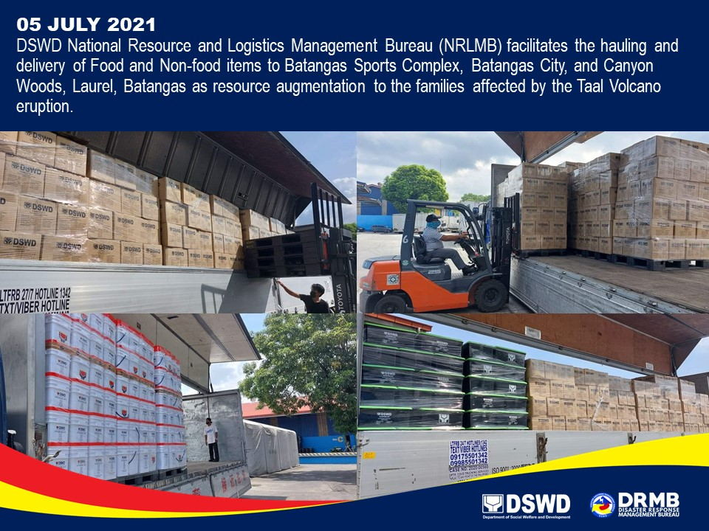

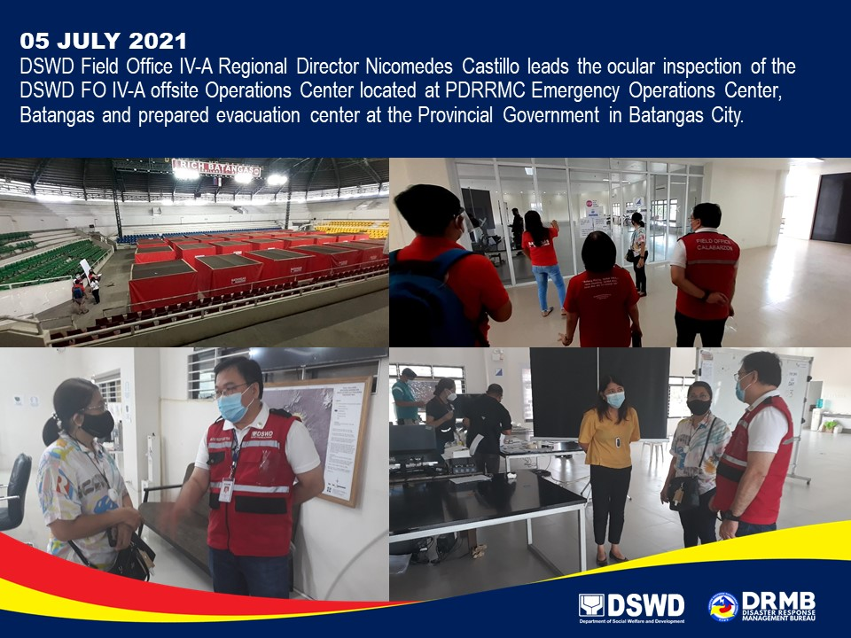
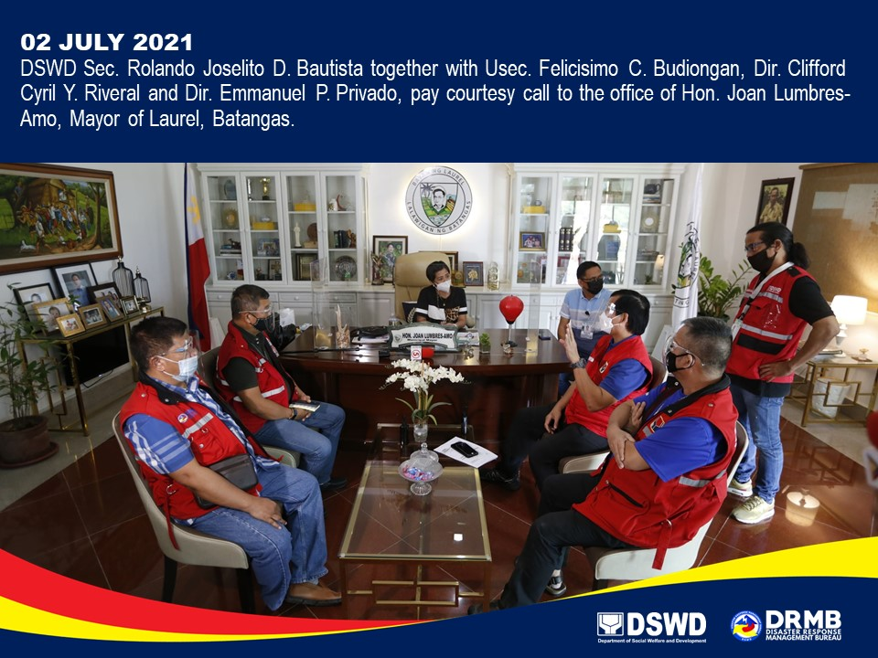

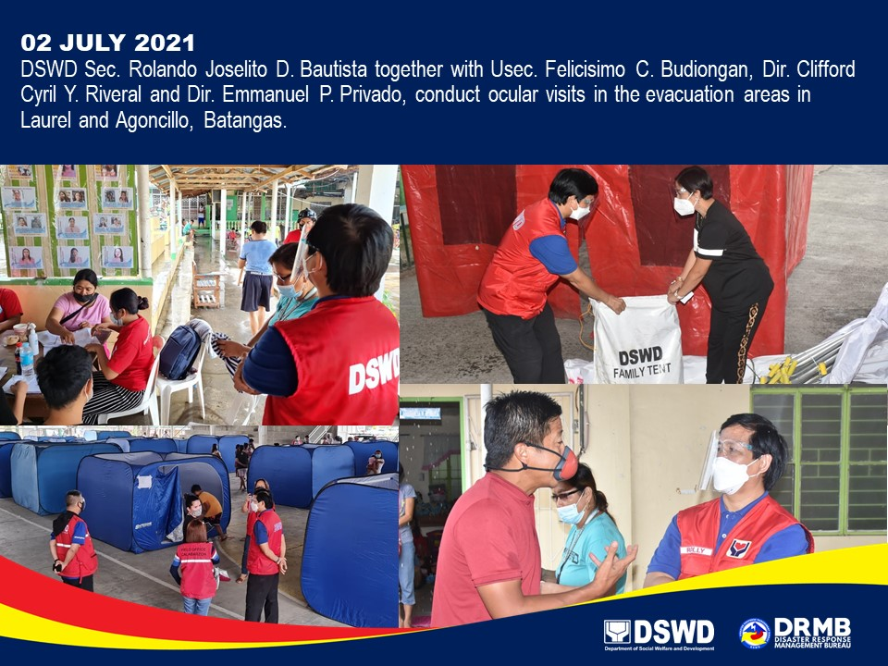

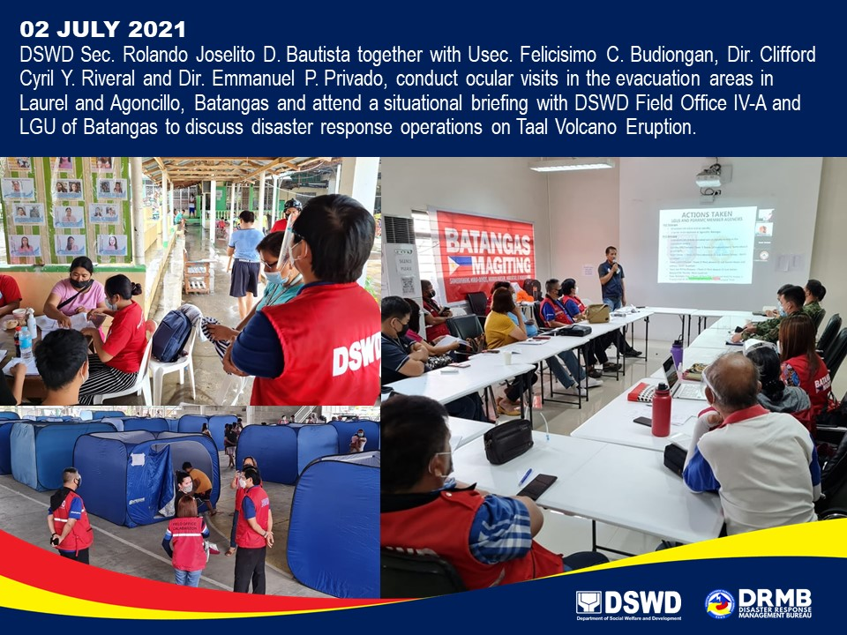

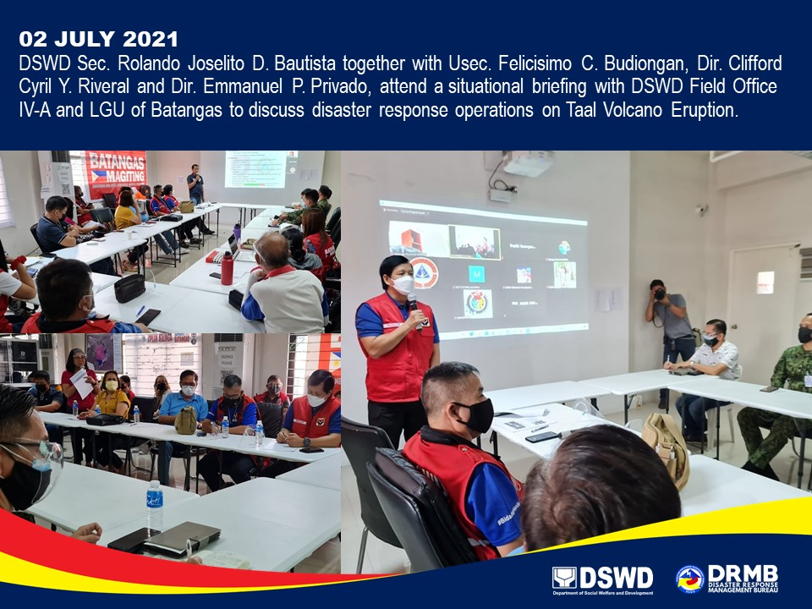

*****
The Disaster Response Operations Monitoring and Information Center (DROMIC) of DSWD-DRMB is closely coordinating with DSWD-FO CALABARZON for significant disaster response updates and assistance provided.

Prepared by:  MARIEL B. FERRARIZ | Released by:  MARC LEO L. BUTAC

