DSWD DROMIC Report #03 on the Taal Volcano Eruption
as of 06 July 2021, 6PM

- Situation Overview

On 01 July 2021 at 3:37 PM, the Philippine Institute of Volcanology and Seismology (PHIVOLCS) has raised alert level 3 over Taal Volcano after a phreatomagmatic eruption from the main crater occurred at 3:16 PM. Communities around the Taal Lake shores were advised to remain vigilant, take precautionary measures against possible airborne ash and vog and calmly prepare for possible evacuation should unrest intensify.
Source: Philippine Institute of Volcanology and Seismology (PHIVOLCS)

- Status of Affected Areas and Population

A total of 1,554 families or 5,872 persons were affected by the Taal Volcano eruption in 63 Barangays in CALABARZON (see Table 1).

Table 1. Number of Affected Families / Persons
REGION / PROVINCE / MUNICIPALITY |  | NUMBER OF AFFECTED
 |  | Barangays | Families | Persons
GRAND TOTAL |  | 63 | 1,554 | 5,872
CALABARZON |  | 63 | 1,554 | 5,872
Batangas |  | 63 | 1,554 | 5,872
 | Agoncillo | 11 | 427 | 1,633
 | Balete | 2 | 64 | 236
 | Cuenca | 1 | 20 | 59
 | Laurel | 11 | 735 | 2,833
 | Lemery | 8 | 36 | 142
 | Mataas Na Kahoy | 1 | 5 | 12
 | San Jose | 1 | 2 | 9
 | San Nicolas | 8 | 54 | 208
 | Taal | 6 | 26 | 72
 | Talisay | 5 | 11 | 43
 | City of Tanauan | 9 | 174 | 625
Note: Ongoing assessment and validation are continuously being conducted.
Sources: DSWD-FO CALABARZON

- Status of Displaced Population

- Inside Evacuation Centers

There are 797 families or 3,027 persons currently taking temporary shelter in 20 evacuation centers in CALABARZON (see Table 2):

Table 2. Number of Displaced Families / Persons Inside Evacuation Centers
REGION / PROVINCE / MUNICIPALITY |  | NUMBER OF EVACUATION CENTERS (ECs) |  | NUMBER OF DISPLACED
 |  |  |  | INSIDE ECs
 |  |  |  | Families |  | Persons
 |  | CUM | NOW | CUM | NOW | CUM | NOW
GRAND TOTAL |  | 20 | 20 | 809 | 797 | 3,098 | 3,027
CALABARZON |  | 20 | 20 | 809 | 797 | 3,098 | 3,027
Batangas |  | 20 | 20 | 809 | 797 | 3,098 | 3,027
 | Agoncillo | 7 | 7 | 266 | 266 | 1,014 | 1,014
 | Balete | 1 | 1 | 63 | 63 | 231 | 231
 | Laurel | 10 | 10 | 412 | 406 | 1,591 | 1,554
 | Nasugbu | 2 | 2 | 68 | 62 | 262 | 228
Note: Ongoing assessment and validation are continuously being conducted.
Sources: DSWD-FO CALABARZON

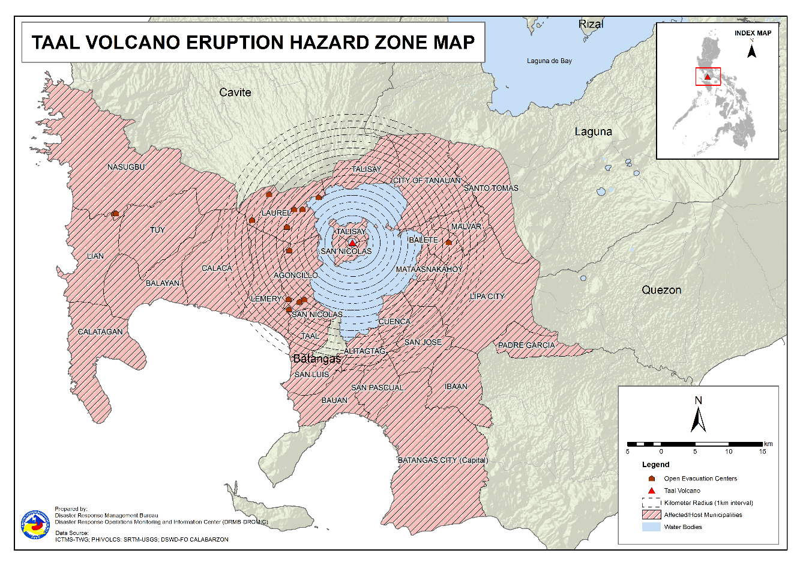

- Outside Evacuation Centers

There are 738 families or 2,759 persons temporarily staying with their relatives and/or friends in CALABARZON (see Table 3):

Table 3. Number of Displaced Families / Persons Outside Evacuation Centers
REGION / PROVINCE / MUNICIPALITY |  | NUMBER OF DISPLACED
 |  | OUTSIDE ECs
 |  | Families |  | Persons
 |  | CUM | NOW | CUM | NOW
GRAND TOTAL |  | 747 | 738 | 2,786 | 2,759
CALABARZON |  | 747 | 738 | 2,786 | 2,759
Batangas |  | 747 | 738 | 2,786 | 2,759
 | Agoncillo | 66 | 63 | 270 | 261
 | Alitagtag | 21 | 21 | 73 | 73
 | Balayan | 37 | 36 | 142 | 141
 | Balete | 1 | 1 | 3 | 3
 | Batangas City (capital) | 24 | 24 | 72 | 72
 | Bauan | 68 | 63 | 227 | 213
 | Calaca | 25 | 25 | 84 | 84
 | Calatagan | 22 | 22 | 94 | 91
 | Cuenca | 20 | 20 | 59 | 59
 | Ibaan | 4 | 4 | 16 | 16
 | Laurel | 209 | 209 | 765 | 765
 | Lemery | 7 | 7 | 31 | 31
 | Lian | 3 | 3 | 4 | 4
 | Lipa City | 4 | 4 | 9 | 9
 | Malvar | 7 | 7 | 19 | 19
 | Nasugbu | 1 | 1 | 13 | 13
 | Padre Garcia | 1 | 1 | 3 | 3
 | San Jose | 21 | 21 | 85 | 85
 | San Luis | 15 | 15 | 65 | 65
 | San Nicolas | 7 | 7 | 31 | 31
 | San Pascual | 5 | 5 | 14 | 14
 | Santo Tomas | 33 | 33 | 173 | 173
 | Taal | 7 | 7 | 20 | 20
 | Talisay | 3 | 3 | 17 | 17
 | City of Tanauan | 131 | 131 | 469 | 469
 | Tuy | 5 | 5 | 28 | 28
Note: Ongoing assessment and validation are continuously being conducted.
Sources: DSWD-FO CALABARZON

- Total Displaced Population

A total of 1,535 families or 5,786 persons are displaced in CALABARZON due to Taal Volcano eruption (see Table 4):

Table 4. Total Number of Displaced Families / Persons
REGION / PROVINCE / MUNICIPALITY |  | TOTAL DISPLACED SERVED
 |  | Families |  | Persons
 |  | CUM | NOW | CUM | NOW
GRAND TOTAL |  | 1,556 | 1,535 | 5,884 | 5,786
CALABARZON |  | 1,556 | 1,535 | 5,884 | 5,786
Batangas |  | 1,556 | 1,535 | 5,884 | 5,786
 | Agoncillo | 332 | 329 | 1,284 | 1,275
 | Alitagtag | 21 | 21 | 73 | 73
 | Balayan | 37 | 36 | 142 | 141
 | Balete | 64 | 64 | 234 | 234
 | Batangas City (capital) | 24 | 24 | 72 | 72
 | Bauan | 68 | 63 | 227 | 213
 | Calaca | 25 | 25 | 84 | 84
 | Calatagan | 22 | 22 | 94 | 91
 | Cuenca | 20 | 20 | 59 | 59
 | Ibaan | 4 | 4 | 16 | 16
 | Laurel | 621 | 615 | 2,356 | 2,319
 | Lemery | 7 | 7 | 31 | 31
 | Lian | 3 | 3 | 4 | 4
 | Lipa City | 4 | 4 | 9 | 9
 | Malvar | 7 | 7 | 19 | 19
 | Nasugbu | 69 | 63 | 275 | 241
 | Padre Garcia | 1 | 1 | 3 | 3
 | San Jose | 21 | 21 | 85 | 85
 | San Luis | 15 | 15 | 65 | 65
 | San Nicolas | 7 | 7 | 31 | 31
 | San Pascual | 5 | 5 | 14 | 14
 | Santo Tomas | 33 | 33 | 173 | 173
 | Taal | 7 | 7 | 20 | 20
 | Talisay | 3 | 3 | 17 | 17
 | City of Tanauan | 131 | 131 | 469 | 469
 | Tuy | 5 | 5 | 28 | 28

Note: Ongoing assessment and validation are continuously being conducted.
Sources: DSWD-FO CALABARZON

- Response Actions and Interventions

- Standby Funds and Prepositioned Relief Stockpile

Office | QRF /  Standby Funds | FFPs |  | Other F/NFIs | Total
 |  | No. | Cost
DSWD-CO | 156,765,441.32 | - | - | - | 156,765,441.32
NROC | - | 32,001 | 24,794,388.20 | 257,774,463.48 | 282,568,851.68
VDRC | - | 741 | 329,745.00 | 39,223,439.05 | 39,553,184.05
DSWD-FO IV-A | 3,000,000.00 | 3,953 | 1,970,024.00 | 18,427,066.67 | 23,397,090.67
Other DSWD-FOs | 39,926,915.97 | 271,548 | 140,666,248.08 | 395,383,715.37 | 575,976,879.42
Total | 199,692,357.29 | 308,243 | 167,760,405.28 | 710,808,684.57 | 1,078,261,447.14
Note: The Inventory Summary is as of 06 July 2021, 3PM.

- Standby Funds

- ₱156.8 million Quick Response Fund (QRF) at the DSWD-Central Office. Request for replenishment in the amount of ₱662.5 million dated 16 June 2021 is currently on process for release of SARO by the Department of Budget and Management (DBM).
- ₱3 million at DSWD-FO CALABARZON.
- ₱39.9 million in other DSWD-FOs which may support the relief needs of the displaced families due to Taal Volcano eruption through inter-FO augmentation.

- Prepositioned FFPs and Other Relief Items

- 32,742 FFPs available in Disaster Response Centers; of which, 32,001 FFPs are at the National Resource Operations Center (NROC), Pasay City and 741 FFPs are at the Visayas Disaster Response Center (VDRC), Cebu City.
- 3,953 FFPs at DSWD-FO CALABARZON.
- 271,548 FFPs in other DSWD-FOs which may support the relief needs of the displaced families due to Taal Volcano Eruption through inter-FO augmentation.
- ₱710.8 million worth of other food and non-food items (FNIs) at NROC, VDRC and DSWD-FO warehouse countrywide.

- Food and Non-Food Items (NFIs)

- NRLMB augmentation support to DSWD-FO CALABARZON amounting to ₱42,950,905.00.
- A total of 8,500 FFPs (₱6,616,825.00), 200 family tents (₱3,280,000.00), 5,000 family kits (₱11,440,000.00), 3,000 hygiene kits (₱4,420,500.00), and 4,279 sleeping kits (₱6,350,000.00) out of total number of augmentation support provided by NRLMB to DSWD-FO CALABARZON were directly delivered to the Provincial Social Welfare Office (PSWDO) of Batangas for the needs of the displaced families.
- 300 Family tents (₱4,920,000.00) and 2,000 hygiene kits (₱2,947,000.00) were provided to Laurel, Batangas.
- Additional 5,000 FFPs (₱3,892,250.00) are in-transit to Batangas Provincial Sports Complex.

- Camp Coordination and Camp Management (CCCM)

- Deployment of Quick Response Teams (QRTs) by the DSWD-FO CALABARZON in the evacuation centers in Agoncillo and Laurel, Batangas to conduct rapid needs assessment.

- Ocular visit by Secretary Rolando Joselito D. Bautista and other officials and staffs from DSWD-Central Office and DSWD-FO CALABARZON on 02 July 2021 in various evacuation centers in Agoncillo and Laurel, Batangas to assess the needs of the displaced families.

- Provision of 450 modular tents, 150 information board, and personal protective equipment (PPE) donated by the International Organization for Migration (IOM) currently being facilitated by DSWD-FO CALABARZON for transport Batangas through the support of the RDRRMC Logistics Cluster.

- Other Activities

- 24/7 operations of DROMIC and Emergency Operations Centers (EOCs) at the DSWD-Central and DSWD-FO CALABARZON levels.

- Participation in virtual meetings to present and discuss preparedness and response efforts:

- DRMB and NRLMB at the NDRRMC level
- DSWD-FO CALABARZON at the RDRRMC level

- DSWD-FO CALABARZON is set to deliver 1,200 FFPs in Agoncillo, Batangas on 06 July 2021 while the remaining 300 FFPs will be delivered within the week.

- Photo Documentation

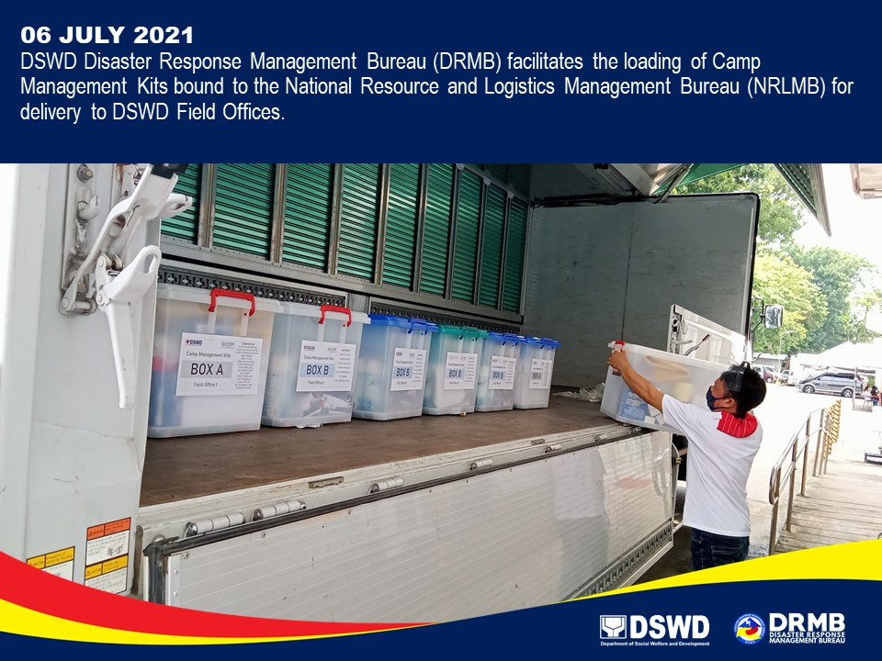

*****
The Disaster Response Operations Monitoring and Information Center (DROMIC) of DSWD-DRMB is closely coordinating with DSWD-FO CALABARZON for significant disaster response updates and assistance provided.

Prepared by:  MARIEL B. FERRARIZ | Released by:  MARC LEO L. BUTAC

