DSWD DROMIC Report #04 on the Taal Volcano Eruption
as of 07 July 2021, 6PM

- Situation Overview

On 01 July 2021 at 3:37 PM, the Philippine Institute of Volcanology and Seismology (PHIVOLCS) has raised alert level 3 over Taal Volcano after a phreatomagmatic eruption from the main crater occurred at 3:16 PM. Communities around the Taal Lake shores were advised to remain vigilant, take precautionary measures against possible airborne ash and vog and calmly prepare for possible evacuation should unrest intensify.
Source: Philippine Institute of Volcanology and Seismology (PHIVOLCS)

- Status of Affected Areas and Population

A total of 1,570 families or 5,929 persons were affected by the Taal Volcano eruption in 64 Barangays in CALABARZON (see Table 1).

Table 1. Number of Affected Families / Persons
REGION / PROVINCE / MUNICIPALITY |  | NUMBER OF AFFECTED
 |  | Barangays | Families | Persons
GRAND TOTAL |  | 64 | 1,570 | 5,929
CALABARZON |  | 64 | 1,570 | 5,929
Batangas |  | 64 | 1,570 | 5,929
 | Agoncillo | 12 | 441 | 1,678
 | Balete | 2 | 64 | 236
 | Cuenca | 1 | 20 | 59
 | Laurel | 11 | 737 | 2,845
 | Lemery | 8 | 36 | 142
 | Mataas Na Kahoy | 1 | 5 | 12
 | San Jose | 1 | 2 | 9
 | San Nicolas | 8 | 54 | 208
 | Taal | 6 | 26 | 72
 | Talisay | 5 | 11 | 43
 | City of Tanauan | 9 | 174 | 625
Note: Ongoing assessment and validation are continuously being conducted.
Sources: DSWD-FO CALABARZON

- Status of Displaced Population

- Inside Evacuation Centers

There are 797 families or 3,027 persons currently taking temporary shelter in 20 evacuation centers in CALABARZON (see Table 2):

Table 2. Number of Displaced Families / Persons Inside Evacuation Centers
REGION / PROVINCE / MUNICIPALITY |  | NUMBER OF EVACUATION CENTERS (ECs) |  | NUMBER OF DISPLACED
 |  |  |  | INSIDE ECs
 |  |  |  | Families |  | Persons
 |  | CUM | NOW | CUM | NOW | CUM | NOW
GRAND TOTAL |  | 20 | 20 | 809 | 797 | 3,098 | 3,027
CALABARZON |  | 20 | 20 | 809 | 797 | 3,098 | 3,027
Batangas |  | 20 | 20 | 809 | 797 | 3,098 | 3,027
 | Agoncillo | 7 | 7 | 266 | 266 | 1,014 | 1,014
 | Balete | 1 | 1 | 63 | 63 | 231 | 231
 | Laurel | 10 | 10 | 412 | 406 | 1,591 | 1,554
 | Nasugbu | 2 | 2 | 68 | 62 | 262 | 228
Note: Ongoing assessment and validation are continuously being conducted.
Sources: DSWD-FO CALABARZON

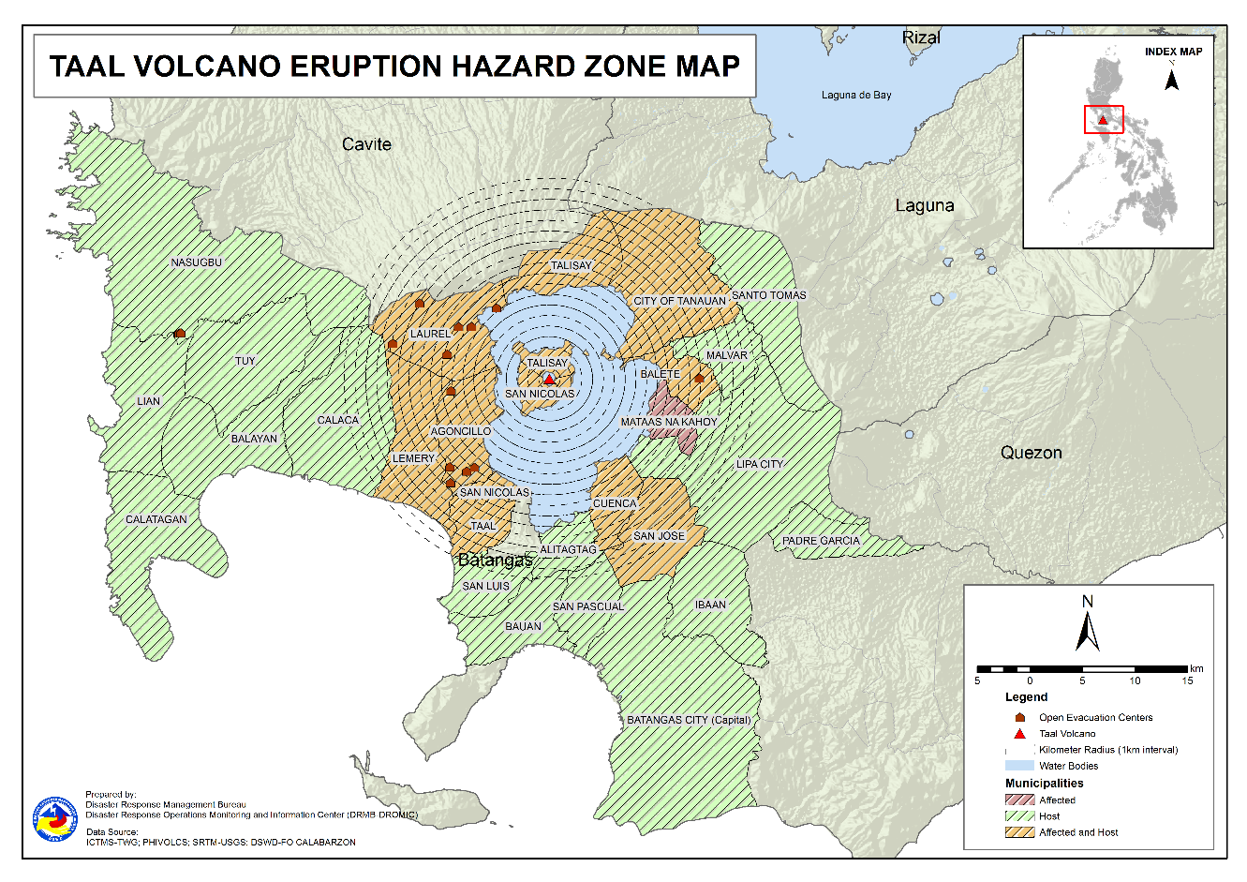

- Outside Evacuation Centers

There are 747 families or 2,786 persons temporarily staying with their relatives and/or friends in CALABARZON (see Table 3):

Table 3. Number of Displaced Families / Persons Outside Evacuation Centers
REGION / PROVINCE / MUNICIPALITY |  | NUMBER OF DISPLACED
 |  | OUTSIDE ECs
 |  | Families |  | Persons
 |  | CUM | NOW | CUM | NOW
GRAND TOTAL |  | 756 | 747 | 2,813 | 2,786
CALABARZON |  | 756 | 747 | 2,813 | 2,786
Batangas |  | 756 | 747 | 2,813 | 2,786
 | Agoncillo | 72 | 69 | 284 | 275
 | Alitagtag | 21 | 21 | 73 | 73
 | Balayan | 37 | 36 | 142 | 141
 | Balete | 1 | 1 | 3 | 3
 | Batangas City (capital) | 24 | 24 | 72 | 72
 | Bauan | 68 | 63 | 227 | 213
 | Calaca | 25 | 25 | 84 | 84
 | Calatagan | 22 | 22 | 94 | 91
 | Cuenca | 20 | 20 | 59 | 59
 | Ibaan | 4 | 4 | 16 | 16
 | Laurel | 209 | 209 | 765 | 765
 | Lemery | 7 | 7 | 31 | 31
 | Lian | 3 | 3 | 4 | 4
 | Lipa City | 4 | 4 | 9 | 9
 | Malvar | 7 | 7 | 19 | 19
 | Nasugbu | 1 | 1 | 13 | 13
 | Padre Garcia | 1 | 1 | 3 | 3
 | San Jose | 24 | 24 | 98 | 98
 | San Luis | 15 | 15 | 65 | 65
 | San Nicolas | 7 | 7 | 31 | 31
 | San Pascual | 5 | 5 | 14 | 14
 | Santo Tomas | 33 | 33 | 173 | 173
 | Taal | 7 | 7 | 20 | 20
 | Talisay | 3 | 3 | 17 | 17
 | City of Tanauan | 131 | 131 | 469 | 469
 | Tuy | 5 | 5 | 28 | 28
Note: Ongoing assessment and validation are continuously being conducted.
Sources: DSWD-FO CALABARZON

- Total Displaced Population

A total of 1,544 families or 5,813 persons are displaced in CALABARZON due to Taal Volcano eruption (see Table 4):

Table 4. Total Number of Displaced Families / Persons
REGION / PROVINCE / MUNICIPALITY |  | TOTAL DISPLACED SERVED
 |  | Families |  | Persons
 |  | Total Families |  | Total Persons
 |  | CUM | NOW | CUM | NOW
GRAND TOTAL |  | 1,565 | 1,544 | 5,911 | 5,813
CALABARZON |  | 1,565 | 1,544 | 5,911 | 5,813
Batangas |  | 1,565 | 1,544 | 5,911 | 5,813
 | Agoncillo | 338 | 335 | 1,298 | 1,289
 | Alitagtag | 21 | 21 | 73 | 73
 | Balayan | 37 | 36 | 142 | 141
 | Balete | 64 | 64 | 234 | 234
 | Batangas City (capital) | 24 | 24 | 72 | 72
 | Bauan | 68 | 63 | 227 | 213
 | Calaca | 25 | 25 | 84 | 84
 | Calatagan | 22 | 22 | 94 | 91
 | Cuenca | 20 | 20 | 59 | 59
 | Ibaan | 4 | 4 | 16 | 16
 | Laurel | 621 | 615 | 2,356 | 2,319
 | Lemery | 7 | 7 | 31 | 31
 | Lian | 3 | 3 | 4 | 4
 | Lipa City | 4 | 4 | 9 | 9
 | Malvar | 7 | 7 | 19 | 19
 | Nasugbu | 69 | 63 | 275 | 241
 | Padre Garcia | 1 | 1 | 3 | 3
 | San Jose | 24 | 24 | 98 | 98
 | San Luis | 15 | 15 | 65 | 65
 | San Nicolas | 7 | 7 | 31 | 31
 | San Pascual | 5 | 5 | 14 | 14
 | Santo Tomas | 33 | 33 | 173 | 173
 | Taal | 7 | 7 | 20 | 20
 | Talisay | 3 | 3 | 17 | 17
 | City of Tanauan | 131 | 131 | 469 | 469
 | Tuy | 5 | 5 | 28 | 28
Note: Ongoing assessment and validation are continuously being conducted.
Sources: DSWD-FO CALABARZON

- Response Actions and Interventions

- Standby Funds and Prepositioned Relief Stockpile

Office | QRF /  Standby Funds | FFPs |  | Other F/NFIs | Total
 |  | No. | Cost
DSWD-CO | 156,765,441.32 | - | - | - | 156,765,441.32
NROC | - | 27,601 | 21,485,998.45 | 260,523,812.41 | 282,009,810.86
VDRC | - | 741 | 329,745.00 | 39,223,439.05 | 39,553,184.05
DSWD-FO IV-A | 3,000,000.00 | 4,472 | 2,227,448.00 | 16,333,885.18 | 21,561,333.18
Other DSWD-FOs | 39,926,915.97 | 278,955 | 144,248,839.07 | 396,430,503.18 | 580,606,258.22
Total | 199,692,357.29 | 311,769 | 168,292,030.52 | 712,511,639.82 | 1,080,496,027.63
Note: The Inventory Summary is as of 07 July 2021, 4PM.

- Standby Funds

- ₱156.8 million Quick Response Fund (QRF) at the DSWD-Central Office. Request for replenishment in the amount of ₱662.5 million dated 16 June 2021 is currently on process for release of SARO by the Department of Budget and Management (DBM).
- ₱3 million at DSWD-FO CALABARZON.
- ₱39.9 million in other DSWD-FOs which may support the relief needs of the displaced families due to Taal Volcano eruption through inter-FO augmentation.

- Prepositioned FFPs and Other Relief Items

- 28,342 FFPs available in Disaster Response Centers; of which, 27,601 FFPs are at the National Resource Operations Center (NROC), Pasay City and 741 FFPs are at the Visayas Disaster Response Center (VDRC), Cebu City.
- 4,472 FFPs at DSWD-FO CALABARZON.
- 278,955 FFPs in other DSWD-FOs which may support the relief needs of the displaced families due to Taal Volcano Eruption through inter-FO augmentation.
- ₱712.5 million worth of other food and non-food items (FNIs) at NROC, VDRC and DSWD-FO warehouse countrywide.

- Food and Non-Food Items (NFIs)

- NRLMB augmentation support to DSWD-FO CALABARZON amounting to ₱42,950,905.00; delivery completed on 07 July 2021.
- A total of 13,500 FFPs (₱10,509,075.00), 200 family tents (₱3,280,000.00), 5,000 family kits (₱11,440,000.00), 3,000 hygiene kits (₱4,420,500.00), and 4,279 sleeping kits (₱6,350,000.00) out of total number of augmentation support provided by NRLMB to DSWD-FO CALABARZON were directly delivered to the Provincial Social Welfare Office (PSWDO) of Batangas for the needs of the displaced families.
- 300 Family tents (₱4,920,000.00) and 2,000 hygiene kits (₱2,947,000.00) were provided to Laurel, Batangas.

- Internally Displaced Person (IDP) Population

- On 6 July 2021, the Emergency Operations Center (EOC) of DSWD-FO CALABARZON coordinated with the Police Regional Office IV-A for the deployment of police personnel in all the activated evacuation centers.

- Camp Coordination and Camp Management (CCCM)

- DSWD-FO CALABARZON Regional Director Marcelo Nicomedes Castillo conducted a site visit in the Batangas Provincial Evacuation Center at the Batangas Provincial Sports Complex, Batangas City on 6 July 2021.

- The Disaster Response Management Bureau (DRMD) of DSWD-FO CALABARZON tracked and monitored the delivery of the International Organization for Migration (IOM)-donated 477 modular tents and CCCM kits to the Batangas PSWDO warehouse on 6 July 2021.

- The EOC of DSWD-FO CALABARZON coordinated with the local government units (LGUs) with existing evacuation centers and provided technical assistance on the implementation of COVID-19 health and safety protocols on 06 July 2021.

- Other Activities

- 24/7 operations of DROMIC and EOCs at the DSWD-Central and DSWD-FO CALABARZON levels.

- Participation in virtual meetings to present and discuss preparedness and response efforts:

- Disaster Response Management Bureau (DRMB) and National Resource and Logistics Management Bureau (NRLMB) at the NDRRMC level
- DSWD-FO CALABARZON at the RDRRMC level

- A team from DSWD Central Office composed of staffs from DRMB, NRLMB and Information and Communications Technology Management Service (ICTMS) conducted inspection and installation of emergency telecommunication (ETC) equipment at the EOC of DSWD-FO CALABARZON in Alabang, Muntinlupa City and EOC located at the Batangas Provincial Sports Complex, Batangas City on 07 July 2021.

*****
The Disaster Response Operations Monitoring and Information Center (DROMIC) of DSWD-DRMB is closely coordinating with DSWD-FO CALABARZON for significant disaster response updates and assistance provided.

Prepared by:  MARIEL B. FERRARIZ  DIANE C. PELEGRINO | Released by:  MARC LEO L. BUTAC

