DSWD DROMIC Report #05 on the Taal Volcano Eruption
as of 08 July 2021, 6PM

- Situation Overview

On 01 July 2021 at 3:37 PM, the Philippine Institute of Volcanology and Seismology (PHIVOLCS) has raised alert level 3 over Taal Volcano after a phreatomagmatic eruption from the main crater occurred at 3:16 PM. Communities around the Taal Lake shores were advised to remain vigilant, take precautionary measures against possible airborne ash and vog and calmly prepare for possible evacuation should unrest intensify.
Source: Philippine Institute of Volcanology and Seismology (PHIVOLCS)

- Status of Affected Areas and Population

A total of 2,086 families or 7,670 persons were affected by the Taal Volcano eruption in 66 Barangays in CALABARZON (see Table 1).

Table 1. Number of Affected Families / Persons
REGION / PROVINCE / MUNICIPALITY |  | NUMBER OF AFFECTED
 |  | Barangays | Families | Persons
GRAND TOTAL |  | 66 | 2,086 | 7,670
CALABARZON |  | 66 | 2,086 | 7,670
Batangas |  | 66 | 2,086 | 7,670
 | Agoncillo | 12 | 560 | 2,076
 | Balete | 3 | 78 | 271
 | Cuenca | 1 | 22 | 63
 | Laurel | 11 | 1,073 | 3,971
 | Lemery | 8 | 36 | 142
 | Mataas Na Kahoy | 1 | 5 | 12
 | San Jose | 1 | 2 | 9
 | San Nicolas | 8 | 86 | 325
 | Taal | 7 | 33 | 97
 | Talisay | 5 | 18 | 81
 | City of Tanauan | 9 | 173 | 623
Note: Ongoing assessment and validation are continuously being conducted.
Sources: DSWD-FO CALABARZON

- Status of Displaced Population

- Inside Evacuation Centers

There are 1,038 families or 3,691 persons currently taking temporary shelter in 22 evacuation centers in CALABARZON (see Table 2):

Table 2. Number of Displaced Families / Persons Inside Evacuation Centers
REGION / PROVINCE / MUNICIPALITY |  | NUMBER OF EVACUATION CENTERS (ECs) |  | NUMBER OF DISPLACED
 |  |  |  | INSIDE ECs
 |  |  |  | Families |  | Persons
 |  | CUM | NOW | CUM | NOW | CUM | NOW
GRAND TOTAL |  | 22 | 22 | 1,181 | 1,038 | 4,299 | 3,691
CALABARZON |  | 22 | 22 | 1,181 | 1,038 | 4,299 | 3,691
Batangas |  | 22 | 22 | 1,181 | 1,038 | 4,299 | 3,691
 | Agoncillo | 8 | 8 | 330 | 330 | 1,201 | 1,201
 | Balayan | 1 | 1 | 26 | 26 | 94 | 94
 | Balete | 1 | 1 | 76 | 75 | 264 | 258
 | Laurel | 10 | 10 | 679 | 543 | 2,466 | 1,898
 | Nasugbu | 2 | 2 | 70 | 64 | 274 | 240
Note: Ongoing assessment and validation are continuously being conducted.
Sources: DSWD-FO CALABARZON

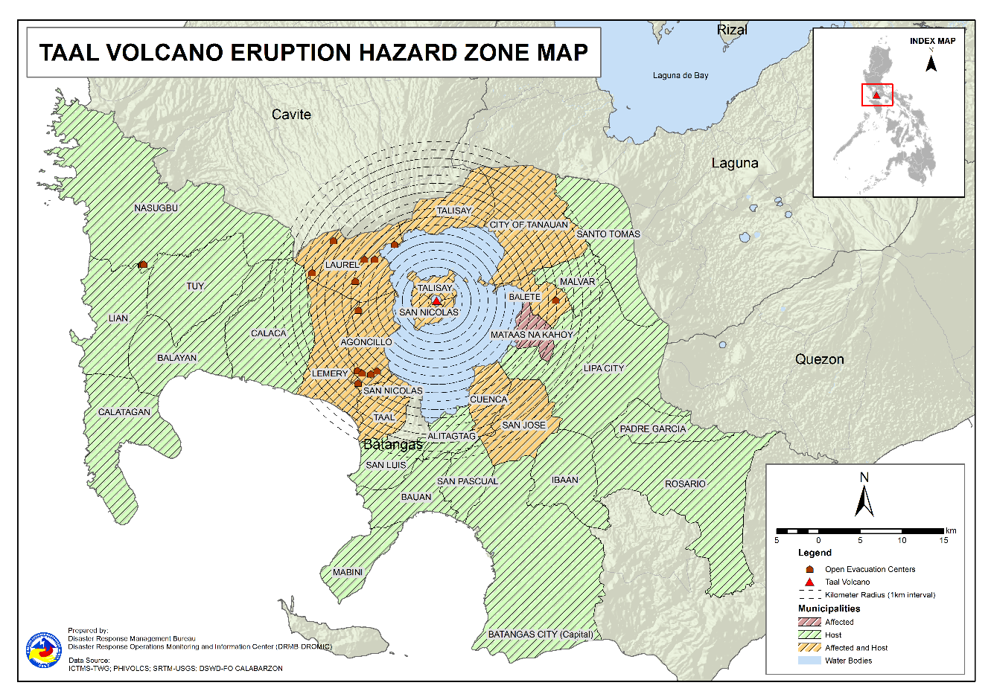

- Outside Evacuation Centers

There are 891 families or 3,319 persons temporarily staying with their relatives and/or friends in CALABARZON (see Table 3):

Table 3. Number of Displaced Families / Persons Outside Evacuation Centers
REGION / PROVINCE / MUNICIPALITY |  | NUMBER OF DISPLACED
 |  | OUTSIDE ECs
 |  | Families |  | Persons
 |  | CUM | NOW | CUM | NOW
GRAND TOTAL |  | 904 | 891 | 3,371 | 3,319
CALABARZON |  | 904 | 891 | 3,371 | 3,319
Batangas |  | 904 | 891 | 3,371 | 3,319
 | Agoncillo | 76 | 76 | 301 | 301
 | Alitagtag | 21 | 21 | 73 | 73
 | Balayan | 38 | 37 | 148 | 145
 | Balete | 1 | 1 | 3 | 3
 | Batangas City (capital) | 24 | 24 | 72 | 72
 | Bauan | 95 | 95 | 335 | 335
 | Calaca | 25 | 25 | 84 | 84
 | Calatagan | 22 | 22 | 94 | 91
 | Cuenca | 22 | 18 | 63 | 48
 | Ibaan | 4 | 4 | 16 | 16
 | Laurel | 276 | 276 | 1,004 | 1,004
 | Lemery | 22 | 22 | 97 | 97
 | Lian | 3 | 3 | 4 | 4
 | Lipa City | 4 | 4 | 9 | 9
 | Mabini | 2 | 2 | 5 | 5
 | Malvar | 9 | 9 | 26 | 26
 | Nasugbu | 1 | 1 | 13 | 13
 | Padre Garcia | 1 | 1 | 3 | 3
 | Rosario | 1 | 1 | 3 | 3
 | San Jose | 25 | 22 | 101 | 88
 | San Luis | 15 | 15 | 65 | 65
 | San Nicolas | 7 | 7 | 31 | 31
 | San Pascual | 16 | 16 | 47 | 47
 | Santo Tomas | 34 | 34 | 183 | 183
 | Taal | 17 | 17 | 48 | 48
 | Talisay | 3 | 3 | 17 | 17
 | City of Tanauan | 135 | 130 | 498 | 480
 | Tuy | 5 | 5 | 28 | 28
Note: Ongoing assessment and validation are continuously being conducted.
Sources: DSWD-FO CALABARZON

- Total Displaced Population

A total of 1,929 families or 7,010 persons are displaced in CALABARZON due to Taal Volcano eruption (see Table 4):

Table 4. Total Number of Displaced Families / Persons
REGION / PROVINCE / MUNICIPALITY |  | TOTAL DISPLACED SERVED
 |  | Families |  | Persons
 |  | Total Families |  | Total Persons
 |  | CUM | NOW | CUM | NOW
GRAND TOTAL |  | 2,085 | 1,929 | 7,670 | 7,010
CALABARZON |  | 2,085 | 1,929 | 7,670 | 7,010
Batangas |  | 2,085 | 1,929 | 7,670 | 7,010
 | Agoncillo | 406 | 406 | 1,502 | 1,502
 | Alitagtag | 21 | 21 | 73 | 73
 | Balayan | 64 | 63 | 242 | 239
 | Balete | 77 | 76 | 267 | 261
 | Batangas City (capital) | 24 | 24 | 72 | 72
 | Bauan | 95 | 95 | 335 | 335
 | Calaca | 25 | 25 | 84 | 84
 | Calatagan | 22 | 22 | 94 | 91
 | Cuenca | 22 | 18 | 63 | 48
 | Ibaan | 4 | 4 | 16 | 16
 | Laurel | 955 | 819 | 3,470 | 2,902
 | Lemery | 22 | 22 | 97 | 97
 | Lian | 3 | 3 | 4 | 4
 | Lipa City | 4 | 4 | 9 | 9
 | Mabini | 2 | 2 | 5 | 5
 | Malvar | 9 | 9 | 26 | 26
 | Nasugbu | 71 | 65 | 287 | 253
 | Padre Garcia | 1 | 1 | 3 | 3
 | Rosario | 1 | 1 | 3 | 3
 | San Jose | 25 | 22 | 101 | 88
 | San Luis | 15 | 15 | 65 | 65
 | San Nicolas | 7 | 7 | 31 | 31
 | San Pascual | 16 | 16 | 47 | 47
 | Santo Tomas | 34 | 34 | 183 | 183
 | Taal | 17 | 17 | 48 | 48
 | Talisay | 3 | 3 | 17 | 17
 | City of Tanauan | 135 | 130 | 498 | 480
 | Tuy | 5 | 5 | 28 | 28
Note: Ongoing assessment and validation are continuously being conducted.
Sources: DSWD-FO CALABARZON

- Cost of Humanitarian Assistance Provided
A total of ₱4,416,586.20 worth of assistance was provided to the affected families; of which, ₱1,196,477.20 was provided by DSWD and ₱3,220,109.00 from LGUs (see Table 5).

Table 5. Cost of Assistance Provided to Affected Families / Persons
REGION / PROVINCE / MUNICIPALITY |  | COST OF ASSISTANCE
 |  | DSWD | LGU | NGOs | OTHERS | GRAND TOTAL
GRAND TOTAL |  | 1,196,477.20 | 3,220,109.00 | - | - | 4,416,586.20
CALABARZON |  | 1,196,477.20 | 3,220,109.00 | - | - | 4,416,586.20
Batangas |  | 1,196,477.20 | 3,220,109.00 | - | - | 4,416,586.20
 | Agoncillo | 697,491.20 | 1,485,568.00 | - | - | 2,183,059.20
 | Balete | - | 29,952.00 | - | - | 29,952.00
 | Laurel | 498,986.00 | 1,704,589.00 | - | - | 2,203,575.00
Sources: DSWD-FO CALABARZON

- Response Actions and Interventions

- Standby Funds and Prepositioned Relief Stockpile

Office | QRF /  Standby Funds | FFPs |  | Other F/NFIs | Total
 |  | No. | Cost
DSWD-CO | 156,765,441.32 | - | - | - | 156,765,441.32
NROC | - | 30,784 | 23,244,538.45 | 259,202,130.03 | 282,446,668.48
VDRC | - | 741 | 329,745.00 | 39,223,439.05 | 39,553,184.05
DSWD-FO IV-A | 3,000,000.00 | 5,472 | 2,723,448.00 | 16,824,902.18 | 22,548,350.18
Other DSWD-FOs | 45,926,915.97 | 279,949 | 143,484,318.94 | 392,328,790.59 | 581,740,025.50
Total | 205,692,357.29 | 316,946 | 169,782,050.39 | 707,579,261.85 | 1,083,053,669.53
Note: The Inventory Summary is as of 08 July 2021, 4PM.

- Standby Funds

- ₱156.8 million Quick Response Fund (QRF) at the DSWD-Central Office. Request for replenishment in the amount of ₱662.5 million dated 16 June 2021 is currently on process for release of SARO by the Department of Budget and Management (DBM).
- ₱3 million at DSWD-FO CALABARZON.
- ₱45.9 million in other DSWD-FOs which may support the relief needs of the displaced families due to Taal Volcano eruption through inter-FO augmentation.

- Prepositioned FFPs and Other Relief Items

- 31,525 FFPs available in Disaster Response Centers; of which, 30,784 FFPs are at the National Resource Operations Center (NROC), Pasay City and 741 FFPs are at the Visayas Disaster Response Center (VDRC), Cebu City.
- 5,472 FFPs at DSWD-FO CALABARZON.
- 279,949 FFPs in other DSWD-FOs which may support the relief needs of the displaced families due to Taal Volcano Eruption through inter-FO augmentation.
- ₱707.6 million worth of other food and non-food items (FNIs) at NROC, VDRC and DSWD-FO warehouse countrywide.

- Food and Non-Food Items (NFIs)

- NRLMB augmentation support to DSWD-FO CALABARZON amounting to ₱42,950,905.00; delivery completed on 07 July 2021.
- A total of 13,500 FFPs (₱10,509,075.00), 200 family tents (₱3,280,000.00), 5,000 family kits (₱11,440,000.00), 3,000 hygiene kits (₱4,420,500.00), and 4,279 sleeping kits (₱6,350,000.00) out of total number of augmentation support provided by NRLMB to DSWD-FO CALABARZON were directly delivered to the Provincial Social Welfare Office (PSWDO) of Batangas for the needs of the displaced families.
- 300 Family tents (₱4,920,000.00) and 2,000 hygiene kits (₱2,947,000.00) were provided to Laurel, Batangas.

- Internally Displaced Person (IDP) Population

- On 7 July 2021, the Emergency Operations Center (EOC) of DSWD-FO CALABARZON provided technical assistance to local government units (LGUs) with existing evacuation centers to ensure that safety and security measures are in place to avoid gender-based violence inside camps.

- Camp Coordination and Camp Management (CCCM)

- The Batangas Provincial Quick Response Team (PQRT) through the Municipal Action Teams (MATs) conducted ocular visits on 07 July 2021 in all the evacuation centers to ensure that information boards are installed and regularly updated.

- Other Activities

- 24/7 operations of DROMIC and EOCs at the DSWD-Central and DSWD-FO CALABARZON levels.

- Participation in virtual meetings to present and discuss preparedness and response efforts:

- Disaster Response Management Bureau (DRMB) and National Resource and Logistics Management Bureau (NRLMB) at the NDRRMC level
- DSWD-FO CALABARZON at the RDRRMC level

- On 07 July 2021, DSWD-FO CALABARZON through its Disaster Response Management Division (DRMD) coordinated with the Office of Civil Defense (OCD) IV-A for the preparatory activity relative to the coordinating conference with the Executive Director of the National Disaster Risk Reduction and Management Council (NDRRMC) scheduled on 08 July 2021.

*****
The Disaster Response Operations Monitoring and Information Center (DROMIC) of DSWD-DRMB is closely coordinating with DSWD-FO CALABARZON for significant disaster response updates and assistance provided.

Prepared by:  MARIEL B. FERRARIZ | Released by:  MARC LEO L. BUTAC

PHOTO DOCUMENTATION

