DSWD DROMIC Report #06 on the Taal Volcano Eruption
as of 09 July 2021, 6PM

- Situation Overview

On 01 July 2021 at 3:37 PM, the Philippine Institute of Volcanology and Seismology (PHIVOLCS) has raised alert level 3 over Taal Volcano after a phreatomagmatic eruption from the main crater occurred at 3:16 PM. Communities around the Taal Lake shores were advised to remain vigilant, take precautionary measures against possible airborne ash and vog and calmly prepare for possible evacuation should unrest intensify.
Source: Philippine Institute of Volcanology and Seismology (PHIVOLCS)

- Status of Affected Areas and Population

A total of 2,611 families or 9,371 persons were affected by the Taal Volcano eruption in 66 Barangays in CALABARZON (see Table 1).

Table 1. Number of Affected Families / Persons
REGION / PROVINCE / MUNICIPALITY |  | NUMBER OF AFFECTED
 |  | Barangays | Families | Persons
GRAND TOTAL |  | 66 | 2,611 | 9,371
CALABARZON |  | 66 | 2,611 | 9,371
Batangas |  | 66 | 2,611 | 9,371
 | Agoncillo | 12 | 967 | 3,377
 | Balete | 3 | 78 | 271
 | Calaca | - | 1 | 2
 | Cuenca | 1 | 22 | 63
 | Laurel | 11 | 1,148 | 4,222
 | Lemery | 8 | 75 | 287
 | Mataas Na Kahoy | 1 | 5 | 12
 | San Jose | 1 | 2 | 9
 | San Nicolas | 8 | 86 | 325
 | Taal | 7 | 36 | 99
 | Talisay | 5 | 18 | 81
 | City of Tanauan | 9 | 173 | 623
Note: Ongoing assessment and validation are continuously being conducted.
Sources: DSWD-FO CALABARZON

- Status of Displaced Population

- Inside Evacuation Centers

There are 1,094 families or 3,798 persons currently taking temporary shelter in 23 evacuation centers in CALABARZON (see Table 2):

Table 2. Number of Displaced Families / Persons Inside Evacuation Centers
REGION / PROVINCE / MUNICIPALITY |  | NUMBER OF EVACUATION CENTERS (ECs) |  | NUMBER OF DISPLACED
 |  |  |  | INSIDE ECs
 |  |  |  | Families |  | Persons
 |  | CUM | NOW | CUM | NOW | CUM | NOW
GRAND TOTAL |  | 23 | 23 | 1,296 | 1,094 | 4,664 | 3,798
CALABARZON |  | 23 | 23 | 1,296 | 1,094 | 4,664 | 3,798
Batangas |  | 23 | 23 | 1,296 | 1,094 | 4,664 | 3,798
 | Agoncillo | 8 | 8 | 371 | 366 | 1,326 | 1,306
 | Balayan | 1 | 1 | 26 | 26 | 86 | 86
 | Balete | 1 | 1 | 76 | 75 | 264 | 258
 | Laurel | 10 | 10 | 743 | 564 | 2,719 | 1,953
 | Nasugbu | 3 | 3 | 80 | 63 | 269 | 195
Note: Ongoing assessment and validation are continuously being conducted.
Sources: DSWD-FO CALABARZON

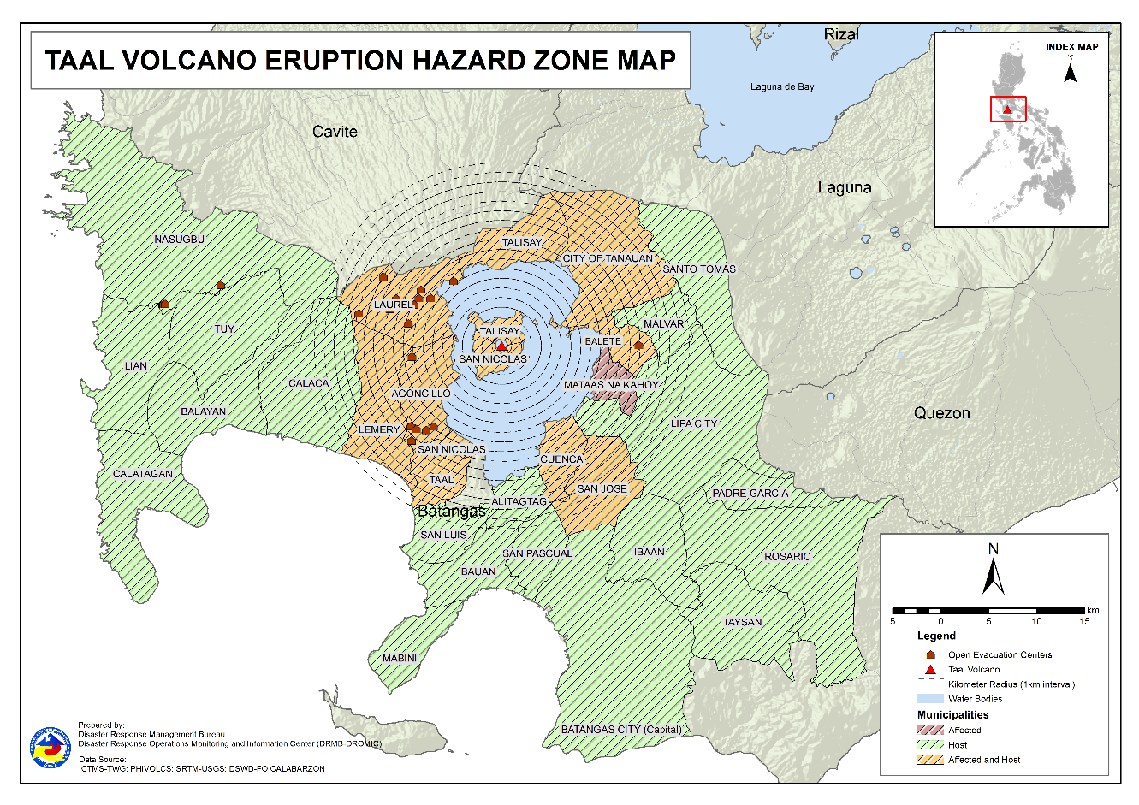

- Outside Evacuation Centers

There are 1,252 families or 4,493 persons temporarily staying with their relatives and/or friends in CALABARZON (see Table 3):

Table 3. Number of Displaced Families / Persons Outside Evacuation Centers
REGION / PROVINCE / MUNICIPALITY |  | NUMBER OF DISPLACED
 |  | OUTSIDE ECs
 |  | Families |  | Persons
 |  | CUM | NOW | CUM | NOW
GRAND TOTAL |  | 1,310 | 1,252 | 4,701 | 4,493
CALABARZON |  | 1,310 | 1,252 | 4,701 | 4,493
Batangas |  | 1,310 | 1,252 | 4,701 | 4,493
 | Agoncillo | 192 | 181 | 715 | 676
 | Alitagtag | 42 | 33 | 132 | 99
 | Balayan | 42 | 38 | 157 | 140
 | Balete | 1 | 1 | 3 | 3
 | Batangas City (capital) | 25 | 21 | 82 | 80
 | Bauan | 108 | 94 | 390 | 343
 | Calaca | 95 | 95 | 240 | 240
 | Calatagan | 25 | 25 | 106 | 106
 | Cuenca | 27 | 23 | 86 | 71
 | Ibaan | 4 | 4 | 16 | 16
 | Laurel | 276 | 276 | 1,004 | 1,004
 | Lemery | 101 | 99 | 382 | 365
 | Lian | 3 | 3 | 4 | 4
 | Lipa City | 4 | 4 | 9 | 9
 | Mabini | 2 | 2 | 5 | 5
 | Malvar | 9 | 9 | 26 | 26
 | Nasugbu | 1 | 1 | 13 | 13
 | Padre Garcia | 1 | 1 | 3 | 3
 | Rosario | 1 | 1 | 3 | 3
 | San Jose | 25 | 20 | 101 | 81
 | San Luis | 62 | 62 | 240 | 240
 | San Nicolas | 48 | 48 | 157 | 157
 | San Pascual | 18 | 18 | 54 | 54
 | Santo Tomas | 34 | 34 | 183 | 183
 | Taal | 17 | 17 | 48 | 48
 | Talisay | 3 | 3 | 17 | 17
 | City of Tanauan | 135 | 130 | 498 | 480
 | Taysan | 1 | 1 | 2 | 2
 | Tuy | 8 | 8 | 25 | 25
Note: Ongoing assessment and validation are continuously being conducted.
Sources: DSWD-FO CALABARZON

- Total Displaced Population

A total of 2,346 families or 8,291 persons are displaced in CALABARZON due to Taal Volcano eruption (see Table 4):

Table 4. Total Number of Displaced Families / Persons
REGION / PROVINCE / MUNICIPALITY |  | TOTAL DISPLACED
 |  | Families |  | Persons
 |  | CUM | NOW | CUM | NOW
GRAND TOTAL |  | 2,606 | 2,346 | 9,365 | 8,291
CALABARZON |  | 2,606 | 2,346 | 9,365 | 8,291
Batangas |  | 2,606 | 2,346 | 9,365 | 8,291
 | Agoncillo | 563 | 547 | 2,041 | 1,982
 | Alitagtag | 42 | 33 | 132 | 99
 | Balayan | 68 | 64 | 243 | 226
 | Balete | 77 | 76 | 267 | 261
 | Batangas City | 25 | 21 | 82 | 80
 | Bauan | 108 | 94 | 390 | 343
 | Calaca | 95 | 95 | 240 | 240
 | Calatagan | 25 | 25 | 106 | 106
 | Cuenca | 27 | 23 | 86 | 71
 | Ibaan | 4 | 4 | 16 | 16
 | Laurel | 1,019 | 840 | 3,723 | 2,957
 | Lemery | 101 | 99 | 382 | 365
 | Lian | 3 | 3 | 4 | 4
 | Lipa City | 4 | 4 | 9 | 9
 | Mabini | 2 | 2 | 5 | 5
 | Malvar | 9 | 9 | 26 | 26
 | Nasugbu | 81 | 64 | 282 | 208
 | Padre Garcia | 1 | 1 | 3 | 3
 | Rosario | 1 | 1 | 3 | 3
 | San Jose | 25 | 20 | 101 | 81
 | San Luis | 62 | 62 | 240 | 240
 | San Nicolas | 48 | 48 | 157 | 157
 | San Pascual | 18 | 18 | 54 | 54
 | Santo Tomas | 34 | 34 | 183 | 183
 | Taal | 17 | 17 | 48 | 48
 | Talisay | 3 | 3 | 17 | 17
 | City of Tanauan | 135 | 130 | 498 | 480
 | Taysan | 1 | 1 | 2 | 2
 | Tuy | 8 | 8 | 25 | 25
Note: Ongoing assessment and validation are continuously being conducted.
Sources: DSWD-FO CALABARZON

- Cost of Humanitarian Assistance Provided
A total of ₱4,416,586.20 worth of assistance was provided to the affected families; of which, ₱1,196,477.20 was provided by DSWD and ₱3,220,109.00 from LGUs (see Table 5).

Table 5. Cost of Assistance Provided to Affected Families / Persons
REGION / PROVINCE / MUNICIPALITY |  | COST OF ASSISTANCE
 |  | DSWD | LGU | NGOs | OTHERS | GRAND TOTAL
GRAND TOTAL |  | 1,196,477.20 | 3,220,109.00 | - | - | 4,416,586.20
CALABARZON |  | 1,196,477.20 | 3,220,109.00 | - | - | 4,416,586.20
Batangas |  | 1,196,477.20 | 3,220,109.00 | - | - | 4,416,586.20
 | Agoncillo | 697,491.20 | 1,485,568.00 | - | - | 2,183,059.20
 | Balete | - | 29,952.00 | - | - | 29,952.00
 | Laurel | 498,986.00 | 1,704,589.00 | - | - | 2,203,575.00
Sources: DSWD-FO CALABARZON

- Response Actions and Interventions

- Standby Funds and Prepositioned Relief Stockpile

Office | QRF /  Standby Funds | Family Food Packs (FFPs) |  | Other F/NFIs | Total
 |  | No. | Cost
DSWD-CO | 156,765,441.32 | - | - | - | 156,765,441.32
NROC | - | 33,984 | 25,735,578.45 | 260,047,504.15 | 285,783,082.60
VDRC | - | 741 | 329,745.00 | 39,223,439.05 | 39,553,184.05
DSWD-FO CALABARZON | 3,000,000.00 | 5,472 | 2,723,448.00 | 16,824,902.18 | 22,548,350.18
Other DSWD-FOs | 45,926,915.97 | 281,300 | 144,181,633.37 | 391,127,528.83 | 581,236,078.17
Total | 205,692,357.29 | 321,497 | 172,970,404.82 | 707,223,374.21 | 1,085,886,136.32
Note: The Inventory Summary is as of 09 July 2021, 4PM.

- Standby Funds

- ₱156.8 million Quick Response Fund (QRF) at the DSWD-Central Office. Request for replenishment in the amount of ₱662.5 million dated 16 June 2021 is currently on process for release of SARO by the Department of Budget and Management (DBM).
- ₱3 million at DSWD-Field Office (FO) CALABARZON.
- ₱45.9 million in other DSWD-FOs which may support the relief needs of the displaced families due to Taal Volcano eruption through inter-FO augmentation.

- Prepositioned FFPs and Other Relief Items

- 34,725 FFPs available in Disaster Response Centers; of which, 33,984 FFPs are at the National Resource Operations Center (NROC), Pasay City and 741 FFPs are at the Visayas Disaster Response Center (VDRC), Cebu City.
- 5,472 FFPs at DSWD-FO CALABARZON.
- 281,300 FFPs in other DSWD-FOs which may support the relief needs of the displaced families due to Taal Volcano Eruption through inter-FO augmentation.
- ₱707.2 million worth of other food and non-food items (FNIs) at NROC, VDRC and DSWD-FO warehouse countrywide.

- Food and Non-Food Items (NFIs)

- The National Resource and Logistics Management Bureau (NRLMB) augmentation support to DSWD-FO CALABARZON amounting to ₱42,950,905.00; delivery completed on 07 July 2021.
- A total of 13,500 FFPs (₱10,509,075.00), 200 family tents (₱3,280,000.00), 5,000 family kits (₱11,440,000.00), 3,000 hygiene kits (₱4,420,500.00), and 4,279 sleeping kits (₱6,350,000.00) out of total number of augmentation support provided by NRLMB to DSWD-FO CALABARZON were directly delivered to the Provincial Social Welfare Office (PSWDO) of Batangas for the needs of the displaced families.
- 300 Family tents (₱4,920,000.00) and 2,000 hygiene kits (₱2,947,000.00) were provided to Laurel, Batangas.

- Internally Displaced Person (IDP) Population

- On 7 July 2021, the Emergency Operations Center (EOC) of DSWD-FO CALABARZON provided technical assistance to local government units (LGUs) with existing evacuation centers to ensure that safety and security measures are in place to avoid gender-based violence inside camps.

- Camp Coordination and Camp Management (CCCM)

- DSWD-FO CALABARZON in collaboration with the Disaster Response Management Bureau (DRMB) and International Organization for Migration (IOM) Philippines conducted training session in setting up modular tents held on 08 July 2021. This was attended by the personnel of the Batangas PSWDO.

- Other Activities

DATE | ACTIVITIES
08 July 2021 | - DSWD-FO CALABARZON Regional Director (RD) Marcelo Nicomedes J. Castillo attended a virtual meeting with National Disaster Risk Reduction and Management Council (NDRRMC) Executive Director, Usec. Ricardo Jalad. The meeting served as an avenue of the NDRRMC to provide guidance to the members of the Response Cluster in the implementation of response protocols should the volcanic unrest escalates.  - DSWD-FO CALABARZON through its Disaster Response Management Division (DRMD) attended in the virtual teleconference with Batangas PSWDO to reconcile the data of the Local Social Welfare and Development Offices (LSWDOs) and Local Disaster Risk Reduction and Management Offices (LDRRMOs). It was also agreed that the DROMIC Reporting format would be adopted by the LGUs.  - The EOC of DSWD-FO CALABARZON coordinated with the Department of Health (DOH) for the vaccination of the members of the Regional and Provincial Quick Response Team (RPQRT) who signified willingness to render services for the ongoing humanitarian relief and disaster response operations.  - NLRMB provided technical assistance to DSWD-FO CALABARZON. The activity served as venue for the identification of areas for collaboration and cooperation in the implementation of the IMPLAN for delivering assistance to host LGUs in an event of destructive volcanic eruption. RD Castillo facilitated the meeting to discuss how they would support the displaced population. NRLMB has assured the FO of the action plan that is currently being developed.  - The members of the DSWD-FO CALABARZON Regional Incident Management Team (RIMT) convened through virtual teleconference to closely monitor the situations and plan the effective response scenarios for the possible impacts of volcanic unrest.  - The EOC of DSWD-FO CALABARZON coordinated with the National Food Authority (NFA) for the schedule of hauling of 1,800 cavan of NFA rice for the production of FFPs at the DSWD-FO CALABARZON warehouse in Gen. Mariano Alvarez, Cavite.

PHOTO DOCUMENTATION

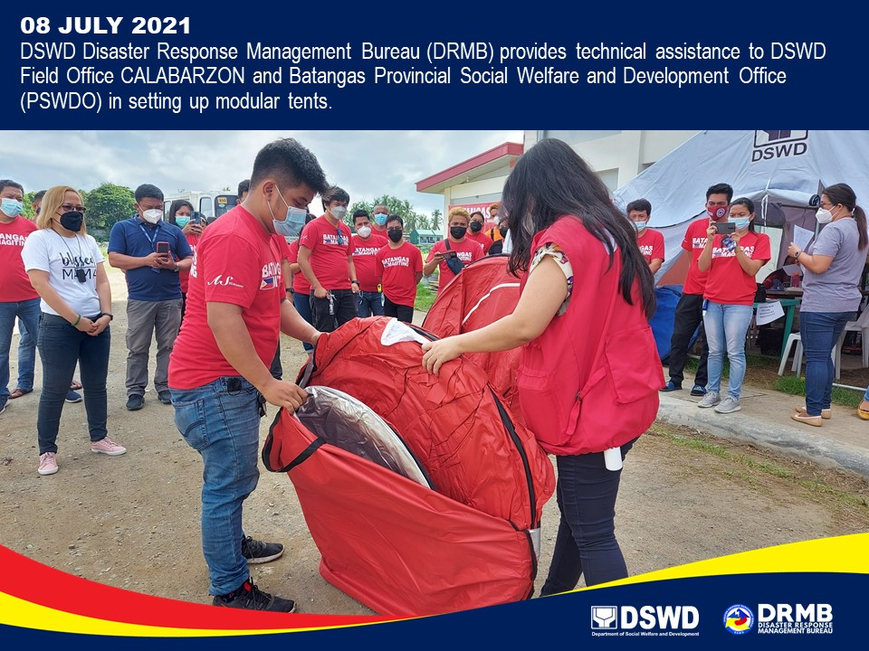

*****
The Disaster Response Operations Monitoring and Information Center (DROMIC) of DSWD-DRMB is closely coordinating with DSWD-FO CALABARZON for significant disaster response updates and assistance provided.

Prepared by:  MARIEL B. FERRARIZ | Released by:  MARC LEO L. BUTAC

