DSWD DROMIC Report #1 Social Disorganization in
Polomolok, South Cotabato
as of 27 July 2021, 6PM

- Situation Overview
On 24 July 2021, affected families at Purok 1, 2, and 6 of Barangay Lapu and Purok Datu Tinimbang of Barangay Bentung in Polomolok, South Cotabato were displaced and forced to vacate their residences due to the presence of alleged armed group.

Source: DSWD-FO XII

- Status of Affected Areas and Population
A total of 341 families or 1,705 persons were affected in Polomolok, South Cotabato (see Table 1).

Table 1. Number of Affected Families / Persons
REGION / PROVINCE / MUNICIPALITY |  | NUMBER OF AFFECTED
 |  | Barangays | Families | Persons
GRAND TOTAL |  | 2 | 341 | 1,705
REGION XII |  | 2 | 341 | 1,705
South Cotabato |  | 2 | 341 | 1,705
 | Polomolok | 2 | 341 | 1,705
Note: Ongoing assessment and validation are continuously being conducted.
Source: DSWD-FO XII

- Status of Displaced Population
- Inside Evacuation Centers
A total of 112 families or 560 persons sought temporary shelter in two (2) evacuation centers (see Table 2).

Table 2. Number of Displaced Families / Persons Inside Evacuation Centers
REGION / PROVINCE / MUNICIPALITY |  | NUMBER OF EVACUATION CENTERS (ECs) |  | NUMBER OF DISPLACED
 |  |  |  | INSIDE ECs
 |  |  |  | Families |  | Persons
 |  | CUM | NOW | CUM | NOW | CUM | NOW
GRAND TOTAL |  | 2 | - | 112 | - | 560 | -
REGION XII |  | 2 | - | 112 | - | 560 | -
South Cotabato |  | 2 | - | 112 | - | 560 | -
 | Polomolok | 2 | - | 112 | - | 560 | -
Note: Ongoing assessment and validation are continuously being conducted.
Source: DSWD-FO XII

- Outside Evacuation Centers
A total of 229 families or 1,145 persons have temporarily stayed with their relatives and/or friends (see Table 3).

Table 3. Number of Displaced Families / Persons Outside Evacuation Centers
REGION / PROVINCE / MUNICIPALITY |  | NUMBER OF DISPLACED
 |  | OUTSIDE ECs
 |  | Families |  | Persons
 |  | CUM | NOW | CUM | NOW
GRAND TOTAL |  | 229 | - | 1,145 | -
REGION XII |  | 229 | - | 1,145 | -
South Cotabato |  | 229 | - | 1,145 | -
 | Polomolok | 229 | - | 1,145 | -
Note: Ongoing assessment and validation are continuously being conducted.
Source: DSWD-FO XII

- Total Displaced Population
A total of 341 families or 1,705 persons are displaced in Polomolok, South (see Table 4).

Table 4. Total Number of Displaced Families / Persons
REGION / PROVINCE / MUNICIPALITY |  | TOTAL DISPLACED SERVED
 |  | Families |  | Persons
 |  | Total Families |  | Total Persons
 |  | CUM | NOW | CUM | NOW
GRAND TOTAL |  | 341 | - | 1,705 | -
REGION XII |  | 341 | - | 1,705 | -
South Cotabato |  | 341 | - | 1,705 | -
 | Polomolok | 341 | - | 1,705 | -
Note: Ongoing assessment and validation are continuously being conducted.
Source: DSWD-FO XII

- Cost of Humanitarian Assistance Provided
A total of ₱108,380.00 worth of assistance was provided to the affected families; of which, ₱61,900.00 from LGU, ₱33,600.00 from NGOs and ₱12,880.00 from Other Partners (see Table 5).

Table 5. Cost of Assistance Provided to Affected Families / Persons
REGION / PROVINCE / MUNICIPALITY |  | COST OF ASSISTANCE
 |  | DSWD | LGU | NGOs | OTHERS | GRAND TOTAL
GRAND TOTAL |  | - | 61,900.00 | 33,600.00 | 12,880.00 | 108,380.00
REGION XII |  | - | 61,900.00 | 33,600.00 | 12,880.00 | 108,380.00
South Cotabato |  | - | 61,900.00 | 33,600.00 | 12,880.00 | 108,380.00
 | Polomolok | - | 61,900.00 | 33,600.00 | 12,880.00 | 108,380.00
Source: DSWD-FO XII

- Response Actions and Interventions

- Standby Funds and Prepositioned Relief Stockpile
  - Standby Funds
- DSWD-FO XII has a total standby funds amounting to ₱3,000,969.85.

  - Prepositioned FFPs and Other Relief Items
- DSWD-FO XII has a total of 13,786 family food packs amounting to 9,567,920.00 prepositioned in the warehouses readily available for release to Local Government Unit (LGUs) for possible relief augmentation.

- Food and Non-Food Items (FNIs)
- The LGU of Polomolok provided 326 packs of 5kg rice amounting to ₱48,900 to the affected families.
- The Provincial Government Office of South Cotabato extended 150kg of cooked rice and 15 borrowed modular tents to the affected families.
- The Armed Forces of the Philippines (Special Force Infantry) provided 112 food packs the to the affected families.
- The Mahintana Foundation (NGO) served 224 hot meals amounting to ₱33,600.00 to the affected families.

- Internally Displaced Person (IDP) Protection
- Medical Check-up and Medicines was conducted by the Municipal Health Office of Polomolok to the affected families inside evacuation centers.

- Photo Documentation
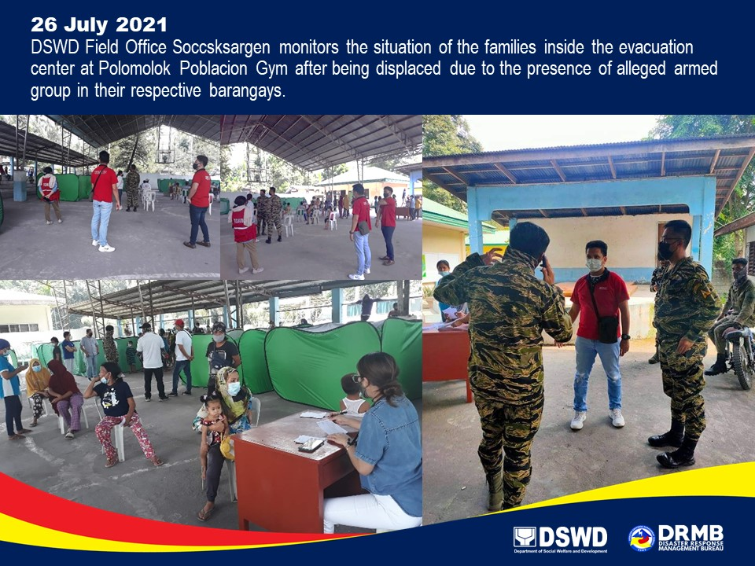

*****
The Disaster Response Operations Monitoring and Information Center (DROMIC) of DSWD-DRMB is closely coordinating with DSWD-FO XII for significant disaster response updates and assistance provided.

Prepared by:  MARIE JOYCE G. RAFANAN | Released by:  LESLIE R. JAWILI

