DSWD DROMIC Report #10 on the Taal Volcano Eruption
as of 14 July 2021, 6PM

- Situation Overview

On 13 July 2021 at 8 AM, Alert Level 3 (Magmatic Unrest) now prevails over Taal Volcano. At Alert Level 3, magma extruding from the Main Crater could drive explosive eruption. The public is reminded that the entire Taal Volcano Island is a Permanent Danger Zone (PDZ), and entry into the island as well as into the high-risk barangays of Agoncillo and Laurel must be prohibited due to the hazards of pyroclastic density currents and volcanic tsunami should strong eruptions occur. All activities on Taal Lake should not be allowed at this time. Communities around the Taal Lake shores were advised to remain vigilant, take precautionary measures against possible airborne ash and vog and calmly prepare for possible evacuation should unrest intensify.
Source: Philippine Institute of Volcanology and Seismology (PHIVOLCS)

- Status of Affected Areas and Population

A total of 4,798 families or 17,013 persons were affected by the Taal Volcano eruption in 120 Barangays in CALABARZON (see Table 1).

Table 1. Number of Affected Families / Persons
REGION / PROVINCE / MUNICIPALITY |  | NUMBER OF AFFECTED
 |  | Barangays | Families | Persons
GRAND TOTAL |  | 120 | 4,798 | 17,013
CALABARZON |  | 120 | 4,798 | 17,013
Batangas |  | 120 | 4,798 | 17,013
 | Agoncillo | 18 | 1,572 | 5,557
 | Alitagtag | 3 | 6 | 25
 | Balete | 7 | 93 | 322
 | Cuenca | 2 | 27 | 77
 | Laurel | 13 | 2,539 | 8,937
 | Lemery | 21 | 87 | 319
 | Mataas Na Kahoy | 3 | 11 | 27
 | Nasugbu | - | 1 | 4
 | San Nicolas | 14 | 173 | 657
 | Santa Teresita | 1 | 2 | 9
 | Taal | 10 | 45 | 145
 | Talisay | 17 | 115 | 443
 | City of Tanauan | 11 | 127 | 491
Note: Changes in figures are based on the ongoing assessment and validation being conducted.
Sources: DSWD-FO CALABARZON

- Status of Displaced Population

- Inside Evacuation Centers

There are 1,065 families or 3,718 persons currently taking temporary shelter in 24 evacuation centers in CALABARZON (see Table 2):

Table 2. Number of Displaced Families / Persons Inside Evacuation Centers
REGION / PROVINCE / MUNICIPALITY |  | NUMBER OF EVACUATION CENTERS (ECs) |  | NUMBER OF DISPLACED
 |  |  |  | INSIDE ECs
 |  |  |  | Families |  | Persons
 |  | CUM | NOW | CUM | NOW | CUM | NOW
GRAND TOTAL |  | 27 | 24 | 1,541 | 1,065 | 5,515 | 3,718
CALABARZON |  | 27 | 24 | 1,541 | 1,065 | 5,515 | 3,718
Batangas |  | 27 | 24 | 1,541 | 1,065 | 5,515 | 3,718
 | Agoncillo | 9 | 8 | 387 | 371 | 1,401 | 1,339
 | Balayan | 1 | 1 | 28 | 27 | 94 | 93
 | Balete | 1 | 1 | 76 | - | 264 | -
 | Ibaan | 1 | 1 | 2 | 2 | 7 | 7
 | Laurel | 9 | 9 | 950 | 572 | 3,441 | 1,992
 | Nasugbu | 6 | 4 | 98 | 93 | 308 | 287
Note: The decrease in the number of displaced families and persons CUM is based on the ongoing assessment and validation being conducted.
Sources: DSWD-FO CALABARZON

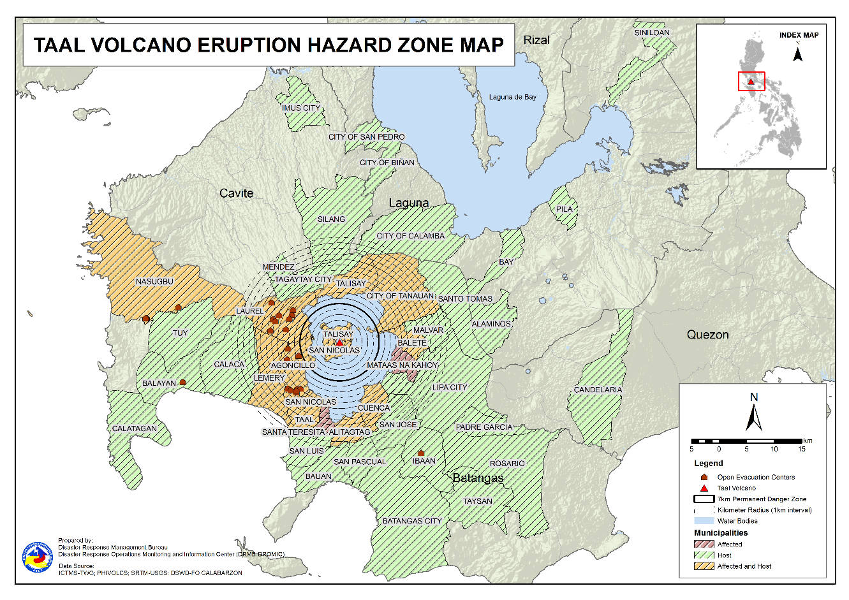

- Outside Evacuation Centers

There are 2,630 families or 9,309 persons temporarily staying with their relatives and/or friends in CALABARZON (see Table 3):

Table 3. Number of Displaced Families / Persons Outside Evacuation Centers
REGION / PROVINCE / MUNICIPALITY |  | NUMBER OF DISPLACED
 |  | OUTSIDE ECs
 |  | Families |  | Persons
 |  | CUM | NOW | CUM | NOW
GRAND TOTAL |  | 3,194 | 2,630 | 11,275 | 9,309
CALABARZON |  | 3,194 | 2,630 | 11,275 | 9,309
Batangas |  | 3,112 | 2,549 | 10,977 | 9,013
 | Agoncillo | 469 | 451 | 1,679 | 1,607
 | Alitagtag | 63 | 43 | 190 | 123
 | Balayan | 88 | 71 | 294 | 266
 | Balete | 2 | 2 | 7 | 7
 | Batangas City (capital) | 64 | 56 | 239 | 201
 | Bauan | 112 | 94 | 412 | 337
 | Calaca | 238 | 214 | 739 | 722
 | Calatagan | 46 | 33 | 175 | 117
 | Cuenca | 39 | 31 | 129 | 99
 | Ibaan | 44 | 40 | 170 | 143
 | Laurel | 1,151 | 767 | 4,031 | 2,690
 | Lemery | 150 | 138 | 557 | 505
 | Lipa City | 8 | 8 | 18 | 18
 | Malvar | 32 | 31 | 99 | 98
 | Nasugbu | 88 | 88 | 268 | 268
 | Padre Garcia | 9 | 9 | 32 | 29
 | Rosario | 11 | 11 | 35 | 35
 | San Jose | 35 | 35 | 121 | 118
 | San Luis | 104 | 100 | 397 | 387
 | San Nicolas | 83 | 75 | 339 | 301
 | San Pascual | 35 | 26 | 118 | 85
 | Santo Tomas | 30 | 29 | 127 | 107
 | Taal | 63 | 56 | 215 | 197
 | City of Tanauan | 131 | 131 | 521 | 520
 | Taysan | 4 | 4 | 11 | 11
 | Tuy | 13 | 6 | 54 | 22
Cavite |  | 18 | 17 | 67 | 65
 | Imus | 2 | 2 | 4 | 4
 | Mendez (MENDEZ-NUÑEZ) | 1 | 1 | 4 | 4
 | Silang | 12 | 11 | 48 | 46
 | Tagaytay City | 3 | 3 | 11 | 11
Laguna |  | 63 | 63 | 227 | 227
 | Alaminos | 2 | 2 | 9 | 9
 | Bay | 1 | 1 | 2 | 2
 | Biñan | 1 | 1 | 5 | 5
 | City of Calamba | 52 | 52 | 174 | 174
 | Pila | 1 | 1 | 5 | 5
 | San Pedro | 3 | 3 | 12 | 12
 | Siniloan | 3 | 3 | 20 | 20
Quezon |  | 1 | 1 | 4 | 4
 | Candelaria | 1 | 1 | 4 | 4
Note: Ongoing assessment and validation are continuously being conducted.

Sources: DSWD-FO CALABARZON

- Total Displaced Population

A total of 3,695 families or 13,027 persons are displaced in CALABARZON due to Taal Volcano eruption (see Table 4):

Table 4. Total Number of Displaced Families / Persons
REGION / PROVINCE / MUNICIPALITY |  | TOTAL DISPLACED SERVED
 |  | Families |  | Persons
 |  | Total Families |  | Total Persons
 |  | CUM | NOW | CUM | NOW
GRAND TOTAL |  | 4,735 | 3,695 | 16,790 | 13,027
CALABARZON |  | 4,735 | 3,695 | 16,790 | 13,027
Batangas |  | 4,653 | 3,614 | 16,492 | 12,731
 | Agoncillo | 856 | 822 | 3,080 | 2,946
 | Alitagtag | 63 | 43 | 190 | 123
 | Balayan | 116 | 98 | 388 | 359
 | Balete | 78 | 2 | 271 | 7
 | Batangas City (capital) | 64 | 56 | 239 | 201
 | Bauan | 112 | 94 | 412 | 337
 | Calaca | 238 | 214 | 739 | 722
 | Calatagan | 46 | 33 | 175 | 117
 | Cuenca | 39 | 31 | 129 | 99
 | Ibaan | 46 | 42 | 177 | 150
 | Laurel | 2,101 | 1,339 | 7,472 | 4,682
 | Lemery | 150 | 138 | 557 | 505
 | Lipa City | 8 | 8 | 18 | 18
 | Malvar | 32 | 31 | 99 | 98
 | Nasugbu | 186 | 181 | 576 | 555
 | Padre Garcia | 9 | 9 | 32 | 29
 | Rosario | 11 | 11 | 35 | 35
 | San Jose | 35 | 35 | 121 | 118
 | San Luis | 104 | 100 | 397 | 387
 | San Nicolas | 83 | 75 | 339 | 301
 | San Pascual | 35 | 26 | 118 | 85
 | Santo Tomas | 30 | 29 | 127 | 107
 | Taal | 63 | 56 | 215 | 197
 | City of Tanauan | 131 | 131 | 521 | 520
 | Taysan | 4 | 4 | 11 | 11
 | Tuy | 13 | 6 | 54 | 22
Cavite |  | 18 | 17 | 67 | 65
 | Imus | 2 | 2 | 4 | 4
 | Mendez (MENDEZ-NUÑEZ) | 1 | 1 | 4 | 4
 | Silang | 12 | 11 | 48 | 46
 | Tagaytay City | 3 | 3 | 11 | 11
Laguna |  | 63 | 63 | 227 | 227
 | Alaminos | 2 | 2 | 9 | 9
 | Bay | 1 | 1 | 2 | 2
 | Biñan | 1 | 1 | 5 | 5
 | City of Calamba | 52 | 52 | 174 | 174
 | Pila | 1 | 1 | 5 | 5
 | San Pedro | 3 | 3 | 12 | 12
 | Siniloan | 3 | 3 | 20 | 20
Quezon |  | 1 | 1 | 4 | 4
 | Candelaria | 1 | 1 | 4 | 4
Note: Ongoing assessment and validation are continuously being conducted.
Sources: DSWD-FO CALABARZON
- Cost of Humanitarian Assistance Provided

A total of ₱5,023,060.58 worth of assistance was provided to the affected families; of which, ₱1,375,151.58 was provided by DSWD, ₱3,220,109.00 from LGUs and ₱427,800.00 from NGOs (see Table 5).

Table 5. Cost of Assistance Provided to Affected Families / Persons
REGION / PROVINCE / MUNICIPALITY |  | COST OF ASSISTANCE
 |  | DSWD | LGUs | NGOs | OTHERS | GRAND TOTAL
GRAND TOTAL |  | 1,375,151.58 | 3,220,109.00 | 427,800.00 | - | 5,023,060.58
CALABARZON |  | 1,375,151.58 | 3,220,109.00 | 427,800.00 | - | 5,023,060.58
Batangas |  | 1,375,151.58 | 3,220,109.00 | 427,800.00 | - | 5,023,060.58
 | Agoncillo | 755,015.58 | 1,485,568.00 | - | - | 2,240,583.58
 | Balete | - | 29,952.00 | - | - | 29,952.00
 | Laurel | 620,136.00 | 1,704,589.00 | - | - | 2,324,725.00
 | City of Tanauan | - | - | 427,800.00 | - | 427,800.00
Sources: DSWD-FO CALABARZON

- Response Actions and Interventions

- Standby Funds and Prepositioned Relief Stockpile

Office | QRF /  Standby Funds | Family Food Packs (FFPs) |  | Other F/NFIs | Total
 |  | No. | Cost
DSWD-CO | 143,909,750.57 | - | - | - | 143,909,750.57
NROC | - | 45,967 | 34,601,119.30 | 262,640,624.61 | 297,241,743.91
VDRC | - | 5,941 | 2,721,745.00 | 40,184,606.17 | 42,906,351.17
DSWD-FO CALABARZON | 3,000,000.00 | 4,972 | 2,470,448.00 | 17,574,902.18 | 23,045,350.18
Other DSWD-FOs | 45,439,479.27 | 266,638 | 140,514,736.82 | 400,013,110.01 | 585,967,326.10
Total | 192,349,229.84 | 323,518.00 | 180,308,049.12 | 720,413,242.97 | 1,093,070,521.93
Note: The Inventory Summary is as of 14 July 2021, 4PM.

  - Standby Funds

- ₱143.9 million Quick Response Fund (QRF) at the DSWD-Central Office. Request for replenishment in the amount of ₱662.5 million dated 16 June 2021 is currently on process for release of SARO by the Department of Budget and Management (DBM).
- ₱3 million at DSWD-Field Office (FO) CALABARZON.
- ₱45.4 million in other DSWD-FOs which may support the relief needs of the displaced families due to Taal Volcano eruption through inter-FO augmentation.

  - Prepositioned FFPs and Other Relief Items

- 51,908 FFPs available in Disaster Response Centers; of which, 45,967 FFPs are at the National Resource Operations Center (NROC), Pasay City and 5,941 FFPs are at the Visayas Disaster Response Center (VDRC), Cebu City.
- 4,972 FFPs at DSWD-FO CALABARZON.
- 266,638 FFPs in other DSWD-FOs which may support the relief needs of the displaced families due to Taal Volcano Eruption through inter-FO augmentation.
- ₱720.4 million worth of other food and non-food items (FNIs) at NROC, VDRC and DSWD-FO warehouse countrywide.

- Food and Non-Food Items (NFIs)

- The National Resource and Logistics Management Bureau (NRLMB) augmentation support to DSWD-FO CALABARZON amounting to ₱42,950,905.00; delivery completed on 07 July 2021.
- A total of 13,500 FFPs (₱10,509,075.00), 200 family tents (₱3,280,000.00), 5,000 family kits (₱11,440,000.00), 3,000 hygiene kits (₱4,420,500.00), and 4,279 sleeping kits (₱6,350,000.00) out of total number of augmentation support provided by NRLMB to DSWD-FO CALABARZON were directly delivered to the Provincial Social Welfare Office (PSWDO) of Batangas for the needs of the displaced families.
- 300 Family tents (₱4,920,000.00) and 2,000 hygiene kits (₱2,947,000.00) were provided to Laurel, Batangas.

- Internally Displaced Person (IDP) Protection

- The DSWD-FO CALABARZON QRT coordinated with the camp managers on 12 July 2021 to establish Child and Women Friendly Spaces in various ECs to ensure productive activities will be undertaken.
- The Emergency Operations Center (EOC) of DSWD-FO CALABARZON are in constant coordination for the technical assistance needed by the local government units (LGUs) with existing evacuation centers to ensure that safety and security measures are in place to avoid gender-based violence inside camps.
- DSWD-FO CALABARZON is continuously coordinating with all the LGUs with existing open ECs to ensure compliance with the provision of emergency relief and protection for the children (RA10821) before, during and after disasters and other emergency situations as well as to monitor the compliance with the safety health protocols set by the IATF.

- Camp Coordination and Camp Management (CCCM)

- DSWD-FO CALABARZON conducted an orientation to 16 camp managers of Laurel, Batangas on the utilization of IDP Reporting Form developed by the Social Marketing Section (SMS) on 11 July 2021. The participants agreed to utilize the reporting tool to ensure the accuracy of data which will be submitted to Batangas PSWDO and the Field Office.
- DSWD-FO CALABARZON provided technical assistance on 11 July 2021 to LGUs of Agoncillo and Laurel on the conduct of informal learning opportunities and fun activities to children who are currently staying in evacuation centers.
- The Provincial Quick Response Team (QRT) of DSWD-FO CALABARZON monitored the evacuation centers and its facilities on 11 July 2021, and provided technical guidance on managing the camps.
- Other Activities

DATE | ACTIVITIES
13 July 2021 | - DSWD-FO CALABARZON attended to the virtual meeting with OCD-IVA and NHA to discuss utilization as temporary shelter of the vacant housing projects in Quezon Province.  - The DSWD-FO CAR Regional Director Castillo discuss with CALABARZON Police Regional Director Gen DC Cruz to discuss areas of cooperation and collaboration in an event of escalation of Taal volcanic unrest.
12 July 2021 | - DSWD-FO CALABARZON Director Castillo met with Air, Education, Training and Doctrine Command Head – Philippine Air Force, Lipa City, Batangas to discuss the utilization of their facility as a warehouse in the event that a massive Taal Volcano eruption activity occurs. The Philippine Air Force Head agreed to utilize the said facilities including available personnel.  - DSWD-FO CALABARZON IMT attended thevirtual meeting presided by Usec Fel Budiongan to discuss the delineation of roles/duties and responsibilities of DSWD Central Office OBSUs and Field Office for DSWD’s Task Group Taal.
11 July 2021 | - DSWD-FO CALABARZON coordinated with Batangas Province Inter-Agency Task Force (IATF) and EOC in preparation for the pilot testing of the IDP Reporting Form in Laurel, Batangas.
08 July 2021 | - The EOC of DSWD-FO CALABARZON coordinated with the National Food Authority (NFA) for the schedule of hauling of 1,800 cavan of NFA rice for the production of FFPs at the DSWD-FO CALABARZON warehouse in Gen. Mariano Alvarez, Cavite.
DATE | ACTIVITIES
12 July 2021 | - DSWD-FO CALABARZON Director Castillo met with Air, Education, Training and Doctrine Command Head – Philippine Air Force, Lipa City, Batangas to discuss the utilization of their facility as a warehouse in the event that a massive Taal Volcano eruption activity occurs. The Philippine Air Force Head agreed to utilize the said facilities including available personnel.  - DSWD-FO CALABARZON IMT attended thevirtual meeting presided by Usec Fel Budiongan to discuss the delineation of roles/duties and responsibilities of DSWD Central Office OBSUs and Field Office for DSWD’s Task Group Taal.
11 July 2021 | - DSWD-FO CALABARZON coordinated with Batangas Province Inter-Agency Task Force (IATF) and EOC in preparation for the pilot testing of the IDP Reporting Form in Laurel, Batangas.
08 July 2021 | - The EOC of DSWD-FO CALABARZON coordinated with the National Food Authority (NFA) for the schedule of hauling of 1,800 cavan of NFA rice for the production of FFPs at the DSWD-FO CALABARZON warehouse in Gen. Mariano Alvarez, Cavite.

- Photo Documentation

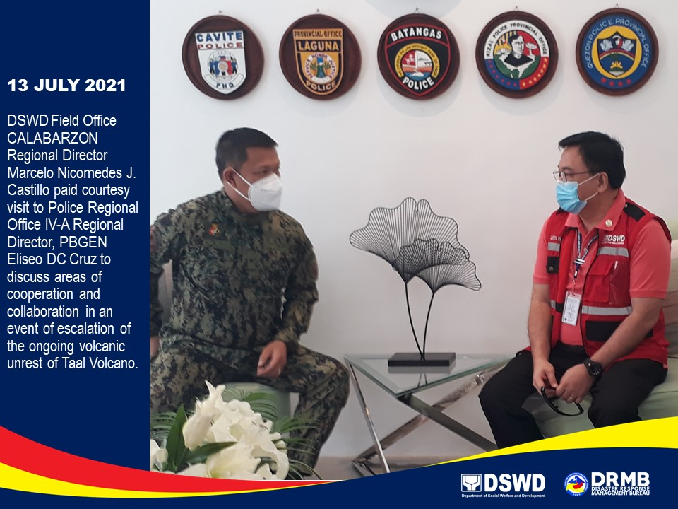

*****
The Disaster Response Operations Monitoring and Information Center (DROMIC) of DSWD-DRMB is closely coordinating with DSWD-FO CALABARZON for significant disaster response updates and assistance provided.

Prepared by:  MARIEL B. FERRARIZ  MARIE JOYCE G. RAFANAN | Released by:  RODEL V. CABADDU

