DSWD DROMIC Report #13 on the Taal Volcano Eruption
as of 17 July 2021, 6PM

- Situation Overview

On 16 July 2021 at 8 AM, Alert Level 3 (Magmatic Unrest) now prevails over Taal Volcano. At Alert Level 3, magma extruding from the Main Crater could drive explosive eruption. The public is reminded that the entire Taal Volcano Island is a Permanent Danger Zone (PDZ), and entry into the island as well as into the high-risk barangays of Agoncillo and Laurel must be prohibited due to the hazards of pyroclastic density currents and volcanic tsunami should strong eruptions occur. All activities on Taal Lake should not be allowed at this time. Communities around the Taal Lake shores were advised to remain vigilant, take precautionary measures against possible airborne ash and vog and calmly prepare for possible evacuation should unrest intensify.
Source: Philippine Institute of Volcanology and Seismology (PHIVOLCS)

- Status of Affected Areas and Population

A total of 5,247 families or 18,631 persons were affected by the Taal Volcano eruption in 132 Barangays in CALABARZON (see Table 1).

Table 1. Number of Affected Families / Persons
REGION / PROVINCE / MUNICIPALITY |  | NUMBER OF AFFECTED
 |  | Barangays | Families | Persons
GRAND TOTAL |  | 132 | 5,247 | 18,631
CALABARZON |  | 132 | 5,247 | 18,631
Batangas |  | 131 | 5,246 | 18,628
 | Agoncillo | 23 | 1,595 | 5,761
 | Alitagtag | 2 | 7 | 28
 | Balete | 6 | 101 | 348
 | Cuenca | 2 | 27 | 77
 | Laurel | 13 | 2,753 | 9,581
 | Lemery | 23 | 128 | 456
 | Mataas Na Kahoy | 4 | 42 | 123
 | San Nicolas | 14 | 216 | 809
 | Santa Teresita | 1 | 4 | 18
 | Taal | 12 | 48 | 160
 | Talisay | 18 | 161 | 619
 | City of Tanauan | 13 | 164 | 648
Cavite |  | 1 | 1 | 3
 | Tagaytay City | 1 | 1 | 3
Note: Ongoing assessment and validation are continuously being conducted.
Source: DSWD-FO CALABARZON

- Status of Displaced Population

- Inside Evacuation Centers

There are 1,053 families or 3,674 persons currently taking temporary shelter in 23 evacuation centers in CALABARZON (see Table 2):

Table 2. Number of Displaced Families / Persons Inside Evacuation Centers
REGION / PROVINCE / MUNICIPALITY |  | NUMBER OF EVACUATION CENTERS (ECs) |  | NUMBER OF DISPLACED
 |  |  |  | INSIDE ECs
 |  |  |  | Families |  | Persons
 |  | CUM | NOW | CUM | NOW | CUM | NOW
GRAND TOTAL |  | 26 | 23 | 1,545 | 1,053 | 5,533 | 3,674
CALABARZON |  | 26 | 23 | 1,545 | 1,053 | 5,533 | 3,674
Batangas |  | 26 | 23 | 1,545 | 1,053 | 5,533 | 3,674
 | Agoncillo | 11 | 10 | 361 | 345 | 1,323 | 1,261
 | Balayan | 1 | 1 | 28 | 27 | 94 | 93
 | Balete | 1 | - | 76 | - | 264 | -
 | Ibaan | 1 | 1 | 2 | 2 | 7 | 7
 | Laurel | 9 | 8 | 979 | 586 | 3,537 | 2,026
 | Nasugbu | 3 | 3 | 99 | 93 | 308 | 287
Note: Ongoing assessment and validation are continuously being conducted.
Source: DSWD-FO CALABARZON

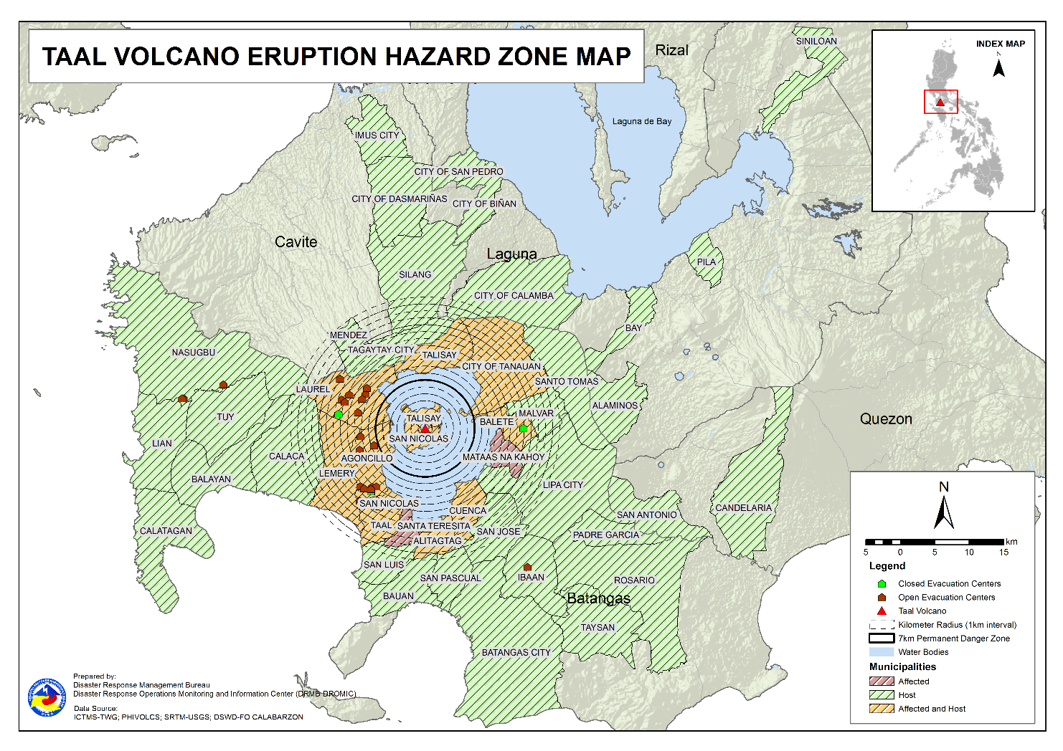

- Outside Evacuation Centers

There are 2,763 families or 9,777 persons temporarily staying with their relatives and/or friends in CALABARZON (see Table 3):

Table 3. Number of Displaced Families / Persons Outside Evacuation Centers
REGION / PROVINCE / MUNICIPALITY |  | NUMBER OF DISPLACED
 |  | OUTSIDE ECs
 |  | Families |  | Persons
 |  | CUM | NOW | CUM | NOW
GRAND TOTAL |  | 3,676 | 2,763 | 13,007 | 9,777
CALABARZON |  | 3,676 | 2,763 | 13,007 | 9,777
Batangas |  | 3,545 | 2,636 | 12,520 | 9,302
 | Agoncillo | 491 | 443 | 1,775 | 1,584
 | Alitagtag | 76 | 45 | 227 | 121
 | Balayan | 99 | 86 | 325 | 302
 | Balete | 3 | 3 | 9 | 9
 | Batangas City (capital) | 83 | 70 | 299 | 238
 | Bauan | 115 | 77 | 432 | 297
 | Calaca | 307 | 271 | 1,087 | 952
 | Calatagan | 47 | 34 | 179 | 118
 | Cuenca | 39 | 22 | 129 | 74
 | Ibaan | 66 | 55 | 258 | 197
 | Laurel | 1,299 | 695 | 4,474 | 2,402
 | Lemery | 157 | 145 | 572 | 522
 | Lian | 9 | 9 | 16 | 16
 | Lipa City | 30 | 23 | 77 | 61
 | Malvar | 33 | 32 | 105 | 104
 | Mataas Na Kahoy | 1 | 1 | 2 | 2
 | Nasugbu | 88 | 88 | 268 | 268
 | Padre Garcia | 10 | 9 | 37 | 32
 | Rosario | 13 | 13 | 41 | 41
 | San Jose | 46 | 43 | 164 | 151
 | San Luis | 116 | 114 | 446 | 436
 | San Nicolas | 83 | 75 | 339 | 301
 | San Pascual | 39 | 29 | 135 | 96
 | Santo Tomas | 43 | 42 | 180 | 174
 | Taal | 65 | 36 | 206 | 128
 | City of Tanauan | 171 | 167 | 675 | 647
 | Taysan | 4 | 4 | 11 | 11
 | Tuy | 12 | 5 | 52 | 18
Cavite |  | 30 | 29 | 108 | 106
 | Dasmariñas | 1 | 1 | 4 | 4
 | Imus | 3 | 3 | 10 | 10
 | Mendez (MENDEZ-NUÑEZ) | 1 | 1 | 4 | 4
 | Silang | 22 | 21 | 79 | 77
 | Tagaytay City | 3 | 3 | 11 | 11
Laguna |  | 99 | 96 | 372 | 362
 | Alaminos | 3 | 3 | 14 | 14
 | Bay | 1 | - | 2 | -
 | Biñan | 1 | 1 | 5 | 5
 | City of Calamba | 87 | 85 | 314 | 306
 | Pila | 1 | 1 | 5 | 5
 | San Pedro | 3 | 3 | 12 | 12
 | Siniloan | 3 | 3 | 20 | 20
Quezon |  | 2 | 2 | 7 | 7
 | Candelaria | 1 | 1 | 4 | 4
 | San Antonio | 1 | 1 | 3 | 3
Note: Ongoing assessment and validation are continuously being conducted.

Sources: DSWD-FO CALABARZON

- Total Displaced Population

A total of 3,816 families or 13,451 persons are displaced in CALABARZON due to Taal Volcano eruption (see Table 4):

Table 4. Total Number of Displaced Families / Persons
REGION / PROVINCE / MUNICIPALITY |  | TOTAL DISPLACED SERVED
 |  | Families |  | Persons
 |  | Total Families |  | Total Persons
 |  | CUM | NOW | CUM | NOW
GRAND TOTAL |  | 5,221 | 3,816 | 18,540 | 13,451
CALABARZON |  | 5,221 | 3,816 | 18,540 | 13,451
Batangas |  | 5,090 | 3,689 | 18,053 | 12,976
 | Agoncillo | 852 | 788 | 3,098 | 2,845
 | Alitagtag | 76 | 45 | 227 | 121
 | Balayan | 127 | 113 | 419 | 395
 | Balete | 79 | 3 | 273 | 9
 | Batangas City (capital) | 83 | 70 | 299 | 238
 | Bauan | 115 | 77 | 432 | 297
 | Calaca | 307 | 271 | 1,087 | 952
 | Calatagan | 47 | 34 | 179 | 118
 | Cuenca | 39 | 22 | 129 | 74
 | Ibaan | 68 | 57 | 265 | 204
 | Laurel | 2,278 | 1,281 | 8,011 | 4,428
 | Lemery | 157 | 145 | 572 | 522
 | Lian | 9 | 9 | 16 | 16
 | Lipa City | 30 | 23 | 77 | 61
 | Malvar | 33 | 32 | 105 | 104
 | Mataas Na Kahoy | 1 | 1 | 2 | 2
 | Nasugbu | 187 | 181 | 576 | 555
 | Padre Garcia | 10 | 9 | 37 | 32
 | Rosario | 13 | 13 | 41 | 41
 | San Jose | 46 | 43 | 164 | 151
 | San Luis | 116 | 114 | 446 | 436
 | San Nicolas | 83 | 75 | 339 | 301
 | San Pascual | 39 | 29 | 135 | 96
 | Santo Tomas | 43 | 42 | 180 | 174
 | Taal | 65 | 36 | 206 | 128
 | City of Tanauan | 171 | 167 | 675 | 647
 | Taysan | 4 | 4 | 11 | 11
 | Tuy | 12 | 5 | 52 | 18
Cavite |  | 30 | 29 | 108 | 106
 | Dasmariñas | 1 | 1 | 4 | 4
 | Imus | 3 | 3 | 10 | 10
 | Mendez (MENDEZ-NUÑEZ) | 1 | 1 | 4 | 4
 | Silang | 22 | 21 | 79 | 77
 | Tagaytay City | 3 | 3 | 11 | 11
Laguna |  | 99 | 96 | 372 | 362
 | Alaminos | 3 | 3 | 14 | 14
 | Bay | 1 | - | 2 | -
 | Biñan | 1 | 1 | 5 | 5
 | City of Calamba | 87 | 85 | 314 | 306
 | Pila | 1 | 1 | 5 | 5
 | San Pedro | 3 | 3 | 12 | 12
 | Siniloan | 3 | 3 | 20 | 20
Quezon |  | 2 | 2 | 7 | 7
 | Candelaria | 1 | 1 | 4 | 4
 | San Antonio | 1 | 1 | 3 | 3
Note: Ongoing assessment and validation are continuously being conducted.
Sources: DSWD-FO CALABARZON

- Cost of Humanitarian Assistance Provided

A total of ₱12,541,742.58 worth of assistance was provided to the affected families; of which, ₱1,375,151.58 was provided by DSWD, ₱7,057,356.10 from LGUs and ₱4,109,234.90 from NGOs (see Table 5).

Table 5. Cost of Assistance Provided to Affected Families / Persons
REGION / PROVINCE / MUNICIPALITY |  | COST OF ASSISTANCE
 |  | DSWD | LGUs | NGOs | OTHERS | GRAND TOTAL
GRAND TOTAL |  | 1,375,151.58 | 7,057,356.10 | 4,109,234.90 | - | 12,541,742.58
CALABARZON |  | 1,375,151.58 | 7,057,356.10 | 4,109,234.90 | - | 12,541,742.58
Batangas |  | 1,375,151.58 | 7,057,356.10 | 4,109,234.90 | - | 12,541,742.58
 | Province | - | 3,837,247.10 | - | - | 3,837,247.10
 | Agoncillo | 755,015.58 | 1,485,568.00 | 2,074,307.70 | - | 4,314,891.28
 | Balayan | - | - | 57,065.70 | - | 57,065.70
 | Balete | - | 29,952.00 | 129,518.10 | - | 159,470.10
 | Laurel | 620,136.00 | 1,704,589.00 | 985,500.00 | - | 3,310,225.00
 | Nasugbu | - | - | 112,152.30 | - | 112,152.30
 | Talisay | - | - | 322,891.10 | - | 322,891.10
 | City of Tanauan | - | - | 427,800.00 | - | 427,800.00
Sources: DSWD-FO CALABARZON

- Response Actions and Interventions

- Standby Funds and Prepositioned Relief Stockpile

Office | QRF /  Standby Funds | Family Food Packs (FFPs) |  | Other F/NFIs | Total
 |  | No. | Cost
DSWD-CO | 806,582,400.57 | - | - |  | 806,582,400.57
NROC | - | 50,184 | 37,624,892.95 | 252,087,553.51 | 289,712,446.46
VDRC | - | 5,841 | 2,686,860.00 | 38,748,603.82 | 41,435,463.82
DSWD-FO CALABARZON | 3,000,000.00 | 4,565 | 2,264,506.00 | 17,574,902.18 | 22,839,408.18
Other DSWD-FOs | 45,439,479.27 | 275,438 | 142,761,563.58 | 399,056,984.90 | 587,258,027.75
Total | 855,021,879.84 | 336,028 | 185,337,822.53 | 707,468,044.41 | 1,747,827,746.78
Note: The Inventory Summary is as of 17 July 2021, 4PM.
  - Standby Funds
- ₱806.5 million Quick Response Fund (QRF) at the DSWD-Central Office. Received the amount of ₱662.5 million replenishment from Department of Budget and Management (DBM) as per SARO dated July 6, 2021.
- ₱3 million at DSWD-Field Office (FO) CALABARZON.
- ₱45.4 million in other DSWD-FOs which may support the relief needs of the displaced families due to Taal Volcano eruption through inter-FO augmentation.

  - Prepositioned FFPs and Other Relief Items

- 56,025 FFPs available in Disaster Response Centers; of which, 50,184 FFPs are at the National Resource Operations Center (NROC), Pasay City and 5,841 FFPs are at the Visayas Disaster Response Center (VDRC), Cebu City.
- 4,565 FFPs at DSWD-FO CALABARZON.
- 275,438 FFPs in other DSWD-FOs which may support the relief needs of the displaced families due to Taal Volcano Eruption through inter-FO augmentation.
- ₱707.5 million worth of other food and non-food items (FNIs) at NROC, VDRC and DSWD-FO warehouse countrywide.

- Food and Non-Food Items (NFIs)

- The National Resource and Logistics Management Bureau (NRLMB) delivered 1,000 FFPs amounting to ₱778,450.00 in Batangas City Sports Complex on 16 July 2021, as partial delivery to the 5,000 FFPs additional augmentation support to DSWD-FO CALABARZON.
- The National Resource and Logistics Management Bureau (NRLMB) augmentation support to DSWD-FO CALABARZON amounting to ₱42,950,905.00; delivery completed on 07 July 2021.
- A total of 13,500 FFPs (₱10,509,075.00), 200 family tents (₱3,280,000.00), 5,000 family kits (₱11,440,000.00), 3,000 hygiene kits (₱4,420,500.00), and 4,279 sleeping kits (₱6,350,000.00) out of total number of augmentation support provided by NRLMB to DSWD-FO CALABARZON were directly delivered to the Provincial Social Welfare Office (PSWDO) of Batangas for the needs of the displaced families.
- 300 Family tents (₱4,920,000.00) and 2,000 hygiene kits (₱2,947,000.00) were provided to Laurel, Batangas.

- Internally Displaced Person (IDP) Protection

- DSWD-FO CALABARZON are in constant coordination for the technical assistance needed by the local government units (LGUs) with existing evacuation centers to ensure that safety and security measures are in place to avoid gender-based violence inside camps.
- DSWD-FO CALABARZON is continuously coordinating with all the LGUs with existing open ECs to ensure compliance with the provision of emergency relief and protection for the children (RA10821) before, during and after disasters and other emergency situations as well as to monitor the compliance with the safety health protocols set by the IATF.

- Camp Coordination and Camp Management (CCCM)

- DSWD-FO CALABARZON thru its Disaster Response Management Division attended the virtual conference meeting relative to the utilization of the NHA houses as temporary shelter of the IDPs. As agreed during the meeting, the IDPs can utilize the housing units for one (1)
- year or as long as it’s already safe for them to return to their respective dwellings.
- The Provincial Quick Response Team (QRT) of DSWD-FO CALABARZON continuously monitored the evacuation centers and its facilities to properly respond and plan out the need and impact of the volcanic eruption.

- Other Activities

DATE | ACTIVITIES
16 July 2021 | - DSWD Secretary Rolando Joselito D. Bautista together with Dir Jun Castillo visited the proposed site for the construction of DSWD-FO CALABARZON warehouse in Brgy. Malinlin, Ibaan, Batangas. They also visited the alternate hub and Evacuation Center in Laurel, Batangas.
14 July 2021 | - DSWD-FO CALABARZON thru its Disaster Response Management Division (DRMD) coordinated with the National Resource and Logistics Management Bureau (NRLMB) for the provision of ten-wheeler truck to haul the 600 sacks of rice from NFA warehouse in Gen. Trias City, and ferried to DSWD FO warehouses located in Dasmarinas City and Gen Mariano Alvarez, Cavite..
13 July 2021 | - DSWD-FO CALABARZON attended to the virtual meeting with OCD-IVA and NHA to discuss utilization as temporary shelter of the vacant housing projects in Quezon Province.  - The DSWD-FO CAR Regional Director Castillo discuss with CALABARZON Police Regional Director Gen DC Cruz to discuss areas of cooperation and collaboration in an event of escalation of Taal volcanic unrest.
12 July 2021 | - DSWD-FO CALABARZON Director Castillo met with Air, Education, Training and Doctrine Command Head – Philippine Air Force, Lipa City, Batangas to discuss the utilization of their facility as a warehouse in the event that a massive Taal Volcano eruption activity occurs. The Philippine Air Force Head agreed to utilize the said facilities including available personnel.  - DSWD-FO CALABARZON IMT attended thevirtual meeting presided by Usec Fel Budiongan to discuss the delineation of roles/duties and responsibilities of DSWD Central Office OBSUs and Field Office for DSWD’s Task Group Taal.
11 July 2021 | - DSWD-FO CALABARZON coordinated with Batangas Province Inter-Agency Task Force (IATF) and EOC in preparation for the pilot testing of the IDP Reporting Form in Laurel, Batangas.
08 July 2021 | - The EOC of DSWD-FO CALABARZON coordinated with the National Food Authority (NFA) for the schedule of hauling of 1,800 cavan of NFA rice for the production of FFPs at the DSWD-FO CALABARZON warehouse in Gen. Mariano Alvarez, Cavite.

- Photo Documentation
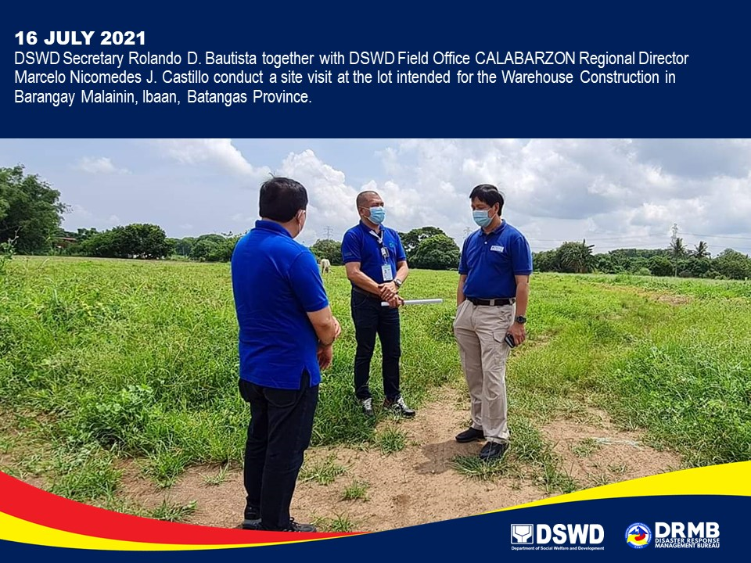

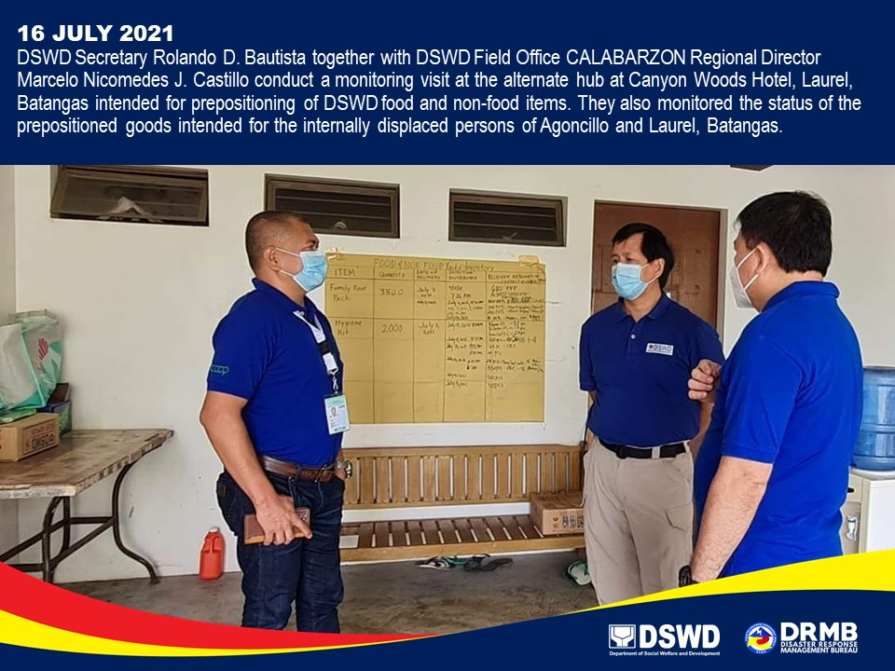

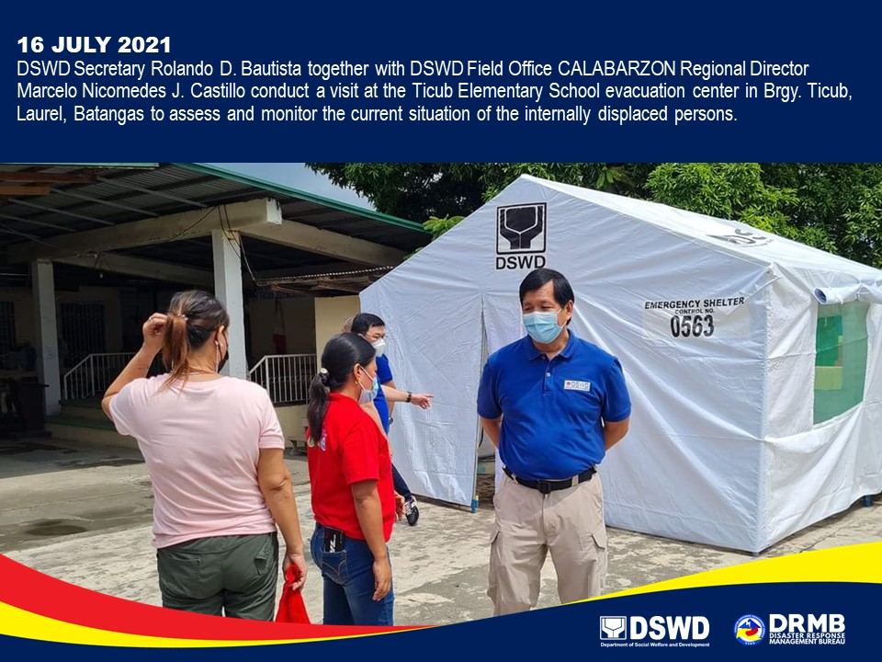

*****
The Disaster Response Operations Monitoring and Information Center (DROMIC) of DSWD-DRMB is closely coordinating with DSWD-FO CALABARZON for significant disaster response updates and assistance provided.

Prepared by:  MARIE JOYCE G. RAFANAN  JAN ERWIN ANDREW I. ONTANILLAS | Released by:  LESLIE R. JAWILI

