DSWD DROMIC Report #15 on the Taal Volcano Eruption
as of 19 July 2021, 6PM

- Situation Overview

On 18 July 2021 at 8 AM, Alert Level 3 (Magmatic Unrest) now prevails over Taal Volcano. At Alert Level 3, magma extruding from the Main Crater could drive explosive eruption. The public is reminded that the entire Taal Volcano Island is a Permanent Danger Zone (PDZ), and entry into the island as well as into the high-risk barangays of Agoncillo and Laurel must be prohibited due to the hazards of pyroclastic density currents and volcanic tsunami should strong eruptions occur. All activities on Taal Lake should not be allowed at this time. Communities around the Taal Lake shores were advised to remain vigilant, take precautionary measures against possible airborne ash and vog and calmly prepare for possible evacuation should unrest intensify.
Source: Philippine Institute of Volcanology and Seismology (PHIVOLCS)

- Status of Affected Areas and Population

A total of 5,459 families or 19,333 persons were affected by the Taal Volcano eruption in 137 Barangays in CALABARZON (see Table 1).

Table 1. Number of Affected Families / Persons
REGION / PROVINCE / MUNICIPALITY |  | NUMBER OF AFFECTED
 |  | Barangays | Families | Persons
GRAND TOTAL |  | 137 | 5,459 | 19,333
CALABARZON |  | 137 | 5,459 | 19,333
Batangas |  | 136 | 5,458 | 19,330
 | Agoncillo | 22 | 1,625 | 5,855
 | Alitagtag | 2 | 7 | 28
 | Balete | 6 | 101 | 348
 | Cuenca | 2 | 27 | 77
 | Laurel | 14 | 2,874 | 9,960
 | Lemery | 23 | 134 | 473
 | Mataas Na Kahoy | 4 | 43 | 129
 | San Nicolas | 18 | 242 | 897
 | Santa Teresita | 1 | 4 | 18
 | Taal | 12 | 50 | 167
 | Talisay | 18 | 176 | 687
 | City of Tanauan | 14 | 175 | 691
Cavite |  | 1 | 1 | 3
 | Tagaytay City | 1 | 1 | 3
Note: Ongoing assessment and validation are continuously being conducted.
Source: DSWD-FO CALABARZON

- Status of Displaced Population

- Inside Evacuation Centers
There are 1,039 families or 3,609 persons currently taking temporary shelter in 23 evacuation centers in CALABARZON (see Table 2).

Table 2. Number of Displaced Families / Persons Inside Evacuation Centers
REGION / PROVINCE / MUNICIPALITY |  | NUMBER OF EVACUATION CENTERS (ECs) |  | NUMBER OF DISPLACED
 |  |  |  | INSIDE ECs
 |  |  |  | Families |  | Persons
 |  | CUM | NOW | CUM | NOW | CUM | NOW
GRAND TOTAL |  | 26 | 23 | 1,584 | 1,039 | 5,659 | 3,609
CALABARZON |  | 26 | 23 | 1,584 | 1,039 | 5,659 | 3,609
Batangas |  | 26 | 23 | 1,584 | 1,039 | 5,659 | 3,609
 | Agoncillo | 11 | 10 | 361 | 329 | 1,323 | 1,214
 | Balayan | 1 | 1 | 28 | 27 | 94 | 93
 | Balete | 1 | - | 76 | - | 264 | -
 | Ibaan | 1 | 1 | 3 | 3 | 12 | 12
 | Laurel | 9 | 8 | 1,016 | 589 | 3,657 | 2,023
 | Nasugbu | 3 | 3 | 100 | 91 | 309 | 267
Note: Ongoing assessment and validation are continuously being conducted.
Source: DSWD-FO CALABARZON

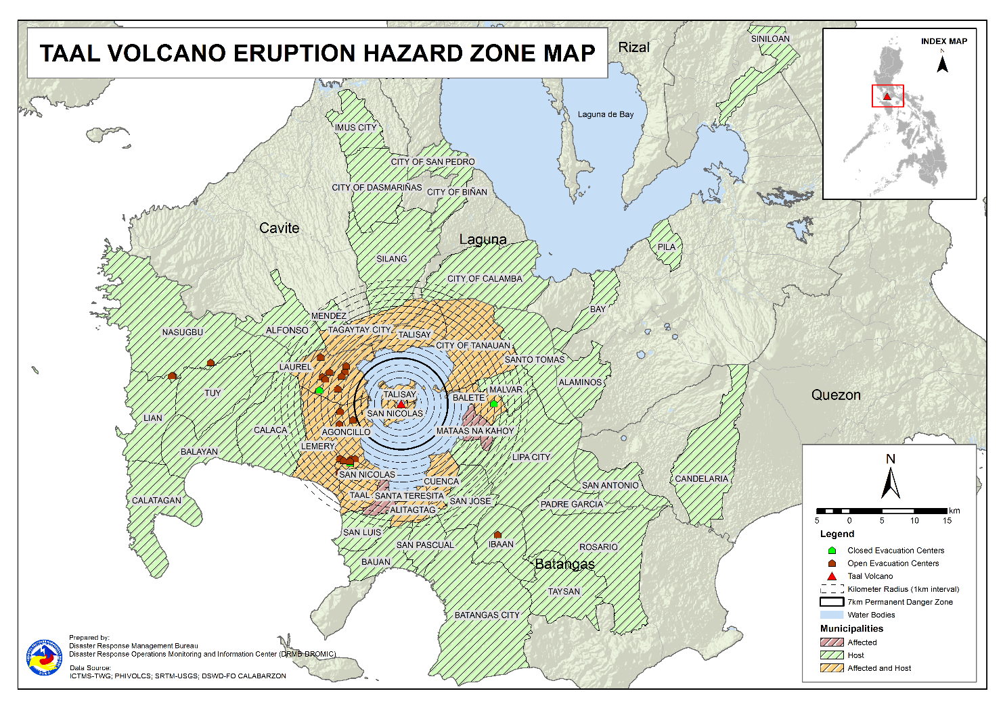

- Outside Evacuation Centers
There are 2,388 families or 8,425 persons temporarily staying with their relatives and/or friends in CALABARZON (see Table 3).

Table 3. Number of Displaced Families / Persons Outside Evacuation Centers
REGION / PROVINCE / MUNICIPALITY |  | NUMBER OF DISPLACED
 |  | OUTSIDE ECs
 |  | Families |  | Persons
 |  | CUM | NOW | CUM | NOW
GRAND TOTAL |  | 3,874 | 2,388 | 13,513 | 8,425
CALABARZON |  | 3,874 | 2,388 | 13,513 | 8,425
Batangas |  | 3,731 | 2,251 | 12,990 | 7,931
 | Agoncillo | 491 | 241 | 1,775 | 883
 | Alitagtag | 77 | 40 | 227 | 116
 | Balayan | 99 | 58 | 328 | 201
 | Balete | 3 | 3 | 9 | 9
 | Batangas City (capital) | 92 | 63 | 331 | 217
 | Bauan | 115 | 73 | 433 | 281
 | Calaca | 311 | 281 | 1,092 | 988
 | Calatagan | 47 | 34 | 179 | 118
 | Cuenca | 39 | 22 | 129 | 74
 | Ibaan | 75 | 61 | 290 | 233
 | Laurel | 1,325 | 639 | 4,545 | 2,179
 | Lemery | 159 | 147 | 586 | 536
 | Lian | 20 | 19 | 41 | 38
 | Lipa City | 31 | 24 | 81 | 65
 | Malvar | 34 | 31 | 108 | 107
 | Mataas Na Kahoy | 1 | 1 | 2 | 2
 | Nasugbu | 91 | 3 | 281 | 13
 | Padre Garcia | 10 | 9 | 37 | 32
 | Rosario | 13 | 13 | 41 | 41
 | San Jose | 46 | 43 | 164 | 151
 | San Luis | 116 | 114 | 446 | 436
 | San Nicolas | 98 | 83 | 384 | 296
 | San Pascual | 85 | 24 | 145 | 81
 | Santo Tomas | 55 | 44 | 221 | 182
 | Taal | 77 | 28 | 240 | 94
 | City of Tanauan | 199 | 140 | 797 | 526
 | Taysan | 10 | 10 | 26 | 26
 | Tuy | 12 | 3 | 52 | 6
Cavite |  | 33 | 32 | 114 | 112
 | Alfonso | 1 | 1 | 2 | 2
 | Dasmariñas | 1 | 1 | 4 | 4
 | Imus | 5 | 5 | 14 | 14
 | Mendez (MENDEZ-NUÑEZ) | 1 | 1 | 4 | 4
 | Silang | 22 | 21 | 79 | 77
 | Tagaytay City | 3 | 3 | 11 | 11
Laguna |  | 108 | 103 | 402 | 375
 | Alaminos | 3 | 3 | 14 | 14
 | Bay | 1 | - | 2 | -
 | Biñan | 1 | 1 | 5 | 5
 | City of Calamba | 96 | 94 | 344 | 336
 | Pila | 1 | 1 | 5 | 5
 | San Pedro | 3 | 3 | 12 | 12
 | Siniloan | 3 | 1 | 20 | 3
Quezon |  | 2 | 2 | 7 | 7
 | Candelaria | 1 | 1 | 4 | 4
 | San Antonio | 1 | 1 | 3 | 3
Note: Ongoing assessment and validation are continuously being conducted.
Source: DSWD-FO CALABARZON

- Total Displaced Population
A total of 3,415 families or 11,988 persons are displaced in CALABARZON due to Taal Volcano eruption (see Table 4).

Table 4. Total Number of Displaced Families / Persons
REGION / PROVINCE / MUNICIPALITY |  | TOTAL DISPLACED SERVED
 |  | Families |  | Persons
 |  | Total Families |  | Total Persons
 |  | CUM | NOW | CUM | NOW
GRAND TOTAL |  | 5,373 | 3,415 | 18,887 | 11,988
CALABARZON |  | 5,373 | 3,415 | 18,887 | 11,988
Batangas |  | 5,230 | 3,278 | 18,364 | 11,494
 | Agoncillo | 852 | 570 | 3,098 | 2,097
 | Alitagtag | 77 | 40 | 227 | 116
 | Balayan | 127 | 85 | 422 | 294
 | Balete | 79 | 3 | 273 | 9
 | Batangas City (capital) | 92 | 63 | 331 | 217
 | Bauan | 115 | 73 | 433 | 281
 | Calaca | 311 | 281 | 1,092 | 988
 | Calatagan | 47 | 34 | 179 | 118
 | Cuenca | 39 | 22 | 129 | 74
 | Ibaan | 78 | 64 | 302 | 245
 | Laurel | 2,256 | 1,216 | 7,917 | 4,156
 | Lemery | 159 | 147 | 586 | 536
 | Lian | 20 | 19 | 41 | 38
 | Lipa City | 31 | 24 | 81 | 65
 | Malvar | 34 | 31 | 108 | 107
 | Mataas Na Kahoy | 1 | 1 | 2 | 2
 | Nasugbu | 191 | 94 | 590 | 280
 | Padre Garcia | 10 | 9 | 37 | 32
 | Rosario | 13 | 13 | 41 | 41
 | San Jose | 46 | 43 | 164 | 151
 | San Luis | 116 | 114 | 446 | 436
 | San Nicolas | 98 | 83 | 384 | 296
 | San Pascual | 85 | 24 | 145 | 81
 | Santo Tomas | 55 | 44 | 221 | 182
 | Taal | 77 | 28 | 240 | 94
 | City of Tanauan | 199 | 140 | 797 | 526
 | Taysan | 10 | 10 | 26 | 26
 | Tuy | 12 | 3 | 52 | 6
Cavite |  | 33 | 32 | 114 | 112
 | Alfonso | 1 | 1 | 2 | 2
 | Dasmariñas | 1 | 1 | 4 | 4
 | Imus | 5 | 5 | 14 | 14
 | Mendez (MENDEZ-NUÑEZ) | 1 | 1 | 4 | 4
 | Silang | 22 | 21 | 79 | 77
 | Tagaytay City | 3 | 3 | 11 | 11
Laguna |  | 108 | 103 | 402 | 375
 | Alaminos | 3 | 3 | 14 | 14
 | Bay | 1 | - | 2 | -
 | Biñan | 1 | 1 | 5 | 5
 | City of Calamba | 96 | 94 | 344 | 336
 | Pila | 1 | 1 | 5 | 5
 | San Pedro | 3 | 3 | 12 | 12
 | Siniloan | 3 | 1 | 20 | 3
Quezon |  | 2 | 2 | 7 | 7
 | Candelaria | 1 | 1 | 4 | 4
 | San Antonio | 1 | 1 | 3 | 3
Note: Ongoing assessment and validation are continuously being conducted.
Source: DSWD-FO CALABARZON

- Cost of Humanitarian Assistance Provided

A total of ₱14,824,621.80 worth of assistance was provided to the affected families; of which, ₱3,658,030.80 was provided by DSWD, ₱7,057,356.10 from LGUs and ₱4,109,234.90 from NGOs (see Table 5).

Table 5. Cost of Assistance Provided to Affected Families / Persons
REGION / PROVINCE / MUNICIPALITY |  | COST OF ASSISTANCE
 |  | DSWD | LGUs | NGOs | OTHERS | GRAND TOTAL
GRAND TOTAL |  | 3,658,030.80 | 7,057,356.10 | 4,109,234.90 | - | 14,824,621.80
CALABARZON |  | 3,658,030.80 | 7,057,356.10 | 4,109,234.90 | - | 14,824,621.80
Batangas |  | 3,658,030.80 | 7,057,356.10 | 4,109,234.90 | - | 14,824,621.80
 | Province | - | 3,837,247.10 | - | - | 3,837,247.10
 | Agoncillo | 758,210.30 | 1,485,568.00 | 2,074,307.70 | - | 4,318,086.00
 | Balayan | - | - | 57,065.70 | - | 57,065.70
 | Balete | - | 29,952.00 | 129,518.10 | - | 159,470.10
 | Laurel | 2,899,820.50 | 1,704,589.00 | 985,500.00 | - | 5,589,909.50
 | Nasugbu | - | - | 112,152.30 | - | 112,152.30
 | Talisay | - | - | 322,891.10 | - | 322,891.10
 | City of Tanauan | - | - | 427,800.00 | - | 427,800.00
Source: DSWD-FO CALABARZON

- Response Actions and Interventions

- Standby Funds and Prepositioned Relief Stockpile

Office | QRF /  Standby Funds | Family Food Packs (FFPs) |  | Other F/NFIs | Total
 |  | No. | Cost
DSWD-CO | 806,582,400.57 | - | - | - | 806,582,400.57
NROC | - | 40,184 | 29,840,392.95 | 252,087,553.51 | 281,968,130.46
VDRC | - | 5,841 | 2,686,860.00 | 38,748,603.82 | 41,441,304.82
DSWD-FO CALABARZON | 3,000,000.00 | 4,495 | 2,229,786.00 | 17,574,902.18 | 22,809,304.82
Other DSWD-FOs | 45,439,479.27 | 274,788 | 142,074,057.18 | 398,868,539.10 | 586,656,863.55
Total | 855,021,879.84 | 325,308 | 176,831,096.13 | 707,279,598.61 | 1,739,132,574.58
Note: The Inventory Summary is as of 19 July 2021, 4PM.

  - Standby Funds
- ₱806.6 million Quick Response Fund (QRF) at the DSWD-Central Office. Received the replenishment from Department of Budget and Management (DBM) amounting to ₱662.5 million as per SARO dated July 6, 2021.
- ₱3 million at DSWD-Field Office (FO) CALABARZON.
- ₱45.4 million in other DSWD-FOs which may support the relief needs of the displaced families due to Taal Volcano eruption through inter-FO augmentation.

  - Prepositioned FFPs and Other Relief Items
- 46,025 FFPs available in Disaster Response Centers; of which, 40,184 FFPs are at the National Resource Operations Center (NROC), Pasay City and 5,841 FFPs are at the Visayas Disaster Response Center (VDRC), Cebu City.
- 4,495 FFPs at DSWD-FO CALABARZON.
- 267,438 FFPs in other DSWD-FOs which may support the relief needs of the displaced families due to Taal Volcano Eruption through inter-FO augmentation.
- ₱707.3 million worth of other food and non-food items (FNIs) at NROC, VDRC and DSWD-FO warehouse countrywide.

- Food and Non-Food Items (NFIs)

- The National Resource and Logistics Management Bureau (NRLMB) delivered 1,000 FFPs amounting to ₱778,450.00 in Batangas City Sports Complex on 16 July 2021, as partial delivery of the 5,000 FFPs additional augmentation support to DSWD-FO CALABARZON.
- NRLMB augmentation support to DSWD-FO CALABARZON amounting to ₱42,950,905.00; delivery completed on 07 July 2021.
- A total of 13,500 FFPs (₱10,509,075.00), 200 family tents (₱3,280,000.00), 5,000 family kits (₱11,440,000.00), 3,000 hygiene kits (₱4,420,500.00), and 4,279 sleeping kits (₱6,350,000.00) out of total number of augmentation support provided by NRLMB to DSWD-FO CALABARZON were directly delivered to the Provincial Social Welfare Office (PSWDO) of Batangas for the needs of the displaced families.
- 300 Family tents (₱4,920,000.00) and 2,000 hygiene kits (₱2,947,000.00) were provided to Laurel, Batangas.
- DSWD-FO CALABARZON through its Disaster Response Management Division (DRMD) mobilized 20 community volunteers on 19 July 2021 to assist in the hauling of 600 cavans of NFA Rice from their warehouse in Gen. Trias, Cavite to DSWD-FO CALABARZON warehouse in Gen. Mariano Alvarez, Cavite.

- Internally Displaced Person (IDP) Protection

- DSWD-FO CALABARZON are in constant coordination for the technical assistance needed by the local government units (LGUs) with existing evacuation centers to ensure that safety and security measures are in place to avoid gender-based violence inside camps.
- DSWD-FO CALABARZON is continuously coordinating with all the LGUs with existing open ECs to ensure compliance with the provision of emergency relief and protection for the children (RA10821) before, during and after disasters and other emergency situations as well as to monitor the compliance with the safety health protocols set by the IATF.

- Camp Coordination and Camp Management (CCCM)

- On 19 July 2021, DSWD-FO CALABARZON provided guidance to the Local Social Welfare and Development Offices (LSWDOs) of different LGUs with existing evacuation centers to support camp management partners in order to strengthen their response.
- The Provincial Quick Response Team (QRT) of DSWD-FO CALABARZON continuously monitored the evacuation centers and its facilities to properly respond and plan out the need and impact of the volcanic eruption.
- DSWD-FO CALABARZON’s Emergency Operations Center (EOC) through its QRT continues to monitor the development and situation in the evacuation centers and is adjusting the plans to respond to the impact of the volcanic eruption.

- Other Activities

DATE | ACTIVITIES
17 July 2021 | - The DRMD continuously coordinated with Department of Health – Center for Health Development and requested them to conduct information campaign in the evacuation centers to avoid outbreak of COVID-19 other communicable diseases.

*****
The Disaster Response Operations Monitoring and Information Center (DROMIC) of DSWD-DRMB is closely coordinating with DSWD-FO CALABARZON for significant disaster response updates and assistance provided.

Prepared by:  MARIEL B. FERRARIZ  DIANE C. PELEGRINO  MARIE JOYCE G. RAFANAN  JAN ERWIN ANDREW I. ONTANILLAS | Released by:  LESLIE R. JAWILI

