DSWD DROMIC Report #16 on the Taal Volcano Eruption
as of 20 July 2021, 6PM

- Situation Overview

On 01 July 2021 at 3:37 PM, the Philippine Institute of Volcanology and Seismology (PHIVOLCS) has raised Alert Level 3 over Taal Volcano after a phreatomagmatic eruption from the main crater occurred at 3:16 PM.

As of 20 July 2021 at 8 AM, Alert Level 3 (Magmatic Unrest) now prevails over Taal Volcano. At Alert Level 3, magma extruding from the main crater could drive explosive eruption. The public is reminded that the entire Taal Volcano Island is a Permanent Danger Zone (PDZ), and entry into the island as well as into the high-risk barangays of Agoncillo and Laurel must be prohibited due to the hazards of pyroclastic density currents and volcanic tsunami should strong eruptions occur. All activities on Taal Lake should not be allowed at this time. Communities around the Taal Lake shores are advised to remain vigilant, take precautionary measures against possible airborne ash and vog and calmly prepare for possible evacuation should unrest intensify.
Source: PHIVOLCS

- Status of Affected Areas and Population

A total of 5,710 families or 19,617 persons were affected by the Taal Volcano eruption in 190 Barangays in CALABARZON (see Table 1).

Table 1. Number of Affected Families / Persons
REGION / PROVINCE / MUNICIPALITY |  | NUMBER OF AFFECTED
 |  | Barangays | Families | Persons
GRAND TOTAL |  | 190 | 5,710 | 19,617
CALABARZON |  | 190 | 5,710 | 19,617
Batangas |  | 188 | 5,708 | 19,612
 | Agoncillo | 70 | 1,853 | 6,042
 | Alitagtag | 2 | 7 | 28
 | Balete | 8 | 102 | 354
 | Cuenca | 2 | 29 | 88
 | Laurel | 14 | 2,880 | 9,976
 | Lemery | 24 | 133 | 467
 | Mataas Na Kahoy | 4 | 43 | 129
 | San Nicolas | 18 | 248 | 928
 | Santa Teresita | 1 | 4 | 18
 | Taal | 12 | 50 | 167
 | Talisay | 19 | 179 | 702
 | City of Tanauan | 14 | 180 | 713
Cavite |  | 2 | 2 | 5
 | Tagaytay City | 2 | 2 | 5
Note: Ongoing assessment and validation are continuously being conducted.
Source: DSWD-FO CALABARZON

- Status of Displaced Population

- Inside Evacuation Centers
There are 1,103 families or 3,839 persons currently taking temporary shelter in 23 evacuation centers in CALABARZON (see Table 2).

Table 2. Number of Displaced Families / Persons Inside Evacuation Centers
REGION / PROVINCE / MUNICIPALITY |  | NUMBER OF EVACUATION CENTERS (ECs) |  | NUMBER OF DISPLACED
 |  |  |  | INSIDE ECs
 |  |  |  | Families |  | Persons
 |  | CUM | NOW | CUM | NOW | CUM | NOW
GRAND TOTAL |  | 26 | 23 | 1,654 | 1,103 | 5,889 | 3,839
CALABARZON |  | 26 | 23 | 1,654 | 1,103 | 5,889 | 3,839
Batangas |  | 26 | 23 | 1,654 | 1,103 | 5,889 | 3,839
 | Agoncillo | 11 | 10 | 431 | 391 | 1,553 | 1,444
 | Balayan | 1 | 1 | 28 | 27 | 94 | 93
 | Balete | 1 | - | 76 | - | 264 | -
 | Ibaan | 1 | 1 | 3 | 3 | 12 | 12
 | Laurel | 9 | 8 | 1,016 | 589 | 3,657 | 2,023
 | Nasugbu | 3 | 3 | 100 | 93 | 309 | 267
Note: Ongoing assessment and validation are continuously being conducted.
Source: DSWD-FO CALABARZON

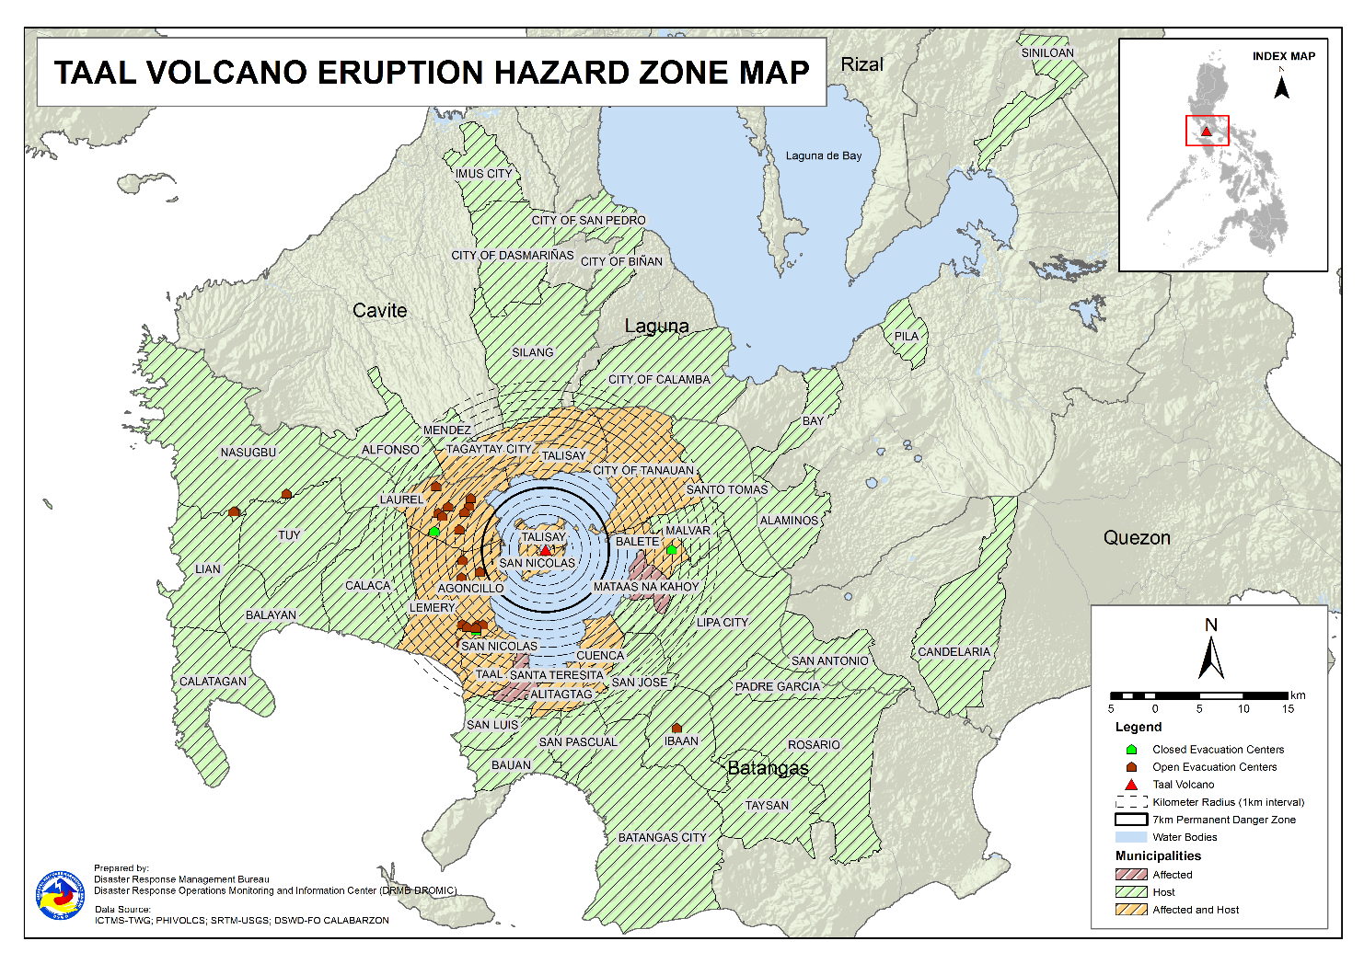

- Outside Evacuation Centers
There are 2,539 families or 8,888 persons temporarily staying with their relatives and/or friends in CALABARZON (see Table 3).

Table 3. Number of Displaced Families / Persons Outside Evacuation Centers
REGION / PROVINCE / MUNICIPALITY |  | NUMBER OF DISPLACED
 |  | OUTSIDE ECs
 |  | Families |  | Persons
 |  | CUM | NOW | CUM | NOW
GRAND TOTAL |  | 3,946 | 2,539 | 13,775 | 8,888
CALABARZON |  | 3,946 | 2,539 | 13,775 | 8,888
Batangas |  | 3,793 | 2,399 | 13,205 | 8,365
 | Agoncillo | 522 | 280 | 1,858 | 995
 | Alitagtag | 77 | 40 | 227 | 116
 | Balayan | 99 | 58 | 328 | 201
 | Balete | 3 | 3 | 9 | 9
 | Batangas City (capital) | 92 | 63 | 331 | 217
 | Bauan | 122 | 74 | 466 | 282
 | Calaca | 315 | 278 | 1,109 | 964
 | Calatagan | 47 | 34 | 179 | 118
 | Cuenca | 40 | 16 | 138 | 58
 | Ibaan | 87 | 74 | 351 | 262
 | Laurel | 1,329 | 747 | 4,545 | 2,522
 | Lemery | 160 | 148 | 590 | 540
 | Lian | 20 | 19 | 41 | 38
 | Lipa City | 31 | 24 | 81 | 65
 | Malvar | 34 | 31 | 108 | 107
 | Mataas Na Kahoy | 1 | 1 | 2 | 2
 | Nasugbu | 91 | 3 | 281 | 13
 | Padre Garcia | 12 | 11 | 45 | 42
 | Rosario | 13 | 13 | 41 | 41
 | San Jose | 46 | 43 | 164 | 151
 | San Luis | 116 | 112 | 446 | 430
 | San Nicolas | 98 | 83 | 384 | 296
 | San Pascual | 85 | 23 | 145 | 78
 | Santo Tomas | 55 | 40 | 221 | 166
 | Taal | 77 | 28 | 240 | 94
 | City of Tanauan | 199 | 140 | 797 | 526
 | Taysan | 10 | 10 | 26 | 26
 | Tuy | 12 | 3 | 52 | 6
Cavite |  | 33 | 25 | 114 | 94
 | Alfonso | 1 | 1 | 2 | 2
 | Dasmariñas | 1 | 1 | 4 | 4
 | Imus | 5 | 5 | 14 | 14
 | Mendez (MENDEZ-NUÑEZ) | 1 | 1 | 4 | 4
 | Silang | 22 | 14 | 79 | 59
 | Tagaytay City | 3 | 3 | 11 | 11
Laguna |  | 118 | 113 | 449 | 422
 | Alaminos | 3 | 3 | 14 | 14
 | Bay | 1 | - | 2 | -
 | Biñan | 1 | 1 | 5 | 5
 | City of Calamba | 106 | 104 | 391 | 383
 | Pila | 1 | 1 | 5 | 5
 | San Pedro | 3 | 3 | 12 | 12
 | Siniloan | 3 | 1 | 20 | 3
Quezon |  | 2 | 2 | 7 | 7
 | Candelaria | 1 | 1 | 4 | 4
 | San Antonio | 1 | 1 | 3 | 3
Note: Ongoing assessment and validation are continuously being conducted.
Source: DSWD-FO CALABARZON

- Total Displaced Population
A total of 3,642 families or 12,727 persons are displaced in CALABARZON due to Taal Volcano eruption (see Table 4).

Table 4. Total Number of Displaced Families / Persons
REGION / PROVINCE / MUNICIPALITY |  | TOTAL DISPLACED
 |  | Families |  | Persons
 |  | CUM | NOW | CUM | NOW
GRAND TOTAL |  | 5,600 | 3,642 | 19,664 | 12,727
CALABARZON |  | 5,600 | 3,642 | 19,664 | 12,727
Batangas |  | 5,447 | 3,502 | 19,094 | 12,204
 | Agoncillo | 953 | 671 | 3,411 | 2,439
 | Alitagtag | 77 | 40 | 227 | 116
 | Balayan | 127 | 85 | 422 | 294
 | Balete | 79 | 3 | 273 | 9
 | Batangas City | 92 | 63 | 331 | 217
 | Bauan | 122 | 74 | 466 | 282
 | Calaca | 315 | 278 | 1,109 | 964
 | Calatagan | 47 | 34 | 179 | 118
 | Cuenca | 40 | 16 | 138 | 58
 | Ibaan | 90 | 77 | 363 | 274
 | Laurel | 2,345 | 1,336 | 8,202 | 4,545
 | Lemery | 160 | 148 | 590 | 540
 | Lian | 20 | 19 | 41 | 38
 | Lipa City | 31 | 24 | 81 | 65
 | Malvar | 34 | 31 | 108 | 107
 | Mataas Na Kahoy | 1 | 1 | 2 | 2
 | Nasugbu | 191 | 96 | 590 | 280
 | Padre Garcia | 12 | 11 | 45 | 42
 | Rosario | 13 | 13 | 41 | 41
 | San Jose | 46 | 43 | 164 | 151
 | San Luis | 116 | 112 | 446 | 430
 | San Nicolas | 98 | 83 | 384 | 296
 | San Pascual | 85 | 23 | 145 | 78
 | Santo Tomas | 55 | 40 | 221 | 166
 | Taal | 77 | 28 | 240 | 94
 | City of Tanauan | 199 | 140 | 797 | 526
 | Taysan | 10 | 10 | 26 | 26
 | Tuy | 12 | 3 | 52 | 6
Cavite |  | 33 | 25 | 114 | 94
 | Alfonso | 1 | 1 | 2 | 2
 | Dasmariñas | 1 | 1 | 4 | 4
 | Imus | 5 | 5 | 14 | 14
 | Mendez (MENDEZ-NUÑEZ) | 1 | 1 | 4 | 4
 | Silang | 22 | 14 | 79 | 59
 | Tagaytay City | 3 | 3 | 11 | 11
Laguna |  | 118 | 113 | 449 | 422
 | Alaminos | 3 | 3 | 14 | 14
 | Bay | 1 | - | 2 | -
 | Biñan | 1 | 1 | 5 | 5
 | City of Calamba | 106 | 104 | 391 | 383
 | Pila | 1 | 1 | 5 | 5
 | San Pedro | 3 | 3 | 12 | 12
 | Siniloan | 3 | 1 | 20 | 3
Quezon |  | 2 | 2 | 7 | 7
 | Candelaria | 1 | 1 | 4 | 4
 | San Antonio | 1 | 1 | 3 | 3
Note: Ongoing assessment and validation are continuously being conducted.
Source: DSWD-FO CALABARZON

- Cost of Humanitarian Assistance Provided

A total of ₱16,009,434.70 worth of assistance was provided to the affected families; of which, ₱3,658,030.80 was provided by DSWD, ₱7,057,356.10 from LGUs and ₱5,294,047.80 from NGOs (see Table 5).

Table 5. Cost of Assistance Provided to Affected Families / Persons
REGION / PROVINCE / MUNICIPALITY |  | COST OF ASSISTANCE
 |  | DSWD | LGUs | NGOs | OTHERS | GRAND TOTAL
GRAND TOTAL |  | 3,658,030.80 | 7,057,356.10 | 5,294,047.80 | - | 16,009,434.70
CALABARZON |  | 3,658,030.80 | 7,057,356.10 | 5,294,047.80 | - | 16,009,434.70
Batangas |  | 3,658,030.80 | 7,057,356.10 | 5,294,047.80 | - | 16,009,434.70
 | Province | - | 3,837,247.10 | - | - | 3,837,247.10
 | Agoncillo | 758,210.30 | 1,485,568.00 | 2,175,966.10 | - | 4,419,744.40
 | Balayan | - | - | 57,065.70 | - | 57,065.70
 | Balete | - | 29,952.00 | 149,480.10 | - | 179,432.10
 | Laurel | 2,899,820.50 | 1,704,589.00 | 2,048,692.50 | - | 6,653,102.00
 | Nasugbu | - | - | 112,152.30 | - | 112,152.30
 | Talisay | - | - | 322,891.10 | - | 322,891.10
 | City of Tanauan | - | - | 427,800.00 | - | 427,800.00
Source: DSWD-FO CALABARZON

- Response Actions and Interventions

- Standby Funds and Prepositioned Relief Stockpile

Office | QRF /  Standby Funds | Family Food Packs (FFPs) |  | Other F/NFIs | Total
 |  | No. | Cost
DSWD-CO | 806,582,400.57 | - | - | - | 806,582,400.57
NROC | - | 43,688 | 31,145,451.75 | 248,582,567.65 | 279,728,019.40
VDRC | - | 3,641 | 1,674,860.00 | 37,596,459.82 | 39,271,319.82
DSWD-FO CALABARZON | 3,000,000.00 | 4,495 | 2,229,786.00 | 17,574,902.18 | 22,804,688.18
Other DSWD-FOs | 45,439,479.27 | 286,089 | 146,826,796.20 | 400,223,792.32 | 592,490,067.79
Total | 855,021,879.84 | 337,913 | 181,876,893.95 | 703,977,721.97 | 1,740,876,495.76
Note: The Inventory Summary is as of 19 July 2021, 4PM.

  - Standby Funds
- ₱806.6 million Quick Response Fund (QRF) at the DSWD-Central Office.
- ₱3 million at DSWD-Field Office (FO) CALABARZON.
- ₱45.4 million in other DSWD-FOs which may support the relief needs of the displaced families due to Taal Volcano eruption through inter-FO augmentation.

  - Prepositioned FFPs and Other Relief Items
- 47,329 FFPs available in Disaster Response Centers; of which, 43,688 FFPs are at the National Resource Operations Center (NROC), Pasay City and 3,641 FFPs are at the Visayas Disaster Response Center (VDRC), Cebu City.
- 4,495 FFPs at DSWD-FO CALABARZON.
- 286,089 FFPs in other DSWD-FOs which may support the relief needs of the displaced families due to Taal Volcano Eruption through inter-FO augmentation.
- ₱704 million worth of other food and non-food items (FNIs) at NROC, VDRC and DSWD-FO warehouses countrywide.

- Food and Non-Food Items (NFIs)

- The National Resource and Logistics Management Bureau (NRLMB) delivered 1,000 FFPs amounting to ₱778,450.00 in Batangas City Sports Complex on 16 July 2021, as partial delivery of the 5,000 FFPs additional augmentation support to DSWD-FO CALABARZON.
- NRLMB augmentation support to DSWD-FO CALABARZON amounting to ₱42,950,905.00; delivery completed on 07 July 2021.
- A total of 13,500 FFPs (₱10,509,075.00), 200 family tents (₱3,280,000.00), 5,000 family kits (₱11,440,000.00), 3,000 hygiene kits (₱4,420,500.00), and 4,279 sleeping kits (₱6,350,000.00) out of total number of augmentation support provided by NRLMB to DSWD-FO CALABARZON were directly delivered to the Provincial Social Welfare and Development Office (PSWDO) of Batangas for the needs of the displaced families.
- 300 Family tents (₱4,920,000.00) and 2,000 hygiene kits (₱2,947,000.00) were provided to Laurel, Batangas.
- DSWD-FO CALABARZON’s Emergency Operations Center (EOC) coordinated with the Municipal Social Welfare and Development Offices (MSWDOs) of Agoncillo and Laurel, Batangas on 19 July 2021 and provided technical assistance on monitoring and reporting of donated FNIs as support to the ongoing humanitarian response operations.

- Internally Displaced Person (IDP) Protection

- DSWD-FO CALABARZON through its Disaster Response Management Division attended the emergency meeting of the Management of the Dead and Missing (MDM) Cluster on 19 July 2021. The meeting served as a venue to discuss provision of Mental Health and Psychosocial Support (MHPSS) and other social services to the bereaved families in the event of deaths a volcanic eruption may cause.
- DSWD-FO CALABARZON are in constant coordination for the technical assistance needed by the local government units (LGUs) with existing evacuation centers to ensure that safety and security measures are in place to avoid gender-based violence inside camps.
- DSWD-FO CALABARZON is continuously coordinating with all the LGUs with existing open ECs to ensure compliance with the provision of emergency relief and protection for the children (RA10821) before, during and after disasters and other emergency situations as well as to monitor the compliance with the safety health protocols set by the IATF.

- Camp Coordination and Camp Management (CCCM)

- On 19 July 2021, DSWD-FO CALABARZON through its DRMD coordinated with the Department of Education (DepEd) IV-A and the PSWDOs of Batangas, Laguna and Cavite for the identification of additional evacuation centers to ensure that there will be no overcrowding in evacuation centers should the situation of Taal Volcano escalates. The Department of Health (DOH) has recommended that if schools will be utilized as evacuation centers, only one (1) family should be allowed in a class room to avoid COVID-19 outbreak.
- DSWD-FO CALABARZON coordinated with the Department of Human Settlements and Urban Development (DHSUD) on 19 July 2021 for the inventory of unfinished and unoccupied residential houses, and commercial buildings for IDPs to support their relocation from schools and those in host community.
- DSWD-FO CALABARZON continues to provide technical guidance to Local Social Welfare and Development Offices (LSWDOs) on the management of their evacuation centers and monitoring of the status of the IDPs in terms of their pressing needs and concerns.
- DSWD-FO CALABARZON’s EOC through its QRT continues to monitor the development and situation in the evacuation centers and is adjusting the plans to respond to the impact of the volcanic eruption.

- Other Activities

DATE | ACTIVITIES
17 July 2021 | - The DRMD continuously coordinated with Department of Health – Center for Health Development and requested them to conduct information campaign in the evacuation centers to avoid outbreak of COVID-19 other communicable diseases.

*****
The Disaster Response Operations Monitoring and Information Center (DROMIC) of DSWD-DRMB is closely coordinating with DSWD-FO CALABARZON for significant disaster response updates and assistance provided.

Prepared by:  MARIEL B. FERRARIZ  JEM ERIC F. FAMORCAN  MARIE JOYCE G. RAFANAN  JAN ERWIN ANDREW I. ONTANILLAS | Released by:  MARC LEO L. BUTAC

