DSWD DROMIC Report #17 on the Taal Volcano Eruption
as of 21 July 2021, 6PM

- Situation Overview

On 01 July 2021 at 3:37 PM, the Philippine Institute of Volcanology and Seismology (PHIVOLCS) has raised Alert Level 3 over Taal Volcano after a phreatomagmatic eruption from the main crater occurred at 3:16 PM.

As of 21 July 2021 at 8 AM, Alert Level 3 (Magmatic Unrest) now prevails over Taal Volcano. At Alert Level 3, magma extruding from the main crater could drive explosive eruption. The public is reminded that the entire Taal Volcano Island is a Permanent Danger Zone (PDZ), and entry into the island as well as into the high-risk barangays of Agoncillo and Laurel must be prohibited due to the hazards of pyroclastic density currents and volcanic tsunami should strong eruptions occur. All activities on Taal Lake should not be allowed at this time. Communities around the Taal Lake shores are advised to remain vigilant, take precautionary measures against possible airborne ash and vog and calmly prepare for possible evacuation should unrest intensify
Source: PHIVOLCS

- Status of Affected Areas and Population

A total of 6,086 families or 21,984 persons were affected by the Taal Volcano eruption in 147 Barangays in CALABARZON (see Table 1).

Table 1. Number of Affected Families / Persons
REGION / PROVINCE / MUNICIPALITY |  | NUMBER OF AFFECTED
 |  | Barangays | Families | Persons
GRAND TOTAL |  | 147 | 6,086 | 21,984
CALABARZON |  | 147 | 6,086 | 21,984
Batangas |  | 145 | 6,084 | 21,979
 | Agoncillo | 22 | 2,246 | 8,337
 | Alitagtag | 2 | 7 | 28
 | Balete | 9 | 102 | 354
 | Cuenca | 2 | 29 | 88
 | Laurel | 14 | 2,847 | 10,004
 | Lemery | 30 | 137 | 480
 | Mataas Na Kahoy | 4 | 43 | 129
 | San Nicolas | 16 | 249 | 925
 | Santa Teresita | 1 | 4 | 18
 | Taal | 11 | 50 | 167
 | Talisay | 19 | 181 | 710
 | City of Tanauan | 15 | 189 | 739
Cavite |  | 2 | 2 | 5
 | Tagaytay City | 2 | 2 | 5
Note: The decrease in the number of affected barangays is based on the ongoing assessment and validation being conducted.
Source: DSWD-FO CALABARZON

- Status of Displaced Population

- Inside Evacuation Centers
There are 1,115 families or 3,844 persons currently taking temporary shelter in 23 evacuation centers in CALABARZON (see Table 2).

Table 2. Number of Displaced Families / Persons Inside Evacuation Centers
REGION / PROVINCE / MUNICIPALITY |  | NUMBER OF EVACUATION CENTERS (ECs) |  | NUMBER OF DISPLACED
 |  |  |  | INSIDE ECs
 |  |  |  | Families |  | Persons
 |  | CUM | NOW | CUM | NOW | CUM | NOW
GRAND TOTAL |  | 26 | 23 | 1,668 | 1,115 | 5,922 | 3,844
CALABARZON |  | 26 | 23 | 1,668 | 1,115 | 5,922 | 3,844
Batangas |  | 26 | 23 | 1,668 | 1,115 | 5,922 | 3,844
 | Agoncillo | 11 | 10 | 435 | 402 | 1,573 | 1,460
 | Balayan | 1 | 1 | 28 | 27 | 94 | 93
 | Balete | 1 | - | 76 | - | 264 | -
 | Ibaan | 1 | 1 | 3 | 3 | 12 | 12
 | Laurel | 9 | 8 | 1,016 | 589 | 3,657 | 2,023
 | Nasugbu | 3 | 3 | 110 | 94 | 322 | 256
Note: Ongoing assessment and validation are continuously being conducted.
Source: DSWD-FO CALABARZON

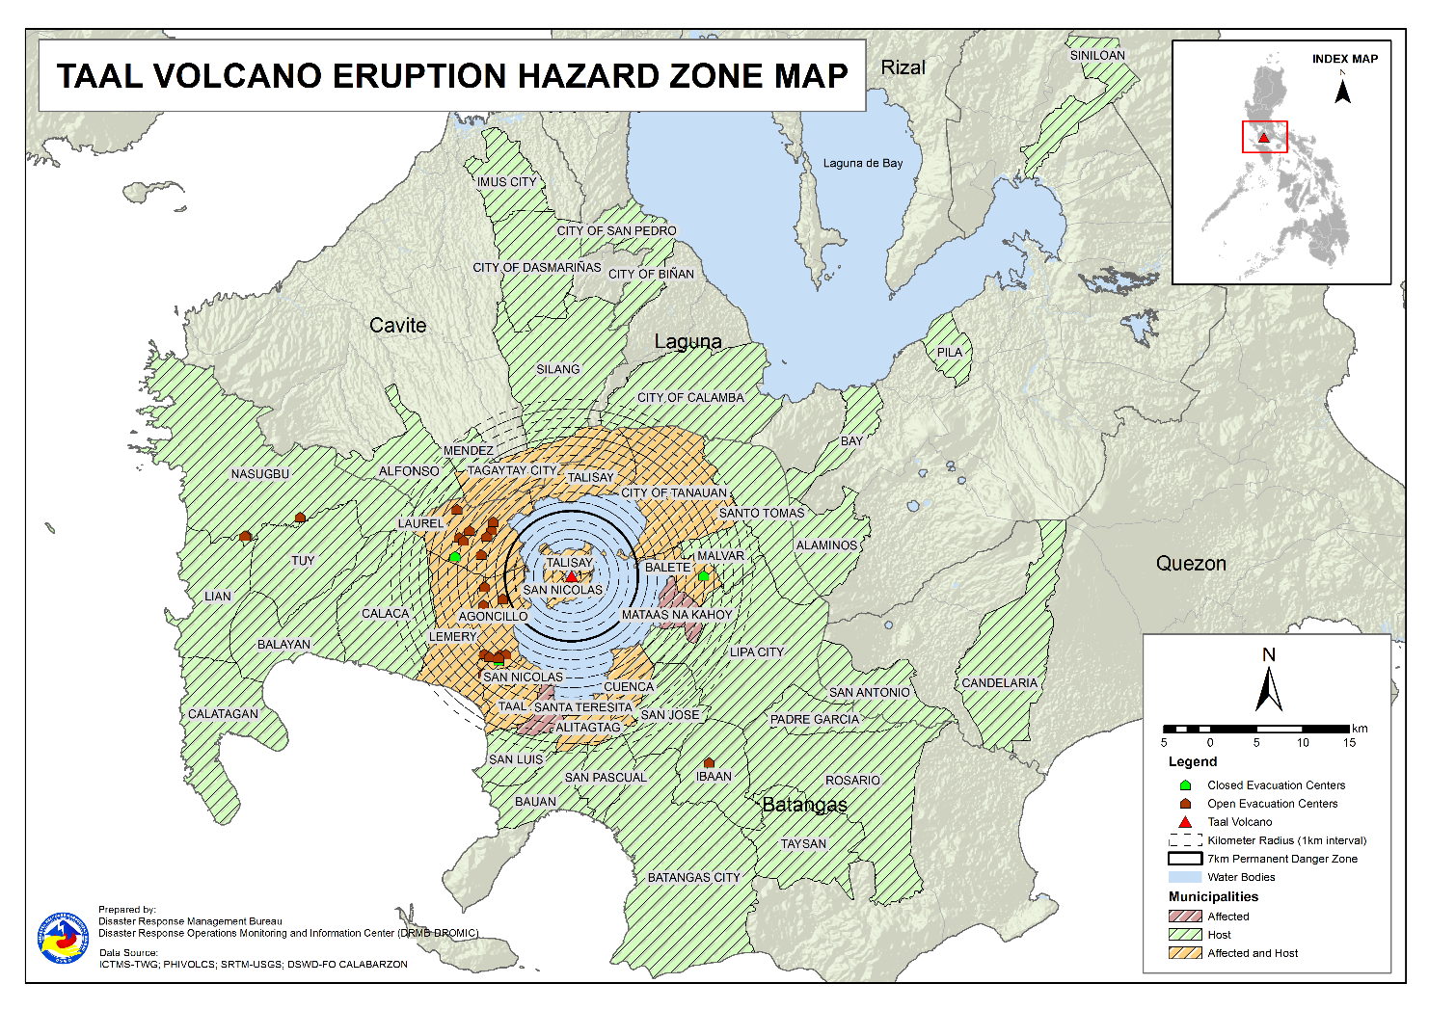

- Outside Evacuation Centers
There are 3,038 families or 10,922 persons temporarily staying with their relatives and/or friends in CALABARZON (see Table 3).

Table 3. Number of Displaced Families / Persons Outside Evacuation Centers
REGION / PROVINCE / MUNICIPALITY |  | NUMBER OF DISPLACED
 |  | OUTSIDE ECs
 |  | Families |  | Persons
 |  | CUM | NOW | CUM | NOW
GRAND TOTAL |  | 4,396 | 3,038 | 15,848 | 10,922
CALABARZON |  | 4,396 | 3,038 | 15,848 | 10,922
Batangas |  | 4,236 | 2,896 | 15,256 | 10,394
 | Agoncillo | 1,019 | 779 | 3,922 | 3,043
 | Alitagtag | 77 | 40 | 227 | 116
 | Balayan | 71 | 58 | 234 | 201
 | Balete | 4 | 4 | 11 | 11
 | Batangas City (capital) | 93 | 64 | 336 | 222
 | Bauan | 122 | 73 | 466 | 279
 | Calaca | 318 | 281 | 1,121 | 978
 | Calatagan | 47 | 32 | 180 | 108
 | Cuenca | 40 | 16 | 138 | 58
 | Ibaan | 87 | 74 | 351 | 262
 | Laurel | 1,280 | 746 | 4,545 | 2,516
 | Lemery | 160 | 148 | 590 | 540
 | Lian | 20 | 19 | 41 | 38
 | Lipa City | 31 | 24 | 81 | 65
 | Malvar | 34 | 31 | 108 | 107
 | Nasugbu | 91 | 3 | 281 | 13
 | Padre Garcia | 12 | 11 | 45 | 42
 | Rosario | 13 | 13 | 41 | 41
 | San Jose | 46 | 43 | 164 | 151
 | San Luis | 117 | 113 | 451 | 435
 | San Nicolas | 101 | 73 | 395 | 253
 | San Pascual | 85 | 23 | 145 | 78
 | Santo Tomas | 55 | 39 | 221 | 163
 | Taal | 84 | 35 | 261 | 115
 | City of Tanauan | 205 | 140 | 815 | 523
 | Taysan | 10 | 10 | 26 | 26
 | Tuy | 14 | 4 | 60 | 10
Cavite |  | 33 | 25 | 114 | 94
 | Alfonso | 1 | 1 | 2 | 2
 | Dasmariñas | 1 | 1 | 4 | 4
 | Imus | 5 | 5 | 14 | 14
 | Mendez (MENDEZ-NUÑEZ) | 1 | 1 | 4 | 4
 | Silang | 22 | 14 | 79 | 59
 | Tagaytay City | 3 | 3 | 11 | 11
Laguna |  | 123 | 113 | 463 | 419
 | Alaminos | 3 | 3 | 14 | 14
 | Bay | 1 | - | 2 | -
 | Biñan | 1 | 1 | 5 | 5
 | City of Calamba | 110 | 103 | 403 | 378
 | Los Baños | 1 | 1 | 2 | 2
 | Pila | 1 | 1 | 5 | 5
 | San Pedro | 3 | 3 | 12 | 12
 | Siniloan | 3 | 1 | 20 | 3
Quezon |  | 4 | 4 | 15 | 15
 | Candelaria | 1 | 1 | 4 | 4
 | San Antonio | 1 | 1 | 3 | 3
 | Tiaong | 2 | 2 | 8 | 8
Note: Ongoing assessment and validation are continuously being conducted.
Source: DSWD-FO CALABARZON
- Total Displaced Population
A total of 4,153 families or 14,766 persons are displaced in CALABARZON due to Taal Volcano eruption (see Table 4).

Table 4. Total Number of Displaced Families / Persons
REGION / PROVINCE / MUNICIPALITY |  | TOTAL DISPLACED SERVED
 |  | Families |  | Persons
 |  | Total Families |  | Total Persons
 |  | CUM | NOW | CUM | NOW
GRAND TOTAL |  | 6,064 | 4,153 | 21,770 | 14,766
CALABARZON |  | 6,064 | 4,153 | 21,770 | 14,766
Batangas |  | 5,904 | 4,011 | 21,178 | 14,238
 | Agoncillo | 1,454 | 1,181 | 5,495 | 4,503
 | Alitagtag | 77 | 40 | 227 | 116
 | Balayan | 99 | 85 | 328 | 294
 | Balete | 80 | 4 | 275 | 11
 | Batangas City (capital) | 93 | 64 | 336 | 222
 | Bauan | 122 | 73 | 466 | 279
 | Calaca | 318 | 281 | 1,121 | 978
 | Calatagan | 47 | 32 | 180 | 108
 | Cuenca | 40 | 16 | 138 | 58
 | Ibaan | 90 | 77 | 363 | 274
 | Laurel | 2,296 | 1,335 | 8,202 | 4,539
 | Lemery | 160 | 148 | 590 | 540
 | Lian | 20 | 19 | 41 | 38
 | Lipa City | 31 | 24 | 81 | 65
 | Malvar | 34 | 31 | 108 | 107
 | Nasugbu | 201 | 97 | 603 | 269
 | Padre Garcia | 12 | 11 | 45 | 42
 | Rosario | 13 | 13 | 41 | 41
 | San Jose | 46 | 43 | 164 | 151
 | San Luis | 117 | 113 | 451 | 435
 | San Nicolas | 101 | 73 | 395 | 253
 | San Pascual | 85 | 23 | 145 | 78
 | Santo Tomas | 55 | 39 | 221 | 163
 | Taal | 84 | 35 | 261 | 115
 | City of Tanauan | 205 | 140 | 815 | 523
 | Taysan | 10 | 10 | 26 | 26
 | Tuy | 14 | 4 | 60 | 10
Cavite |  | 33 | 25 | 114 | 94
 | Alfonso | 1 | 1 | 2 | 2
 | Dasmariñas | 1 | 1 | 4 | 4
 | Imus | 5 | 5 | 14 | 14
 | Mendez (MENDEZ-NUÑEZ) | 1 | 1 | 4 | 4
 | Silang | 22 | 14 | 79 | 59
 | Tagaytay City | 3 | 3 | 11 | 11
Laguna |  | 123 | 113 | 463 | 419
 | Alaminos | 3 | 3 | 14 | 14
 | Bay | 1 | - | 2 | -
 | Biñan | 1 | 1 | 5 | 5
 | City of Calamba | 110 | 103 | 403 | 378
 | Los Baños | 1 | 1 | 2 | 2
 | Pila | 1 | 1 | 5 | 5
 | San Pedro | 3 | 3 | 12 | 12
 | Siniloan | 3 | 1 | 20 | 3
Quezon |  | 4 | 4 | 15 | 15
 | Candelaria | 1 | 1 | 4 | 4
 | San Antonio | 1 | 1 | 3 | 3
 | Tiaong | 2 | 2 | 8 | 8
Note: Ongoing assessment and validation are continuously being conducted.
Source: DSWD-FO CALABARZON

- Cost of Humanitarian Assistance Provided

A total of ₱16,038,946.70 worth of assistance was provided to the affected families; of which, ₱3,658,030.80 was provided by DSWD, ₱7,086,868.10 from Local Government Units (LGUs) and ₱5,294,047.80 from Non-Government Organizations (NGOs) (see Table 5).

Table 5. Cost of Assistance Provided to Affected Families / Persons
REGION / PROVINCE / MUNICIPALITY |  | COST OF ASSISTANCE
 |  | DSWD | LGUs | NGOs | OTHERS | GRAND TOTAL
GRAND TOTAL |  | 3,658,030.80 | 7,086,868.10 | 5,294,047.80 | - | 16,038,946.70
CALABARZON |  | 3,658,030.80 | 7,086,868.10 | 5,294,047.80 | - | 16,038,946.70
Batangas |  | 3,658,030.80 | 7,086,868.10 | 5,294,047.80 | - | 16,038,946.70
 | Province | - | 3,837,247.10 | - | - | 3,837,247.10
 | Agoncillo | 758,210.30 | 1,485,568.00 | 2,175,966.10 | - | 4,419,744.40
 | Balayan | - | - | 57,065.70 | - | 57,065.70
 | Balete | - | 29,952.00 | 149,480.10 | - | 179,432.10
 | Batangas City (capital) | - | 29,512.00 | - | - | 29,512.00
 | Laurel | 2,899,820.50 | 1,704,589.00 | 2,048,692.50 | - | 6,653,102.00
 | Nasugbu | - | - | 112,152.30 | - | 112,152.30
 | Talisay | - | - | 322,891.10 | - | 322,891.10
 | City of Tanauan | - | - | 427,800.00 | - | 427,800.00
Source: DSWD-FO CALABARZON

- Response Actions and Interventions

- Standby Funds and Prepositioned Relief Stockpile

Office | QRF /  Standby Funds | Family Food Packs (FFPs) |  | Other F/NFIs | Total
 |  | No. | Cost
DSWD-CO | 806,582,400.57 | - | - | - | 806,582,400.57
NROC | - | 43,688 | 31,145,451.75 | 225,888,536.29 | 257,033,988.04
VDRC | - | 3,641 | 1,674,860.00 | 34,413,368.82 | 36,088,228.82
DSWD-FO CALABARZON | 5,240,440.00 | 4,495 | 2,229,786.00 | 17,574,902.18 | 25,045,128.18
Other DSWD-FOs | 43,711,479.27 | 291,110 | 149,004,049.92 | 398,847,902.82 | 591,563,432.01
Total | 855,534,319.84 | 342,934 | 184,054,147.67 | 676,724,710.11 | 1,716,313,177.62
Note: The Inventory Summary is as of 21 July 2021, 4PM.

  - Standby Funds
- ₱806.6 million Quick Response Fund (QRF) at the DSWD-Central Office.
- ₱5.2 million at DSWD-Field Office (FO) CALABARZON.
- ₱43.7 million in other DSWD-FOs which may support the relief needs of the displaced families due to Taal Volcano eruption through inter-FO augmentation.

  - Prepositioned FFPs and Other Relief Items
- 47,329 FFPs available in Disaster Response Centers; of which, 43,688 FFPs are at the National Resource Operations Center (NROC), Pasay City and 3,641 FFPs are at the Visayas Disaster Response Center (VDRC), Cebu City.
- 4,495 FFPs at DSWD-FO CALABARZON.
- 291,110 FFPs in other DSWD-FOs which may support the relief needs of the displaced families due to Taal Volcano Eruption through inter-FO augmentation.
- ₱676.7 million worth of other food and non-food items (FNIs) at NROC, VDRC and DSWD-FO warehouses countrywide.

- Food and Non-Food Items (NFIs)

- The National Resource and Logistics Management Bureau (NRLMB) delivered 1,000 FFPs amounting to ₱778,450.00 in Batangas City Sports Complex on 16 July 2021, as partial delivery of the 5,000 FFPs additional augmentation support to DSWD-FO CALABARZON.
- NRLMB augmentation support to DSWD-FO CALABARZON amounting to ₱42,950,905.00; delivery completed on 07 July 2021.
- A total of 13,500 FFPs (₱10,509,075.00), 200 family tents (₱3,280,000.00), 5,000 family kits (₱11,440,000.00), 3,000 hygiene kits (₱4,420,500.00), and 4,279 sleeping kits (₱6,350,000.00) out of total number of augmentation support provided by NRLMB to DSWD-FO CALABARZON were directly delivered to the Provincial Social Welfare and Development Office (PSWDO) of Batangas for the needs of the displaced families.
- 300 Family tents (₱4,920,000.00) and 2,000 hygiene kits (₱2,947,000.00) were provided to Laurel, Batangas.
- DSWD-FO CALABARZON in collaboration with NRLMB facilitated the hauling of 300 cavans of NFA rice from Gen. Trias City to its warehouse in Dasmariñas City on 20 July 2021. Twenty (20) community volunteers were mobilized to assist in the hauling.
- DSWD-FO CALABARZON’s Emergency Operations Center (EOC) coordinated with Department of Science and Technology (DOST) IV-A on 20 July 2021 for the status of delivery of DOST-developed and DOST-assisted food items to the affected families in Laurel and Agoncillo, Batangas.

- Internally Displaced Person (IDP) Protection

- DSWD-FO CALABARZON are in constant coordination for the technical assistance needed by the LGUs with existing evacuation centers to ensure that safety and security measures are in place to avoid gender-based violence inside camps.
- DSWD-FO CALABARZON is continuously coordinating with all the LGUs with existing open ECs to ensure compliance with the provision of emergency relief and protection for the children (RA10821) before, during and after disasters and other emergency situations as well as to monitor the compliance with the safety health protocols set by the IATF. Moreover, DSWD-FO CALABARZON also provided technical assistance on 20 July 2021 on setting up and activating a hotline for IDPs, to continuously provide services related to protection.

- Camp Coordination and Camp Management (CCCM)

- The DSWD-FO CALABARZON Provincial Quick Response Team (QRT) in Batangas dispatched Municipal Action Teams (MATs) of Agoncillo, Balayan, Laurel and Nasugbu on 20 July 2021 to conduct assessment in the evacuation centers and identify the immediate needs of the IDPs.
- DSWD-FO CALABARZON’s EOC coordinated with Local Social Welfare and Development Offices (LSWDOs) on 20 July 2021 and provided technical assistance on the management and improvement of their evacuation centers in response to the threats of COVID-19 outbreak.
- DSWD-FO CALABARZON coordinated with the Department of Health – Center for Health Development (DOH-CHD) IV-A and National Nutrition Council (NNC) IV-A on 20 July 2021 for the conduct of supplementary feeding for children, pregnant, and lactating mothers in evacuation centers while conducting a screening.

- Other Activities

DATE | ACTIVITIES
17 July 2021 | - The Disaster Response Management Division (DRMD) of DSWD-FO CALABARZON continuously coordinated with DOH-CHD and requested them to conduct information campaign in the evacuation centers to avoid outbreak of COVID-19 other communicable diseases.

*****
The Disaster Response Operations Monitoring and Information Center (DROMIC) of DSWD-DRMB is closely coordinating with DSWD-FO CALABARZON for significant disaster response updates and assistance provided.

Prepared by:  MARIEL B. FERRARIZ  MARIE JOYCE G. RAFANAN  JAN ERWIN ANDREW I. ONTANILLAS | Released by:  MARC LEO L. BUTAC

