DSWD DROMIC Report #18 on the Taal Volcano Eruption
as of 22 July 2021, 6PM

- Situation Overview

On 01 July 2021 at 3:37 PM, the Philippine Institute of Volcanology and Seismology (PHIVOLCS) has raised Alert Level 3 over Taal Volcano after a phreatomagmatic eruption from the main crater occurred at 3:16 PM.

As of 22 July 2021 at 8 AM, Alert Level 3 (Magmatic Unrest) now prevails over Taal Volcano. At Alert Level 3, magma extruding from the main crater could drive explosive eruption. The public is reminded that the entire Taal Volcano Island is a Permanent Danger Zone (PDZ), and entry into the island as well as into the high-risk barangays of Agoncillo and Laurel must be prohibited due to the hazards of pyroclastic density currents and volcanic tsunami should strong eruptions occur. All activities on Taal Lake should not be allowed at this time. Communities around the Taal Lake shores are advised to remain vigilant, take precautionary measures against possible airborne ash and vog and calmly prepare for possible evacuation should unrest intensify.
Source: PHIVOLCS

- Status of Affected Areas and Population

A total of 6,100 families or 22,036 persons were affected by the Taal Volcano eruption in 148 Barangays in CALABARZON (see Table 1).

Table 1. Number of Affected Families / Persons
REGION / PROVINCE / MUNICIPALITY |  | NUMBER OF AFFECTED
 |  | Barangays | Families | Persons
GRAND TOTAL |  | 148 | 6,100 | 22,036
CALABARZON |  | 148 | 6,100 | 22,036
Batangas |  | 146 | 6,098 | 22,031
 | Agoncillo | 22 | 2,251 | 8,356
 | Alitagtag | 2 | 7 | 28
 | Balete | 9 | 102 | 354
 | Cuenca | 2 | 31 | 94
 | Laurel | 14 | 2,847 | 10,004
 | Lemery | 30 | 137 | 480
 | Mataas Na Kahoy | 4 | 43 | 129
 | San Nicolas | 16 | 249 | 925
 | Santa Teresita | 1 | 4 | 18
 | Taal | 11 | 50 | 167
 | Talisay | 19 | 182 | 713
 | City of Tanauan | 16 | 195 | 763
Cavite |  | 2 | 2 | 5
 | Tagaytay City | 2 | 2 | 5
Note: Ongoing assessment and validation are continuously being conducted.

Source: DSWD-FO CALABARZON

- Status of Displaced Population

- Inside Evacuation Centers
There are 1,113 families or 3,834 persons currently taking temporary shelter in 23 evacuation centers in CALABARZON (see Table 2).

Table 2. Number of Displaced Families / Persons Inside Evacuation Centers
REGION / PROVINCE / MUNICIPALITY |  | NUMBER OF EVACUATION CENTERS (ECs) |  | NUMBER OF DISPLACED
 |  |  |  | INSIDE ECs
 |  |  |  | Families |  | Persons
 |  | CUM | NOW | CUM | NOW | CUM | NOW
GRAND TOTAL |  | 26 | 23 | 1,668 | 1,113 | 5,922 | 3,834
CALABARZON |  | 26 | 23 | 1,668 | 1,113 | 5,922 | 3,834
Batangas |  | 26 | 23 | 1,668 | 1,113 | 5,922 | 3,834
 | Agoncillo | 11 | 10 | 435 | 402 | 1,573 | 1,460
 | Balayan | 1 | 1 | 28 | 27 | 94 | 93
 | Balete | 1 | - | 76 | - | 264 | -
 | Ibaan | 1 | 1 | 3 | 3 | 12 | 12
 | Laurel | 9 | 8 | 1,016 | 588 | 3,657 | 2,021
 | Nasugbu | 3 | 3 | 110 | 93 | 322 | 248
Note: Ongoing assessment and validation are continuously being conducted.
Source: DSWD-FO CALABARZON

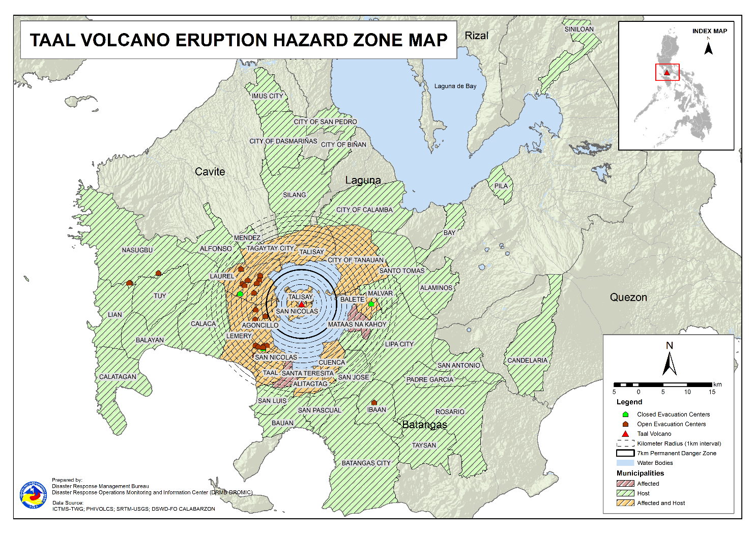

- Outside Evacuation Centers
There are 3,051 families or 10,971 persons temporarily staying with their relatives and/or friends in CALABARZON (see Table 3).

Table 3. Number of Displaced Families / Persons Outside Evacuation Centers
REGION / PROVINCE / MUNICIPALITY |  | NUMBER OF DISPLACED
 |  | OUTSIDE ECs
 |  | Families |  | Persons
 |  | CUM | NOW | CUM | NOW
GRAND TOTAL |  | 4,410 | 3,051 | 15,900 | 10,971
CALABARZON |  | 4,410 | 3,051 | 15,900 | 10,971
Batangas |  | 4,246 | 2,906 | 15,293 | 10,431
 | Agoncillo | 1,019 | 779 | 3,926 | 3,047
 | Alitagtag | 77 | 40 | 227 | 116
 | Balayan | 71 | 58 | 234 | 201
 | Balete | 6 | 6 | 19 | 19
 | Batangas City (capital) | 93 | 64 | 336 | 222
 | Bauan | 123 | 74 | 471 | 284
 | Calaca | 322 | 285 | 1,131 | 988
 | Calatagan | 47 | 32 | 180 | 108
 | Cuenca | 40 | 16 | 138 | 58
 | Ibaan | 87 | 74 | 351 | 262
 | Laurel | 1,280 | 746 | 4,545 | 2,516
 | Lemery | 160 | 148 | 590 | 540
 | Lian | 20 | 19 | 41 | 38
 | Lipa City | 31 | 24 | 81 | 65
 | Malvar | 34 | 31 | 108 | 107
 | Nasugbu | 91 | 3 | 281 | 13
 | Padre Garcia | 12 | 11 | 45 | 42
 | Rosario | 13 | 13 | 41 | 41
 | San Jose | 47 | 44 | 168 | 155
 | San Luis | 117 | 113 | 451 | 435
 | San Nicolas | 101 | 73 | 395 | 253
 | San Pascual | 85 | 23 | 145 | 78
 | Santo Tomas | 55 | 39 | 221 | 163
 | Taal | 84 | 35 | 261 | 115
 | City of Tanauan | 207 | 142 | 821 | 529
 | Taysan | 10 | 10 | 26 | 26
 | Tuy | 14 | 4 | 60 | 10
Cavite |  | 33 | 25 | 114 | 94
 | Alfonso | 1 | 1 | 2 | 2
 | Dasmariñas | 1 | 1 | 4 | 4
 | Imus | 5 | 5 | 14 | 14
 | Mendez (MENDEZ-NUÑEZ) | 1 | 1 | 4 | 4
 | Silang | 22 | 14 | 79 | 59
 | Tagaytay City | 3 | 3 | 11 | 11
Laguna |  | 127 | 116 | 478 | 431
 | Alaminos | 3 | 3 | 14 | 14
 | Bay | 2 | - | 5 | -
 | Biñan | 1 | 1 | 5 | 5
 | Cabuyao | 3 | 3 | 12 | 12
 | City of Calamba | 110 | 103 | 403 | 378
 | Los Baños | 1 | 1 | 2 | 2
 | Pila | 1 | 1 | 5 | 5
 | San Pedro | 3 | 3 | 12 | 12
 | Siniloan | 3 | 1 | 20 | 3
Quezon |  | 4 | 4 | 15 | 15
 | Candelaria | 1 | 1 | 4 | 4
 | San Antonio | 1 | 1 | 3 | 3
 | Tiaong | 2 | 2 | 8 | 8
Note: Ongoing assessment and validation are continuously being conducted.
Source: DSWD-FO CALABARZON
- Total Displaced Population
A total of 4,164 families or 14,805 persons are displaced in CALABARZON due to Taal Volcano eruption (see Table 4).

Table 4. Total Number of Displaced Families / Persons
REGION / PROVINCE / MUNICIPALITY |  | TOTAL DISPLACED SERVED
 |  | Families |  | Persons
 |  | Total Families |  | Total Persons
 |  | CUM | NOW | CUM | NOW
GRAND TOTAL |  | 6,078 | 4,164 | 21,822 | 14,805
CALABARZON |  | 6,078 | 4,164 | 21,822 | 14,805
Batangas |  | 5,914 | 4,019 | 21,215 | 14,265
 | Agoncillo | 1,454 | 1,181 | 5,499 | 4,507
 | Alitagtag | 77 | 40 | 227 | 116
 | Balayan | 99 | 85 | 328 | 294
 | Balete | 82 | 6 | 283 | 19
 | Batangas City (capital) | 93 | 64 | 336 | 222
 | Bauan | 123 | 74 | 471 | 284
 | Calaca | 322 | 285 | 1,131 | 988
 | Calatagan | 47 | 32 | 180 | 108
 | Cuenca | 40 | 16 | 138 | 58
 | Ibaan | 90 | 77 | 363 | 274
 | Laurel | 2,296 | 1,334 | 8,202 | 4,537
 | Lemery | 160 | 148 | 590 | 540
 | Lian | 20 | 19 | 41 | 38
 | Lipa City | 31 | 24 | 81 | 65
 | Malvar | 34 | 31 | 108 | 107
 | Nasugbu | 201 | 96 | 603 | 261
 | Padre Garcia | 12 | 11 | 45 | 42
 | Rosario | 13 | 13 | 41 | 41
 | San Jose | 47 | 44 | 168 | 155
 | San Luis | 117 | 113 | 451 | 435
 | San Nicolas | 101 | 73 | 395 | 253
 | San Pascual | 85 | 23 | 145 | 78
 | Santo Tomas | 55 | 39 | 221 | 163
 | Taal | 84 | 35 | 261 | 115
 | City of Tanauan | 207 | 142 | 821 | 529
 | Taysan | 10 | 10 | 26 | 26
 | Tuy | 14 | 4 | 60 | 10
Cavite |  | 33 | 25 | 114 | 94
 | Alfonso | 1 | 1 | 2 | 2
 | Dasmariñas | 1 | 1 | 4 | 4
 | Imus | 5 | 5 | 14 | 14
 | Mendez (MENDEZ-NUÑEZ) | 1 | 1 | 4 | 4
 | Silang | 22 | 14 | 79 | 59
 | Tagaytay City | 3 | 3 | 11 | 11
Laguna |  | 127 | 116 | 478 | 431
 | Alaminos | 3 | 3 | 14 | 14
 | Bay | 2 | - | 5 | -
 | Biñan | 1 | 1 | 5 | 5
 | Cabuyao | 3 | 3 | 12 | 12
 | City of Calamba | 110 | 103 | 403 | 378
 | Los Baños | 1 | 1 | 2 | 2
 | Pila | 1 | 1 | 5 | 5
 | San Pedro | 3 | 3 | 12 | 12
 | Siniloan | 3 | 1 | 20 | 3
Quezon |  | 4 | 4 | 15 | 15
 | Candelaria | 1 | 1 | 4 | 4
 | San Antonio | 1 | 1 | 3 | 3
 | Tiaong | 2 | 2 | 8 | 8
Note: Ongoing assessment and validation are continuously being conducted.
Source: DSWD-FO CALABARZON

- Cost of Humanitarian Assistance Provided

A total of ₱16,093,396.30 worth of assistance was provided to the affected families; of which, ₱3,658,030.80 was provided by DSWD, ₱7,141,317.70 from Local Government Units (LGUs) and ₱5,294,047.80 from Non-Government Organizations (NGOs) (see Table 5).

Table 5. Cost of Assistance Provided to Affected Families / Persons
REGION / PROVINCE / MUNICIPALITY |  | COST OF ASSISTANCE
 |  | DSWD | LGUs | NGOs | OTHERS | GRAND TOTAL
GRAND TOTAL |  | 3,658,030.80 | 7,141,317.70 | 5,294,047.80 | - | 16,093,396.30
CALABARZON |  | 3,658,030.80 | 7,141,317.70 | 5,294,047.80 | - | 16,093,396.30
Batangas |  | 3,658,030.80 | 7,141,317.70 | 5,294,047.80 | - | 16,093,396.30
 | Province | - | 3,837,247.10 | - | - | 3,837,247.10
 | Agoncillo | 758,210.30 | 1,485,568.00 | 2,175,966.10 | - | 4,419,744.40
 | Balayan | - | - | 57,065.70 | - | 57,065.70
 | Balete | - | 29,952.00 | 149,480.10 | - | 179,432.10
 | Batangas City (capital) | - | 29,512.00 | - | - | 29,512.00
 | Laurel | 2,899,820.50 | 1,704,589.00 | 2,048,692.50 | - | 6,653,102.00
 | Nasugbu | - | - | 112,152.30 | - | 112,152.30
 | Talisay | - | - | 322,891.10 | - | 322,891.10
 | City of Tanauan | - | 54,449.60 | 427,800.00 | - | 482,249.60
Source: DSWD-FO CALABARZON

- Response Actions and Interventions

- Standby Funds and Prepositioned Relief Stockpile

Office | QRF /  Standby Funds | Family Food Packs (FFPs) |  | Other F/NFIs | Total
 |  | No. | Cost
DSWD-CO | 806,582,400.57 | - | - | - | 806,582,400.57
NROC | - | 43,188 | 31,019,676.75 | 245,351,341.21 | 276,371,017.96
VDRC | - | 5,841 | 2,686,860.00 | 33,608,112.82 | 36,294,972.82
DSWD-FO CALABARZON | 5,240,440.00 | 4,495 | 2,229,786.00 | 19,577,388.68 | 27,047,614.68
Other DSWD-FOs | 42,957,159.27 | 276,345 | 145,827,476.80 | 391,688,356.53 | 580,472,992.60
Total | 854,779,999.84 | 329,869 | 181,763,799.55 | 690,225,199.24 | 1,726,768,998.63
Note: The Inventory Summary is as of 22 July 2021, 4PM.

  - Standby Funds
- ₱806.6 million Quick Response Fund (QRF) at the DSWD-Central Office.
- ₱5.2 million at DSWD-Field Office (FO) CALABARZON.
- ₱43 million in other DSWD-FOs which may support the relief needs of the displaced families due to Taal Volcano eruption through inter-FO augmentation.
  - Prepositioned FFPs and Other Relief Items
- 49,029 FFPs available in Disaster Response Centers; of which, 43,188 FFPs are at the National Resource Operations Center (NROC), Pasay City and 5,841 FFPs are at the Visayas Disaster Response Center (VDRC), Cebu City.
- 4,495 FFPs at DSWD-FO CALABARZON.
- 276,345 FFPs in other DSWD-FOs which may support the relief needs of the displaced families due to Taal Volcano Eruption through inter-FO augmentation.
- ₱690.2 million worth of other food and non-food items (FNIs) at NROC, VDRC and DSWD-FO warehouses countrywide.

- Food and Non-Food Items (NFIs)

- The National Resource and Logistics Management Bureau (NRLMB) delivered 1,000 FFPs amounting to ₱778,450.00 in Batangas City Sports Complex on 16 July 2021, as partial delivery of the 5,000 FFPs additional augmentation support to DSWD-FO CALABARZON.
- NRLMB augmentation support to DSWD-FO CALABARZON amounting to ₱42,950,905.00; delivery completed on 07 July 2021.
- A total of 13,500 FFPs (₱10,509,075.00), 200 family tents (₱3,280,000.00), 5,000 family kits (₱11,440,000.00), 3,000 hygiene kits (₱4,420,500.00), and 4,279 sleeping kits (₱6,350,000.00) out of total number of augmentation support provided by NRLMB to DSWD-FO CALABARZON were directly delivered to the Provincial Social Welfare and Development Office (PSWDO) of Batangas for the needs of the displaced families.
- 300 Family tents (₱4,920,000.00) and 2,000 hygiene kits (₱2,947,000.00) were provided to Laurel, Batangas.
- DSWD-FO CALABARZON in collaboration with NRLMB facilitated the hauling of 300 cavans of NFA rice from Gen. Trias City to its warehouse in Dasmariñas City on 21 July 2021. Fifteen (15) community volunteers were mobilized to assist in the hauling.
- DSWD-FO CALABARZON’s through the Supplementary Feeding Program (SFP) facilitated the distribution of 21,725 Nutribun with Nutributter amounting to ₱325,875.00 in high-risk LGUs and evacuation centers where 6,585 children were served on 21 July 2021.
- The DSWD-FO CALABAZON’s Emergency Operations Center (EOC) coordinated with the Local Social Welfare and Development Officers (LSWDOs) of Balayan, Bauan, Calaca and Nasugbu, Batangas on 21 July 2021 for the administrative and logistical preparations relative to the conduct of an ocular inspection in identified areas for the establishment of temporary warehouses and Mobile Storage Units (MSUs).

- Internally Displaced Person (IDP) Protection

- The DSWD-FO CALABARZON EOC provided electronic copies of the Commission on Human Rights (CHR) Displacement Monitoring Tool to the Provincial/City/Municipal Social Welfare and Development Offices in Batangas on 21 July 2021.

- Camp Coordination and Camp Management (CCCM)

- The members of DSWD-FO CALABARZON Provincial Quick Response Team (QRT) through Municipal Action Teams (MATs) conducted ocular visits in the evacuation centers of Agoncillo, Balayan, Laurel and Nasugbu, Batangas on 21 July 2021. Information boards were installed in 18 evacuation centers during this visit.

- Other Activities

DATE | ACTIVITIES
21 July 2021 | - DSWD-FO CALABARZON through its Disaster Response Management Division (DRMD) attended the Management of the Dead and Missing (MDM) Cluster Virtual Meeting. This served as a venue to review and strengthen the protocols in reporting casualties should the situation of Taal Volcano escalates.  - DSWD-FO CALABARZON participated in the launching of Operation Listo Manual for Taal Volcano, which serves as a checklist of preparedness for response actions of the LGUs.

*****
The Disaster Response Operations Monitoring and Information Center (DROMIC) of DSWD-DRMB is closely coordinating with DSWD-FO CALABARZON for significant disaster response updates and assistance provided.

Prepared by:  JEM ERIC F. FAMORCAN  MARIE JOYCE G. RAFANAN  JAN ERWIN ANDREW I. ONTANILLAS | Released by:  MARC LEO L. BUTAC

