DSWD DROMIC Report #19 on the Taal Volcano Eruption
as of 23 July 2021, 6PM

- Situation Overview

On 01 July 2021 at 3:37 PM, the Philippine Institute of Volcanology and Seismology (PHIVOLCS) has raised Alert Level 3 over Taal Volcano after a phreatomagmatic eruption from the main crater occurred at 3:16 PM.

As of 23 July 2021 at 8 AM, Alert Level 3 (Magmatic Unrest) now prevails over Taal Volcano. At Alert Level 3, magma extruding from the main crater could drive explosive eruption. The public is reminded that the entire Taal Volcano Island is a Permanent Danger Zone (PDZ), and entry into the island as well as into the high-risk barangays of Agoncillo and Laurel must be prohibited due to the hazards of pyroclastic density currents and volcanic tsunami should strong eruptions occur. All activities on Taal Lake should not be allowed at this time. Communities around the Taal Lake shores are advised to remain vigilant, take precautionary measures against possible airborne ash and vog and calmly prepare for possible evacuation should unrest intensify.
Source: PHIVOLCS

- Status of Affected Areas and Population

A total of 6,135 families or 22,148 persons were affected by the Taal Volcano eruption in 148 Barangays in CALABARZON (see Table 1).

Table 1. Number of Affected Families / Persons
REGION / PROVINCE / MUNICIPALITY |  | NUMBER OF AFFECTED
 |  | Barangays | Families | Persons
GRAND TOTAL |  | 148 | 6,135 | 22,148
CALABARZON |  | 148 | 6,135 | 22,148
Batangas |  | 146 | 6,133 | 22,143
 | Agoncillo | 22 | 2,279 | 8,443
 | Alitagtag | 2 | 7 | 28
 | Balete | 9 | 102 | 354
 | Cuenca | 2 | 31 | 94
 | Laurel | 14 | 2,847 | 10,004
 | Lemery | 30 | 139 | 490
 | Mataas Na Kahoy | 4 | 43 | 129
 | San Nicolas | 16 | 250 | 931
 | Santa Teresita | 1 | 4 | 18
 | Taal | 11 | 50 | 167
 | Talisay | 19 | 184 | 718
 | City of Tanauan | 16 | 197 | 767
Cavite |  | 2 | 2 | 5
 | Tagaytay City | 2 | 2 | 5
Note: Ongoing assessment and validation are continuously being conducted.

Source: DSWD-FO CALABARZON

- Status of Displaced Population

- Inside Evacuation Centers
There are 1,118 families or 3,853 persons currently taking temporary shelter in 23 evacuation centers in CALABARZON (see Table 2).

Table 2. Number of Displaced Families / Persons Inside Evacuation Centers
REGION / PROVINCE / MUNICIPALITY |  | NUMBER OF EVACUATION CENTERS (ECs) |  | NUMBER OF DISPLACED
 |  |  |  | INSIDE ECs
 |  |  |  | Families |  | Persons
 |  | CUM | NOW | CUM | NOW | CUM | NOW
GRAND TOTAL |  | 26 | 23 | 1,673 | 1,118 | 5,941 | 3,853
CALABARZON |  | 26 | 23 | 1,673 | 1,118 | 5,941 | 3,853
Batangas |  | 26 | 23 | 1,673 | 1,118 | 5,941 | 3,853
 | Agoncillo | 11 | 10 | 440 | 407 | 1,592 | 1,479
 | Balayan | 1 | 1 | 28 | 27 | 94 | 93
 | Balete | 1 | - | 76 | - | 264 | -
 | Ibaan | 1 | 1 | 3 | 3 | 12 | 12
 | Laurel | 9 | 8 | 1,016 | 588 | 3,657 | 2,021
 | Nasugbu | 3 | 3 | 110 | 93 | 322 | 248
Note: Ongoing assessment and validation are continuously being conducted.
Source: DSWD-FO CALABARZON

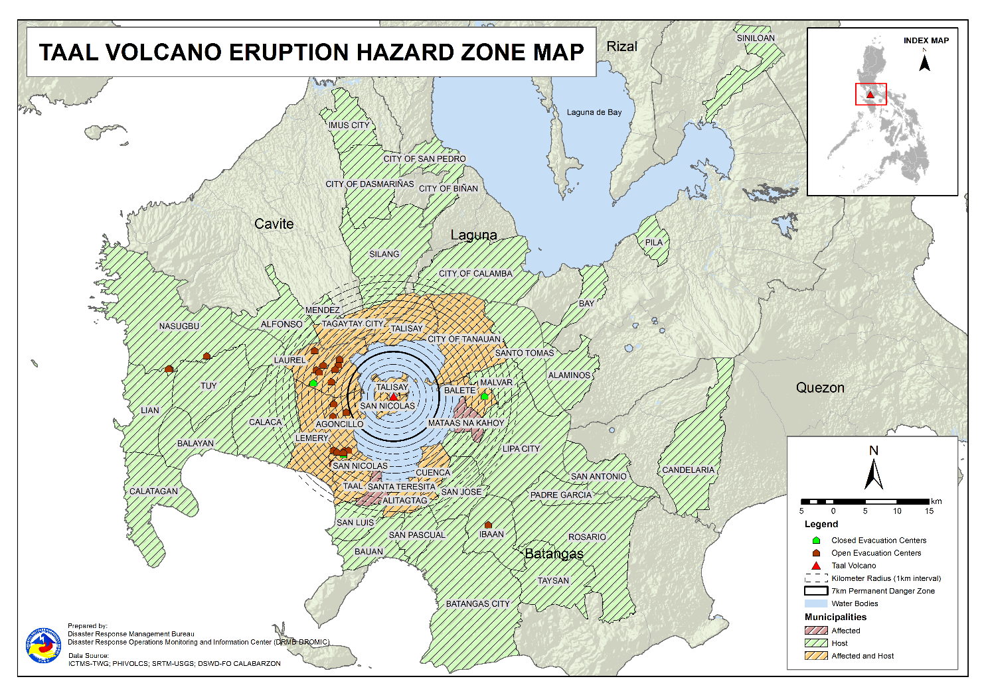

- Outside Evacuation Centers
There are 3,081 families or 11,078 persons temporarily staying with their relatives and/or friends in CALABARZON (see Table 3).

Table 3. Number of Displaced Families / Persons Outside Evacuation Centers
REGION / PROVINCE / MUNICIPALITY |  | NUMBER OF DISPLACED
 |  | OUTSIDE ECs
 |  | Families |  | Persons
 |  | CUM | NOW | CUM | NOW
GRAND TOTAL |  | 4,453 | 3,081 | 16,046 | 11,078
CALABARZON |  | 4,453 | 3,081 | 16,046 | 11,078
Batangas |  | 4,289 | 2,936 | 15,439 | 10,540
 | Agoncillo | 1,038 | 798 | 3,986 | 3,107
 | Alitagtag | 77 | 40 | 227 | 116
 | Balayan | 71 | 58 | 234 | 201
 | Balete | 6 | 6 | 19 | 19
 | Batangas City (capital) | 93 | 64 | 336 | 222
 | Bauan | 123 | 74 | 471 | 284
 | Calaca | 323 | 286 | 1,134 | 991
 | Calatagan | 47 | 32 | 180 | 108
 | Cuenca | 40 | 16 | 138 | 58
 | Ibaan | 93 | 78 | 369 | 272
 | Laurel | 1,280 | 746 | 4,545 | 2,516
 | Lemery | 161 | 149 | 595 | 545
 | Lian | 20 | 19 | 41 | 38
 | Lipa City | 31 | 24 | 81 | 65
 | Malvar | 34 | 31 | 108 | 107
 | Nasugbu | 91 | 3 | 281 | 13
 | Padre Garcia | 12 | 11 | 45 | 42
 | Rosario | 13 | 13 | 41 | 41
 | San Jose | 47 | 44 | 168 | 155
 | San Luis | 124 | 120 | 476 | 460
 | San Nicolas | 101 | 73 | 395 | 253
 | San Pascual | 85 | 23 | 145 | 78
 | Santo Tomas | 55 | 39 | 221 | 163
 | Taal | 86 | 31 | 269 | 105
 | City of Tanauan | 214 | 144 | 849 | 545
 | Taysan | 10 | 10 | 26 | 26
 | Tuy | 14 | 4 | 59 | 10
Cavite |  | 33 | 25 | 114 | 94
 | Alfonso | 1 | 1 | 2 | 2
 | Dasmariñas | 1 | 1 | 4 | 4
 | Imus | 5 | 5 | 14 | 14
 | Mendez (MENDEZ-NUÑEZ) | 1 | 1 | 4 | 4
 | Silang | 22 | 14 | 79 | 59
 | Tagaytay City | 3 | 3 | 11 | 11
Laguna |  | 127 | 116 | 478 | 429
 | Alaminos | 3 | 2 | 14 | 9
 | Bay | 2 | 1 | 5 | 3
 | Biñan | 1 | 1 | 5 | 5
 | Cabuyao | 3 | 3 | 12 | 12
 | City of Calamba | 110 | 103 | 403 | 378
 | Los Baños | 1 | 1 | 2 | 2
 | Pila | 1 | 1 | 5 | 5
 | San Pedro | 3 | 3 | 12 | 12
 | Siniloan | 3 | 1 | 20 | 3
Quezon |  | 4 | 4 | 15 | 15
 | Candelaria | 1 | 1 | 4 | 4
 | San Antonio | 1 | 1 | 3 | 3
 | Tiaong | 2 | 2 | 8 | 8
Note: Ongoing assessment and validation are continuously being conducted.
Source: DSWD-FO CALABARZON
- Total Displaced Population
A total of 4,199 families or 14,931 persons are displaced in CALABARZON due to Taal Volcano eruption (see Table 4).

Table 4. Total Number of Displaced Families / Persons
REGION / PROVINCE / MUNICIPALITY |  | TOTAL DISPLACED
 |  | Families |  | Persons
 |  | CUM | NOW | CUM | NOW
GRAND TOTAL |  | 6,126 | 4,199 | 21,987 | 14,931
CALABARZON |  | 6,126 | 4,199 | 21,987 | 14,931
Batangas |  | 5,962 | 4,054 | 21,380 | 14,393
 | Agoncillo | 1,478 | 1,205 | 5,578 | 4,586
 | Alitagtag | 77 | 40 | 227 | 116
 | Balayan | 99 | 85 | 328 | 294
 | Balete | 82 | 6 | 283 | 19
 | Batangas City (capital) | 93 | 64 | 336 | 222
 | Bauan | 123 | 74 | 471 | 284
 | Calaca | 323 | 286 | 1,134 | 991
 | Calatagan | 47 | 32 | 180 | 108
 | Cuenca | 40 | 16 | 138 | 58
 | Ibaan | 96 | 81 | 381 | 284
 | Laurel | 2,296 | 1,334 | 8,202 | 4,537
 | Lemery | 161 | 149 | 595 | 545
 | Lian | 20 | 19 | 41 | 38
 | Lipa City | 31 | 24 | 81 | 65
 | Malvar | 34 | 31 | 108 | 107
 | Nasugbu | 201 | 96 | 603 | 261
 | Padre Garcia | 12 | 11 | 45 | 42
 | Rosario | 13 | 13 | 41 | 41
 | San Jose | 47 | 44 | 168 | 155
 | San Luis | 124 | 120 | 476 | 460
 | San Nicolas | 101 | 73 | 395 | 253
 | San Pascual | 85 | 23 | 145 | 78
 | Santo Tomas | 55 | 39 | 221 | 163
 | Taal | 86 | 31 | 269 | 105
 | City of Tanauan | 214 | 144 | 849 | 545
 | Taysan | 10 | 10 | 26 | 26
 | Tuy | 14 | 4 | 59 | 10
Cavite |  | 33 | 25 | 114 | 94
 | Alfonso | 1 | 1 | 2 | 2
 | Dasmariñas | 1 | 1 | 4 | 4
 | Imus | 5 | 5 | 14 | 14
 | Mendez (MENDEZ-NUÑEZ) | 1 | 1 | 4 | 4
 | Silang | 22 | 14 | 79 | 59
 | Tagaytay City | 3 | 3 | 11 | 11
Laguna |  | 127 | 116 | 478 | 429
 | Alaminos | 3 | 2 | 14 | 9
 | Bay | 2 | 1 | 5 | 3
 | Biñan | 1 | 1 | 5 | 5
 | Cabuyao | 3 | 3 | 12 | 12
 | City of Calamba | 110 | 103 | 403 | 378
 | Los Baños | 1 | 1 | 2 | 2
 | Pila | 1 | 1 | 5 | 5
 | San Pedro | 3 | 3 | 12 | 12
 | Siniloan | 3 | 1 | 20 | 3
Quezon |  | 4 | 4 | 15 | 15
 | Candelaria | 1 | 1 | 4 | 4
 | San Antonio | 1 | 1 | 3 | 3
 | Tiaong | 2 | 2 | 8 | 8
Note: Ongoing assessment and validation are continuously being conducted.
Source: DSWD-FO CALABARZON

- Cost of Humanitarian Assistance Provided

A total of ₱16,093,396.30 worth of assistance was provided to the affected families; of which, ₱3,658,030.80 was provided by DSWD, ₱7,141,317.70 from Local Government Units (LGUs) and ₱5,294,047.80 from Non-Government Organizations (NGOs) (see Table 5).

Table 5. Cost of Assistance Provided to Affected Families / Persons
REGION / PROVINCE / MUNICIPALITY |  | COST OF ASSISTANCE
 |  | DSWD | LGUs | NGOs | OTHERS | GRAND TOTAL
GRAND TOTAL |  | 3,658,030.80 | 7,141,317.70 | 5,294,047.80 | - | 16,093,396.30
CALABARZON |  | 3,658,030.80 | 7,141,317.70 | 5,294,047.80 | - | 16,093,396.30
Batangas |  | 3,658,030.80 | 7,141,317.70 | 5,294,047.80 | - | 16,093,396.30
 | Province | - | 3,837,247.10 | - | - | 3,837,247.10
 | Agoncillo | 758,210.30 | 1,485,568.00 | 2,175,966.10 | - | 4,419,744.40
 | Balayan | - | - | 57,065.70 | - | 57,065.70
 | Balete | - | 29,952.00 | 149,480.10 | - | 179,432.10
 | Batangas City (capital) | - | 29,512.00 | - | - | 29,512.00
 | Laurel | 2,899,820.50 | 1,704,589.00 | 2,048,692.50 | - | 6,653,102.00
 | Nasugbu | - | - | 112,152.30 | - | 112,152.30
 | Talisay | - | - | 322,891.10 | - | 322,891.10
 | City of Tanauan | - | 54,449.60 | 427,800.00 | - | 482,249.60
Source: DSWD-FO CALABARZON

- Response Actions and Interventions

- Standby Funds and Prepositioned Relief Stockpile

Office | QRF /  Standby Funds | Family Food Packs (FFPs) |  | Other F/NFIs | Total
 |  | No. | Cost
DSWD-CO | 806,582,400.57 | - | - | - | 806,582,400.57
NROC | - | 46,088 | 32,517,176.75 | 231,996,108.43 | 264,513,285.18
VDRC | - | 3,541 | 1,628,860.00 | 34,410,877.30 | 36,039,737.30
DSWD-FO CALABARZON | 5,240,440.00 | 4,750 | 2,356,266.00 | 19,577,388.68 | 27,174,094.68
Other DSWD-FOs | 37,695,659.27 | 250,869 | 132,682,801.17 | 390,490,090.50 | 560,868,550.94
Total | 849,518,499.84 | 305,248.00 | 169,185,103.92 | 676,474,464.91 | 1,695,178,068.67
Note: The Inventory Summary is as of 23 July 2021, 4PM.

  - Standby Funds
- ₱806.6 million Quick Response Fund (QRF) at the DSWD-Central Office.
- ₱5.2 million at DSWD-Field Office (FO) CALABARZON.
- ₱37.7 million in other DSWD-FOs which may support the relief needs of the displaced families due to Taal Volcano eruption through inter-FO augmentation.
  - Prepositioned FFPs and Other Relief Items
- 49,629 FFPs available in Disaster Response Centers; of which, 46,088 FFPs are at the National Resource Operations Center (NROC), Pasay City and 3,541 FFPs are at the Visayas Disaster Response Center (VDRC), Cebu City.
- 4,750 FFPs at DSWD-FO CALABARZON.
- 250,869 FFPs in other DSWD-FOs which may support the relief needs of the displaced families due to Taal Volcano Eruption through inter-FO augmentation.
- ₱676.5 million worth of other food and non-food items (FNIs) at NROC, VDRC and DSWD-FO warehouses countrywide.

- Food and Non-Food Items (FNIs)

- The National Resource and Logistics Management Bureau (NRLMB) delivered 1,000 FFPs amounting to ₱778,450.00 in Batangas City Sports Complex on 16 July 2021, as partial delivery of the 5,000 FFPs additional augmentation support to DSWD-FO CALABARZON.
- NRLMB augmentation support to DSWD-FO CALABARZON amounting to ₱42,950,905.00; delivery completed on 07 July 2021.
- A total of 13,500 FFPs (₱10,509,075.00), 200 family tents (₱3,280,000.00), 5,000 family kits (₱11,440,000.00), 3,000 hygiene kits (₱4,420,500.00), and 4,279 sleeping kits (₱6,350,000.00) out of total number of augmentation support provided by NRLMB to DSWD-FO CALABARZON were directly delivered to the Provincial Social Welfare and Development Office (PSWDO) of Batangas for the needs of the displaced families.
- 300 Family tents (₱4,920,000.00) and 2,000 hygiene kits (₱2,947,000.00) were provided to Laurel, Batangas.
- The DSWD-FO CALABARZON’s Emergency Operations Center (EOC) coordinated with the Department of Science and Technology (DOST) IV-A on 22 July 2021 for the updates on their relief operations effort through the Science and Technology Bayanihan. DOST IV-A was able to provide FNIs such as facemask, rice mongo crunchies, rice mongo sesame food, enhanced Nutribun, alcohol and laundry detergent to displaced families in Agoncillo and Laurel Batangas on 16 July 2021.
- The DSWD-FO CALABAZON in collaboration with NRLMB conducted ocular inspection in the proposed locations for the establishment of Mobile Storage Units (MSUs) and temporary warehouses in the municipalities of Balayan, Bauan, Calaca, and Nasugbu in Batangas.

- Internally Displaced Person (IDP) Protection

- The DSWD-FO CALABARZON’s Incident Management Team (IMT) together with Batangas Provincial Social Welfare and Development Office (PSWDO) convened on 22 July 2021 to identify strategies in ensuring that adequate access to clean water, waste disposal and latrines are provided in all evacuation centers, and that IDPs are also protected from possible outbreak of COVID-19 and other communicable diseases.

- Camp Coordination and Camp Management (CCCM)

- The EOC of DSWD-FO CALABARZON coordinated with the Department of Education (DepEd) IV-A on 22 July 2021 for the utilization of other school buildings as evacuation centers. DepEd IV-A assured the use of all public school buildings.

*****
The Disaster Response Operations Monitoring and Information Center (DROMIC) of DSWD-DRMB is closely coordinating with DSWD-FO CALABARZON for significant disaster response updates and assistance provided.

Prepared by:  JEM ERIC F. FAMORCAN  MARIE JOYCE G. RAFANAN  JAN ERWIN ANDREW I. ONTANILLAS | Released by:  MARC LEO L. BUTAC

