DSWD DROMIC Report #20 on the Taal Volcano Eruption
as of 24 July 2021, 6PM

- Situation Overview

On 01 July 2021 at 3:37 PM, the Philippine Institute of Volcanology and Seismology (PHIVOLCS) has raised Alert Level 3 over Taal Volcano after a phreatomagmatic eruption from the main crater occurred at 3:16 PM.

As of 24 July 2021 at 8 AM, Alert Level 2 (Decreased Unrest) now prevails over Taal Volcano. DOST-PHIVOLCS reminds the public that at Alert Level 2, sudden steam- or gas-driven explosions, volcanic earthquakes, minor ashfall, and lethal accumulations or expulsions of volcanic gas can occur and threaten areas within and around TVI. DOST-PHIVOLCS strongly recommends that entry must be strictly prohibited into Taal Volcano Island, Taal’s Permanent Danger Zone or PDZ, especially the vicinities of the Main Crater and the Daang Kastila fissure, and occupancy and boating on Taal Lake. Local government officials are advised to continuously assess and strengthen the preparedness of previously evacuated barangays around Taal Lake in case of renewed unrest.
Source: PHIVOLCS

- Status of Affected Areas and Population

A total of 6,165 families or 22,228 persons were affected by the Taal Volcano eruption in 148 Barangays in CALABARZON (see Table 1).

Table 1. Number of Affected Families / Persons
REGION / PROVINCE / MUNICIPALITY |  | NUMBER OF AFFECTED
 |  | Barangays | Families | Persons
GRAND TOTAL |  | 148 | 6,165 | 22,228
CALABARZON |  | 148 | 6,165 | 22,228
Batangas |  | 146 | 6,163 | 22,223
 | Agoncillo | 22 | 2,300 | 8,495
 | Alitagtag | 2 | 7 | 28
 | Balete | 9 | 102 | 354
 | Cuenca | 2 | 33 | 102
 | Laurel | 14 | 2,850 | 10,015
 | Lemery | 30 | 140 | 493
 | Mataas Na Kahoy | 4 | 43 | 129
 | San Nicolas | 16 | 250 | 931
 | Santa Teresita | 1 | 4 | 18
 | Taal | 11 | 50 | 167
 | Talisay | 19 | 184 | 718
 | City of Tanauan | 16 | 200 | 773
Cavite |  | 2 | 2 | 5
 | Tagaytay City | 2 | 2 | 5
Note: Ongoing assessment and validation are continuously being conducted.

Source: DSWD-Field Office (FO) CALABARZON

- Status of Displaced Population

- Inside Evacuation Centers
There are 1,119 families or 3,857 persons currently taking temporary shelter in 24 evacuation centers in CALABARZON (see Table 2).

Table 2. Number of Displaced Families / Persons Inside Evacuation Centers
REGION / PROVINCE / MUNICIPALITY |  | NUMBER OF EVACUATION CENTERS (ECs) |  | NUMBER OF DISPLACED
 |  |  |  | INSIDE ECs
 |  |  |  | Families |  | Persons
 |  | CUM | NOW | CUM | NOW | CUM | NOW
GRAND TOTAL |  | 27 | 24 | 1,674 | 1,119 | 5,945 | 3,857
CALABARZON |  | 27 | 24 | 1,674 | 1,119 | 5,945 | 3,857
Batangas |  | 27 | 24 | 1,674 | 1,119 | 5,945 | 3,857
 | Agoncillo | 12 | 11 | 441 | 408 | 1,596 | 1,483
 | Balayan | 1 | 1 | 28 | 27 | 94 | 93
 | Balete | 1 | - | 76 | - | 264 | -
 | Ibaan | 1 | 1 | 3 | 3 | 12 | 12
 | Laurel | 9 | 8 | 1,016 | 588 | 3,657 | 2,021
 | Nasugbu | 3 | 3 | 110 | 93 | 322 | 248
Note: Ongoing assessment and validation are continuously being conducted.
Source: DSWD-FO CALABARZON

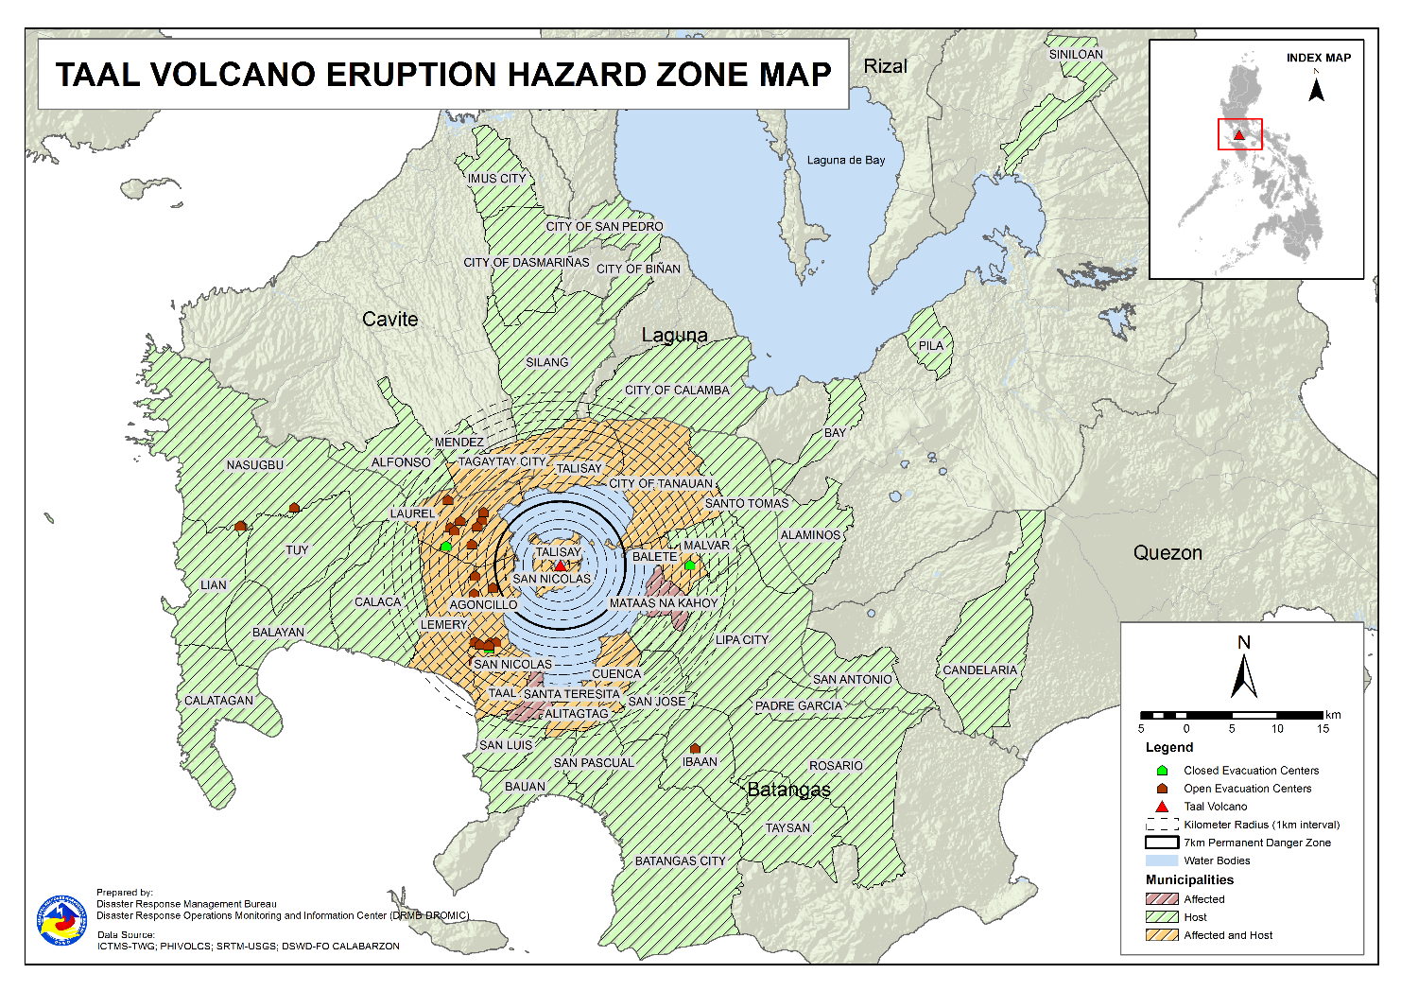

- Outside Evacuation Centers
There are 2,718 families or 9,447 persons temporarily staying with their relatives and/or friends in CALABARZON (see Table 3).

Table 3. Number of Displaced Families / Persons Outside Evacuation Centers
REGION / PROVINCE / MUNICIPALITY |  | NUMBER OF DISPLACED
 |  | OUTSIDE ECs
 |  | Families |  | Persons
 |  | CUM | NOW | CUM | NOW
GRAND TOTAL |  | 4,490 | 2,718 | 16,145 | 9,447
CALABARZON |  | 4,490 | 2,718 | 16,145 | 9,447
Batangas |  | 4,324 | 2,571 | 15,532 | 8,903
 | Agoncillo | 1,054 | 398 | 4,024 | 1,394
 | Alitagtag | 79 | 42 | 233 | 115
 | Balayan | 71 | 60 | 234 | 205
 | Balete | 6 | 4 | 19 | 11
 | Batangas City (capital) | 93 | 65 | 336 | 229
 | Bauan | 123 | 71 | 471 | 258
 | Calaca | 323 | 282 | 1,134 | 977
 | Calatagan | 47 | 34 | 180 | 111
 | Cuenca | 42 | 16 | 146 | 58
 | Ibaan | 95 | 78 | 372 | 271
 | Laurel | 1,283 | 776 | 4,556 | 2,625
 | Lemery | 161 | 149 | 595 | 545
 | Lian | 20 | 19 | 41 | 38
 | Lipa City | 31 | 24 | 81 | 64
 | Malvar | 34 | 33 | 108 | 107
 | Nasugbu | 91 | 3 | 281 | 13
 | Padre Garcia | 13 | 12 | 45 | 42
 | Rosario | 13 | 13 | 41 | 41
 | San Jose | 47 | 42 | 168 | 147
 | San Luis | 126 | 120 | 482 | 455
 | San Nicolas | 101 | 73 | 395 | 253
 | San Pascual | 85 | 23 | 145 | 78
 | Santo Tomas | 55 | 39 | 221 | 163
 | Taal | 86 | 31 | 269 | 105
 | City of Tanauan | 221 | 151 | 870 | 566
 | Taysan | 10 | 10 | 26 | 26
 | Tuy | 14 | 3 | 59 | 6
Cavite |  | 33 | 25 | 114 | 94
 | Alfonso | 1 | 1 | 2 | 2
 | Dasmariñas | 1 | 1 | 4 | 4
 | Imus | 5 | 5 | 14 | 14
 | Mendez (MENDEZ-NUÑEZ) | 1 | 1 | 4 | 4
 | Silang | 22 | 14 | 79 | 59
 | Tagaytay City | 3 | 3 | 11 | 11
Laguna |  | 129 | 118 | 484 | 435
 | Alaminos | 3 | 2 | 14 | 9
 | Bay | 2 | 1 | 5 | 3
 | Biñan | 1 | 1 | 5 | 5
 | Cabuyao | 3 | 3 | 12 | 12
 | City of Calamba | 112 | 105 | 409 | 384
 | Los Baños | 1 | 1 | 2 | 2
 | Pila | 1 | 1 | 5 | 5
 | San Pedro | 3 | 3 | 12 | 12
 | Siniloan | 3 | 1 | 20 | 3
Quezon |  | 4 | 4 | 15 | 15
 | Candelaria | 1 | 1 | 4 | 4
 | San Antonio | 1 | 1 | 3 | 3
 | Tiaong | 2 | 2 | 8 | 8
Note: Ongoing assessment and validation are continuously being conducted.
Source: DSWD-FO CALABARZON

- Total Displaced Population
A total of 3,837 families or 13,304 persons are displaced in CALABARZON due to Taal Volcano eruption (see Table 4).

Table 4. Total Number of Displaced Families / Persons
REGION / PROVINCE / MUNICIPALITY |  | TOTAL DISPLACED
 |  | Families |  | Persons
 |  | Total Families |  | Total Persons
 |  | CUM | NOW | CUM | NOW
GRAND TOTAL |  | 6,164 | 3,837 | 22,090 | 13,304
CALABARZON |  | 6,164 | 3,837 | 22,090 | 13,304
Batangas |  | 5,998 | 3,690 | 21,477 | 12,760
 | Agoncillo | 1,495 | 806 | 5,620 | 2,877
 | Alitagtag | 79 | 42 | 233 | 115
 | Balayan | 99 | 87 | 328 | 298
 | Balete | 82 | 4 | 283 | 11
 | Batangas City (capital) | 93 | 65 | 336 | 229
 | Bauan | 123 | 71 | 471 | 258
 | Calaca | 323 | 282 | 1,134 | 977
 | Calatagan | 47 | 34 | 180 | 111
 | Cuenca | 42 | 16 | 146 | 58
 | Ibaan | 98 | 81 | 384 | 283
 | Laurel | 2,299 | 1,364 | 8,213 | 4,646
 | Lemery | 161 | 149 | 595 | 545
 | Lian | 20 | 19 | 41 | 38
 | Lipa City | 31 | 24 | 81 | 64
 | Malvar | 34 | 33 | 108 | 107
 | Nasugbu | 201 | 96 | 603 | 261
 | Padre Garcia | 13 | 12 | 45 | 42
 | Rosario | 13 | 13 | 41 | 41
 | San Jose | 47 | 42 | 168 | 147
 | San Luis | 126 | 120 | 482 | 455
 | San Nicolas | 101 | 73 | 395 | 253
 | San Pascual | 85 | 23 | 145 | 78
 | Santo Tomas | 55 | 39 | 221 | 163
 | Taal | 86 | 31 | 269 | 105
 | City of Tanauan | 221 | 151 | 870 | 566
 | Taysan | 10 | 10 | 26 | 26
 | Tuy | 14 | 3 | 59 | 6
Cavite |  | 33 | 25 | 114 | 94
 | Alfonso | 1 | 1 | 2 | 2
 | Dasmariñas | 1 | 1 | 4 | 4
 | Imus | 5 | 5 | 14 | 14
 | Mendez (MENDEZ-NUÑEZ) | 1 | 1 | 4 | 4
 | Silang | 22 | 14 | 79 | 59
 | Tagaytay City | 3 | 3 | 11 | 11
Laguna |  | 129 | 118 | 484 | 435
 | Alaminos | 3 | 2 | 14 | 9
 | Bay | 2 | 1 | 5 | 3
 | Biñan | 1 | 1 | 5 | 5
 | Cabuyao | 3 | 3 | 12 | 12
 | City of Calamba | 112 | 105 | 409 | 384
 | Los Baños | 1 | 1 | 2 | 2
 | Pila | 1 | 1 | 5 | 5
 | San Pedro | 3 | 3 | 12 | 12
 | Siniloan | 3 | 1 | 20 | 3
Quezon |  | 4 | 4 | 15 | 15
 | Candelaria | 1 | 1 | 4 | 4
 | San Antonio | 1 | 1 | 3 | 3
 | Tiaong | 2 | 2 | 8 | 8
Note: Ongoing assessment and validation are continuously being conducted.
Source: DSWD-FO CALABARZON

- Cost of Humanitarian Assistance Provided

A total of ₱16,093,396.30 worth of assistance was provided to the affected families; of which, ₱3,658,030.80 was provided by DSWD, ₱7,141,317.70 from Local Government Units (LGUs) and ₱5,294,047.80 from Non-Government Organizations (NGOs) (see Table 5).

Table 5. Cost of Assistance Provided to Affected Families / Persons
REGION / PROVINCE / MUNICIPALITY |  | COST OF ASSISTANCE
 |  | DSWD | LGUs | NGOs | OTHERS | GRAND TOTAL
GRAND TOTAL |  | 3,658,030.80 | 7,141,317.70 | 5,294,047.80 | - | 16,093,396.30
CALABARZON |  | 3,658,030.80 | 7,141,317.70 | 5,294,047.80 | - | 16,093,396.30
Batangas |  | 3,658,030.80 | 7,141,317.70 | 5,294,047.80 | - | 16,093,396.30
 | Province | - | 3,837,247.10 | - | - | 3,837,247.10
 | Agoncillo | 758,210.30 | 1,485,568.00 | 2,175,966.10 | - | 4,419,744.40
 | Balayan | - | - | 57,065.70 | - | 57,065.70
 | Balete | - | 29,952.00 | 149,480.10 | - | 179,432.10
 | Batangas City (capital) | - | 29,512.00 | - | - | 29,512.00
 | Laurel | 2,899,820.50 | 1,704,589.00 | 2,048,692.50 | - | 6,653,102.00
 | Nasugbu | - | - | 112,152.30 | - | 112,152.30
 | Talisay | - | - | 322,891.10 | - | 322,891.10
 | City of Tanauan | - | 54,449.60 | 427,800.00 | - | 482,249.60
Source: DSWD-FO CALABARZON

- Response Actions and Interventions

- Standby Funds and Prepositioned Relief Stockpile

Office | Quick Response Fund (QRF) /  Standby Funds | Family Food Packs (FFPs) |  | Other Food and Non-Food Items (FNIs) | Total
 |  | No. | Cost
DSWD-CO | 806,582,400.57 | - | - | - | 806,582,400.57
NROC | - | 41,755 | 30,153,956.75 | 222,500,490.87 | 252,654,447.62
VDRC | - | 3,541 | 1,628,860.00 | 34,410,877.30 | 36,039,737.30
DSWD-FO CALABARZON | 5,240,440.00 | 4,750 | 2,356,266.00 | 20,862,388.68 | 28,459,094.68
Other DSWD-FOs | 37,695,659.27 | 246,903 | 130,821,603.13 | 390,582,015.98 | 559,099,278.38
Total | 849,518,499.84 | 296,949.00 | 164,960,685.88 | 668,355,772.83 | 1,682,834,958.55
Note: The Inventory Summary is as of 24 July 2021, 4PM.

  - Standby Funds
- ₱806.6 million QRF at the DSWD-Central Office.
- ₱5.2 million at DSWD-FO CALABARZON.
- ₱37.7 million in other DSWD-FOs which may support the relief needs of the displaced families due to Taal Volcano eruption through inter-FO augmentation.

  - Prepositioned FFPs and Other Relief Items
- 45,296 FFPs available in Disaster Response Centers; of which, 41,755 FFPs are at the National Resource Operations Center (NROC), Pasay City and 3,541 FFPs are at the Visayas Disaster Response Center (VDRC), Cebu City.
- 4,750 FFPs at DSWD-FO CALABARZON.
- 246,903 FFPs in other DSWD-FOs which may support the relief needs of the displaced families due to Taal Volcano Eruption through inter-FO augmentation.
- ₱668.4 million worth of other FNIs at NROC, VDRC and DSWD-FO warehouses countrywide.

- Food and Non-Food Items

- The National Resource and Logistics Management Bureau (NRLMB) delivered 1,000 FFPs amounting to ₱778,450.00 in Batangas City Sports Complex on 16 July 2021, as partial delivery of the 5,000 FFPs additional augmentation support to DSWD-FO CALABARZON.

- NRLMB augmentation support to DSWD-FO CALABARZON amounting to ₱42,950,905.00; delivery completed on 07 July 2021.
- A total of 13,500 FFPs (₱10,509,075.00), 200 family tents (₱3,280,000.00), 5,000 family kits (₱11,440,000.00), 3,000 hygiene kits (₱4,420,500.00), and 4,279 sleeping kits (₱6,350,000.00) out of total number of augmentation support provided by NRLMB to DSWD-FO CALABARZON were directly delivered to the Provincial Social Welfare and Development Office (PSWDO) of Batangas for the needs of the displaced families.
- 300 Family tents (₱4,920,000.00) and 2,000 hygiene kits (₱2,947,000.00) were provided to Laurel, Batangas.

- The Disaster Response Management Division (DRMD) and Administrative Division of DSWD-FO CALABARZON together with the Provincial Quick Response Team (QRT) in Cavite conducted an ocular visit at Canyon Cove satellite warehouse on 23 July 2021 to identify equipment to be installed. This satellite warehouse is now utilized for the FO’s prepositioned FNIs to be used in case of escalation of the current status of Taal Volcano.

- The DRMD of DSWD-FO CALABARZON mobilize 22 community volunteers on 23 July 2021 for the production of FFPs at the DSWD-FO CALABARZON warehouse in Gen. Mariano Alvarez, Cavite.

- Camp Coordination and Camp Management (CCCM)

- The EOC of DSWD-FO CALABARZON coordinated with the Department of Education (DepEd) IV-A and Department of Public Works and Highways (DPWH) IV-A on 23 July 2021 for the possible construction of additional comfort rooms in schools that are being utilized as evacuation centers. The DepEd IV-A sought the advice of their Central Office for the approval of the construction.

- Other Activities

- DSWD-FO CALABARZON through its DRMD coordinated with the Office of Civil Defense (OCD) on 23 July 2021 for the facilitation of the vaccination of 685 personnel for the Humanitarian Assistance and Disaster Response (HADR) deployment.

- DSWD-FO CALABARZON convened the members of CCCM, IDP Protection and FNI sub-clusters of the Response Cluster through a virtual teleconference on 23 July 2021. The meeting further served as a venue to identify areas for collaboration and complementation of response efforts of the Regional Line Agencies (RLAs) and the affected LGUs. The following details were discussed:
- Deployment of DSWD personnel in evacuation centers to assist in the management of IDPs, to ensure that COVID-19 health and safety protocols are observed, and to ensure that the needs of the IDPs are immediately addressed;
- Provision of fresh produce products to IDPs since they have been provided with canned and processed foods for the last 22 days;
- Establishment of community kitchen and preparation of healthy menu plan for the IDPs;
- Installation of IEC materials in evacuation centers to promote breastfeeding among the lactating IDPs;
- Utilization of other school buildings and government facilities as additional evacuation center to decongest the existing ECs and prevent the possible outbreak of COVID-19 and other communicable diseases;
- Provision of economic opportunities and livelihood assistance to IDPs to prevent them from returning to high-risk areas;
- Implementation of IDP tracking system for heads of families allowed to return to the high-risk barangays for economic and livelihood activities;
- Identification and activation of evacuation areas for livestocks and poultry animals to prevent the IDPs from returning to the high-risk barangays;
- Ensure police visibility in the evacuation centers and deployment of personnel in the high-risk areas to prevent possible commission of crimes in the vacated houses;
- Installation of internet connection in the evacuation centers to ensure continuity of distance education for learners and access to news and entertainment for camp residents;
- Provision of medicines and vitamins to IDPs to boost their immune system while taking temporary shelter in evacuation centers;
- Replication of the donations management system of the Provincial Government to the affected LGUs to ensure that donations are tracked and distributed on a targeted manner;
- LGUs and camp managers to ensure that the relief items provided to the IDPs are utilized while they are in the evacuation centers; and,
- Adoption of Response Cluster reporting template by member agencies of the Response Cluster and the LGUs.

*****
The Disaster Response Operations Monitoring and Information Center (DROMIC) of DSWD-DRMB is closely coordinating with DSWD-FO CALABARZON for significant disaster response updates and assistance provided.

Prepared by:  JEM ERIC F. FAMORCAN  MARIEL B. FERRARIZ | Released by:  MARC LEO L. BUTAC

