DSWD DROMIC Report #21 on the Taal Volcano Eruption
as of 26 July 2021, 6PM

- Situation Overview

On 01 July 2021 at 3:37 PM, the Philippine Institute of Volcanology and Seismology (PHIVOLCS) has raised Alert Level 3 over Taal Volcano after a phreatomagmatic eruption from the main crater occurred at 3:16 PM.

As of 26 July 2021 at 8 AM, Alert Level 2 (Decreased Unrest) now prevails over Taal Volcano. DOST-PHIVOLCS reminds the public that at Alert Level 2, sudden steam- or gas-driven explosions, volcanic earthquakes, minor ashfall, and lethal accumulations or expulsions of volcanic gas can occur and threaten areas within and around TVI. DOST-PHIVOLCS strongly recommends that entry must be strictly prohibited into Taal Volcano Island, Taal’s Permanent Danger Zone or PDZ, especially the vicinities of the Main Crater and the Daang Kastila fissure, and occupancy and boating on Taal Lake. Local government officials are advised to continuously assess and strengthen the preparedness of previously evacuated barangays around Taal Lake in case of renewed unrest.
Source: PHIVOLCS

- Status of Affected Areas and Population

A total of 6,212 families or 22,356 persons were affected by the Taal Volcano eruption in 148 Barangays in CALABARZON (see Table 1).

Table 1. Number of Affected Families / Persons
REGION / PROVINCE / MUNICIPALITY |  | NUMBER OF AFFECTED
 |  | Barangays | Families | Persons
GRAND TOTAL |  | 148 | 6,212 | 22,356
CALABARZON |  | 148 | 6,212 | 22,356
Batangas |  | 146 | 6,210 | 22,351
 | Agoncillo | 22 | 2,318 | 8,525
 | Alitagtag | 2 | 7 | 28
 | Balete | 9 | 102 | 354
 | Cuenca | 2 | 33 | 102
 | Laurel | 14 | 2,879 | 10,107
 | Lemery | 30 | 140 | 493
 | Mataas Na Kahoy | 4 | 43 | 129
 | San Nicolas | 16 | 250 | 931
 | Santa Teresita | 1 | 4 | 18
 | Taal | 11 | 50 | 173
 | Talisay | 19 | 184 | 718
 | City of Tanauan | 16 | 200 | 773
Cavite |  | 2 | 2 | 5
 | Tagaytay City | 2 | 2 | 5
Note: Ongoing assessment and validation are continuously being conducted.

Source: DSWD-Field Office (FO) CALABARZON

- Status of Displaced Population

- Inside Evacuation Centers
There are 225 families or 794 persons currently taking temporary shelter in 11 evacuation centers in CALABARZON (see Table 2).

Table 2. Number of Displaced Families / Persons Inside Evacuation Centers
REGION / PROVINCE / MUNICIPALITY |  | NUMBER OF EVACUATION CENTERS (ECs) |  | NUMBER OF DISPLACED
 |  |  |  | INSIDE ECs
 |  |  |  | Families |  | Persons
 |  | CUM | NOW | CUM | NOW | CUM | NOW
GRAND TOTAL |  | 29 | 11 | 1,684 | 255 | 5,957 | 794
CALABARZON |  | 29 | 11 | 1,684 | 255 | 5,957 | 794
Batangas |  | 29 | 11 | 1,684 | 255 | 5,957 | 794
 | Agoncillo | 14 | 3 | 451 | 10 | 1,608 | 29
 | Balayan | 1 | 1 | 28 | 27 | 94 | 93
 | Balete | 1 | - | 76 | - | 264 | -
 | Ibaan | 1 | 1 | 3 | 3 | 12 | 12
 | Laurel | 9 | 3 | 1,016 | 122 | 3,657 | 412
 | Nasugbu | 3 | 3 | 110 | 93 | 322 | 248
Note: Ongoing assessment and validation are continuously being conducted.
Source: DSWD-FO CALABARZON

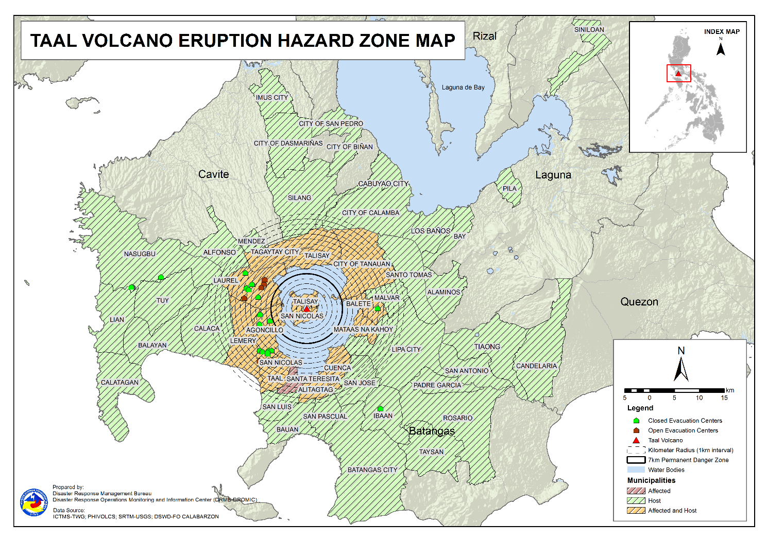

- Outside Evacuation Centers
There are 2,594 families or 8,947 persons temporarily staying with their relatives and/or friends in CALABARZON (see Table 3).

Table 3. Number of Displaced Families / Persons Outside Evacuation Centers
REGION / PROVINCE / MUNICIPALITY |  | NUMBER OF DISPLACED
 |  | OUTSIDE ECs
 |  | Families |  | Persons
 |  | CUM | NOW | CUM | NOW
GRAND TOTAL |  | 4,487 | 2,594 | 16,270 | 8,947
CALABARZON |  | 4,487 | 2,594 | 16,270 | 8,947
Batangas |  | 4,321 | 2,448 | 15,657 | 8,408
 | Agoncillo | 1,056 | 316 | 4,029 | 1,026
 | Alitagtag | 83 | 41 | 242 | 105
 | Balayan | 71 | 60 | 234 | 205
 | Balete | 6 | 4 | 19 | 11
 | Batangas City (capital) | 93 | 60 | 336 | 218
 | Bauan | 123 | 61 | 471 | 220
 | Calaca | 323 | 273 | 1,134 | 950
 | Calatagan | 47 | 34 | 180 | 111
 | Cuenca | 42 | 17 | 146 | 62
 | Ibaan | 95 | 72 | 372 | 247
 | Laurel | 1,283 | 772 | 4,556 | 2,641
 | Lemery | 161 | 149 | 595 | 545
 | Lian | 20 | 19 | 41 | 38
 | Lipa City | 31 | 24 | 81 | 64
 | Malvar | 34 | 33 | 108 | 107
 | Mataas Na Kahoy | 1 | 1 | 2 | 2
 | Nasugbu | 91 | 3 | 281 | 13
 | Padre Garcia | 13 | 12 | 45 | 42
 | Rosario | 13 | 13 | 41 | 41
 | San Jose | 47 | 42 | 168 | 147
 | San Luis | 128 | 69 | 487 | 256
 | San Nicolas | 130 | 122 | 487 | 429
 | San Pascual | 44 | 27 | 157 | 93
 | Santo Tomas | 55 | 31 | 221 | 137
 | Taal | 86 | 31 | 269 | 105
 | City of Tanauan | 221 | 151 | 870 | 566
 | Taysan | 10 | 10 | 26 | 26
 | Tuy | 14 | 1 | 59 | 1
Cavite |  | 33 | 25 | 114 | 94
 | Alfonso | 1 | 1 | 2 | 2
 | Dasmariñas | 1 | 1 | 4 | 4
 | Imus | 5 | 5 | 14 | 14
 | Mendez (MENDEZ-NUÑEZ) | 1 | 1 | 4 | 4
 | Silang | 22 | 14 | 79 | 59
 | Tagaytay City | 3 | 3 | 11 | 11
Laguna |  | 129 | 117 | 484 | 430
 | Alaminos | 3 | 2 | 14 | 9
 | Bay | 2 | 1 | 5 | 3
 | Biñan | 1 | 1 | 5 | 5
 | Cabuyao | 3 | 2 | 12 | 7
 | City of Calamba | 112 | 105 | 409 | 384
 | Los Baños | 1 | 1 | 2 | 2
 | Pila | 1 | 1 | 5 | 5
 | San Pedro | 3 | 3 | 12 | 12
 | Siniloan | 3 | 1 | 20 | 3
Quezon |  | 4 | 4 | 15 | 15
 | Candelaria | 1 | 1 | 4 | 4
 | San Antonio | 1 | 1 | 3 | 3
 | Tiaong | 2 | 2 | 8 | 8
Note: Ongoing assessment and validation are continuously being conducted.
Source: DSWD-FO CALABARZON

- Total Displaced Population
A total of 2,849 families or 9,741 persons are displaced in CALABARZON due to Taal Volcano eruption (see Table 4).

Table 4. Total Number of Displaced Families / Persons
REGION / PROVINCE / MUNICIPALITY |  | TOTAL DISPLACED
 |  | Families |  | Persons
 |  | CUM | NOW | CUM | NOW
GRAND TOTAL |  | 6,171 | 2,849 | 22,227 | 9,741
CALABARZON |  | 6,171 | 2,849 | 22,227 | 9,741
Batangas |  | 6,005 | 2,703 | 21,614 | 9,202
 | Agoncillo | 1,507 | 326 | 5,637 | 1,055
 | Alitagtag | 83 | 41 | 242 | 105
 | Balayan | 99 | 87 | 328 | 298
 | Balete | 82 | 4 | 283 | 11
 | Batangas City (capital) | 93 | 60 | 336 | 218
 | Bauan | 123 | 61 | 471 | 220
 | Calaca | 323 | 273 | 1,134 | 950
 | Calatagan | 47 | 34 | 180 | 111
 | Cuenca | 42 | 17 | 146 | 62
 | Ibaan | 98 | 75 | 384 | 259
 | Laurel | 2,299 | 894 | 8,213 | 3,053
 | Lemery | 161 | 149 | 595 | 545
 | Lian | 20 | 19 | 41 | 38
 | Lipa City | 31 | 24 | 81 | 64
 | Malvar | 34 | 33 | 108 | 107
 | Mataas Na Kahoy | 1 | 1 | 2 | 2
 | Nasugbu | 201 | 96 | 603 | 261
 | Padre Garcia | 13 | 12 | 45 | 42
 | Rosario | 13 | 13 | 41 | 41
 | San Jose | 47 | 42 | 168 | 147
 | San Luis | 128 | 69 | 487 | 256
 | San Nicolas | 130 | 122 | 487 | 429
 | San Pascual | 44 | 27 | 157 | 93
 | Santo Tomas | 55 | 31 | 221 | 137
 | Taal | 86 | 31 | 269 | 105
 | City of Tanauan | 221 | 151 | 870 | 566
 | Taysan | 10 | 10 | 26 | 26
 | Tuy | 14 | 1 | 59 | 1
Cavite |  | 33 | 25 | 114 | 94
 | Alfonso | 1 | 1 | 2 | 2
 | Dasmariñas | 1 | 1 | 4 | 4
 | Imus | 5 | 5 | 14 | 14
 | Mendez (MENDEZ-NUÑEZ) | 1 | 1 | 4 | 4
 | Silang | 22 | 14 | 79 | 59
 | Tagaytay City | 3 | 3 | 11 | 11
Laguna |  | 129 | 117 | 484 | 430
 | Alaminos | 3 | 2 | 14 | 9
 | Bay | 2 | 1 | 5 | 3
 | Biñan | 1 | 1 | 5 | 5
 | Cabuyao | 3 | 2 | 12 | 7
 | City of Calamba | 112 | 105 | 409 | 384
 | Los Baños | 1 | 1 | 2 | 2
 | Pila | 1 | 1 | 5 | 5
 | San Pedro | 3 | 3 | 12 | 12
 | Siniloan | 3 | 1 | 20 | 3
Quezon |  | 4 | 4 | 15 | 15
 | Candelaria | 1 | 1 | 4 | 4
 | San Antonio | 1 | 1 | 3 | 3
 | Tiaong | 2 | 2 | 8 | 8
Note: Ongoing assessment and validation are continuously being conducted.
Source: DSWD-FO CALABARZON

- Cost of Humanitarian Assistance Provided

A total of ₱16,093,396.30 worth of assistance was provided to the affected families; of which, ₱3,658,030.80 was provided by DSWD, ₱7,141,317.70 from Local Government Units (LGUs) and ₱5,294,047.80 from Non-Government Organizations (NGOs) (see Table 5).

Table 5. Cost of Assistance Provided to Affected Families / Persons
REGION / PROVINCE / MUNICIPALITY |  | COST OF ASSISTANCE
 |  | DSWD | LGUs | NGOs | OTHERS | GRAND TOTAL
GRAND TOTAL |  | 3,658,030.80 | 7,141,317.70 | 5,294,047.80 | - | 16,093,396.30
CALABARZON |  | 3,658,030.80 | 7,141,317.70 | 5,294,047.80 | - | 16,093,396.30
Batangas |  | 3,658,030.80 | 7,141,317.70 | 5,294,047.80 | - | 16,093,396.30
 | Province | - | 3,837,247.10 | - | - | 3,837,247.10
 | Agoncillo | 758,210.30 | 1,485,568.00 | 2,175,966.10 | - | 4,419,744.40
 | Balayan | - | - | 57,065.70 | - | 57,065.70
 | Balete | - | 29,952.00 | 149,480.10 | - | 179,432.10
 | Batangas City (capital) | - | 29,512.00 | - | - | 29,512.00
 | Laurel | 2,899,820.50 | 1,704,589.00 | 2,048,692.50 | - | 6,653,102.00
 | Nasugbu | - | - | 112,152.30 | - | 112,152.30
 | Talisay | - | - | 322,891.10 | - | 322,891.10
 | City of Tanauan | - | 54,449.60 | 427,800.00 | - | 482,249.60
Source: DSWD-FO CALABARZON

- Response Actions and Interventions

- Standby Funds and Prepositioned Relief Stockpile

Office | Quick Response Fund (QRF) /  Standby Funds | Family Food Packs (FFPs) |  | Other Food and Non-Food Items (FNIs) | Total
 |  | No. | Cost
DSWD-CO | 806,582,400.57 | - | - | - | 806,582,400.57
NROC | - | 29,755 | 22,941,846.75 | 219,868,554.87 | 242,810,401.62
VDRC | - | 2,741 | 1,260,860.00 | 32,688,037.30 | 33,948,897.30
DSWD-FO CALABARZON | 5,240,440.00 | 4,750 | 2,356,266.00 | 20,862,388.68 | 28,459,094.68
Other DSWD-FOs | 37,695,659.27 | 247,437 | 131,010,513.97 | 390,435,681.91 | 559,141,855.15
Total | 849,518,499.84 | 284,683 | 157,569,486.72 | 663,854,662.76 | 1,670,942,649.32
Note: The Inventory Summary is as of 26 July 2021, 4PM.

  - Standby Funds
- ₱806.6 million QRF at the DSWD-Central Office.
- ₱5.2 million at DSWD-FO CALABARZON.
- ₱37.7 million in other DSWD-FOs which may support the relief needs of the displaced families due to Taal Volcano eruption through inter-FO augmentation.

  - Prepositioned FFPs and Other Relief Items
- 32,496 FFPs available in Disaster Response Centers; of which, 29,755 FFPs are at the National Resource Operations Center (NROC), Pasay City and 2,741 FFPs are at the Visayas Disaster Response Center (VDRC), Cebu City.
- 4,750 FFPs at DSWD-FO CALABARZON.
- 247,437 FFPs in other DSWD-FOs which may support the relief needs of the displaced families due to Taal Volcano Eruption through inter-FO augmentation.
- ₱663.9 million worth of other FNIs at NROC, VDRC and DSWD-FO warehouses countrywide.

- Food and Non-Food Items

- The National Resource and Logistics Management Bureau (NRLMB) delivered 1,000 FFPs amounting to ₱778,450.00 in Batangas City Sports Complex on 16 July 2021, as partial delivery of the 5,000 FFPs additional augmentation support to DSWD-FO CALABARZON.

- NRLMB augmentation support to DSWD-FO CALABARZON amounting to ₱42,950,905.00; delivery completed on 07 July 2021.
- A total of 13,500 FFPs (₱10,509,075.00), 200 family tents (₱3,280,000.00), 5,000 family kits (₱11,440,000.00), 3,000 hygiene kits (₱4,420,500.00), and 4,279 sleeping kits (₱6,350,000.00) out of total number of augmentation support provided by NRLMB to DSWD-FO CALABARZON were directly delivered to the Provincial Social Welfare and Development Office (PSWDO) of Batangas for the needs of the displaced families.
- 300 Family tents (₱4,920,000.00) and 2,000 hygiene kits (₱2,947,000.00) were provided to Laurel, Batangas.

- The Disaster Response Management Division (DRMD) of DSWD-FO CALABARZON coordinated with the Local Social Welfare and Development Offices (LSWDOs) of the municipalities of Laurel and Agoncillo in Batangas on 25 July 2021 relative to the pull out of the remaining FNis and transfer to PSWDO Batangas warehouse as prepositioned goods.

- Camp Coordination and Camp Management (CCCM)

- The EOC of DSWD-FO CALABARZON coordinated with the LGUs on 25 July 2021 to conduct disinfection of the facilities in the evacuation centers following the decampment of the IDPs.

- Other Activities

- The DRMD and Provincial Quick Response Teams (QRTs) of DSWD-FO CALABARZON have coordinated with the LGU-assigned camp managers on the current status of the remaining IDPs in the evacuation centers on 25 July 2021.

- The DRMD of DSWD-FO CALABARZON provided technical assistance to the Municipal Social Welfare and Development Office (MSWDO) of Laurel, Batangas on the conduct of Food-for-Work (FFW) activity which may be implemented.

*****
The Disaster Response Operations Monitoring and Information Center (DROMIC) of DSWD-DRMB is closely coordinating with DSWD-FO CALABARZON for significant disaster response updates and assistance provided.

Prepared by:  DIANE C. PELEGRINO  MARIEL B. FERRARIZ | Released by:  MARC LEO L. BUTAC

