DSWD DROMIC Report #5 on the
Mw 5.7 Earthquake Incident in Kadingilan, Bukidnon
as of 16 July 2021, 6PM

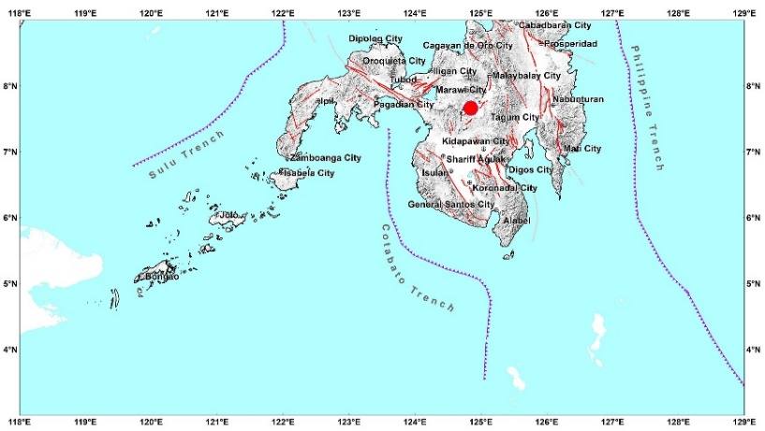

Situation Overview

On 14 June 2021 at 10:38 PM, a 5.7 magnitude earthquake jolted the municipality of Kadingilan, Bukidnon (07.66°N, 124.85°E - 010 km N 44° W) with a tectonic origin and a depth of focus of 12 km. The earthquake was also felt in the neighboring municipalities of Bukidnon.

Date/Time: | 14 Jun 2021 - 10:38:40 PM
Reported Intensities: | Intensity VI- Kadingilan and Pangantucan, Bukidnon  Intensity V - Damulog and Don Carlos, Bukidnon; Wao, Lanao del Sur  Intensity IV - Kalilangan, Kitaotao, Kibawe, Maramag, Quezon, Libona and Talakag, Bukidnon; Cotabato City; Marawi City; Marantao, Lanao del Sur; City of Iligan; Cagayan de Oro City; Banisilan and Pikit, Cotabato  Intensity III - Malaybalay, Baungon, Cabanglasan, Impasug-ong, Malitbog, San Fernando, Lantapan, and Manolo Fortich, Bukidnon; City of El Salvador, Misamis Oriental; Pagadian City; Davao City; Tagum City; Pigcawayan, Cotabato  Intensity II - Arakan and M'lang, Cotabato; Kidapawan City; Dipolog City; Datu Piang, Maguindanao; City of Bayugan, Agusan del Sur; Opol, Misamis Oriental; Monkayo, Davao de Oro  Intensity I- Mambajao, Camiguin; Butuan City
Expecting Damage: | YES
Expecting Aftershocks: | YES
Source: DOST-PHIVOLCS Earthquake Bulletin

- Status of Affected Families / Persons
There were 1,184 families or 5,920 persons affected by the earthquake incident in 29 barangays in Region X (see Table 1).

Table 1. Number of Affected Families / Persons
REGION / PROVINCE / MUNICIPALITY |  | NUMBER OF AFFECTED
 |  | Barangays | Families | Persons
GRAND TOTAL |  | 29 | 1,184 | 5,920
REGION X |  | 29 | 1,184 | 5,920
Bukidnon |  | 29 | 1,184 | 5,920
 | Don Carlos | 15 | 838 | 4,190
 | Kadingilan | 5 | 143 | 715
 | Pangantucan | 9 | 203 | 1,015
Note: Ongoing assessment and validation being conducted.
Source: DSWD-FO X

- Damaged Houses
There were 1,184 damaged houses; of which, 29 were totally damaged and 1,155 were partially damaged (see Table 2).

Table 2. Number of Damaged Houses
REGION / PROVINCE / MUNICIPALITY |  | NO. OF DAMAGED HOUSES
 |  | Total | Totally | Partially
GRAND TOTAL |  | 1,184 | 29 | 1,155
REGION X |  | 1,184 | 29 | 1,155
Bukidnon |  | 1,184 | 29 | 1,155
 | Don Carlos | 838 | 29 | 809
 | Kadingilan | 143 | - | 143
 | Pangantucan | 203 | - | 203
Note: Ongoing assessment and validation being conducted.
Source: DSWD-FO X

- Assistance Provided
A total of ₱1,902,025.88 worth of assistance was provided to the affected families; of which, ₱1,773,025.88 was provided by DSWD and ₱129,000.00 from LGUs (see Table 3).

Table 3. Cost of Assistance Provided to Affected Families / Persons
REGION / PROVINCE / MUNICIPALITY |  | COST OF ASSISTANCE
 |  | DSWD | LGUs | NGOs | OTHERS | GRAND TOTAL
GRAND TOTAL |  | 1,773,025.88 | 129,000.00 | - | - | 1,902,025.88
REGION X |  | 1,773,025.88 | 129,000.00 | - | - | 1,902,025.88
Bukidnon |  | 1,773,025.88 | 129,000.00 | - | - | 1,902,025.88
 | Don Carlos | 788,578.75 | - | - | - | 788,578.75
 | Kadingilan | 558,719.59 | 129,000.00 | - | - | 687,719.59
 | Pangantucan | 425,727.54 | - | - | - | 425,727.54
Source: DSWD-FO X

Situational Reports

DSWD-DRMB
DATE | SITUATIONS / ACTIONS UNDERTAKEN
16 July 2021 | - The Disaster Response Operations Monitoring and Information Center (DROMIC) of the DSWD-DRMB is closely coordinating with DSWD-FO X for significant reports on the status of affected families, assistance, and relief efforts.

DSWD-FO X
DATE | SITUATIONS / ACTIONS UNDERTAKEN
16 July 2021 | - DSWD-FO X through its Disaster Response Management Division is continuously coordinating with the LGUs affected for any significant updates.

*****
The Disaster Response Operations Monitoring and Information Center (DROMIC) of the DSWD-DRMB is closely coordinating with DSWD-FO X for any significant updates and actions taken relative to the Mw 5.7 Earthquake incident in Kadingilan, Bukidnon.

Prepared by: Releasing Officer

MARIEL B. FERRARIZ MARC LEO. L BUTAC

