DSWD DROMIC Terminal Report on the
Social Disorganization in Lebak, Sultan Kudarat
30 August 2021, 6PM

- Situation Overview

This is the final report on the firefight that ensued between the Matabalao and Kalaing Clans on 04 July 2021 in Brgy. Tran, Lebak, Sultan Kudarat resulting to the displacement of families and individuals in the area.
Source: DSWD-Field Office (FO) XII

- Status of Affected Areas and Population
A total of 289 families or 1,445 persons were affected by the fire incident in Lebak, Sultan Kudarat (see Table 1).

Table 1. Number of Affected Families / Persons
REGION / PROVINCE / MUNICIPALITY |  | NUMBER OF AFFECTED
 |  | Barangays | Families | Persons
GRAND TOTAL |  | 1 | 289 | 1,445
REGION XII |  | 1 | 289 | 1,445
Sultan Kudarat |  | 1 | 289 | 1,445
 | Lebak | 1 | 289 | 1,445
Source: DSWD-FO XII

- Status of Displaced Population

- Inside Evacuation Centers
A total of 263 families or 1,315 persons sought temporary shelter at the Tran Elementary School (see Table 2). All of these families have returned home.

Table 2. Number of Displaced Families / Persons Inside Evacuation Centers
REGION / PROVINCE / MUNICIPALITY |  | NUMBER OF EVACUATION CENTERS (ECs) |  | NUMBER OF DISPLACED
 |  |  |  | INSIDE ECs
 |  |  |  | Families |  | Persons
 |  | CUM | NOW | CUM | NOW | CUM | NOW
GRAND TOTAL |  | 1 | - | 263 | - | 1,315 | -
REGION XII |  | 1 | - | 263 | - | 1,315 | -
Sultan Kudarat |  | 1 | - | 263 | - | 1,315 | -
 | Lebak | 1 | - | 263 | - | 1,315 | -
Source: DSWD-FO XII

- Outside Evacuation Centers
A total of 26 families or 130 persons have temporarily stayed with their relatives and/or friends (see Table 3).

Table 3. Number of Displaced Families / Persons Outside Evacuation Centers
REGION / PROVINCE / MUNICIPALITY |  | NUMBER OF DISPLACED
 |  | OUTSIDE ECs
 |  | Families |  | Persons
 |  | CUM | NOW | CUM | NOW
GRAND TOTAL |  | 26 | - | 130 | -
REGION XII |  | 26 | - | 130 | -
Sultan Kudarat |  | 26 | - | 130 | -
 | Lebak | 26 | - | 130 | -
Source: DSWD-FO XII

- Total Displaced Population
A total of 289 families or 1,445 persons were displaced in Lebak, Sultan Kudarat (see Table 4).

Table 4. Total Number of Displaced Families / Persons
REGION / PROVINCE / MUNICIPALITY |  | TOTAL DISPLACED SERVED
 |  | Families |  | Persons
 |  | Total Families |  | Total Persons
 |  | CUM | NOW | CUM | NOW
GRAND TOTAL |  | 289 | - | 1,445 | -
REGION XII |  | 289 | - | 1,445 | -
Sultan Kudarat |  | 289 | - | 1,445 | -
 | Lebak | 289 | - | 1,445 | -
Source: DSWD-FO XII

- Cost of Humanitarian Assistance Provided
A total of ₱299,235.00 worth of assistance was provided to the affected families; of which ₱235,535.00 was provided by DSWD and ₱64,000.00 was provided by the Local Government Unit (LGU) (see Table 5).

Table 5. Cost of Assistance Provided to Affected Families / Persons
REGION / PROVINCE / MUNICIPALITY |  | COST OF ASSISTANCE
 |  | DSWD | LGU | NGOs | OTHERS | GRAND TOTAL
GRAND TOTAL |  | 235,535.00 | 64,000.00 | - | - | 299,235.00
REGION XII |  | 235,535.00 | 64,000.00 | - | - | 299,235.00
Sultan Kudarat |  | 235,535.00 | 64,000.00 | - | - | 299,235.00
 | Lebak | 235,535.00 | 64,000.00 | - | - | 299,235.00
Source: DSWD-FO XII

- Response Actions and Interventions

- Food and Non-Food Items (NFIs)

- DSWD-FO XII provided 163 family food packs, 163 sleeping kits, and 163 malong to the affected families.
- Other Activities

DATE | ACTIVITIES
13 August 2021 | - DSWD-FO XII submitted their terminal report.

- Photo Documentation
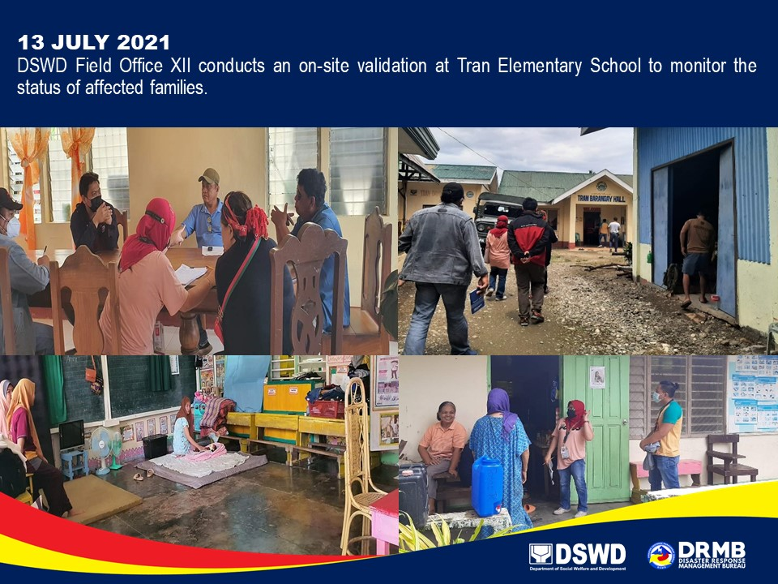

*****
The Disaster Response Operations Monitoring and Information Center (DROMIC) of DSWD-DRMB continues to closely coordinate with DSWD-FO XII for any request of Technical Assistance and Resource Augmentation (TARA).

Prepared by:  MARIE JOYCE G. RAFANAN  PHIL JOBERT A. ZALDIVAR | Released by:  LESLIE R. JAWILI

