DSWD DROMIC Terminal Report on the Tornado Incident
in Lambunao, Iloilo
31 August 2021, 6PM

- Situation Overview
This is the final report on the tornado that struck 13 barangays in Lambunao, Iloilo on 25 June 2021 at 4:00 PM which caused damages to 70 houses.
Source: DSWD-Field Office (FO) VI

- Status of Affected Areas and Population

A total of 70 families or 271 persons were affected in 13 barangays in Lambunao, Iloilo (see Table 1).

Table 1. Number of Affected Families / Persons
REGION / PROVINCE / MUNICIPALITY |  | NUMBER OF AFFECTED
 |  | Barangays | Families | Persons
GRAND TOTAL |  | 13 | 70 | 271
REGION VI |  | 13 | 70 | 271
Iloilo |  | 13 | 70 | 271
 | Lambunao | 13 | 70 | 271
Source: DSWD-FO VI

- Status of Displaced Population

- Outside Evacuation Centers
A total of 70 families or 271 persons have sought temporary shelter with their relatives and/or friends (see Table 2). All of these families have returned home.

Table 2. Number of Displaced Families / Persons Outside Evacuation Centers
REGION / PROVINCE / MUNICIPALITY |  | NUMBER OF DISPLACED
 |  | OUTSIDE ECs
 |  | Families |  | Persons
 |  | CUM | NOW | CUM | NOW
GRAND TOTAL |  | 70 | - | 271 | -
REGION VI |  | 70 | - | 271 | -
Iloilo |  | 70 | - | 271 | -
 | Lambunao | 70 | - | 271 | -
Source: DSWD-FO VI

- Total Displaced Population
There were 70 families or 271 persons displaced in Lambunao, Iloilo due to the tornado incident (see Table 3).

Table 3. Total Number of Displaced Families / Persons
REGION / PROVINCE / MUNICIPALITY |  | TOTAL DISPLACED SERVED
 |  | Families |  | Persons
 |  | Total Families |  | Total Persons
 |  | CUM | NOW | CUM | NOW
GRAND TOTAL |  | 70 | - | 271 | -
REGION VI |  | 70 | - | 271 | -
Iloilo |  | 70 | - | 271 | -
 | Lambunao | 70 | - | 271 | -
Source: DSWD-FO VI

- Damaged Houses

A total of 70 houses were damaged by the tornado; of which 10 were totally damaged and 60 were partially damaged (see Table 4).

Table 4. Number of Damaged Houses
REGION / PROVINCE / MUNICIPALITY |  | NO. OF DAMAGED HOUSES
 |  | Total | Totally | Partially
GRAND TOTAL |  | 70 | 10 | 60
REGION VI |  | 70 | 10 | 60
Iloilo |  | 70 | 10 | 60
 | Lambunao | 70 | 10 | 60
Source: DSWD-FO VI

- Cost of Humanitarian Assistance Provided

A total of ₱320,424.02 worth of assistance was provided to the affected families; of which ₱224,664.02 was provided by DSWD and ₱95,760.00 was provided by the Local Government Unit (LGU) (see Table 5).

Table 5. Cost of Assistance Provided to Affected Families / Persons
REGION / PROVINCE / MUNICIPALITY |  | COST OF ASSISTANCE
 |  | DSWD | LGU | NGOs | OTHERS | GRAND TOTAL
GRAND TOTAL |  | 224,664.02 | 95,760.00 | - | - | 320,424.02
REGION VI |  | 224,664.02 | 95,760.00 | - | - | 320,424.02
Iloilo |  | 224,664.02 | 95,760.00 | - | - | 320,424.02
 | Lambunao | 224,664.02 | 95,760.00 | - | - | 320,424.02
Source: DSWD-FO VI

- Response Actions and Interventions

- Food and Non-Food Items (NFIs)

- DSWD-FO VI provided 147 family food packs, 49 hygiene kits, and 49 sleeping kits to the affected families.
- Other Activities

DATE | ACTIVITIES
23 August 2021 | - DSWD-FO VI submitted their terminal report.

- Photo Documentation
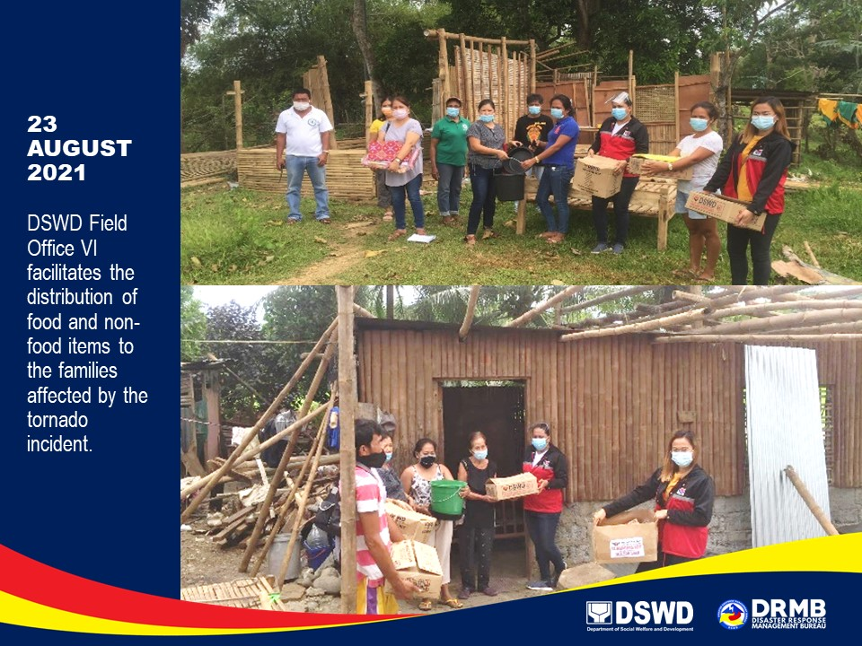

*****
The Disaster Response Operations Monitoring and Information Center (DROMIC) of DSWD-DRMB continues to closely coordinate with DSWD-FO VI for any request of Technical Assistance and Resource Augmentation (TARA).

Prepared by:  MARIE JOYCE G. RAFANAN  PHIL JOBERT A. ZALDIVAR | Released by:  LESLIE R. JAWILI

