DSWD DROMIC Report #1 on the Landslide Incident
in Brgy. Loacan, Itogon, Benguet
as of 21 August 2021, 6PM

- Situation Overview

On 17 August 2021 at around 10:45 AM, a landslide incident occurred at Antamok River, Loacan, Itogon, Benguet affecting 123 families in the area. On the other hand, no damaged houses were reported.
Source: DSWD-FO CAR

- Status of Affected Areas and Population
There are 123 families or 800 persons affected by the landslide incident in Brgy. Loacana, Itogon, Benguet (see Table 1).

Table 1. Number of Affected Families / Persons
REGION / PROVINCE / MUNICIPALITY |  | NUMBER OF AFFECTED
 |  | Barangays | Families | Persons
GRAND TOTAL |  | 1 | 123 | 800
CAR |  | 1 | 123 | 800
Benguet |  | 1 | 123 | 800
 | Itogon | 1 | 123 | 800
Note: Ongoing assessment and validation being conducted.
Source: DSWD-FO CAR

- Cost of Humanitarian Assistance Provided
A total of ₱129,993.00 worth of assistance was provided to the affected families; of which ₱126,993.00 was provided by DSWD and ₱3,000.00 from LGU (see Table 2).

Table 2. Cost of Assistance Provided to Affected Families / Persons
REGION / PROVINCE / MUNICIPALITY |  | COST OF ASSISTANCE
 |  | DSWD | LGU | NGOs | OTHERS | GRAND TOTAL
GRAND TOTAL |  | 126,993.00 | 3,000.00 | - | - | 129,993.00
CAR |  | 126,993.00 | 3,000.00 | - | - | 129,993.00
Benguet |  | 126,993.00 | 3,000.00 | - | - | 129,993.00
 | Itogon | 126,993.00 | 3,000.00 | - | - | 129,993.00
Note: Ongoing assessment and validation being conducted.
Source: DSWD-FO CAR

- Response Actions and Interventions

- Food and Non-Food Items (NFIs)

- DSWD-FO CAR provided 150 family food packs and three (3) family tents to the affected families.
- Other Activities

DATE | SITUATIONS / ACTIONS UNDERTAKEN
18 August 2021 | - DSWD-FO CAR provided ₱20,000 cash assistance to the bereaved families through the Assistance to Individuals in Crisis Situation (AICS).
17 August 2021 | - DSWD-FO CAR through its Psychosocial Support Team Activated conducted Psychological First Aid to the immediate families of the casualties.

- Photo Documentation

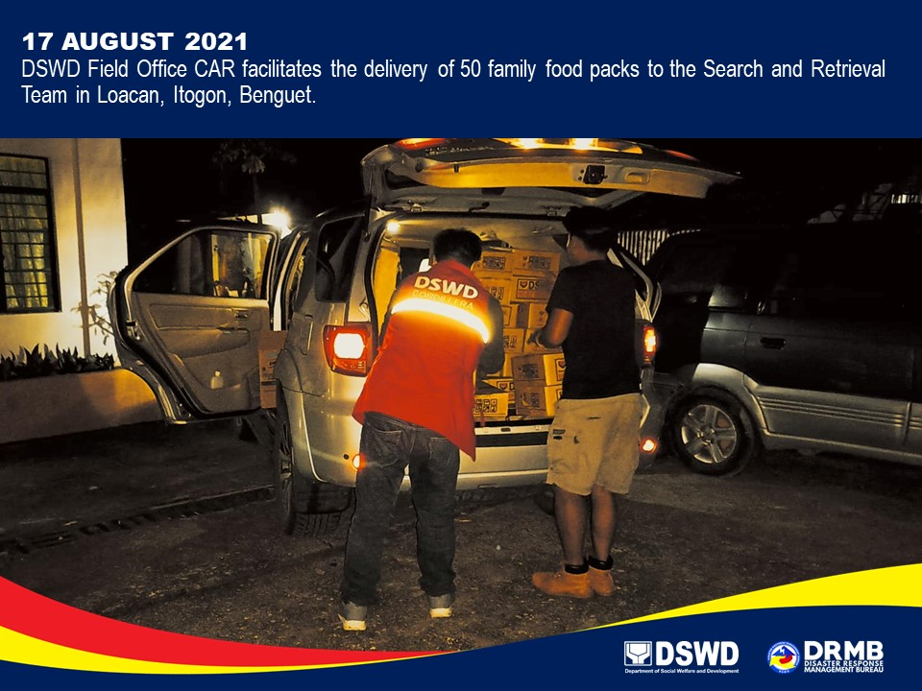

*****

The Disaster Response Operations Monitoring and Information Center (DROMIC) of DSWD-DRMB is closely coordinating with DSWD-FO CAR for significant disaster response updates and assistance provided.

Prepared by:  MARIE JOYCE G. RAFANAN  PHIL JOBERT A. ZALDIVAR | Released by:  LESLIE R. JAWILI

