DSWD DROMIC Report on the Fire Incident
in Brgy. Damag, Aguinaldo, Ifugao
27 August 2021, 6PM

- Situation Overview
This is the first and final report on the fire incident that occurred at Sitio Tamang, Brgy. Damag, Aguinaldo, Ifugao at around 9:40 AM of 22 June 2021 which affected one (1) family and totally damaged one (1) house.
Source: DSWD-FO CAR

- Status of Affected Areas and Population
A total of one (1) family or five (5) persons were affected by the fire incident in Aguinaldo, Ifugao (see Table 1).

Table 1. Number of Affected Families / Persons
REGION / PROVINCE / MUNICIPALITY |  | NUMBER OF AFFECTED
 |  | Barangays | Families | Persons
GRAND TOTAL |  | 1 | 1 | 5
CAR |  | 1 | 1 | 5
Ifugao |  | 1 | 1 | 5
 | Aguinaldo | 1 | 1 | 5
Source: DSWD-FO CAR

- Status of Displaced Population

- Outside Evacuation Centers
There is one (1) family or five (5) persons currently taking temporary shelter with their relatives and/or friends (see Table 2).

Table 2. Number of Displaced Families / Persons Outside Evacuation Centers
REGION / PROVINCE / MUNICIPALITY |  | NUMBER OF DISPLACED
 |  | OUTSIDE ECs
 |  | Families |  | Persons
 |  | CUM | NOW | CUM | NOW
GRAND TOTAL |  | 1 | 1 | 5 | 5
CAR |  | 1 | 1 | 5 | 5
Ifugao |  | 1 | 1 | 5 | 5
 | Aguinaldo | 1 | 1 | 5 | 5
Source: DSWD-FO CAR

- Total Displaced Population
A total of one (1) family or five (5) persons were displaced in Aguinaldo, Ifugao (see Table 3).

Table 3. Total Number of Displaced Families / Persons
REGION / PROVINCE / MUNICIPALITY |  | TOTAL DISPLACED SERVED
 |  | Families |  | Persons
 |  | Total Families |  | Total Persons
 |  | CUM | NOW | CUM | NOW
GRAND TOTAL |  | 1 | 1 | 5 | 5
CAR |  | 1 | 1 | 5 | 5
Ifugao |  | 1 | 1 | 5 | 5
 | Aguinaldo | 1 | 1 | 5 | 5
Source: DSWD-FO CAR

- Damaged Houses
A total of one (1) house was totally damaged by the fire (Table 4).

Table 4. Number of Damaged Houses
REGION / PROVINCE / MUNICIPALITY |  | NO. OF DAMAGED HOUSES
 |  | Total | Totally | Partially
GRAND TOTAL |  | 1 | 1 | -
CAR |  | 1 | 1 | -
Ifugao |  | 1 | 1 | -
 | Aguinaldo | 1 | 1 | -
Source: DSWD-FO CAR

- Cost of Humanitarian Assistance Provided
A total of ₱14,116.48 worth of assistance was provided to the affected families; of which ₱9,616.48 was provided by DSWD and ₱4,500.00 from the Local Government Unit (LGU) (see Table 5).

Table 5. Cost of Assistance Provided to Affected Families / Persons
REGION / PROVINCE / MUNICIPALITY |  | COST OF ASSISTANCE
 |  | DSWD | LGU | NGOs | OTHERS | GRAND TOTAL
GRAND TOTAL |  | 9,616.48 | 4,500.00 | - | - | 14,116.48
CAR |  | 9,616.48 | 4,500.00 | - | - | 14,116.48
Ifugao |  | 9,616.48 | 4,500.00 | - | - | 14,116.48
 | Aguinaldo | 9,616.48 | 4,500.00 | - | - | 14,116.48
Source: DSWD-FO CAR

- Response Actions and Interventions

- Food and Non-Food Items (NFIs)

- DSWD-FO CAR provided five (5) family food packs, one (1) hygiene kit, one (1) sleeping kit, one (1) family kit, and one (1) kitchen kit to the affected family.
- Other Activities

DATE | ACTIVITIES
10 August 2021 | - DSWD-FO CAR submitted their terminal report.
12 July 2021 | - DSWD FO-CAR through its Crisis Intervention Section provided cash assistance worth ₱5,000.00 to the affected family.

- Photo Documentation

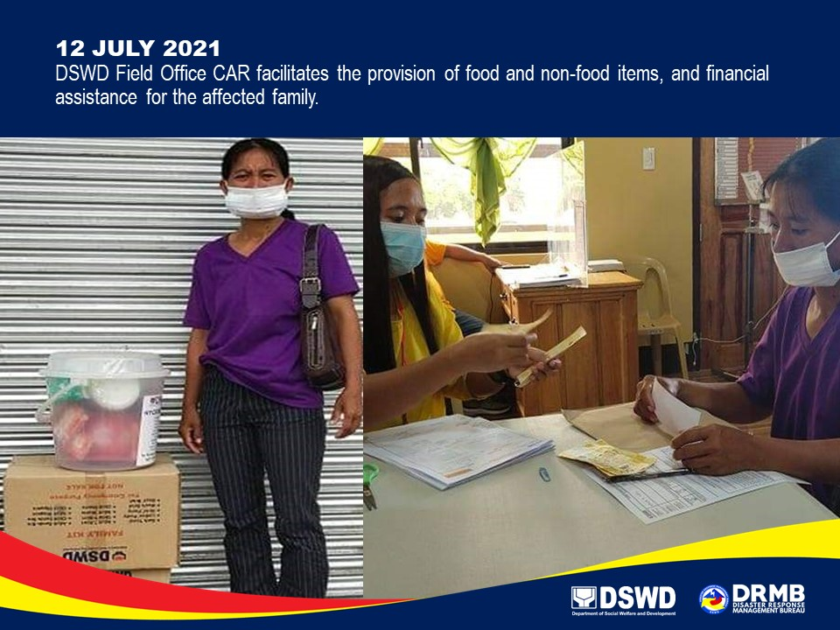

*****
The Disaster Response Operations Monitoring and Information Center (DROMIC) of DSWD-DRMB continues to closely coordinate with DSWD-FO CAR for any request of Technical Assistance and Resource Augmentation (TARA).

Prepared by:  MARIE JOYCE G. RAFANAN  PHIL JOBERT A. ZALDIVAR | Released by:  LESLIE R. JAWILI

