DSWD DROMIC Terminal Report on the Landslide Incident
in Brgy. Loacan, Itogon, Benguet
22 September 2021, 6PM

- Situation Overview

This is the final report on the landslide incident that occurred on 17 August 2021 at around 10:45 AM at Antamok River, Loacan, Itogon, Benguet.
Source: DSWD-FO CAR

- Status of Affected Areas and Population
There were 123 families or 800 persons affected by the landslide incident in Brgy. Loacana, Itogon, Benguet (see Table 1).

Table 1. Number of Affected Families / Persons
REGION / PROVINCE / MUNICIPALITY |  | NUMBER OF AFFECTED
 |  | Barangays | Families | Persons
GRAND TOTAL |  | 1 | 123 | 800
CAR |  | 1 | 123 | 800
Benguet |  | 1 | 123 | 800
 | Itogon | 1 | 123 | 800
Source: DSWD-FO CAR

- Cost of Humanitarian Assistance Provided
A total of ₱129,993.00 worth of assistance was provided to the affected families; of which ₱126,993.00 was provided by DSWD and ₱3,000.00 from LGU (see Table 2).

Table 2. Cost of Assistance Provided to Affected Families / Persons
REGION / PROVINCE / MUNICIPALITY |  | COST OF ASSISTANCE
 |  | DSWD | LGU | NGOs | OTHERS | GRAND TOTAL
GRAND TOTAL |  | 126,993.00 | 3,000.00 | - | - | 129,993.00
CAR |  | 126,993.00 | 3,000.00 | - | - | 129,993.00
Benguet |  | 126,993.00 | 3,000.00 | - | - | 129,993.00
 | Itogon | 126,993.00 | 3,000.00 | - | - | 129,993.00
Note: The LGU assistance was provided to the search and retrieval teams.
Source: DSWD-FO CAR

- Photo Documentation

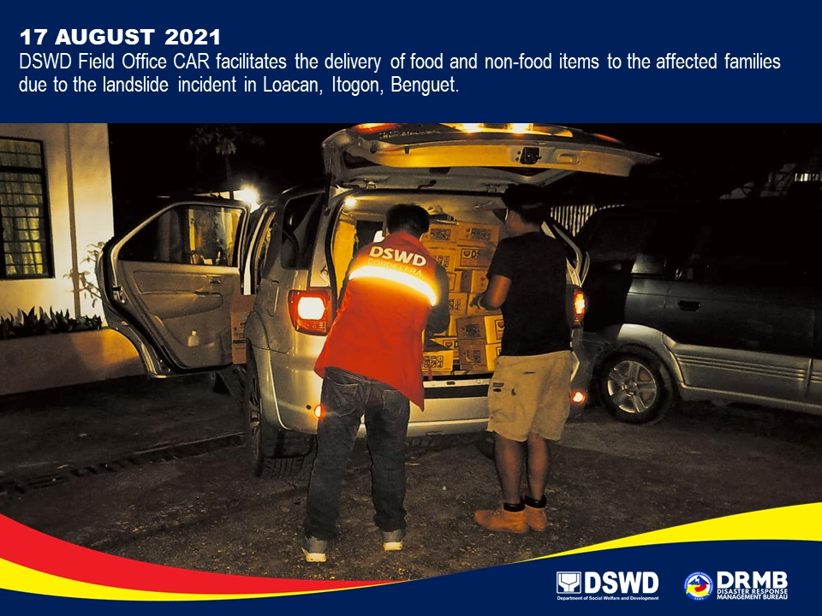

*****

This terminal report is based on the latest report submitted by DSWD-FO CAR on 03 September 2021. The Disaster Response Operations Monitoring and Information Center (DROMIC) of DSWD-DRMB continues to closely coordinate with DSWD-FO CAR for any request of Technical Assistance and Resource Augmentation (TARA).

Prepared by:  JOANNA CAMILLE R. JACINTO | Released by:  RODEL V. CABADDU

