DSWD DROMIC Terminal Report on the
Strong Wind Incident in Surallah, South Cotabato
30 August 2021, 6PM

- Situation Overview

This is the final report on the heavy rain associated with strong wind that raged in Surallah, South Cotabato on 30 June 2021, affecting two (2) barangays namely, Barangay Lamian and Barangay Lambontong.
Source: DSWD-Field Office (FO) XII

- Status of Affected Areas and Population
A total of 66 families or 330 persons were affected in two (2) barangays in Surallah, South Cotabato (see Table 1).

Table 1. Number of Affected Families / Persons
REGION / PROVINCE / MUNICIPALITY |  | NUMBER OF AFFECTED
 |  | Barangays | Families | Persons
GRAND TOTAL |  | 2 | 66 | 330
REGION XII |  | 2 | 66 | 330
South Cotabato |  | 2 | 66 | 330
 | Surallah | 2 | 66 | 330
Source: DSWD-FO XII

- Status of Displaced Population Outside Evacuation Centers
A total of two (2) families or ten (10) persons are currently seeking temporary shelter with their relatives and/or friends (see Table 2).

Table 2. Number of Displaced Families / Persons Outside Evacuation Centers
REGION / PROVINCE / MUNICIPALITY |  | NUMBER OF DISPLACED
 |  | OUTSIDE ECs
 |  | Families |  | Persons
 |  | CUM | NOW | CUM | NOW
GRAND TOTAL |  | 2 | 2 | 10 | 10
REGION XII |  | 2 | 2 | 10 | 10
South Cotabato |  | 2 | 2 | 10 | 10
 | Surallah | 2 | 2 | 10 | 10
Source: DSWD-FO XII

- Damaged Houses
A total of 66 houses were damaged by the fire; of which, three (3) were totally damaged and 63 were partially damaged (see Table 3).

Table 3. Number of Damaged Houses
REGION / PROVINCE / MUNICIPALITY |  | NO. OF DAMAGED HOUSES
 |  | Total | Totally | Partially
GRAND TOTAL |  | 66 | 3 | 63
REGION XII |  | 66 | 3 | 63
South Cotabato |  | 66 | 3 | 63
 | Surallah | 66 | 3 | 63
Source: DSWD-FO XII
- Cost of Humanitarian Response
A total of ₱172,120.00 worth of assistance was provided to the affected families; of which, ₱29,370.00 was provided by DSWD, and ₱142,750.00 was from the Local Government Unit (LGU) (see Table 4).

Table 4. Cost of Assistance Provided to Affected Families / Persons
REGION / PROVINCE / MUNICIPALITY |  | COST OF ASSISTANCE
 |  | DSWD | LGU | NGOs | OTHERS | GRAND TOTAL
GRAND TOTAL |  | 29,370.00 | 142,750.00 | - | - | 172,120.00
REGION XII |  | 29,370.00 | 142,750.00 | - | - | 172,120.00
South Cotabato |  | 29,370.00 | 142,750.00 | - | - | 172,120.00
 | Surallah | 29,370.00 | 142,750.00 | - | - | 172,120.00
Source: DSWD-FO XII

- Response Actions and Interventions

- Food and Non-Food Items (NFIs)

- DSWD-FO CAR provided 66 family food packs amounting to ₱29,370.00 to the affected families.
- Other Activities

DATE | ACTIVITIES
13 August 2021 | - DSWD-FO XII submitted their terminal report.

- Photo Documentation
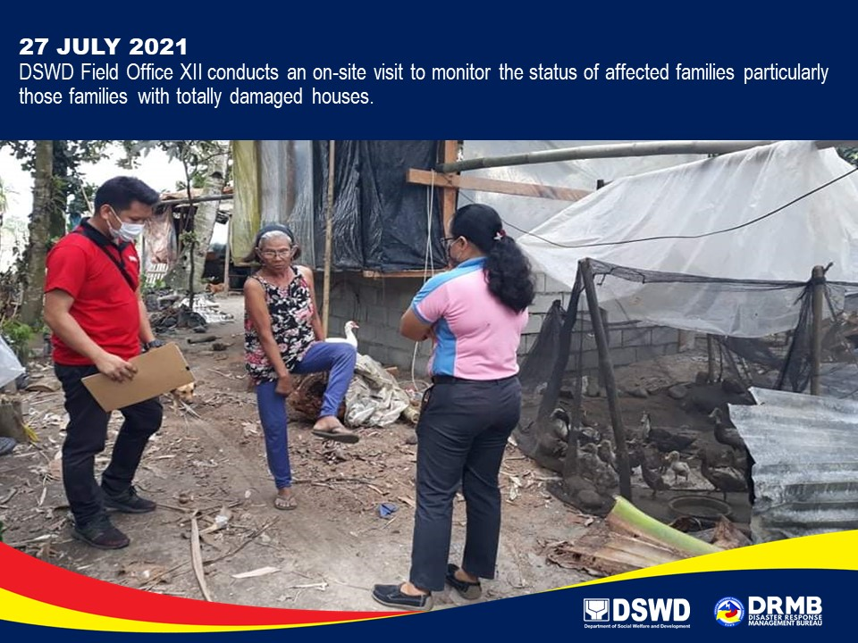

*****
The Disaster Response Operations Monitoring and Information Center (DROMIC) of DSWD-DRMB continues to closely coordinate with DSWD-FO XII for any request of Technical Assistance and Resource Augmentation (TARA).

Prepared by:  MARIE JOYCE G. RAFANAN  PHIL JOBERT A. ZALDIVAR | Released by:  LESLIE R. JAWILI

