DSWD DROMIC Terminal Report on the Taal Volcano Eruption
11 August 2021, 6PM

This is the final report on the monitored eruption of Taal Volcano, which occurred on 01 July 2021.

SUMMARY

On 01 July 2021 at 3:37 PM, the Philippine Institute of Volcanology and Seismology (PHIVOLCS) has raised Alert Level 3 over Taal Volcano after a phreatomagmatic eruption from the main crater occurred at 3:16 PM. There was magmatic intrusion at the Main Crater that might further drive succeeding eruptions.

On 23 July 2021 at 7:30 PM, the alert status of Taal Volcano was lowered to Alert Level 2 (Decreased Unrest). DOST-PHIVOLCS reminded the public that at Alert Level 2, sudden steam- or gas-driven explosions, volcanic earthquakes, minor ashfall, and lethal accumulations or expulsions of volcanic gas could occur and threaten areas within and around Taal Volcano Island (TVI). DOST-PHIVOLCS strongly recommended that entry must be strictly prohibited into TVI, Taal’s Permanent Danger Zone or PDZ, especially the vicinities of the Main Crater and the Daang Kastila fissure, and occupancy and boating on Taal Lake. Local government officials were advised to continuously assess and strengthen the preparedness of previously evacuated barangays around Taal Lake in case of renewed unrest.
Source: PHIVOLCS

- Status of Affected Areas and Population
A total of 6,262 families or 22,433 persons were affected by the Taal Volcano eruption in 131 Barangays in CALABARZON (see Table 1).

Table 1. Number of Affected Families / Persons
REGION / PROVINCE / MUNICIPALITY |  | NUMBER OF AFFECTED
 |  | Barangays | Families | Persons
GRAND TOTAL |  | 131 | 6,262 | 22,433
CALABARZON |  | 131 | 6,262 | 22,433
Batangas |  | 129 | 6,260 | 22,428
 | Agoncillo | 21 | 2,412 | 8,746
 | Alitagtag | 2 | 7 | 28
 | Balete | 7 | 98 | 343
 | Cuenca | 2 | 35 | 108
 | Laurel | 18 | 2,863 | 10,059
 | Lemery | 28 | 123 | 433
 | Mataas Na Kahoy | 4 | 43 | 129
 | San Nicolas | 17 | 246 | 923
 | Santa Teresita | 1 | 4 | 18
 | Taal | 13 | 50 | 167
 | Talisay | - | 179 | 699
 | City of Tanauan | 16 | 200 | 775
Cavite |  | 2 | 2 | 5
 | Tagaytay City | 2 | 2 | 5
Source: DSWD-Field Office (FO) CALABARZON
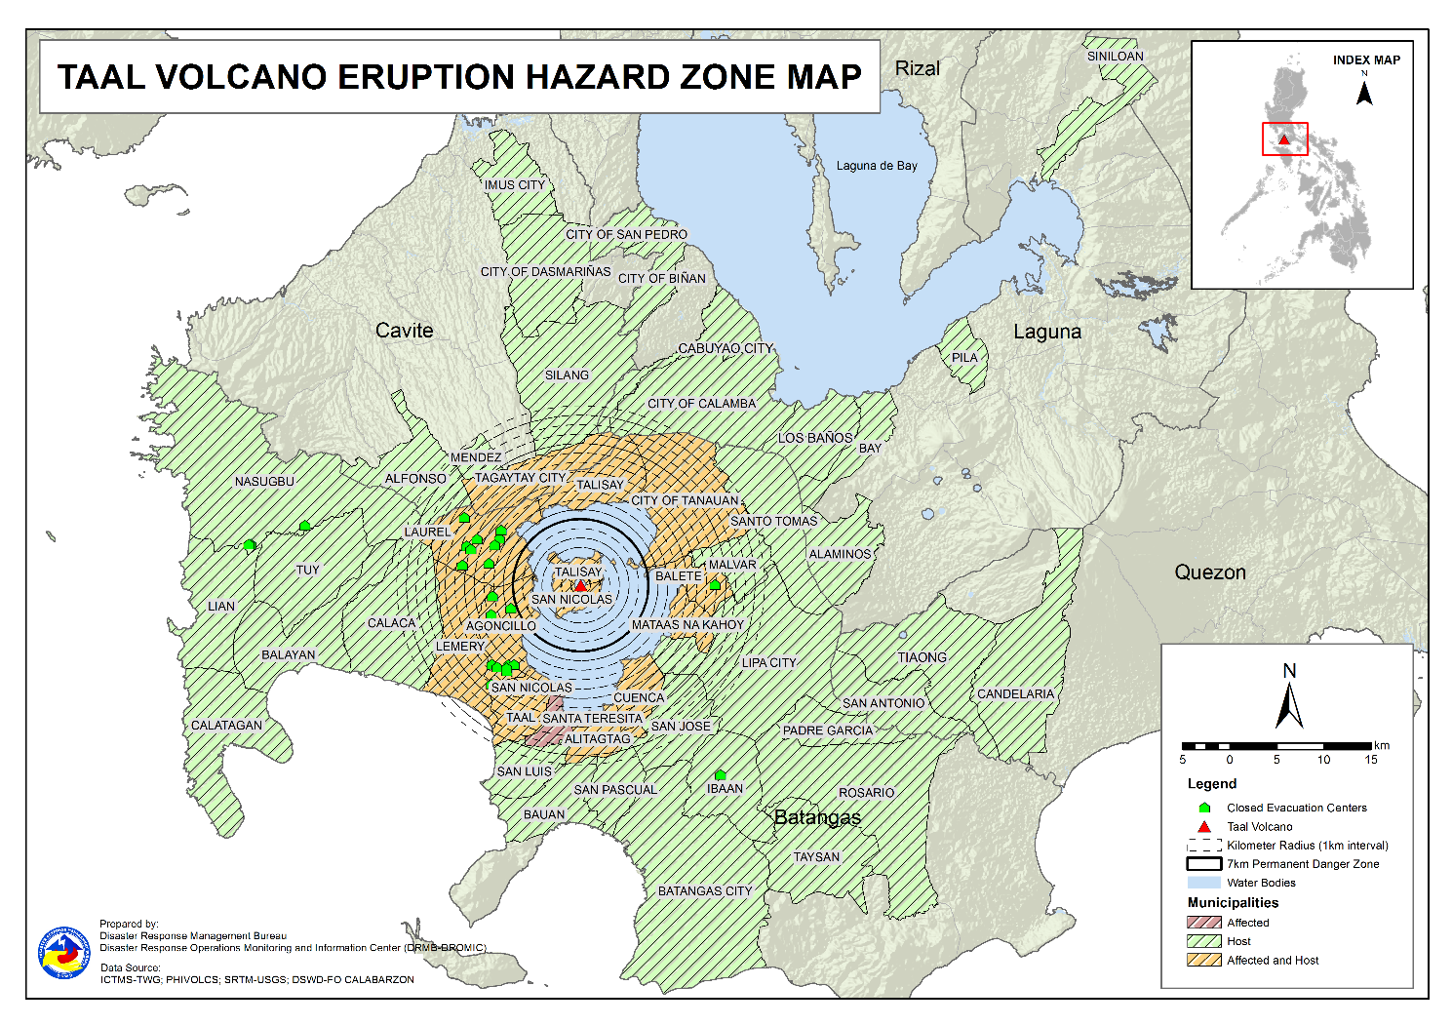

- Status of Displaced Population

- Inside Evacuation Centers
There were 1,655 families or 5,865 persons took temporary shelter in 29 evacuation centers in CALABARZON (see Table 2).

Table 2. Number of Displaced Families / Persons Inside Evacuation Centers
REGION / PROVINCE / MUNICIPALITY |  | NUMBER OF EVACUATION CENTERS (ECs) |  | NUMBER OF DISPLACED
 |  |  |  | INSIDE ECs
 |  |  |  | Families |  | Persons
 |  | CUM | NOW | CUM | NOW | CUM | NOW
GRAND TOTAL |  | 29 | - | 1,655 | - | 5,865 | -
CALABARZON |  | 29 | - | 1,655 | - | 5,865 | -
Batangas |  | 29 | - | 1,655 | - | 5,865 | -
 | Agoncillo | 14 | - | 451 | - | 1,608 | -
 | Balayan | 1 | - | 28 | - | 94 | -
 | Balete | 1 | - | 76 | - | 264 | -
 | Ibaan | 1 | - | 3 | - | 12 | -
 | Laurel | 9 | - | 987 | - | 3,565 | -
 | Nasugbu | 3 | - | 110 | - | 322 | -
Source: DSWD-FO CALABARZON

- Outside Evacuation Centers
There are 1,726 families or 6,120 persons temporarily staying with their relatives and/or friends in CALABARZON (see Table 3).

Table 3. Number of Displaced Families / Persons Outside Evacuation Centers
REGION / PROVINCE / MUNICIPALITY |  | NUMBER OF DISPLACED
 |  | OUTSIDE ECs
 |  | Families |  | Persons
 |  | CUM | NOW | CUM | NOW
GRAND TOTAL |  | 4,607 | 1,726 | 16,568 | 6,120
CALABARZON |  | 4,607 | 1,726 | 16,568 | 6,120
Batangas |  | 4,441 | 1,581 | 15,955 | 5,583
 | Agoncillo | 1,176 | 147 | 4,330 | 575
 | Alitagtag | 83 | 35 | 242 | 94
 | Balayan | 71 | 60 | 234 | 205
 | Balete | 6 | 4 | 19 | 11
 | Batangas City (capital) | 93 | 60 | 332 | 218
 | Bauan | 123 | 67 | 471 | 247
 | Calaca | 323 | 170 | 1,132 | 596
 | Calatagan | 47 | 29 | 180 | 93
 | Cuenca | 42 | 17 | 146 | 61
 | Ibaan | 95 | 38 | 375 | 134
 | Laurel | 1,283 | 470 | 4,556 | 1,596
 | Lemery | 161 | 75 | 595 | 281
 | Lian | 20 | 19 | 41 | 38
 | Lipa City | 31 | 24 | 81 | 64
 | Malvar | 34 | 33 | 108 | 107
 | Mataas Na Kahoy | 1 | 1 | 2 | 2
 | Nasugbu | 91 | 3 | 281 | 13
 | Padre Garcia | 13 | 7 | 45 | 27
 | Rosario | 13 | 13 | 41 | 41
 | San Jose | 47 | 26 | 168 | 107
 | San Luis | 128 | 49 | 487 | 187
 | San Nicolas | 130 | 41 | 487 | 156
 | San Pascual | 44 | 27 | 157 | 84
 | Santo Tomas | 55 | 20 | 221 | 103
 | Taal | 86 | 17 | 269 | 61
 | City of Tanauan | 221 | 118 | 870 | 455
 | Taysan | 10 | 10 | 26 | 26
 | Tuy | 14 | 1 | 59 | 1
Cavite |  | 33 | 25 | 114 | 94
 | Alfonso | 1 | 1 | 2 | 2
 | Dasmariñas | 1 | 1 | 4 | 4
 | Imus | 5 | 5 | 14 | 14
 | Mendez (MENDEZ-NUÑEZ) | 1 | 1 | 4 | 4
 | Silang | 22 | 14 | 79 | 59
 | Tagaytay City | 3 | 3 | 11 | 11
Laguna |  | 129 | 116 | 484 | 428
 | Alaminos | 3 | 2 | 14 | 9
 | Bay | 2 | 1 | 5 | 3
 | Biñan | 1 | 1 | 5 | 5
 | Cabuyao | 3 | 2 | 12 | 7
 | City of Calamba | 112 | 105 | 409 | 384
 | Los Baños | 1 | - | 2 | -
 | Pila | 1 | 1 | 5 | 5
 | San Pedro | 3 | 3 | 12 | 12
 | Siniloan | 3 | 1 | 20 | 3
Quezon |  | 4 | 4 | 15 | 15
 | Candelaria | 1 | 1 | 4 | 4
 | San Antonio | 1 | 1 | 3 | 3
 | Tiaong | 2 | 2 | 8 | 8
Source: DSWD-FO CALABARZON

- Total Displaced Population
A total of 6,262 families or 22,433 persons were displaced in CALABARZON due to Taal Volcano eruption (see Table 4).

Table 4. Total Number of Displaced Families / Persons
REGION / PROVINCE / MUNICIPALITY |  | TOTAL DISPLACED
 |  | Families |  | Persons
 |  | Total Families |  | Total Persons
 |  | CUM | NOW | CUM | NOW
GRAND TOTAL |  | 6,262 | 1,726 | 22,433 | 6,120
CALABARZON |  | 6,262 | 1,726 | 22,433 | 6,120
Batangas |  | 6,096 | 1,581 | 21,820 | 5,583
 | Agoncillo | 1,627 | 147 | 5,938 | 575
 | Alitagtag | 83 | 35 | 242 | 94
 | Balayan | 99 | 60 | 328 | 205
 | Balete | 82 | 4 | 283 | 11
 | Batangas City (capital) | 93 | 60 | 332 | 218
 | Bauan | 123 | 67 | 471 | 247
 | Calaca | 323 | 170 | 1,132 | 596
 | Calatagan | 47 | 29 | 180 | 93
 | Cuenca | 42 | 17 | 146 | 61
 | Ibaan | 98 | 38 | 387 | 134
 | Laurel | 2,270 | 470 | 8,121 | 1,596
 | Lemery | 161 | 75 | 595 | 281
 | Lian | 20 | 19 | 41 | 38
 | Lipa City | 31 | 24 | 81 | 64
 | Malvar | 34 | 33 | 108 | 107
 | Mataas Na Kahoy | 1 | 1 | 2 | 2
 | Nasugbu | 201 | 3 | 603 | 13
 | Padre Garcia | 13 | 7 | 45 | 27
 | Rosario | 13 | 13 | 41 | 41
 | San Jose | 47 | 26 | 168 | 107
 | San Luis | 128 | 49 | 487 | 187
 | San Nicolas | 130 | 41 | 487 | 156
 | San Pascual | 44 | 27 | 157 | 84
 | Santo Tomas | 55 | 20 | 221 | 103
 | Taal | 86 | 17 | 269 | 61
 | City of Tanauan | 221 | 118 | 870 | 455
 | Taysan | 10 | 10 | 26 | 26
 | Tuy | 14 | 1 | 59 | 1
Cavite |  | 33 | 25 | 114 | 94
 | Alfonso | 1 | 1 | 2 | 2
 | Dasmariñas | 1 | 1 | 4 | 4
 | Imus | 5 | 5 | 14 | 14
 | Mendez (MENDEZ-NUÑEZ) | 1 | 1 | 4 | 4
 | Silang | 22 | 14 | 79 | 59
 | Tagaytay City | 3 | 3 | 11 | 11
Laguna |  | 129 | 116 | 484 | 428
 | Alaminos | 3 | 2 | 14 | 9
 | Bay | 2 | 1 | 5 | 3
 | Biñan | 1 | 1 | 5 | 5
 | Cabuyao | 3 | 2 | 12 | 7
 | City of Calamba | 112 | 105 | 409 | 384
 | Los Baños | 1 | - | 2 | -
 | Pila | 1 | 1 | 5 | 5
 | San Pedro | 3 | 3 | 12 | 12
 | Siniloan | 3 | 1 | 20 | 3
Quezon |  | 4 | 4 | 15 | 15
 | Candelaria | 1 | 1 | 4 | 4
 | San Antonio | 1 | 1 | 3 | 3
 | Tiaong | 2 | 2 | 8 | 8
Note: Ongoing assessment and validation are continuously being conducted.
Source: DSWD-FO CALABARZON

- Cost of Humanitarian Assistance Provided

A total of ₱16,419,271.30 worth of assistance was provided to the affected families; of which, ₱3,983,905.80 was provided by DSWD, ₱7,141,317.70 from Local Government Units (LGUs) and ₱5,294,047.80 from Non-Government Organizations (NGOs) (see Table 5).

Table 5. Cost of Assistance Provided to Affected Families / Persons
REGION / PROVINCE / MUNICIPALITY |  | COST OF ASSISTANCE
 |  | DSWD | LGUs | NGOs | OTHERS | GRAND TOTAL
GRAND TOTAL |  | 3,983,905.80 | 7,141,317.70 | 5,294,047.80 | - | 16,419,271.30
CALABARZON |  | 3,983,905.80 | 7,141,317.70 | 5,294,047.80 | - | 16,419,271.30
Batangas |  | 3,983,905.80 | 7,141,317.70 | 5,294,047.80 | - | 16,419,271.30
 | Province | 325,875.00 | 3,837,247.10 | - | - | 4,163,122.10
 | Agoncillo | 3,004,132.80 | 1,485,568.00 | 2,175,966.10 | - | 6,665,666.90
 | Balayan | - | - | 57,065.70 | - | 57,065.70
 | Balete | - | 29,952.00 | 149,480.10 | - | 179,432.10
 | Batangas City (capital) | - | 29,512.00 | - | - | 29,512.00
 | Laurel | 653,898.00 | 1,704,589.00 | 2,048,692.50 | - | 4,407,179.50
 | Nasugbu | - | - | 112,152.30 | - | 112,152.30
 | Talisay | - | - | 322,891.10 | - | 322,891.10
 | City of Tanauan | - | 54,449.60 | 427,800.00 | - | 482,249.60
Source: DSWD-FO CALABARZON

- Ways Forward and Recommendation

OFFICE | ACTIVITIES
DSWD-FO CALABARZON | - Convene the members of the Regional Disaster Risk Reduction and Management Council (RDRRMC) IV-A Response Cluster for the conduct of After Operations Review in connection with the recent volcanic activity of Taal.  - Monitoring of the implementation of Food-for-Work (FFW) activities and early recovery programs of the affected LGUs.  - Conduct technical session on Food and Non-Food items (FNIs), Camp Coordination and Camp Management (CCCM), Internally Displaced Person (IDP) Protection and Information Management to LGUs and members of the Regional/Provincial Quick Response Teams (R/PQRTs).

*****
The Disaster Response Operations Monitoring and Information Center (DROMIC) of DSWD-DRMB continues to closely coordinate with DSWD-FO CALABARZON for any request of technical assistance and resource augmentation (TARA).

Prepared by:  DIANE C. PELEGRINO  MARIEL B. FERRARIZ | Released by:  MARC LEO L. BUTAC

