DSWD DROMIC Preparedness for Response Report #1
on Tropical Depression “Jolina”
as of 06 September 2021, 6PM

Situation Overview

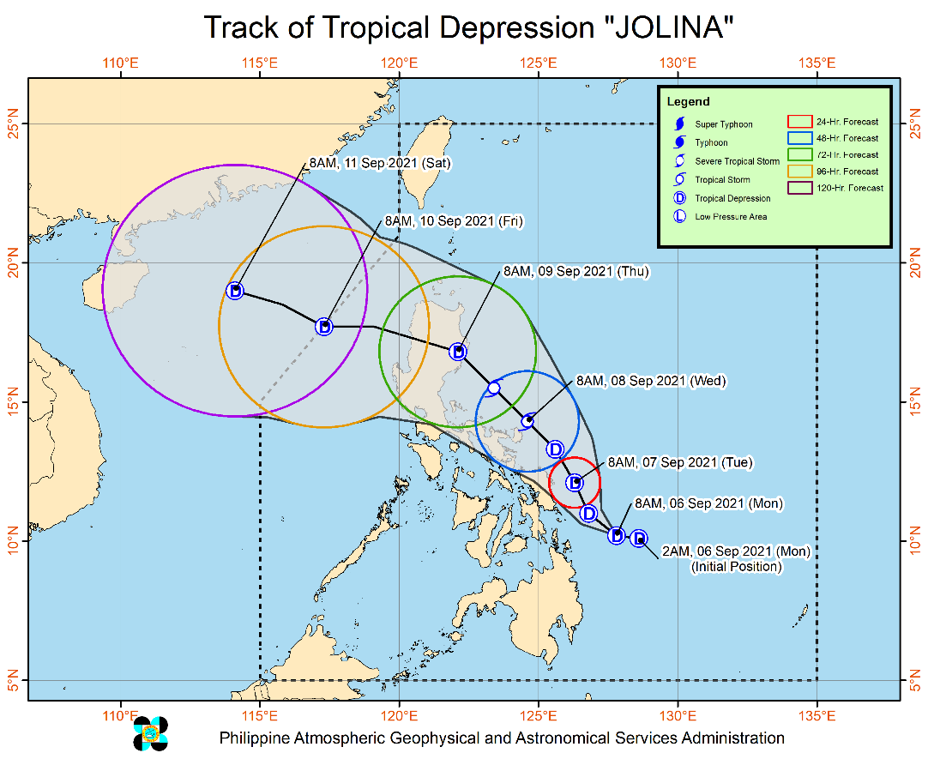
Issued at 11:00 AM, 06 September 2021, “JOLINA” slightly intensifies as it moves westward over the Philippine Sea.

Heavy Rainfall:
- In the next 24 hours, “JOLINA” may bring moderate to heavy rains over Eastern Samar, Dinagat Islands, and Surigao del Norte including Siargao and Bucas Grande Islands. Light to moderate with at times heavy rains over Northern Cebu, Bohol, Camiguin, and the rest of Eastern Visayas. Under these conditions, isolated to scattered flash flooding and rain-induced landslides are possible especially in areas that are highly or very highly susceptible to these hazard as identified in hazard maps.

Severe Winds:
- Strong winds (strong breeze to near gale conditions) with occasional gusts will be experienced in areas where Tropical Cyclone Wind Signal (TCWS) #1 is in effect. Given that “JOLINA” may likely intensify into tropical storm before landfall, the highest possible TCWS that will be raised throughout its passage will be TCWS #2.
- In the next 24 hours, Tropical Depression “JOLINA” may bring moderate to rough seas (1.2 to 2.8 m) over the eastern seaboards of Visayas and Mindanao. Mariners of small seacrafts are advised to take precautionary measures when venturing out to sea. Inexperienced mariners should avoid navigating in these conditions. Moderate to rough seas (1.2 to 3.1 m) will be experienced over the rest of the seaboards of the country. Mariners of small seacrafts are advised to take precautionary measures when venturing out to sea. Inexperienced mariners should avoid navigating in these conditions.

Track:
- “JOLINA” will track generally northwestward parallel to the east coast of the country until it makes landfall over Northern Luzon by Thursday morning (09 September). Then it will move westward while traversing over Northern Luzon and may re-emerge over the West Philippine Sea by Thursday evening. “JOLINA” is forecast to exit the Philippine Area of Responsibility by Friday morning (10 September). However, the public is advised to continue monitoring for possible changes in the track forecast in the succeeding bulletins
- “JOLINA” is forecast to intensify into a tropical storm by Wednesday (08 September) prior to its landfall over Northern Luzon. It will then weaken into a tropical depression as it moves over the rugged terrain of Northern Luzon.

At 10:00 AM today, the center of Tropical Depression “JOLINA” was estimated based on all available data at 205 km East Southeast of Guiuan, Eastern Samar or 230 km East Northeast of Surigao City, Surigao del Norte (10.4°N, 127.5°E)
Source: DOST-PAGASA Severe Weather Bulletin

Predictive Analytics for Humanitarian Response

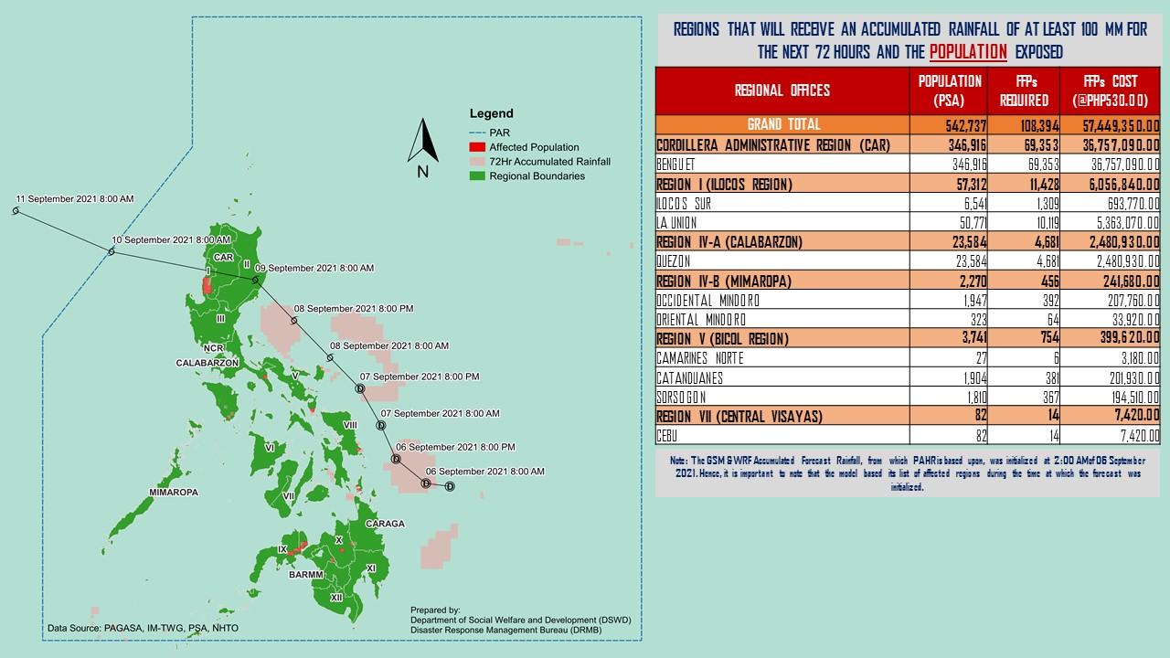
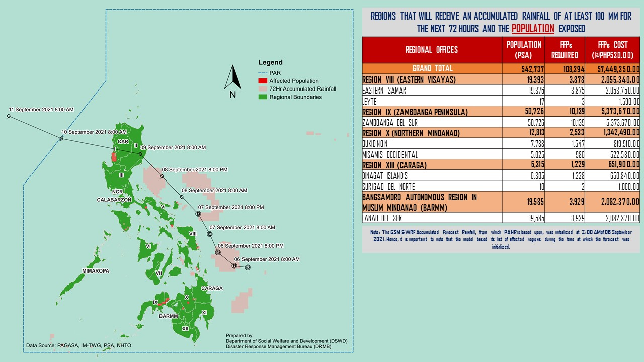
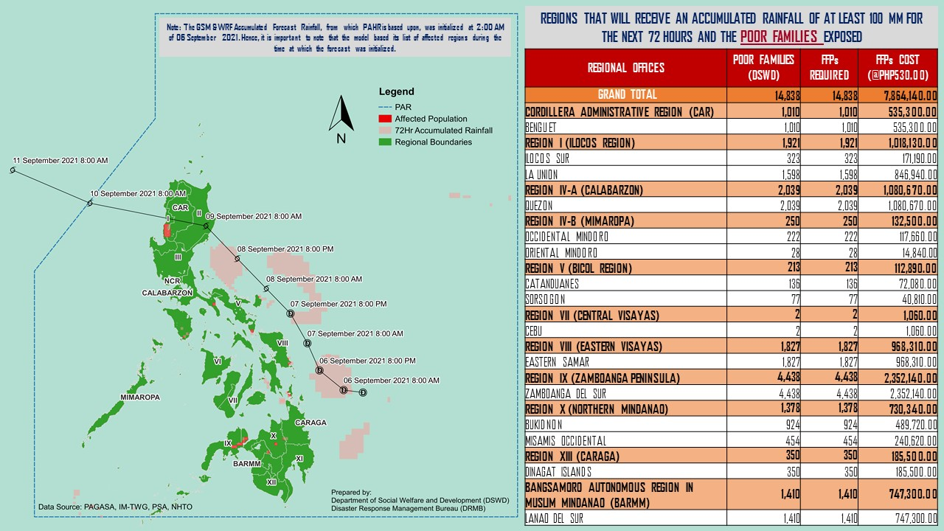

Status of Prepositioned Resources: Stockpile and Standby Funds

The DSWD Central Office (CO), Field Offices (FOs), and National Resource Operations Center (NROC) have stockpiles and standby funds amounting to ₱1,294,678,464.86 with breakdown as follows (see Table 2):

- Standby Funds
A total of ₱489,476,779.10 standby funds in the CO and FOs. Of the said amount, ₱442,892,138.74 is the available Quick Response Fund (QRF) in the CO.

- Stockpiles
A total of 314,719 family food packs (FFPs) amounting to ₱169,136,985.80, other food items amounting to ₱190,968,449.97 and non-food items (FNIs) amounting to ₱445,096,249.99 are available.

Table 1. Available Stockpiles and Standby Funds
REGIONAL / FIELD OFFICE | STANDBY FUNDS | FAMILY FOOD PACKS |  | OTHER FOOD ITEMS | NON-FOOD RELIEF ITEMS | TOTAL STANDBY FUNDS & STOCKPILE
 |  | QUANTITY | TOTAL COST | TOTAL COST | TOTAL COST
TOTAL | 489,476,779.10 | 314,719 | 169,136,985.80 | 190,968,449.97 | 445,096,249.99 | 1,294,678,464.86
Central Office | 442,892,138.74 | - | - | - | - | 442,892,138.74
NRLMB - NROC | - | 11,101 | 8,528,770.60 | 40,386,325.79 | 139,429,060.87 | 188,344,157.26
NRLMB - VDRC | - | 1,434 | 681,150.00 | 12,524,937.96 | 9,305,876.50 | 22,511,964.46
I | 3,000,735.20 | 12,335 | 5,015,850.00 | 9,019,056.00 | 32,928,689.11 | 49,964,330.31
II | 5,031,059.68 | 23,028 | 10,074,360.00 | 8,068,047.20 | 12,699,683.30 | 35,873,150.18
III | 3,000,000.00 | 21,308 | 13,162,354.22 | 1,915,536.30 | 17,840,545.75 | 35,918,436.27
CALABARZON | 5,240,440.00 | 4,305 | 2,135,546.00 | 7,975,713.20 | 7,015,363.48 | 22,367,062.68
MIMAROPA | 5,347,036.87 | 24,221 | 15,059,413.82 | 10,464,672.00 | 8,823,390.40 | 39,694,513.09
V | 3,000,000.00 | 32,948 | 16,547,635.67 | 7,954,321.38 | 20,800,618.40 | 48,302,575.45
VI | 518,196.42 | 33,178 | 16,028,498.59 | 11,348,910.04 | 16,425,576.68 | 44,321,181.73
VII | 3,000,000.00 | 44,129 | 21,176,094.00 | 26,092,708.78 | 13,298,164.05 | 63,566,966.83
VIII | 2,285,000.00 | 8,947 | 4,810,846.27 | 2,251,976.72 | 33,476,678.66 | 42,824,501.65
IX | 3,000,000.00 | 19,958 | 10,906,847.42 | 5,235,700.56 | 9,323,949.60 | 28,466,497.58
X | 238,559.92 | 12,444 | 7,244,105.72 | 8,453,426.76 | 38,827,067.41 | 54,763,159.81
XI | 3,000,000.00 | 4,783 | 2,182,464.80 | 16,538,687.00 | 16,869,189.30 | 38,590,341.10
XII | 3,000,969.85 | 13,161 | 9,427,500.00 | 11,674,608.80 | 28,592,050.17 | 52,695,128.82
CARAGA | 3,000,000.00 | 17,935 | 9,542,587.08 | 628,993.68 | 17,648,257.11 | 30,819,837.87
NCR | 3,002,563.30 | 1,055 | 528,776.55 | 8,064,539.42 | 1,730,344.44 | 13,326,223.71
CAR | 920,079.12 | 28,449 | 16,084,185.06 | 2,370,288.38 | 20,061,744.76 | 39,436,297.32
Note: The Inventory Summary is as of 06 September 2021, 4PM.
Source: DRMB and NRLMB

Situational Reports

DSWD-DRMB
DATE | SITUATIONS / ACTIONS UNDERTAKEN
06 September 2021 | - The Disaster Response Management Bureau (DRMB) is closely coordinating with the concerned field offices for significant disaster response updates.

DSWD-FO CARAGA
DATE | SITUATIONS / ACTIONS UNDERTAKEN
06 September 2021 | - DSWD-FO CARAGA is continuously monitoring weather updates.  - DSWD-FO CARAGA Quick Response Team (QRT) members are on standby for possible deployment.  - DSWD-FO CARAGA has one (1) operational disaster vehicle and one (1) wing van on standby to be utilized for logistics support;  - DSWD-FO CARAGA has two (2) Smartphones available to be utilized for communication support in the Emergency Operations Center;  - DSWD-FO CARAGA is in close coordination with SWADTLs and LSWDOs for monitoring of the situation in their respective area of responsibility.

*****
The Disaster Response Operations Monitoring and Information Center (DROMIC) of the DSWD-DRMB is closely monitoring the effects of Tropical Depression “Jolina” and is coordinating with the concerned DSWD Field Offices for any significant updates.

Prepared by:

MARIEL B. FERRARIZ
DIANE C. PELEGRINO

MARC LEO L. BUTAC
Releasing Officer

