DSWD DROMIC Report #1 on Typhoon “KIKO”
as of 11 September 2021, 6PM

- Situation Overview
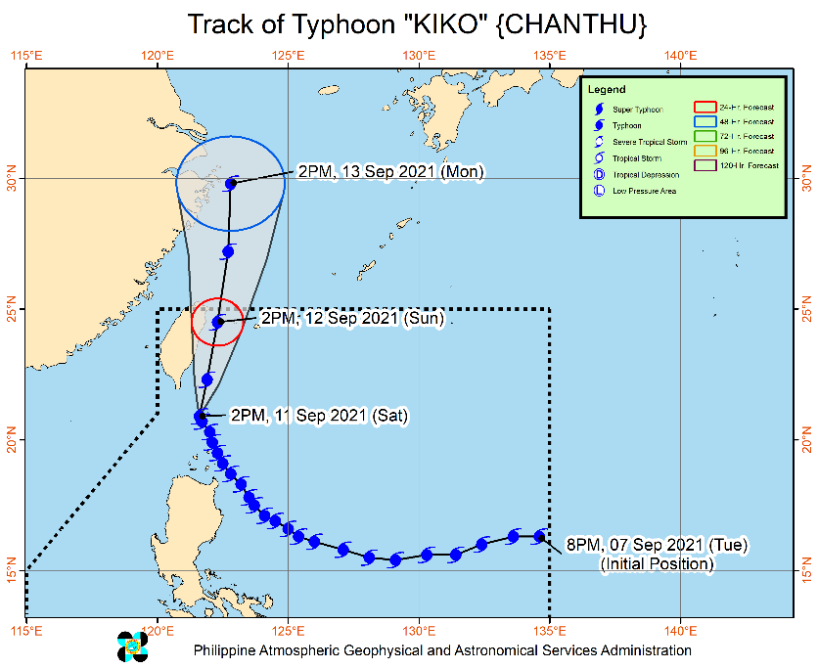
Issued at 3 PM, 11 September 2021, “KIKO” continues to weaken while moving over the coastal waters of Itbayat, Batanes.

Heavy Rainfall:
- In the next 24 hours, Typhoon “KIKO” will bring heavy to intense with at times torrential rains over Batanes. Moderate to heavy with at times intense rains are also likely over Babuyan Islands, the northern portion of Cagayan, Ilocos Norte, Ilocos Sur, Abra, Apayao, Kalinga, and Benguet. Under these conditions, scattered to widespread flooding (including flash floods) and rain-induced landslides are possible especially in areas that are highly or very highly susceptible to these hazard as identified in hazard maps.
- Typhoon “KIKO” will continue to enhance the Southwest Monsoon, bringing monsoon rains over Metro Manila, the rest of Ilocos Region, and the western sections of Central Luzon and Southern Luzon in the next 24 hours. For more information, refer to Weather Advisory #6 for Southwest Monsoon and the 24-Hour Public Weather Forecast issued at 11:00 AM and 4:00 PM today, respectively.

Severe Winds:
- Winds may reach typhoon-force strength between 171 and 220 km/h within any of the areas where Tropical Cyclone Wind Signal (TCWS) #4 is hoisted during the passage of the typhoon. This may cause generally heavy to very heavy damage to structures and vegetation.
- Winds may reach typhoon-force strength of up to 170 km/h within any of the areas where TCWS #3 is hoisted during the passage of the typhoon. This may cause generally moderate to heavy damage to structures and vegetation.
- Winds may reach gale- to storm-force strength within any of the areas where TCWS #2 is in effect. This may result to light to moderate damage to structures and vegetation.
- Winds reaching strong breeze to near gale strength (i.e., strong winds) will be felt within any of the areas where TCWS #1 is in effect. This may result to up to very light damage to structures and vegetation.
- In the next 24 hours, the enhanced Southwest Monsoon will also bring occasional gusts reaching strong breeze to near gale strength over the coastal and upland/mountain areas of Luzon that are not under wind signal.

Track:
- Typhoon “KIKO” will continue moving over the coastal waters of Itbayat, Batanes within the next 3 hours. On the forecast track, “KIKO” is forecast to move north northeastward in the next 12 hours while moving over the sea east of Taiwan and generally northward through the remaining of the forecast period. The typhoon is forecast to exit the Philippine Area of Responsibility tomorrow evening.
- Further weakening will continue throughout the forecast period as the typhoon interacts with the rugged terrain of Taiwan.
Source: DOST-PAGASA Weather Advisory

- Status of Affected Areas and Population
A total of 317 families or 965 persons were affected by Typhoon “Kiko” in 32 Barangays in Region II (see Table 1).

Table 1. Number of Affected Families / Persons
REGION / PROVINCE / MUNICIPALITY |  | NUMBER OF AFFECTED
 |  | Barangays | Families | Persons
GRAND TOTAL |  | 32 | 317 | 965
REGION II |  | 32 | 317 | 965
Cagayan |  | 22 | 199 | 644
 | Abulug | 1 | 1 | 3
 | Alcala | 2 | 5 | 27
 | Baggao | 5 | 49 | 92
 | Buguey | 1 | 3 | 19
 | Calayan | 2 | 49 | 159
 | Lal-lo | 2 | 41 | 172
 | Pamplona | 2 | 12 | 32
 | Santa Teresita | 5 | 36 | 129
 | Solana | 2 | 3 | 11
Isabela |  | 10 | 118 | 321
 | Divilacan | 2 | 23 | 79
 | Maconacon | 8 | 95 | 242
Note: Ongoing assessment and validation are continuously being conducted.
Source: DSWD-Field Offices (FOs)

- Response Actions and Interventions

- Standby Funds and Prepositioned Relief Stockpile

Office | Quick Response Fund (QRF)/ | Family Food Packs (FFPs) |  | Other Food and Non-Food Items (FNIs) | Total
 | Standby Funds | No. | Cost
DSWD-CO | 403,151,648.37 | - | - |  | 403,151,648.37
NROC | - | 46,447 | 31,337,535.60 | 165,018,668.38 | 196,356,203.98
VDRC | - | 12,634 | 6,001,150.00 | 28,288,615.16 | 34,289,765.16
DSWD-FO II | 5,031,059.68 | 20,502 | 8,590,078.00 | 19,380,886.29 | 33,002,023.97
Other DSWD-FOs | 38,643,880.68 | 291,469.00 | 159,698,276.09 | 420,522,614.60 | 618,864,771.37
TOTAL | 446,826,588.73 | 371,052.00 | 205,627,039.69 | 633,210,784.43 | 1,285,664,412.85
Note: The Inventory Summary is as of 11 September 2021, 4PM.
Source: DSWD-NRLMB

  - Standby Funds
    - ₱403.1 million Quick Response Fund (QRF) at the DSWD-Central Office.
    - ₱5 million at DSWD-FO II.
    - ₱38.6 million in other DSWD-FOs which may support the relief needs of the displaced families due to Severe Tropical Storm “KIKO” through inter-FO augmentation.

  - Prepositioned FFPs and Other Relief Items
    - 59,081 FFPs available in Disaster Response Centers; of which, 46,447 FFPs are at the National Resource Operations Center (NROC), Pasay City and 12,634 FFPs are at the Visayas Disaster Response Center (VDRC), Cebu City.
    - 20,502 FFPs at DSWD-FO II.
    - 291,469 FFPs in other DSWD-FOs which may support the relief needs of the displaced families due to Severe Tropical Storm “KIKO” through inter-FO augmentation.
    - ₱633.2 million worth of other food and non-food items (FNIs) at NROC, VDRC and DSWD-FO warehouses countrywide.

- Food and Non-Food Items

DSWD-FO CAR
DATE | ACTIVITIES
9 September 2021 | - DSWD FO-CAR delivered 2,500 FFPs and 135 Hygiene kits to the DSWD warehouse in the province of Abra in September 09, 2021  - Delivered 800 FFPs to the DSWD warehouse in Mt. Province on 08 September 2021  - Ensures availability of food and non-food items for resource augmentation as need arises  - Continuous production at the regional production hubs in the region  - Ensure availability of transportation service

- Camp Coordination and Camp Management

DSWD-FO II
DATE | ACTIVITIES
- There are Two hundred seventy-nine (279) Families with eight hundred sixty-eight (868) individuals were pre-emptively and forcedly evacuated that are currently staying inside twenty-nine (29) Evacuation Centers;
- There are twenty-nine (29) Families with ninety-seven (97) individuals conducted pre-emptive evacuation and they are currently staying with their relatives and friends;
- There are Twenty-three (23) individuals are stranded in Claveria seaport wherein ten (10) individuals from Fuga Island are currently sheltered in the fish port while the remaining thirteen (13) individuals are sheltered in their relatives at Centro 5, Claveria.

- Other Activities

DSWD-FO I
DATE | ACTIVITIES
10 September 2021 | - DSWD FO-I is closely monitoring the effects of the Typhoon “KIKO” through DOST – PAGASA and in close coordination with the RDRRMC1. Likewise,  Provincial Operations Offices (POOs) are in close coordination with the different Provincial/City/Municipal Disaster Risk Reduction and Management Councils (P/C/MDRRMCs) and Provincial/City/ Municipality Social Welfare and Development Offices (P/C/MSWDOs) to monitor the adverse effects that might be brought by the weather disturbance.  - DSWD FO-I attended the Regional Pre-Disaster Risk Assessment (PDRA) – Analyst/Core Group Meeting through VTC.  - The DSWD FO-I Incident Management Team (IMT) is still activated and on duty while other DSWD staff are on standby for possible augmentation. Likewise, the Field Office ensures the availability and readiness of resources.

DSWD-FO II
DATE | ACTIVITIES
10 September 2021 | - DSWF FO- II continuously monitoring and coordinating to LGUs/LSWDOs on affected families thru our SWADTs/MATs for any concerns the FO shall address;  - The Disaster Response Management Division and the Field Office Disaster Monitoring and Response Teams are on 24hour duty to continuously monitor the effects of Typhoon Kiko;  - DSWD FO-II thru the MAT coordinated for any concerns of the said individuals that need to be address;  - Likewise, there are three (3) field office staff from social pension program and disaster response management division who are currently stranded in the Municipality of Calayan and currently rendering DMRT duty at the said municipality;  - The Disaster Response Management Division continuously monitor the weather advisory and updates  - SWADTs/Provincial Operations Offices (POOs)/C/MATs closely coordinated with their respective Provincial/City/Municipal Disaster Risk Reduction and Management Councils (P/C/MDRRMCs) that are currently monitoring the adverse effects brought by TY KIKO;  - The DSWD FO-II DRMD continuously coordinates with RDRRMC for any concerns that the FO will address; and  - Dissemination of updates to agency operation center and to the concerned partner agencies.

DSWD-FO III
DATE | ACTIVITIES
10 September 2021 | - DSWD-FO III has 15 QRTs with 27 members per team ready for deployment upon activation of blue or red alert status by the RDRRMC 3.  - The Rapid Deployment Team of DSWD-FO III DRMD and DSWD Provincial Extension Office (DPEO) QRT were activated.  - Monitoring of weather updates in coordination with DPEOs and concerned LGUs

DSWD-FO CAR
DATE | ACTIVITIES
9 September 2021 | - DSWD FO-CAR conducted Quick Response Team (QRT) via Zoom; succeeding QRT teams are ready for duty.  - DSWD FO-CAR continuously monitor the weather updates;  - Requested replenishment of standby funds and additional raw materials with an equivalent to 5,000 FFPs to NRLMB  - Provide technical assistance to LGUs on Camp Coordination and Camp Management  - Dissemination of stockpile update to AOC and partner agencies

*****
The Disaster Response Operations Monitoring and Information Center (DROMIC) of DSWD-DRMB is closely coordinating with the concerned DSWD-FOs for significant disaster response updates and assistance provided.

Prepared by:  JEM ERIC F. FAMORCAN  JOANNA CAMILLE R. JACINTO | Released by:  RODEL V. CABADDU

