DSWD DROMIC Report #2 on Typhoon “KIKO”
as of 12 September 2021, 6PM

- Situation Overview
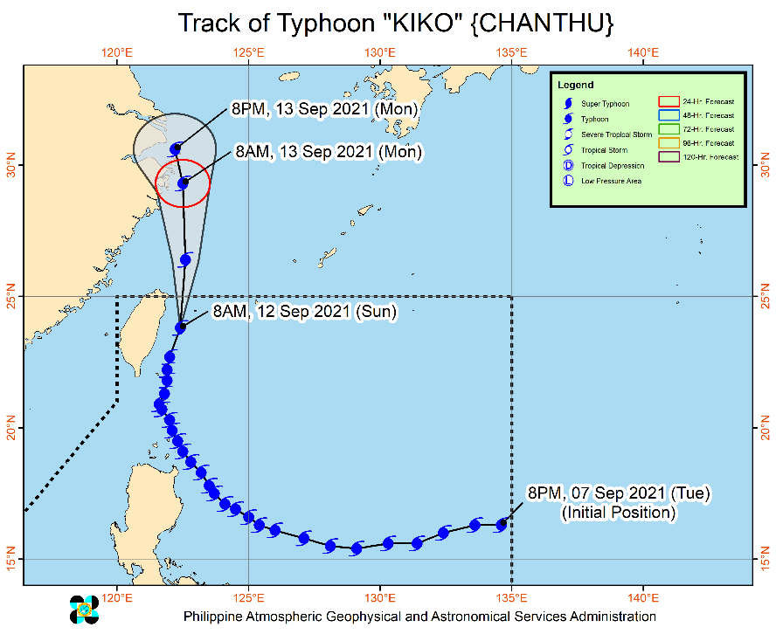
Issued at 5 PM, 12 September 2021, “KIKO” SLIGHTLY WEAKENS AND IS NOW OUTSIDE THE PHILIPPINE AREA OF RESPONSIBILITY.

- The center of the eye of Typhoon “KIKO” was located
based on all available data at 525 km North of
Itbayat, Batanes (25.5°N, 122.4°E) (outside the
PAR).

Heavy Rainfall:
- Typhoon “KIKO” will continue to enhance the Southwest Monsoon, bringing monsoon rains over Batanes, Babuyan Islands, Ilocos Region, Cordillera Administrative Region, and the western section of Central Luzon in the next 24 hours. Under these conditions, scattered to widespread flooding (including flash floods) and rain-induced landslides are possible especially in areas that are highly or very highly susceptible to these hazard as identified in hazard maps.

Severe Winds:
- All Tropical Cyclone Wind Signal is now lifted. However, in the next 24 hours, the enhanced Southwest Monsoon will bring occasional gusts reaching strong breeze to near gale strength over the coastal and upland/mountain areas of Northern Luzon, Central Luzon, Metro Manila, CALABARZON, and MIMAROPA.

Track:
- Typhoon “KIKO” left the Philippine Area of Responsibility at 1:10 PM today. In the next 24 hours, the typhoon is forecast to move generally northward over the East China Sea heading towards eastern China. Further weakening will continue throughout the forecast period but “KIKO” will remain within typhoon category.

Source: DOST-PAGASA Weather Advisory

- Status of Affected Areas and Population

A total of 1,847 families or 5,990 persons were affected by Typhoon “Kiko” in 111 Barangays in Regions I, II and CAR (see Table 1).

Table 1. Number of Affected Families / Persons
REGION / PROVINCE / MUNICIPALITY |  | NUMBER OF AFFECTED
 |  | Barangays | Families | Persons
GRAND TOTAL |  | 111 | 1,847 | 5,990
REGION I |  | 1 | 17 | 63
Ilocos Norte |  | 1 | 17 | 63
 | Pagudpud | 1 | 17 | 63
REGION II |  | 109 | 1,829 | 5,920
Batanes |  | 6 | 20 | 66
 | Itbayat | 4 | 14 | 44
 | Sabtang | 2 | 6 | 22
Cagayan |  | 92 | 1,675 | 5,453
 | Abulug | 1 | 1 | 3
 | Alcala | 2 | 9 | 36
 | Allacapan | 5 | 96 | 346
 | Aparri | 8 | 57 | 252
 | Baggao | 28 | 830 | 2,340
 | Buguey | 1 | - | 19
 | Calayan | 2 | 61 | 205
 | Gattaran | 12 | 205 | 791
 | Gonzaga | 2 | 12 | 47
 | Lal-lo | 6 | 81 | 303
 | Lasam | 2 | 54 | 178
 | Pamplona | 7 | 95 | 264
 | Santa Ana | 7 | 106 | 420
 | Santa Praxedes | 2 | 9 | 30
 | Santa Teresita | 5 | 56 | 208
 | Solana | 2 | 3 | 11
Isabela |  | 11 | 134 | 401
 | Divilacan | 3 | 37 | 136
 | Maconacon | 8 | 97 | 265
CAR |  | 1 | 1 | 7
Benguet |  | 1 | 1 | 7
 | La Trinidad (capital) | 1 | 1 | 7
Note: Ongoing assessment and validation are continuously being conducted.
Source: DSWD-Field Offices (FOs)

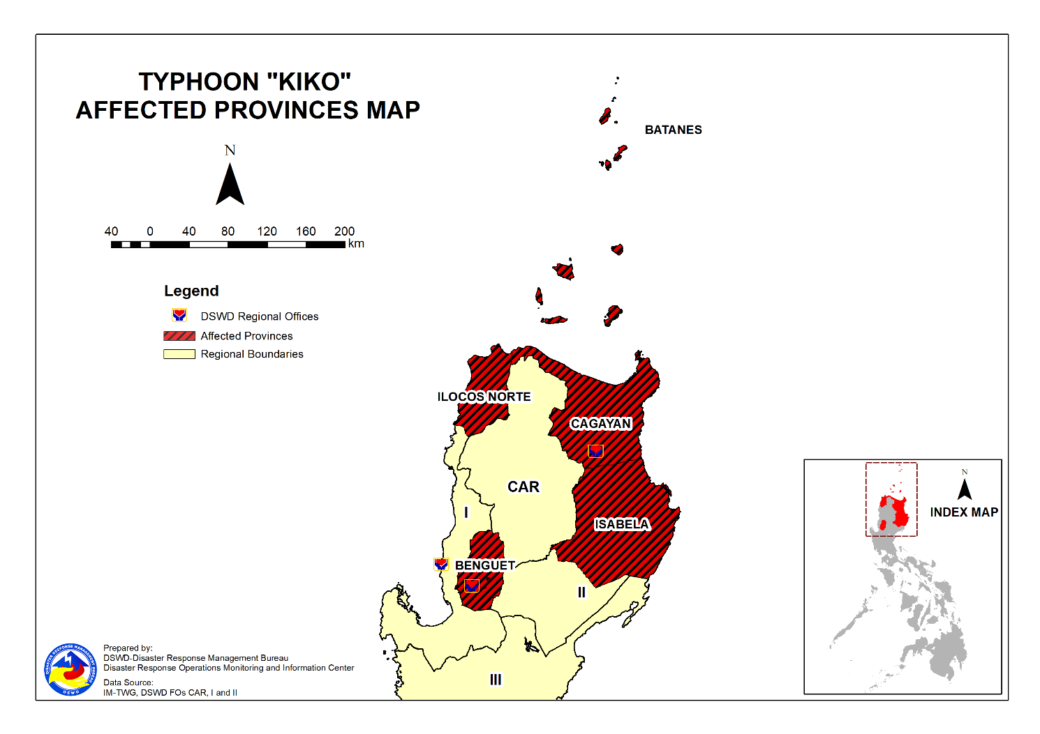
- Status of Displaced Population

- Inside Evacuation Centers
There are 36 families or 108 persons currently taking temporary shelter in three (3) evacuation centers in Region II (see Table 2).

Table 2. Number of Displaced Families / Persons Inside Evacuation Centers
REGION / PROVINCE / MUNICIPALITY |  | NUMBER OF EVACUATION CENTERS (ECs) |  | NUMBER OF DISPLACED
 |  |  |  | INSIDE ECs
 |  |  |  | Families |  | Persons
 |  | CUM | NOW | CUM | NOW | CUM | NOW
GRAND TOTAL |  | 98 | 3 | 1,028 | 36 | 3,590 | 108
REGION I |  | 1 | - | 15 | - | 60 | -
Ilocos Norte |  | 1 | - | 15 | - | 60 | -
 | Pagudpud | 1 | - | 15 | - | 60 | -
REGION II |  | 97 | 3 | 1,013 | 36 | 3,530 | 108
Batanes |  | 2 | 2 | 6 | 6 | 18 | 18
 | Itbayat | 1 | 1 | 5 | 5 | 15 | 15
 | Sabtang | 1 | 1 | 1 | 1 | 3 | 3
Cagayan |  | 86 | 1 | 898 | 30 | 3,185 | 90
 | Abulug | 1 | - | 1 | - | 3 | -
 | Alcala | 2 | - | 9 | - | 36 | -
 | Allacapan | 5 | - | 92 | - | 331 | -
 | Aparri | 6 | - | 19 | - | 87 | -
 | Baggao | 25 | - | 260 | - | 871 | -
 | Buguey | 1 | - | - | - | 19 | -
 | Calayan | 2 | 1 | 49 | 30 | 159 | 90
 | Gattaran | 11 | - | 130 | - | 515 | -
 | Gonzaga | 3 | - | 11 | - | 46 | -
 | Lal-lo | 8 | - | 81 | - | 303 | -
 | Lasam | 3 | - | 42 | - | 136 | -
 | Pamplona | 4 | - | 87 | - | 251 | -
 | Santa Ana | 4 | - | 69 | - | 258 | -
 | Santa Praxedes | 2 | - | 9 | - | 30 | -
 | Santa Teresita | 7 | - | 36 | - | 129 | -
 | Solana | 2 | - | 3 | - | 11 | -
Isabela |  | 9 | - | 109 | - | 327 | -
 | Divilacan | 5 | - | 37 | - | 136 | -
 | Maconacon | 4 | - | 72 | - | 191 | -
Note: Ongoing assessment and validation are continuously being conducted.
Source: DSWD-Field Offices (FOs)

- Outside Evacuation Centers
There are 14 families or 52 persons temporarily staying with their relatives and/or friends in Regions II and CAR (see Table 3).

Table 3. Number of Displaced Families / Persons Outside Evacuation Centers
REGION / PROVINCE / MUNICIPALITY |  | NUMBER OF DISPLACED
 |  | OUTSIDE ECs
 |  | Families |  | Persons
 |  | CUM | NOW | CUM | NOW
GRAND TOTAL |  | 815 | 14 | 2,392 | 52
REGION II |  | 814 | 13 | 2,385 | 45
Batanes |  | 14 | 13 | 48 | 45
 | Itbayat | 9 | 8 | 29 | 26
 | Sabtang | 5 | 5 | 19 | 19
Cagayan |  | 775 | - | 2,263 | -
 | Allacapan | 4 | - | 15 | -
 | Aparri | 38 | - | 165 | -
 | Baggao | 569 | - | 1,465 | -
 | Calayan | 12 | - | 46 | -
 | Gattaran | 75 | - | 276 | -
 | Lasam | 12 | - | 42 | -
 | Pamplona | 8 | - | 13 | -
 | Santa Ana | 37 | - | 162 | -
 | Santa Teresita | 20 | - | 79 | -
Isabela |  | 25 | - | 74 | -
 | Maconacon | 25 | - | 74 | -
CAR |  | 1 | 1 | 7 | 7
Benguet |  | 1 | 1 | 7 | 7
 | La Trinidad (capital) | 1 | 1 | 7 | 7
Note: Ongoing assessment and validation are continuously being conducted.
Source: DSWD-Field Offices (FOs)

- Total Displaced Population
There are 50 families or 160 persons still displaced in Regions II and CAR due to Typhoon “Kiko” (see Table 4).

Table 4. Total Number of Displaced Families / Persons
REGION / PROVINCE / MUNICIPALITY |  | TOTAL DISPLACED SERVED
 |  | Families |  | Persons
 |  | Total Families |  | Total Persons
 |  | CUM | NOW | CUM | NOW
GRAND TOTAL |  | 1,843 | 50 | 5,982 | 160
REGION I |  | 15 | - | 60 | -
Ilocos Norte |  | 15 | - | 60 | -
 | Pagudpud | 15 | - | 60 | -
REGION II |  | 1,827 | 49 | 5,915 | 153
Batanes |  | 20 | 19 | 66 | 63
 | Itbayat | 14 | 13 | 44 | 41
 | Sabtang | 6 | 6 | 22 | 22
Cagayan |  | 1,673 | 30 | 5,448 | 90
 | Abulug | 1 | - | 3 | -
 | Alcala | 9 | - | 36 | -
 | Allacapan | 96 | - | 346 | -
 | Aparri | 57 | - | 252 | -
 | Baggao | 829 | - | 2,336 | -
 | Buguey | - | - | 19 | -
 | Calayan | 61 | 30 | 205 | 90
 | Gattaran | 205 | - | 791 | -
 | Gonzaga | 11 | - | 46 | -
 | Lal-lo | 81 | - | 303 | -
 | Lasam | 54 | - | 178 | -
 | Pamplona | 95 | - | 264 | -
 | Santa Ana | 106 | - | 420 | -
 | Santa Praxedes | 9 | - | 30 | -
 | Santa Teresita | 56 | - | 208 | -
 | Solana | 3 | - | 11 | -
Isabela |  | 134 | - | 401 | -
 | Divilacan | 37 | - | 136 | -
 | Maconacon | 97 | - | 265 | -
CAR |  | 1 | 1 | 7 | 7
Benguet |  | 1 | 1 | 7 | 7
 | La Trinidad (capital) | 1 | 1 | 7 | 7
Note: Ongoing assessment and validation are continuously being conducted.
Source: DSWD-Field Offices (FOs)

- Damaged Houses
A total of seven (7) houses were damaged; of which, two (2) were totally damaged and five (5) were partially damaged in Regions II and CAR (see Table 5).

Table 5. Number of Damaged Houses
REGION / PROVINCE / MUNICIPALITY |  | NO. OF DAMAGED HOUSES
 |  | Total | Totally | Partially
GRAND TOTAL |  | 7 | 2 | 5
REGION II |  | 6 | 2 | 4
Cagayan |  | 6 | 2 | 4
 | Calayan | 6 | 2 | 4
CAR |  | 1 | - | 1
Benguet |  | 1 | - | 1
 | La Trinidad (capital) | 1 | - | 1
Note: Ongoing assessment and validation are continuously being conducted.
Source: DSWD-Field Offices (FOs)

- Response Actions and Interventions

- Standby Funds and Prepositioned Relief Stockpile

Office | Quick Response Fund (QRF)/ | Family Food Packs (FFPs) |  | Other Food and Non-Food Items (FNIs) | Total
 | Standby Funds | No. | Cost
DSWD-CO | 403,151,648.37 | - | - |  | 403,151,648.37
NROC | - | 46,447 | 31,337,535.60 | 165,018,668.38 | 196,356,203.98
VDRC | - | 12,634 | 6,001,150.00 | 28,288,615.16 | 34,289,765.16
DSWD-FO I | 91,035.20 | 15,328 | 7,817,280.00 | 43,868,296.23 | 51,776,611.43
DSWD-FO II | 5,031,059.68 | 20,502 | 8,590,078.00 | 19,380,886.29 | 33,002,023.97
DSWD-FO CAR | 920,079.12 | 17,804 | 9,174,735.92 | 35,924,026.32 | 35,924,026.32
Other DSWD-FOs | 37,632,766.36 | 256,675 | 140,944,666.23 | 351,792,710.57 | 530,370,143.16
TOTAL | 446,826,588.73 | 369,390 | 203,865,445.75 | 634,178,387.91 | 1,284,870,422.39
Note: The Inventory Summary is as of 12 September 2021, 4PM.
Source: DSWD-NRLMB

  - Standby Funds
    - ₱403.15 million Quick Response Fund (QRF) at the DSWD-Central Office.
    - ₱6.04 million available at DSWD-FOs I, II and CAR.
    - ₱37.63 million in other DSWD-FOs which may support the relief needs of the displaced families due to Severe Tropical Storm “KIKO” through inter-FO augmentation.

  - Prepositioned FFPs and Other Relief Items
    - 59,081 FFPs available in Disaster Response Centers; of which, 46,447 FFPs are at the National Resource Operations Center (NROC), Pasay City and 12,634 FFPs are at the Visayas Disaster Response Center (VDRC), Cebu City.
    - 53,634 FFPs available at DSWD-FOs I, II and CAR.
    - 256,675 FFPs in other DSWD-FOs which may support the relief needs of the displaced families due to Severe Tropical Storm “KIKO” through inter-FO augmentation.
    - ₱634.18 million worth of other food and non-food items (FNIs) at NROC, VDRC and DSWD-FO warehouses countrywide.

- Food and Non-Food Items

DSWD-FO CAR
DATE | ACTIVITIES
9 September 2021 | - DSWD FO-CAR delivered 2,500 FFPs and 135 Hygiene kits to the DSWD warehouse in the province of Abra in September 09, 2021  - Delivered 800 FFPs to the DSWD warehouse in Mt. Province on 08 September 2021  - Ensures availability of food and non-food items for resource augmentation as need arises  - Continuous production at the regional production hubs in the region  - Ensure availability of transportation service

DSWD-FO II
DATE | ACTIVITIES
12 September 2021 | - DSWD-FO II approved the request of the municipality of Baggao, Cagayan of 733 FPPs as augmentation support to the affected families.  - DSWD-FO II coordinated with NRLMB on the request of 5,000 FPPs to be airlifted to the Province of Batanes in coordination with OCD RO2 and Phil Force.

- Camp Coordination and Camp Management

DSWD-FO II
DATE | ACTIVITIES
11 September 2021 | - There are Two hundred seventy-nine (279) Families with eight hundred sixty-eight (868) individuals were pre-emptively and forcedly evacuated that are currently staying inside twenty-nine (29) Evacuation Centers;  - There are twenty-nine (29) Families with ninety-seven (97) individuals conducted pre-emptive evacuation and they are currently staying with their relatives and friends;  - There are Twenty-three (23) individuals are stranded in Claveria seaport wherein ten (10) individuals from Fuga Island are currently sheltered in the fish port while the remaining thirteen (13) individuals are sheltered in their relatives at Centro 5, Claveria.

- Other Activities

DSWD-FO I
DATE | ACTIVITIES
10 September 2021 | - DSWD FO-I is closely monitoring the effects of the Typhoon “KIKO” through DOST – PAGASA and in close coordination with the RDRRMC1. Likewise,  Provincial Operations Offices (POOs) are in close coordination with the different Provincial/City/Municipal Disaster Risk Reduction and Management Councils (P/C/MDRRMCs) and Provincial/City/ Municipality Social Welfare and Development Offices (P/C/MSWDOs) to monitor the adverse effects that might be brought by the weather disturbance.  - DSWD FO-I attended the Regional Pre-Disaster Risk Assessment (PDRA) – Analyst/Core Group Meeting through VTC.  - The DSWD FO-I Incident Management Team (IMT) is still activated and on duty while other DSWD staff are on standby for possible augmentation. Likewise, the Field Office ensures the availability and readiness of resources.

DSWD-FO II
DATE | ACTIVITIES
12 September 2021 | - DSWD-FO II together with the LGUs provided immediate needs to the affected families in the Evacuation Centers in Calayan.  - DSWD-FO II provided instructions to SWADTs and MATs to work with the LGUs/LSWDOs for immediate conduct of assessment for the provision of financial assistance to the affected families thru AICS.
10 September 2021 | - DSWF FO- II continuously monitoring and coordinating to LGUs/LSWDOs on affected families thru our SWADTs/MATs for any concerns the FO shall address;  - The Disaster Response Management Division and the Field Office Disaster Monitoring and Response Teams are on 24hour duty to continuously monitor the effects of Typhoon Kiko;  - DSWD FO-II thru the MAT coordinated for any concerns of the said individuals that need to be address;  - Likewise, there are three (3) field office staff from social pension program and disaster response management division who are currently stranded in the Municipality of Calayan and currently rendering DMRT duty at the said municipality;  - The Disaster Response Management Division continuously monitor the weather advisory and updates  - SWADTs/Provincial Operations Offices (POOs)/C/MATs closely coordinated with their respective Provincial/City/Municipal Disaster Risk Reduction and Management Councils (P/C/MDRRMCs) that are currently monitoring the adverse effects brought by TY KIKO;  - The DSWD FO-II DRMD continuously coordinates with RDRRMC for any concerns that the FO will address; and  - Dissemination of updates to agency operation center and to the concerned partner agencies.

DSWD-FO III
DATE | ACTIVITIES
10 September 2021 | - DSWD-FO III has 15 QRTs with 27 members per team ready for deployment upon activation of blue or red alert status by the RDRRMC 3.  - The Rapid Deployment Team of DSWD-FO III DRMD and DSWD Provincial Extension Office (DPEO) QRT were activated.  - Monitoring of weather updates in coordination with DPEOs and concerned LGUs

DSWD-FO CAR
DATE | ACTIVITIES
9 September 2021 | - DSWD FO-CAR conducted Quick Response Team (QRT) via Zoom; succeeding QRT teams are ready for duty.  - DSWD FO-CAR continuously monitor the weather updates;  - Requested replenishment of standby funds and additional raw materials with an equivalent to 5,000 FFPs to NRLMB  - Provide technical assistance to LGUs on Camp Coordination and Camp Management  - Dissemination of stockpile update to AOC and partner agencies

*****
The Disaster Response Operations Monitoring and Information Center (DROMIC) of DSWD-DRMB is closely coordinating with the concerned DSWD-FOs for significant disaster response updates and assistance provided.

Prepared by:  MARIE JOYCE G. RAFANAN | Released by:  LESLIE R. JAWILI

