DSWD DROMIC Report #3 on Typhoon “JOLINA”
as of 08 September 2021, 6PM

- Situation Overview

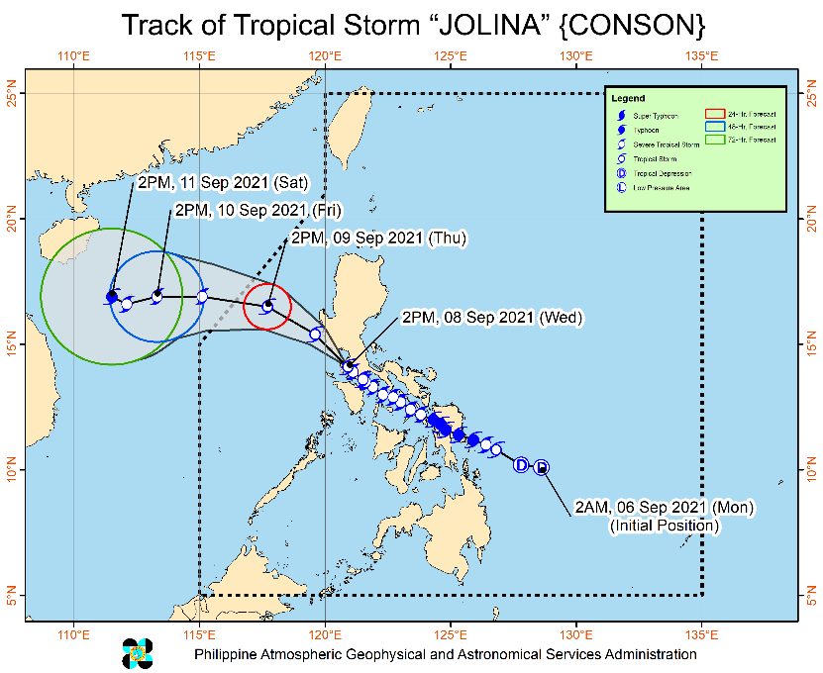
Issued at 5 PM, 08 September 2021, “JOLINA” weakens into a Tropical Storm and is now heading towards Bataan.
Heavy Rainfall:
- In the next 24 hours, heavy to intense will be experienced over Bataan, Cavite, Occidental Mindoro, and Oriental Mindoro.
- Moderate to heavy with at times intense rains are also likely over the rest of Central Luzon and CALABARZON.
- Light to moderate with at times heavy rains over Metro Manila, Ilocos Region, Cordillera Administrative Region, and Cagayan Valley. Under these conditions, scattered to widespread flooding (including flash floods) and rain-induced landslides are highly likely especially in areas that are highly or very highly susceptible to these hazard as identified in hazard maps.
Severe Winds:
- Damaging gale-force to storm-force winds are likely to occur within any of the areas where TCWS #2 is in effect. This may bring generally light to moderate damage to structures and vegetation.
- Strong winds (strong breeze to near gale conditions) with occasional gusts will be experienced in areas where Tropical Cyclone Wind Signal (TCWS) #1 is in effect. This may result to up to very light damage to structures and vegetation.

Coastal Inundation:
- Coastal areas of localities under TCWS, especially those at #2 may experience coastal flooding due to hazardous surf conditions.

Track:
- The tropical storm will continue moving generally northwestward over the mouth of Manila Bay before making its another landfall over the vicinity of Bataan Peninsula this afternoon or evening.
- “JOLINA” is forecast to emerge over the West Philippine Sea on tonight or tomorrow early morning. Re-intensification is forecast to occur beginning tomorrow evening as the tropical cyclone moves generally westward over the West Philippine Sea towards the southern China-northern Vietnam area.
- This tropical cyclone is forecast to exit the Philippine Area of Responsibility on tomorrow evening or Friday early morning.

The center of Tropical Storm “JOLINA” was estimated based on all available data over the Manila Bay or 135 km South of Sangley Point, Cavite (14.3°N,120.6°E).
Source: DOST-PAGASA Weather Advisory

- Status of Affected Areas and Population
A total of 15,250 families or 61,565 persons were affected by Typhoon “Jolina” in 206 Barangays in Regions MIMAROPA, V, VI and VIII (see Table 1).

Table 1. Number of Affected Families / Persons
REGION / PROVINCE / MUNICIPALITY |  | NUMBER OF AFFECTED
 |  | Barangays | Families | Persons
GRAND TOTAL |  | 206 | 15,250 | 61,565
MIMAROPA |  | 23 | 154 | 502
Marinduque |  | 13 | 56 | 201
 | Buenavista | 5 | 21 | 71
 | Gasan | 2 | 7 | 37
 | Santa Cruz | 4 | 23 | 80
 | Torrijos | 2 | 5 | 13
Romblon |  | 10 | 98 | 301
 | Alcantara | 2 | 6 | 19
 | Banton | 3 | 39 | 115
 | Corcuera | 2 | 30 | 58
 | Ferrol | 1 | 1 | 2
 | Odiongan | 1 | 19 | 96
 | Santa Fe | 1 | 3 | 11
REGION V |  | 101 | 3,707 | 13,830
Albay |  | 62 | 2,930 | 10,337
 | Camalig | 13 | 681 | 2,346
 | Guinobatan | 5 | 472 | 1,434
 | Legazpi City (capital) | 1 | 215 | 760
 | City of Ligao | 12 | 169 | 657
 | Malilipot | 5 | 549 | 2,247
 | Manito | 1 | 13 | 33
 | Oas | 8 | 88 | 365
 | Pio Duran | 5 | 290 | 1,015
 | Polangui | 7 | 195 | 681
 | Santo Domingo (Libog) | 1 | 4 | 18
 | Tiwi | 4 | 254 | 781
Camarines Norte |  | 1 | 3 | 9
 | Vinzons | 1 | 3 | 9
Camarines Sur |  | 5 | 96 | 332
 | Del Gallego | 2 | 36 | 160
 | Magarao | 1 | 1 | 5
 | Pasacao | 2 | 59 | 167
Masbate |  | 26 | 638 | 2,966
 | Batuan | 1 | 7 | 23
 | Esperanza | 3 | 16 | 47
 | City of Masbate (capital) | 6 | 123 | 587
 | Mobo | 6 | 206 | 1,186
 | Monreal | 2 | 7 | 38
 | Pio V. Corpuz (Limbuhan) | 2 | 221 | 839
 | San Fernando | 2 | 16 | 78
 | San Jacinto | 1 | 36 | 136
 | Uson | 3 | 6 | 32
Sorsogon |  | 7 | 40 | 186
 | Irosin | 7 | 40 | 186
REGION VI |  | 2 | 40 | 183
Capiz |  | 2 | 40 | 183
 | President Roxas | 2 | 40 | 183
REGION VIII |  | 80 | 11,349 | 47,050
Biliran |  | 15 | 182 | 899
 | Almeria | 1 | 5 | 25
 | Kawayan | 6 | 86 | 426
 | Biliran | 1 | 1 | 5
 | Cabucgayan | 1 | 1 | 5
 | Caibiran | 1 | 5 | 25
 | Culaba | 3 | 55 | 268
 | Maripipi | 2 | 29 | 145
Eastern Samar |  | 41 | 9,313 | 38,316
 | San Julian | - | 1 | 5
 | Balangiga | 1 | 77 | 263
 | General MacArthur | 1 | 55 | 223
 | Giporlos | 1 | 13 | 52
 | Guiuan | 1 | 34 | 189
 | Hernani | 8 | 2,454 | 9,729
 | Lawaan | 1 | 1,187 | 10,475
 | Llorente | 1 | 68 | 240
 | Mercedes | 1 | 91 | 510
 | Quinapondan | 25 | 4,656 | 15,668
 | Salcedo | 1 | 677 | 962
Leyte |  | 18 | 1,447 | 5,832
 | Babatngon | 1 | 12 | 48
 | Santa Fe | 7 | 809 | 3,236
 | Dulag | 1 | 185 | 740
 | Isabel | 1 | 6 | 40
 | Ormoc City | 8 | 435 | 1,768
Western Samar |  | 6 | 407 | 2,003
 | Almagro | 2 | 24 | 99
 | Gandara | 1 | 1 | 4
 | Santo Nino | 1 | 378 | 1,890
 | Tarangnan | 1 | 2 | 3
 | Talalora | 1 | 2 | 7
Note: Ongoing assessment and validation are continuously being conducted.
Source: DSWD-Field Offices (FOs)

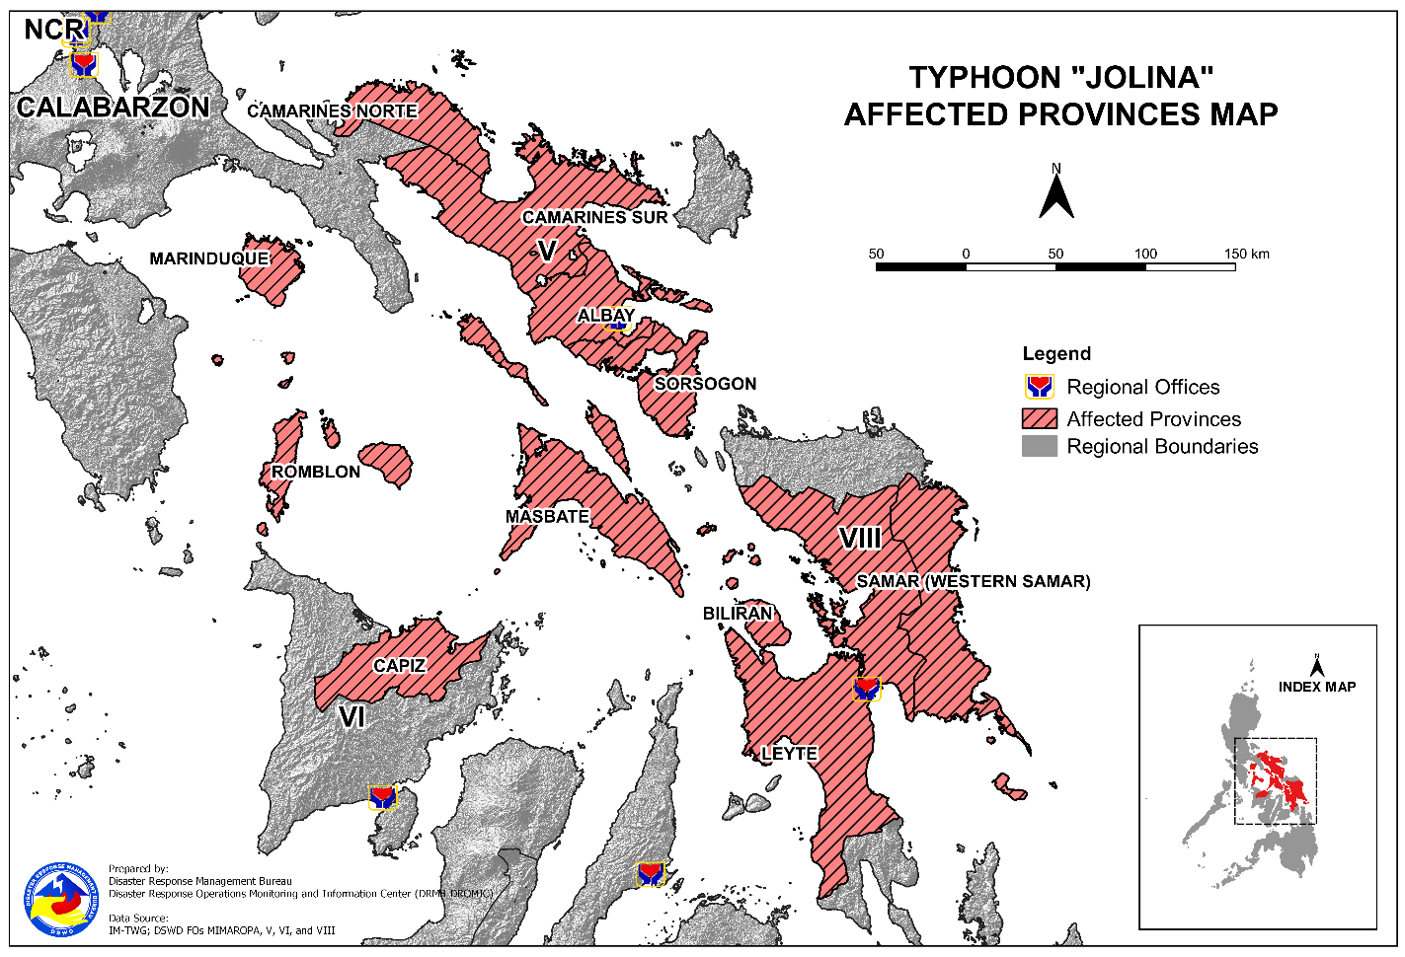

- Status of Displaced Population
- Inside Evacuation Centers
There are 2,045 families or 7,602 persons currently taking temporary shelter in 131 evacuation centers in Regions MIMAROPA, V and VIII (see Table 2).

Table 2. Number of Displaced Families / Persons Inside Evacuation Centers
REGION / PROVINCE / MUNICIPALITY |  | NUMBER OF EVACUATION CENTERS (ECs) |  | NUMBER OF DISPLACED
 |  |  |  | INSIDE ECs
 |  |  |  | Families |  | Persons
 |  | CUM | NOW | CUM | NOW | CUM | NOW
GRAND TOTAL |  | 149 | 131 | 2,634 | 2,045 | 10,106 | 7,602
MIMAROPA |  | 29 | 29 | 131 | 131 | 390 | 390
Marinduque |  | 18 | 18 | 51 | 51 | 182 | 182
 | Buenavista | 5 | 5 | 16 | 16 | 52 | 52
 | Gasan | 2 | 2 | 7 | 7 | 37 | 37
 | Santa Cruz | 9 | 9 | 23 | 23 | 80 | 80
 | Torrijos | 2 | 2 | 5 | 5 | 13 | 13
Romblon |  | 11 | 11 | 80 | 80 | 208 | 208
 | Alcantara | 3 | 3 | 6 | 6 | 19 | 19
 | Banton | 3 | 3 | 39 | 39 | 115 | 115
 | Corcuera | 2 | 2 | 30 | 30 | 58 | 58
 | Ferrol | 1 | 1 | 1 | 1 | 2 | 2
 | Odiongan | 1 | 1 | 1 | 1 | 3 | 3
 | Santa Fe | 1 | 1 | 3 | 3 | 11 | 11
REGION V |  | 105 | 99 | 2,027 | 1,885 | 7,765 | 7,093
Albay |  | 67 | 67 | 1,498 | 1,498 | 5,363 | 5,363
 | Camalig | 8 | 8 | 164 | 164 | 716 | 716
 | Guinobatan | 4 | 4 | 472 | 472 | 1,434 | 1,434
 | Legazpi City (capital) | 2 | 2 | 35 | 35 | 137 | 137
 | City of Ligao | 14 | 14 | 169 | 169 | 657 | 657
 | Malilipot | 4 | 4 | 96 | 96 | 373 | 373
 | Manito | 1 | 1 | 13 | 13 | 33 | 33
 | Oas | 12 | 12 | 88 | 88 | 365 | 365
 | Pio Duran | 8 | 8 | 232 | 232 | 809 | 809
 | Polangui | 11 | 11 | 188 | 188 | 664 | 664
 | Santo Domingo (Libog) | 1 | 1 | 4 | 4 | 18 | 18
 | Tiwi | 2 | 2 | 37 | 37 | 157 | 157
Camarines Norte |  | 2 | 2 | 10 | 10 | 26 | 26
 | Vinzons | 2 | 2 | 10 | 10 | 26 | 26
Camarines Sur |  | 10 | 10 | 96 | 96 | 332 | 332
 | Del Gallego | 2 | 2 | 36 | 36 | 160 | 160
 | Magarao | 1 | 1 | 1 | 1 | 5 | 5
 | Pasacao | 7 | 7 | 59 | 59 | 167 | 167
Masbate |  | 25 | 20 | 383 | 281 | 1,858 | 1,372
 | Esperanza | 1 | 1 | 12 | 12 | 36 | 36
 | City of Masbate (capital) | 5 | - | 102 | - | 486 | -
 | Mobo | 9 | 9 | 150 | 150 | 866 | 866
 | Monreal | 2 | 2 | 7 | 7 | 38 | 38
 | Pio V. Corpuz (Limbuhan) | 2 | 2 | 56 | 56 | 195 | 195
 | San Fernando | 2 | 2 | 16 | 16 | 78 | 78
 | San Jacinto | 1 | 1 | 34 | 34 | 127 | 127
 | Uson | 3 | 3 | 6 | 6 | 32 | 32
Sorsogon |  | 1 | - | 40 | - | 186 | -
 | Irosin | 1 | - | 40 | - | 186 | -
REGION VIII |  | 15 | 3 | 476 | 29 | 1,951 | 119
Eastern Samar |  | 1 | 1 | 5 | 5 | 20 | 20
 | Salcedo | 1 | 1 | 5 | 5 | 20 | 20
Leyte |  | 12 | - | 447 | - | 1,832 | -
 | Santa Fe | 2 | - | 6 | - | 24 | -
 | Isabel | 1 | - | 6 | - | 40 | -
 | Ormoc City | 9 | - | 435 | - | 1,768 | -
Western Samar |  | 2 | 2 | 24 | 24 | 99 | 99
 | Almagro | 2 | 2 | 24 | 24 | 99 | 99
Note: Ongoing assessment and validation are continuously being conducted.
Source: DSWD-FOs

- Outside Evacuation Centers
There are 1,682 families or 6,070 persons temporarily staying with their relatives and/or friends in Regions MIMAROPA and V (see Table 3).

Table 3. Number of Displaced Families / Persons Outside Evacuation Centers
REGION / PROVINCE / MUNICIPALITY |  | NUMBER OF DISPLACED
 |  | OUTSIDE ECs
 |  | Families |  | Persons
 |  | CUM | NOW | CUM | NOW
GRAND TOTAL |  | 1,682 | 1,682 | 6,070 | 6,070
MIMAROPA |  | 23 | 23 | 112 | 112
Marinduque |  | 5 | 5 | 19 | 19
 | Buenavista | 5 | 5 | 19 | 19
Romblon |  | 18 | 18 | 93 | 93
 | Odiongan | 18 | 18 | 93 | 93
REGION V |  | 1,659 | 1,659 | 5,958 | 5,958
Albay |  | 1,432 | 1,432 | 4,974 | 4,974
 | Camalig | 517 | 517 | 1,630 | 1,630
 | Legazpi City (capital) | 180 | 180 | 623 | 623
 | Malilipot | 453 | 453 | 1,874 | 1,874
 | Pio Duran | 58 | 58 | 206 | 206
 | Polangui | 7 | 7 | 17 | 17
 | Tiwi | 217 | 217 | 624 | 624
Masbate |  | 227 | 227 | 984 | 984
 | Esperanza | 4 | 4 | 11 | 11
 | Mobo | 56 | 56 | 320 | 320
 | Pio V. Corpuz (Limbuhan) | 165 | 165 | 644 | 644
 | San Jacinto | 2 | 2 | 9 | 9
Note: Ongoing assessment and validation are continuously being conducted.
Source: DSWD-FOs

- Total Displaced Population
There are 3,727 families or 13,672 persons temporarily staying with their relatives and/or friends in Regions MIMAROPA, V and VIII (see Table 4).

Table 4. Total Displaced Population
REGION / PROVINCE / MUNICIPALITY |  | TOTAL DISPLACED
 |  | Families |  | Persons
 |  | CUM | NOW | CUM | NOW
GRAND TOTAL |  | 4,316 | 3,727 | 16,176 | 13,672
MIMAROPA |  | 154 | 154 | 502 | 502
Marinduque |  | 56 | 56 | 201 | 201
 | Buenavista | 21 | 21 | 71 | 71
 | Gasan | 7 | 7 | 37 | 37
 | Santa Cruz | 23 | 23 | 80 | 80
 | Torrijos | 5 | 5 | 13 | 13
Romblon |  | 98 | 98 | 301 | 301
 | Alcantara | 6 | 6 | 19 | 19
 | Banton | 39 | 39 | 115 | 115
 | Corcuera | 30 | 30 | 58 | 58
 | Ferrol | 1 | 1 | 2 | 2
 | Odiongan | 19 | 19 | 96 | 96
 | Santa Fe | 3 | 3 | 11 | 11
REGION V |  | 3,686 | 3,544 | 13,723 | 13,051
Albay |  | 2,930 | 2,930 | 10,337 | 10,337
 | Camalig | 681 | 681 | 2,346 | 2,346
 | Guinobatan | 472 | 472 | 1,434 | 1,434
 | Legazpi City (capital) | 215 | 215 | 760 | 760
 | City of Ligao | 169 | 169 | 657 | 657
 | Malilipot | 549 | 549 | 2,247 | 2,247
 | Manito | 13 | 13 | 33 | 33
 | Oas | 88 | 88 | 365 | 365
 | Pio Duran | 290 | 290 | 1,015 | 1,015
 | Polangui | 195 | 195 | 681 | 681
 | Santo Domingo (Libog) | 4 | 4 | 18 | 18
 | Tiwi | 254 | 254 | 781 | 781
Camarines Norte |  | 10 | 10 | 26 | 26
 | Vinzons | 10 | 10 | 26 | 26
Camarines Sur |  | 96 | 96 | 332 | 332
 | Del Gallego | 36 | 36 | 160 | 160
 | Magarao | 1 | 1 | 5 | 5
 | Pasacao | 59 | 59 | 167 | 167
Masbate |  | 610 | 508 | 2,842 | 2,356
 | Esperanza | 16 | 16 | 47 | 47
 | City of Masbate (capital) | 102 | - | 486 | -
 | Mobo | 206 | 206 | 1,186 | 1,186
 | Monreal | 7 | 7 | 38 | 38
 | Pio V. Corpuz (Limbuhan) | 221 | 221 | 839 | 839
 | San Fernando | 16 | 16 | 78 | 78
 | San Jacinto | 36 | 36 | 136 | 136
 | Uson | 6 | 6 | 32 | 32
Sorsogon |  | 40 | - | 186 | -
 | Irosin | 40 | - | 186 | -
REGION VIII |  | 476 | 29 | 1,951 | 119
Eastern Samar |  | 5 | 5 | 20 | 20
 | Salcedo | 5 | 5 | 20 | 20
Leyte |  | 447 | - | 1,832 | -
 | Santa Fe | 6 | - | 24 | -
 | Isabel | 6 | - | 40 | -
 | Ormoc City | 435 | - | 1,768 | -
Western Samar |  | 24 | 24 | 99 | 99
 | Almagro | 24 | 24 | 99 | 99
Note: Ongoing assessment and validation are continuously being conducted.
Source: DSWD-FOs

- Damaged Houses
A total of 2,780 houses were damaged; of which, 100 are totally damaged and 2,680 are partially damaged in Regions V and VIII (see Table 4).

REGION / PROVINCE / MUNICIPALITY |  | NO. OF DAMAGED HOUSES
 |  | Total | Totally | Partially
GRAND TOTAL |  | 2,780 | 100 | 2,680
REGION V |  | 17 | - | 17
Masbate |  | 17 | - | 17
 | City of Masbate (capital) | 12 | - | 12
 | Uson | 5 | - | 5
REGION VIII |  | 2,763 | 100 | 2,663
Eastern Samar |  | 2,188 | 21 | 2,167
Leyte |  | 14 | 2 | 12
 | Ormoc City | 2 | 2 | -
Western Samar |  | 379 | 59 | 320
Note: Ongoing assessment and validation are continuously being conducted.
Source: DSWD-FOs

- Response Actions and Interventions

- Standby Funds and Prepositioned Relief Stockpile

Office | Quick Response Fund (QRF) / Standby Funds | Family Food Packs (FFPs) |  | Other Food and Non-Food Items (FNIs) | Total
 |  | No. | Cost
DSWD-CO | 442,892,138.74 | - | - | - | 442,892,138.74
NROC | - | 11,101 | 8,528,770.60 | 179,815,386.66 | 188,344,157.26
VDRC | - | 1,434 | 681,150.00 | 28,115,924.86 | 28,797,074.86
DSWD-FO MIMAROPA | 5,347,036.87 | 24,286 | 15,084,700.03 | 19,586,884.00 | 40,018,620.90
DSWD-FO V | 3,000,000.00 | 31,518 | 15,919,814.46 | 29,004,939.78 | 47,924,754.24
DSWD-FO VI | 518,196.42 | 25,711 | 12,531,128.55 | 27,774,486.72 | 40,823,811.69
DSWD-FO VIII | 2,285,000.00 | 10,825 | 5,832,346.81 | 35,943,613.84 | 44,060,960.65
Other DSWD-FOs | 32,524,707.07 | 215,771 | 117,107,514.70 | 325,451,043.39 | 475,083,265.16
TOTAL | 486,567,079.10 | 320,646 | 175,685,425.15 | 645,692,279.25 | 1,307,944,783.50
Note: The Inventory Summary is as of 08 September 2021, 4PM.
Source: DSWD-DRMB & DSWD-NRLMB

  - Standby Funds
    - ₱442.9 million Quick Response Fund (QRF) at the DSWD-Central Office.
    - ₱11.2 million available at DSWD-FOs MIMAROPA, V, VI, and VIII.
    - ₱32.5 million in other DSWD-FOs which may support the relief needs of the displaced families due to Typhoon “JOLINA” through inter-FO augmentation.

  - Prepositioned FFPs and Other Relief Items
    - 12,535 FFPs available in Disaster Response Centers; of which, 11,101 FFPs are at the National Resource Operations Center (NROC), Pasay City and 1,434 FFPs are at the Visayas Disaster Response Center (VDRC), Cebu City.
    - 92,340 FFPs available at DSWD-FOs MIMAROPA, V, VI, and VIII.
    - 215,771 FFPs in other DSWD-FOs which may support the relief needs of the displaced families due to Taal Volcano Eruption through inter-FO augmentation.
    - ₱645.7 million worth of other food and non-food items (FNIs) at NROC, VDRC and DSWD-FO warehouses countrywide.

- Food and Non-Food Items
- DSWD-FO CAR has a scheduled delivery of 2,500 FFPs and 135 hygiene kits to Abra Satellite Warehouse and 700 FFPs to Mountain Province Satellite Warehouse on 08 September 2021.
- The Disaster Response Management Division (DRMD) of DSWD-FO CALABARZON coordinated with LGUs with existing evacuation centers on 08 September 2021 to ensure the provision of relief items including personal protective equipment (PPE) to IDPs.

- Camp Coordination and Camp Management
- The DRMD of DSWD-FO CALABARZON on 08 September 2021 reminded the local government units (LGUs) with existing evacuation centers to implement COVID-19 Operational Guidance for Camp Coordination and Camp Management (CCCM) and Protection to strengthen infection prevention and control measures inside evacuation centers.

- Internally Displaced Person (IDP) Protection
- The EOC of DSWD-FO CALABARZON coordinated with the Provincial Social Welfare and Development Offices (PSWDOs) in the Region on 08 September 2021 and reminded them to ensure implementation of COVID-19 Minimum Health Public Standard (MHPS) in evacuation centers.

- Other Activities

DSWD-FO NCR
DATE | ACTIVITIES
08 September 2021 | - The DRMD and Quick Response Teams (QRTs) of DSWD-FO NCR are on standby and may be activated in case of eventualities that may occur due to Typhoon “Jolina”.  - DSWD-FO NCR is closely coordinating with the Local Social Welfare and Development Offices (LSWDOs) in Metro Manila for updates and augmentation requests.

DSWD-FO CAR
DATE | ACTIVITIES
08 September 2021 | - DSWD-FO CAR attended the Pre-Disaster Risk Assessment (PDRA) for Typhoon “Jolina” and Typhoon “Kiko”.  - Food pack production is ongoing at the Regional Production Hubs.
07 September 2021 | - DSWD-FO CAR ensured availability of FNIs and transportation services for resource augmentation as need arises.  - QRT members were activated and on standby for possible augmentation.

DSWD-FO I
DATE | ACTIVITIES
08 September 2021 | - Production of FFPs and disinfection of rice are ongoing at the DSWD Regional Warehouse, Biday, City of San Fernando, La Union.
07 September 2021 | - DSWD-FO I closely coordinated with the Regional Disaster Risk Reduction and Management Council (RDRRMC) 1. Its Provincial Operations Offices (POOs) were in close coordination with different Local Disaster Risk Reduction and Management Councils (LDRRMCs) and LSWDOs to monitor the adverse effects of brought by the weather disturbance.  - DSWD-FO I attended the Regional PDRA Analyst Group Meeting and PDRA Core Group Meeting. The discussion focused on the current weather situation and the duly approved Alpha Emergency Preparedness and Response (EPR) Protocol to be adopted by the Region.  - DSWD-FO I Incident Management Team (IMT) remains activated and on duty, while other DSWD staff are on standby for possible augmentation.  - DSWD-FO I ensured availability and readiness of resources.

DSWD-FO II
DATE | ACTIVITIES
07 September 2021 | - DSWD-FO II attended the Virtual PDRA Core Group Meeting relative to preparedness response measures of each council member of Cagayan Valley Regional Disaster Risk Reduction and Management Council (CVRDRRMC).  - DSWD-FO II alerted its Social Welfare and Development Teams (SWADTs) and Municipal Action Teams (MATs) on the possible effects of Typhoon “Jolina” and other weather disturbances. They were advised to coordinate with their respective LDRRMCs and LSWDOs for any concerns that need to be addressed.  - The DRMD of DSWD-FO II, through its Regional Resource Operations Section (RROS) ensured availability of FNIs at any given time.

DSWD-FO CALABARZON
DATE | ACTIVITIES
08 September 2021 | - DSWD-FO CALABARZON Regional Director Marcelo Nicomedes Castillo convened the DRMD to identify priorities for the Humanitarian Assistance and Disaster Relief (HADR).  - The EOC of DSWD-FO CALABARZON coordinated with the RDDRMC IV-A Operations Center for the inventory of available vehicles that may be utilized for hauling and delivery of relief items to affected areas.  - The Regional and Provincial QRT members are placed on red alert status and ready for possible deployment in the affected areas as need arises.
07 September 2021 | - Regional and Provincial QRTs and IMT members were placed on standby alert status and ready for mobilization as need arises.  - DSWD-FO CALABARZON Emergency Operations Center (EOC) has been placed on heightened alert status to monitor the possible effects of Typhoon “Jolina”.  - DSWD-FO CALABARZON attended the Virtual EPR Meeting which served as a venue to check the preparedness level of the Response Cluster and LGUs.  - DRMD conducted close coordination with the LGUs relative to the preparedness efforts undertaken in flood, landslide, and storm surge prone areas, and reports on the possible effects of Typhoon “Jolina”.  - DSWD-FO CALABARZON coordinated with LSWDOs and LDRRMOs to prepare their respective evacuation centers and relief resources should need arises. They were also reminded to ensure the implementation of COVID-19 Health and Safety Protocols.

DSWD-FO MIMAROPA
DATE | ACTIVITIES
07 September 2021 | - DSWD-FO MIMAROPA activated its EOC to monitor the daily weather condition, related eventualities, bulletins, warnings, and other advisories issued by RDRRMC, LDRRMCs, and other surveillance agencies.  - The expanded Regional/Provincial/City/Municipal (R/P/C/M) QRTs together with Special Projects staff were activated to monitor any untoward incidents or eventualities.  - DSWD-FO MIMAROPA is closely coordinating with the Office of Civil Defense (OCD) and RDRRMC MIMAROPA for any updates.  - DSWD-FO MIMAROPA attended the PDRA Analyst Group Meeting and PDRA Core Group Meeting for Typhoon “Jolina” and other weather disturbance.  - Logistical and emergency telecommunication equipment are on standby.

DSWD-FO V
DATE | ACTIVITIES
07 September 2021 | - DSWD-FO V activated its EOC at the regional and provincial levels.  - DSWD-FO V QRT is stationed at Sutherland, Legazpi City Port, Legazpi City, Albay.  - Various coordination meetings in the Region were attended.

DSWD-FO VI
DATE | ACTIVITIES
08 September 2021 | - DSWD-FO VI issued a Memorandum to all QRT members, Provincial/City/Municipal Action Teams (P/C/MATs), and SWADTs to monitor the local situation and to coordinate with LSWDOs and LDRRMOs for possible augmentation.  - DSWD-FO VI joined the RDRRMC PDRA Meeting and provided updates on the agency’s preparedness measures.  - Repacking of FFPs at the Regional Warehouse is ongoing.
07 September 2021 | - RDANA Team of DSWD-FO VI, composed of 40 trained QRT members is on standby and ready for deployment if needed.

DSWD-FO VIII
DATE | ACTIVITIES
07 September 2021 | - DSWD-FO VIII coordinated with the LGUs for updates on the affected families and relief augmentation needs.

DSWD-FO X
DATE | ACTIVITIES
07 September 2021 | - DSWD-FO X through its Disaster Response Information Management Section (DRIMS) closely coordinated with SWADT leaders, Local Disaster Risk Reduction and Management Offices (LDRRMOs), and LSWDOs for updates.

- Photo Documentation

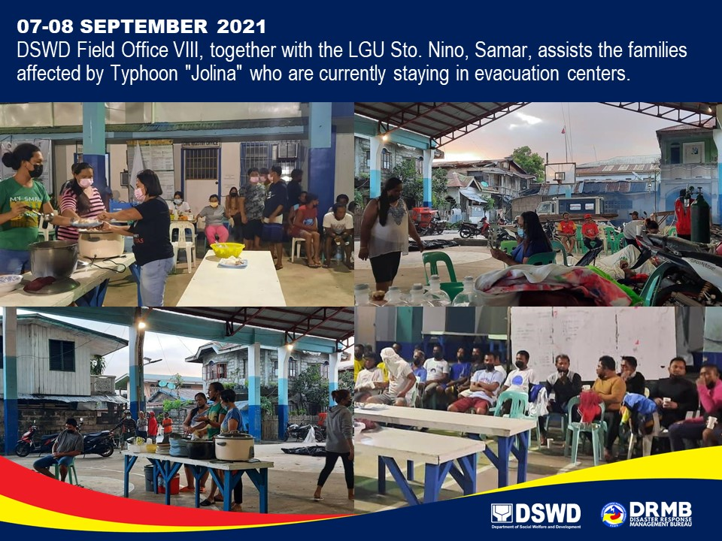

*****
The Disaster Response Operations Monitoring and Information Center (DROMIC) of DSWD-DRMB is closely coordinating with the concerned DSWD-FOs for significant disaster response updates and assistance provided.

Prepared by:  AARON JOHN B. PASCUA  MARIEL B. FERRARIZ  DIANE C. PELEGRINO  JEM ERIC F. FAMORCAN | Released by:  MARC LEO L. BUTAC

